# WORK-CASE №2

Трегуб Ольга

**1.** Install a type II hypervisor on your home workstation - Virtual Box, VMWare Workstation, Hyper-V (or another one of your choice).

1)Download an Ubuntu Image. Make sure to save it to a memorable location on your PC

- Download and install VirtualBox. Once you have completed the installation, go ahead and run VirtualBox.

## 2)Create a new virtual machine

-Click New to create a new virtual machine. Fill in the appropriate details:

* Name: If you include the word Ubuntu in your name the Type and Version will auto-update.
* Machine Folder: This is where your virtual machines will be stored so you can resume working on them whenever you like.
* Type: Linux
* Version: Ubuntu (64-bit)

- You will be able to select the amount of RAM from your main PC that the virtual machine will access. Be sure to remain inside the green bar to ensure you can continue to work outside of the VM whilst it’s running. It’s fine to use the default settings for now.

- After that, you can select how much of your hard disk your VM will use.

- The type of hard disk depends on whether you use VirtualBox with other VM software. For now, we can leave this as a VDI.

- Then you can choose whether the hard disk is dynamically allocated, filling up as the VM requires it. Otherwise, we can tell it to allocate the full amount of memory right from the start. This will improve performance but may take up unnecessary space.

- Finally you can set the maximum amount of memory your VM can access.

- After this click Create to initialize the machine.

## 3)Install your image

## -Click Start to launch the virtual machine. You will be prompted to select the start-up disk. Use the file icon to open the Optical disc selector and click Add to find your .iso file

- Choose the disc image you want to use, then click Start on the start-up disc window. Ubuntu desktop should now boot and display the installation menu.

Притула Владислав  
2. To create a new virtual we need to click on "create"  
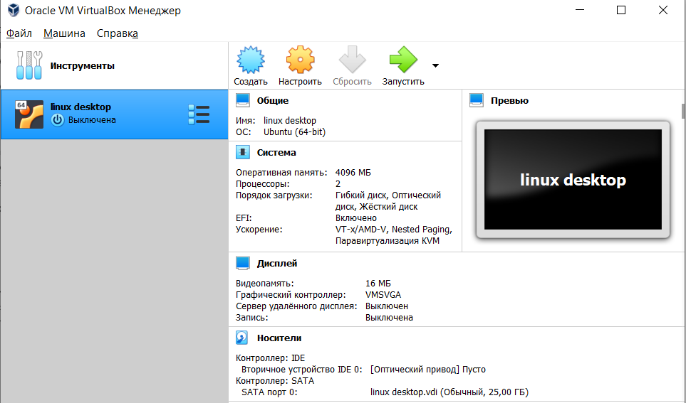  
Enter the name and select the distribution we need, after that click "Next"  
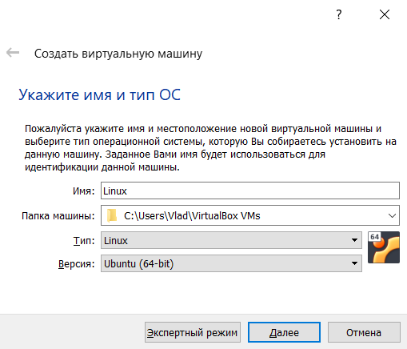

To connect to the Wi-Fi network, we need to go to the virtual settings and select "enable network adapter"  
  
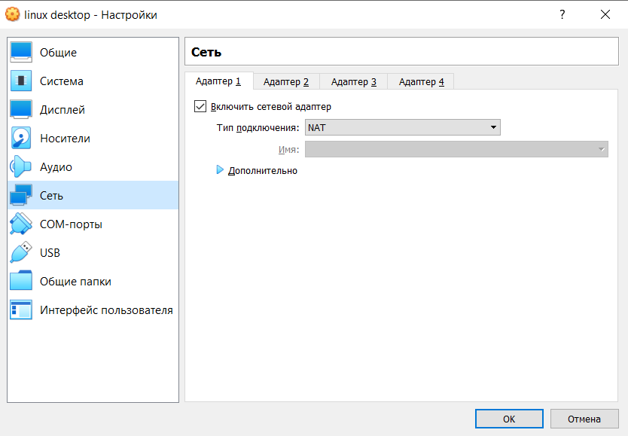  
For external media, we also need to go into the settings and select the memory that is available  
  
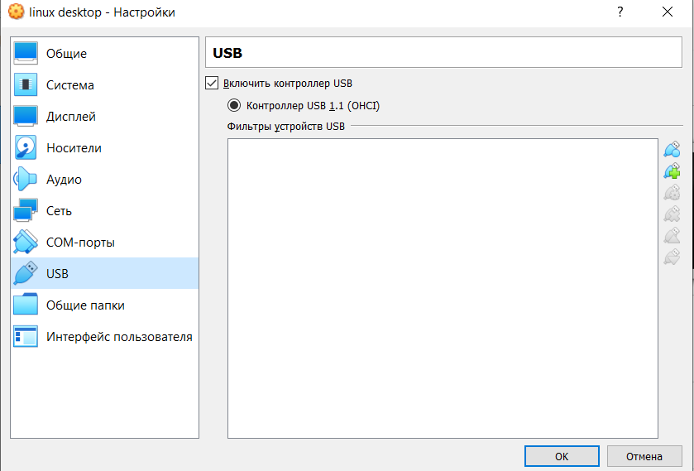  
  
  
3. We create a virtual machine according to the instructions we see in task 1. I used the Ubuntu distribution and I think it is convenient to use. We can also clone this operating system, delete it, change it, change something in the settings  
  
