北京航空航天大学

张金源 76066001

1. Let f(n), g(n) be two non-negative functions. Prove that max{f(n), g(n)} = Θ(f(n)+g(n)).

* functions f(n) and g(n) are non-negative functions
* there exists n0 such that **f(n) ≥ 0** and **g(n) ≥ 0** for all n ≥ n0.
* for all n ≥ n0, **f(n) + g(n) ≥ f(n) ≥ 0** and **f(n) + g(n) ≥ g(n) ≥ 0**.
* Adding both inequalities (since the functions are nonnegative), get **f(n) + g(n) ≥ max(f(n), g(n))** for all n ≥ n0.
* This proves that **max(f(n), g(n)) ≤ c(f(n) + g(n))** for all n ≥ n0 with c = 1, in other words, **max(f(n), g(n)) = O(f(n) + g(n))**.
* Similarly, we can see that **max(f(n), g(n)) ≥ f(n)** and **max(f(n), g(n)) ≥ g(n)** for all n ≥ n0. Adding these two inequalities,
* **2max(f(n), g(n)) ≥ (g(n) + f(n)) , or max(f(n), g(n)) ≥ 1/2 (g(n) + f(n))** for all n ≥ n0.
* Thus **max(f(n), g(n)) = Ω(g(n) + f(n))** with constant c = 1/2 .
* max{f(n), g(n)} = Θ(f(n)+g(n)) always true for asymptotically nonnegative function.

**max(f(n), g(n)) ≤ f(n) + g(n) ≤ 2 max(f(n), g(n)).**

2. Prove Master Theorem.

* Theorem (Master Method) Consider the recurrence **T(n) = aT(n/b) + f(n**), where a, b are constants. Then
  + (A) If f(n) = O(n logb a − ε ) for some constant ε > 0, then T(n) = O(n logb a ).
  + (B) If f(n) = Θ(n logb a ), then T(n) = Θ(n logb a log n).
  + (C) If f(n) = Ω(n logb a + ε ) for some constant ε > 0, and if f satisfies the smoothness condition a f(n/b) ≤ cf(n) for some constant c < 1, then T(n) = Θ(f(n)).
* The solution of the recurrence is T(n) = ai f(n/bi ) + O(n logb a ).
* The value of T(n) is the sum of the labels of all the nodes of the tree. The sum is obtained by summing the ith level sums. The last term O(n logb a ) is the sum across the leaves, which is a logb n f(1) = n logb a f(1). The diagram shows the case a = 2.

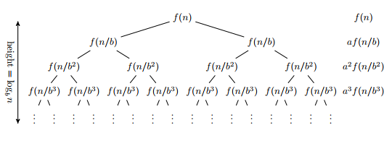

* Case (A)

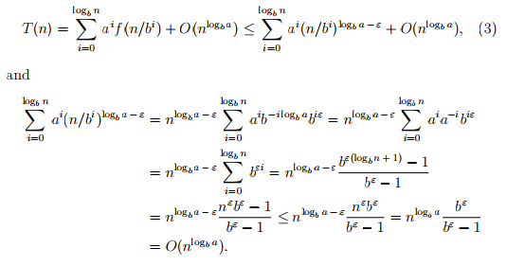

* Combining this with (3), we get T(n) = O(n logb a ). Case (B). Here we have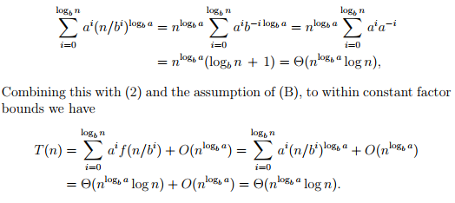
* Case (C). The lower bound is immediate, because f(n) is a term of the sum (2). For the upper bound, we will use the smoothness condition. This condition is satisfied by f(n) = n logb a + ε for any ε > 0 with c = b −ε < 1:



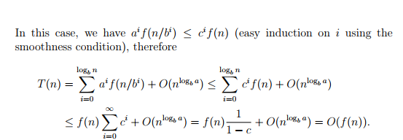

3. Problem Show that for any real constants a and b, where b > 0, (n + a) b = Θ(n b ).

* Solution By the definition of Θ(·), we need find the constants c1, c2, n0 such that 0 ≤ c1n b ≤ (n + a) b ≤ c2n b for all n ≥ n0.
* Note that for large values of n, n ≥ |a| we have n + a ≤ n + |a| ≤ 2n and for further large values of n, n ≥ 2|a|, (i.e., |a| ≤ 1 2 n) n + a ≥ n − |a| ≥ 1 2 n .
* Thus, when n ≥ 2|a|, we have 0 ≤ 1 2 n ≤ n + a ≤ 2n . Since b is a positive constant, we can raise the quantities to the b th power with out affecting the inequality.
* thus 0 ≤ ( 1 2 n) b ≤ (n + a) b ≤ (2n) b 0 ≤ ( 1 2 ) bn b ≤ (n + a) b ≤ (2)b (n) b Thus, with c1 = ( 1 2 ) b , c2 = 2b , and n0 = 2|a| we satisfy the definition.