**Laboratory work #2**

**DDL**

1. Create following tables with corresponding attributes;
2. Define Primary Keys for each tables;

4. Define for all attributes not null constraint;s

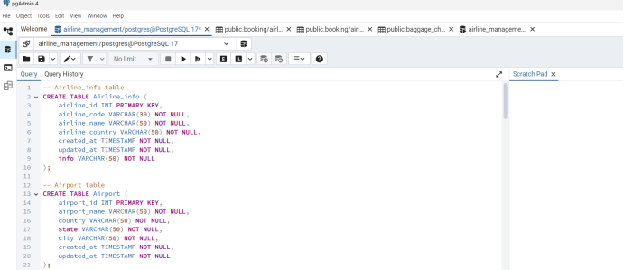

5. Rename airline_info table to airline;

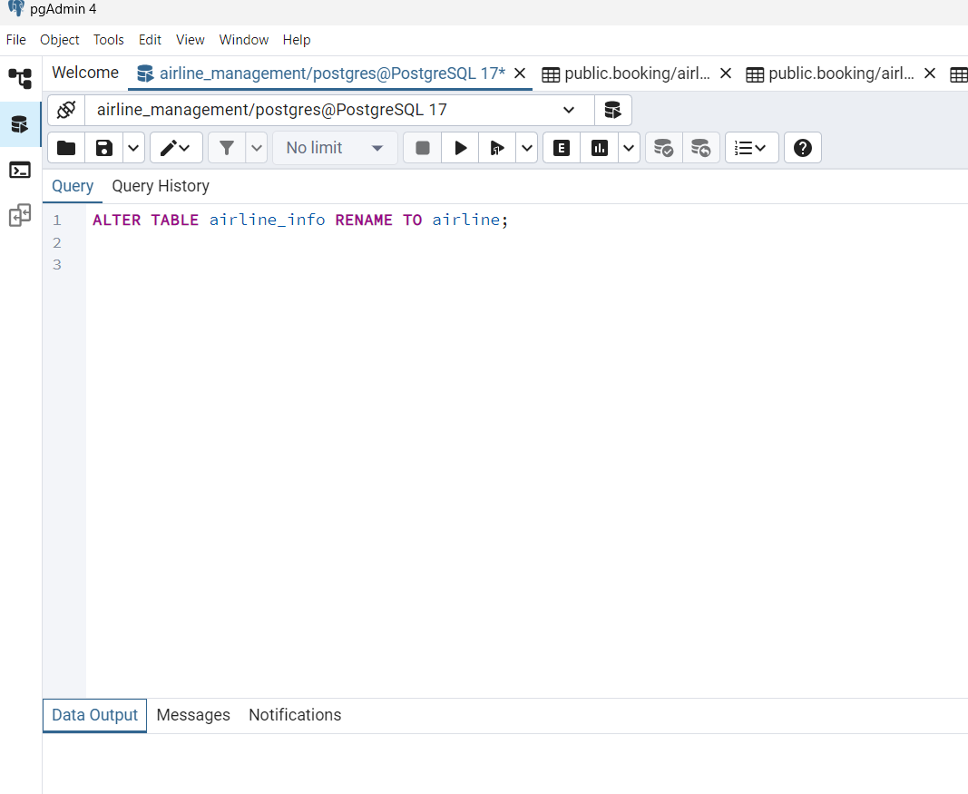6. Rename column price to ticket_price in booking table;

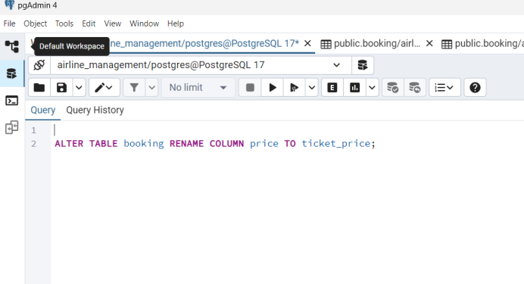

7. Change data type of departing_gate from varchar(50) to text;

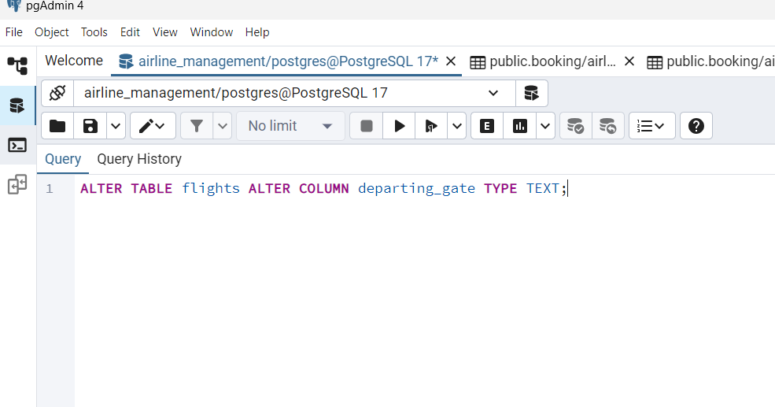8. Drop the column info(varchar(50)) from the airline table.

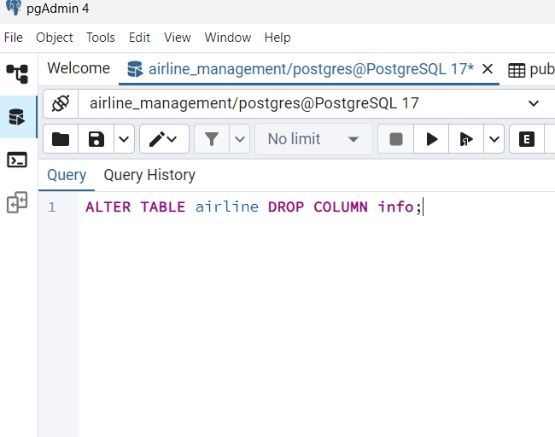9. Make a relationship between following tables:

· Passengers with Secuitiry_check, Booking, Baggage_check by passenger_id;

Booking with Baggage_check, Baggage, Boarding_pass, Booking_flight by booking_id;

Flights with Booking_flight by flight_id;

· Airline with Flights by airline_id;

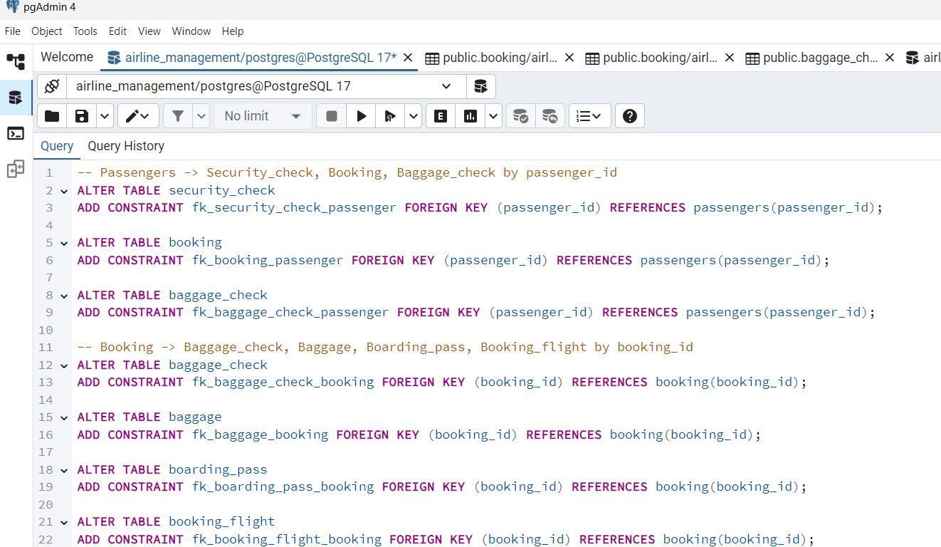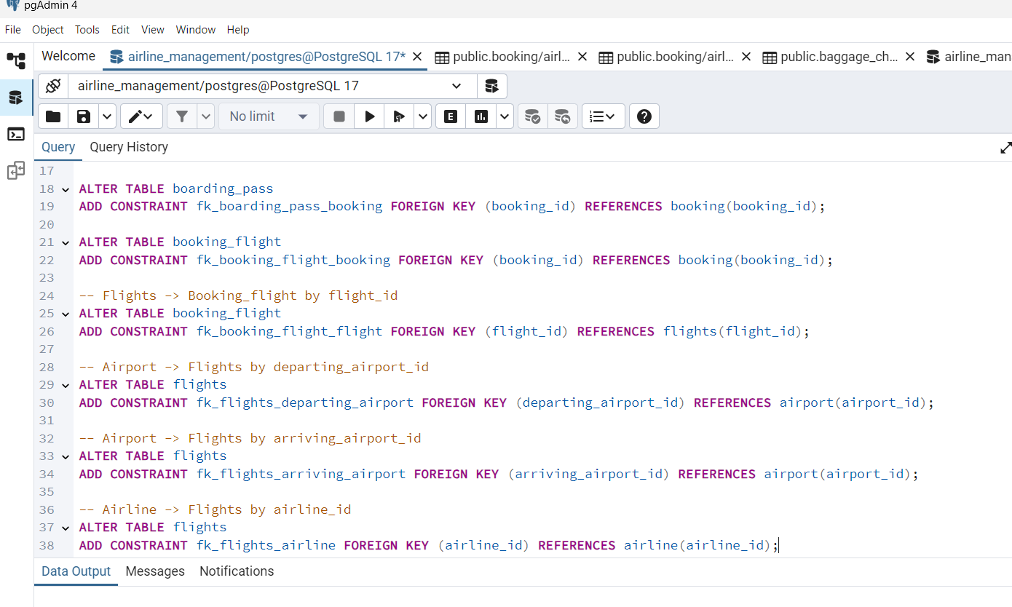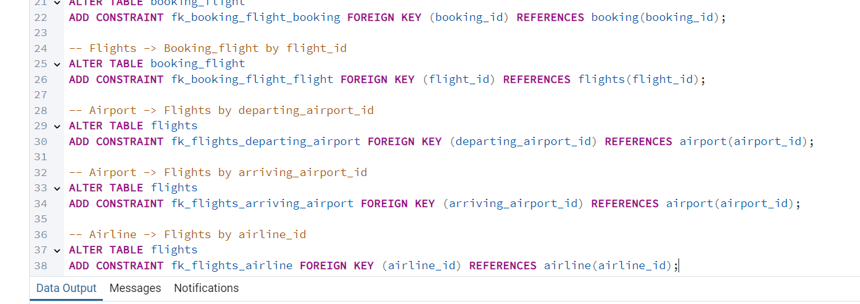DML Tasks

1. 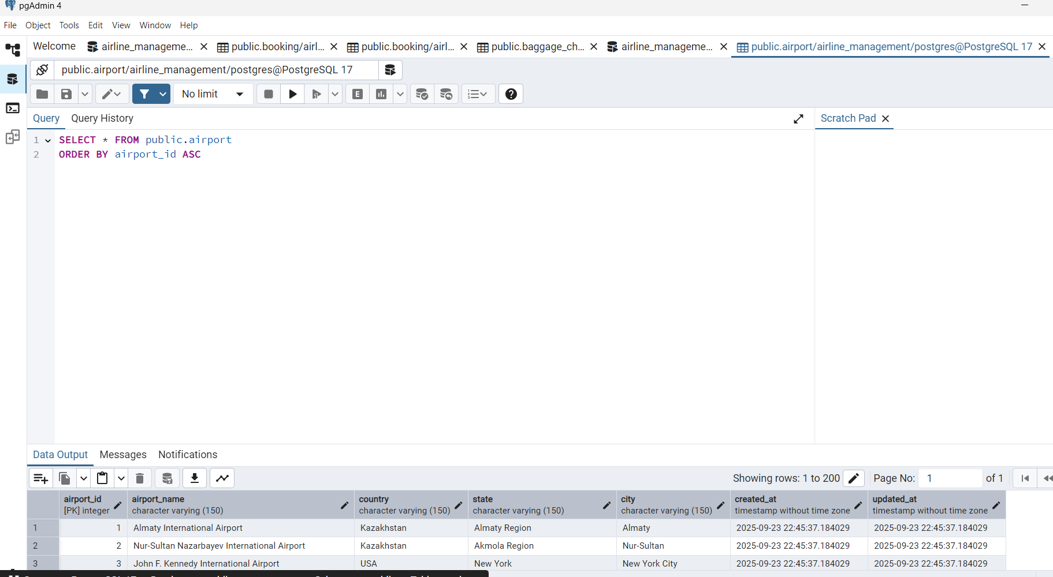2. 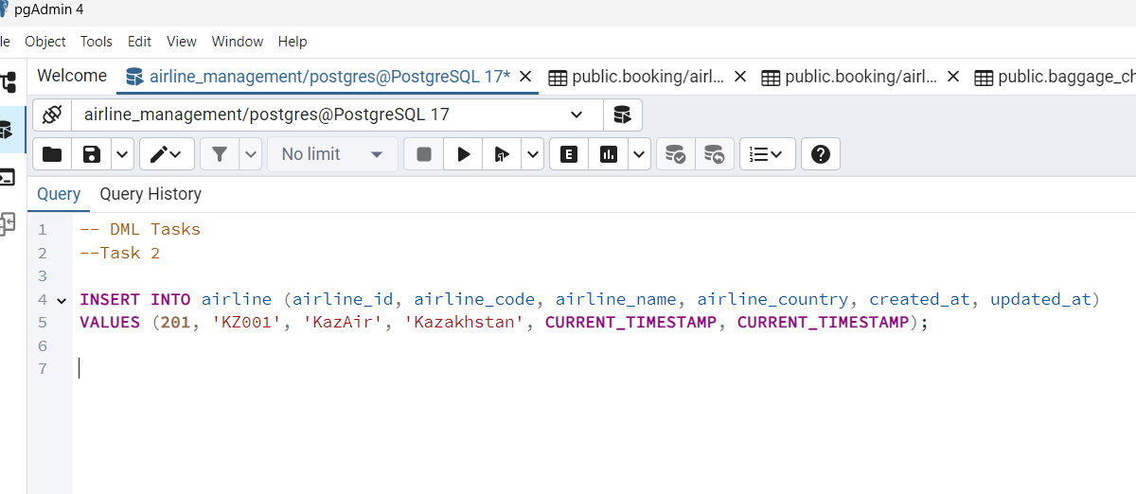3.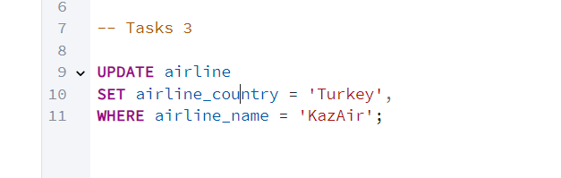4.

5.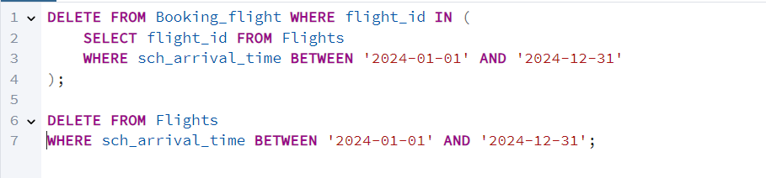7. 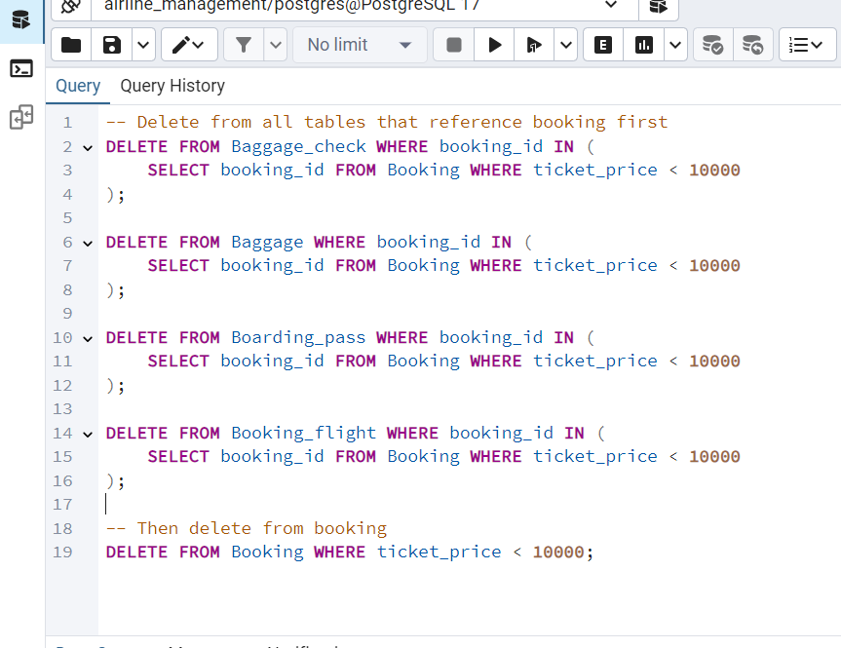

6.