1. Add a CHECK constraint to passenger table to provide that passengers must be at least 10 years old.

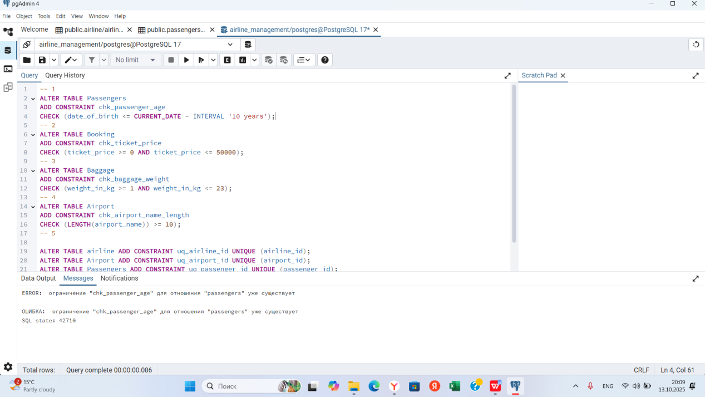

2.Add a CHECK constraint to accept the luggage weight between 1 and 23 kg.

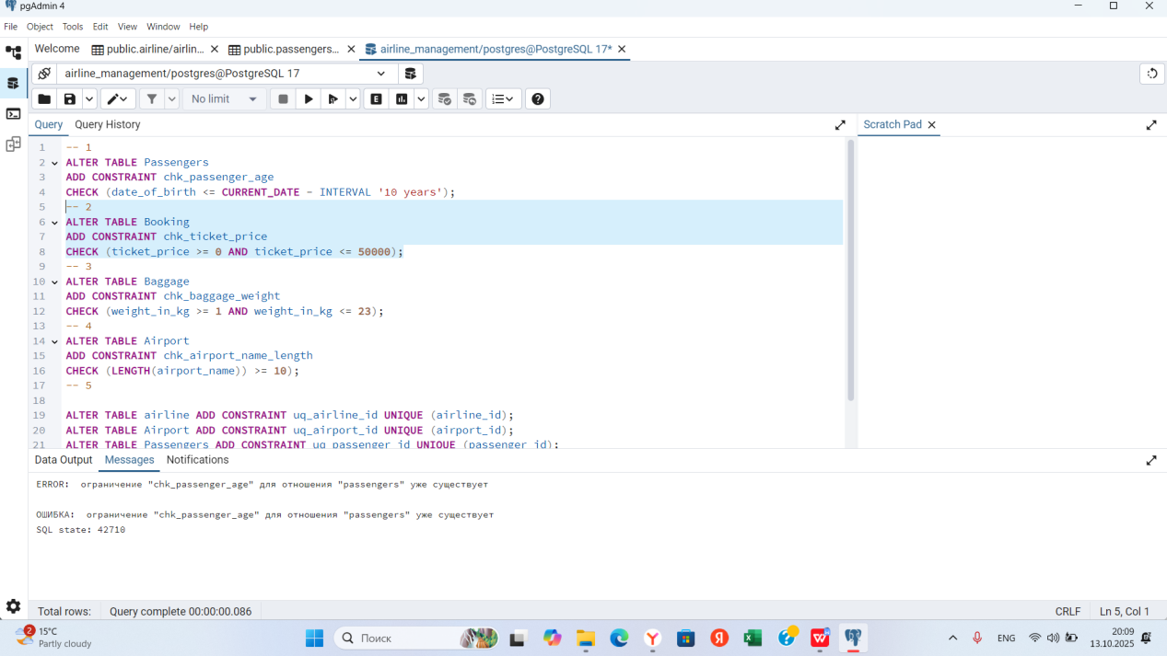

3.Add a CHECK constraint to accept the luggage weight between 1 and 23 kg.

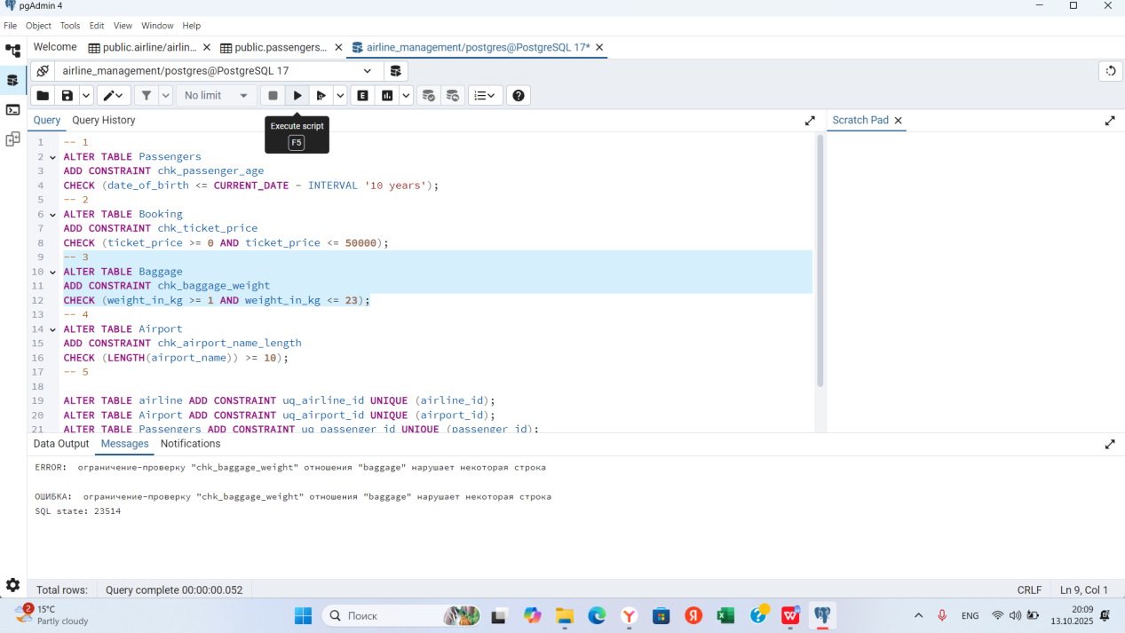

1. Add a CHECK constraint to ensure that all values in airport_name must have at least 10 characters.

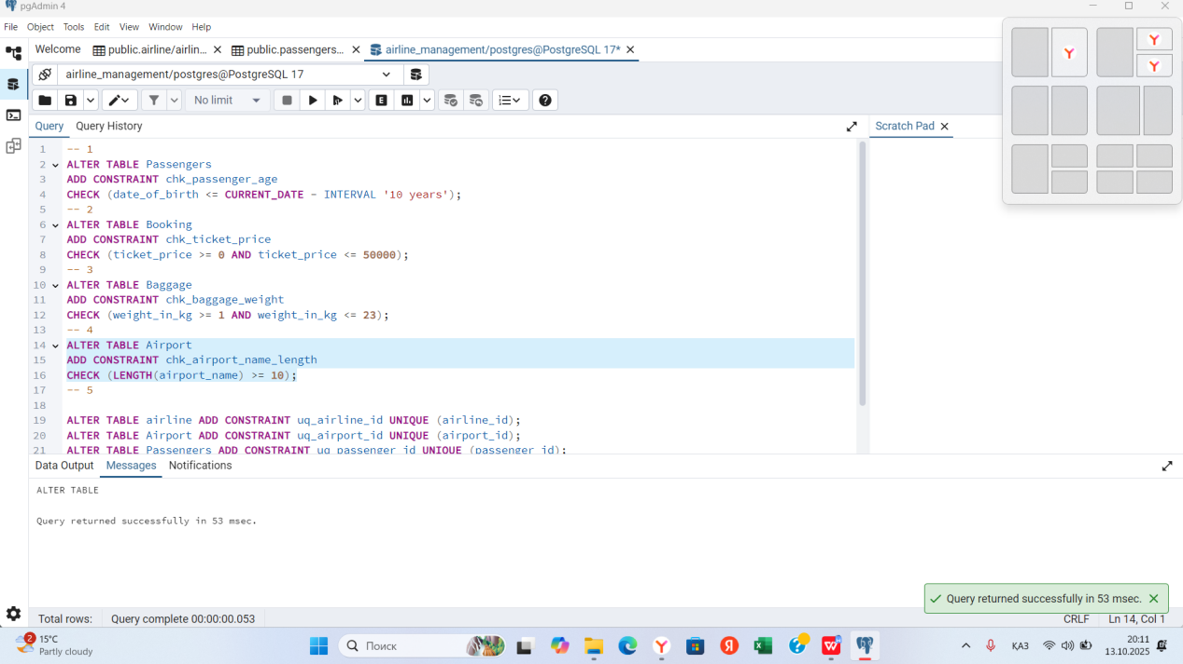

1. Add UNIQUE constraint to some columns in each table in database.

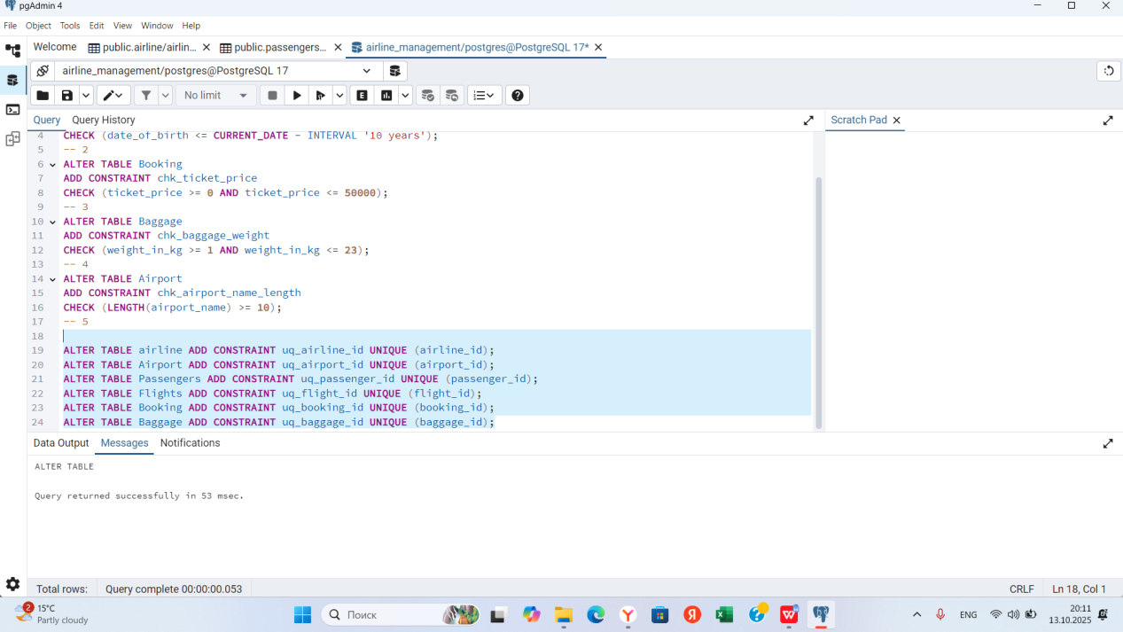

1. Add a CHECK constraint to ensure that male passengers must be at least 18 years old and female passengers must be 19 years old.

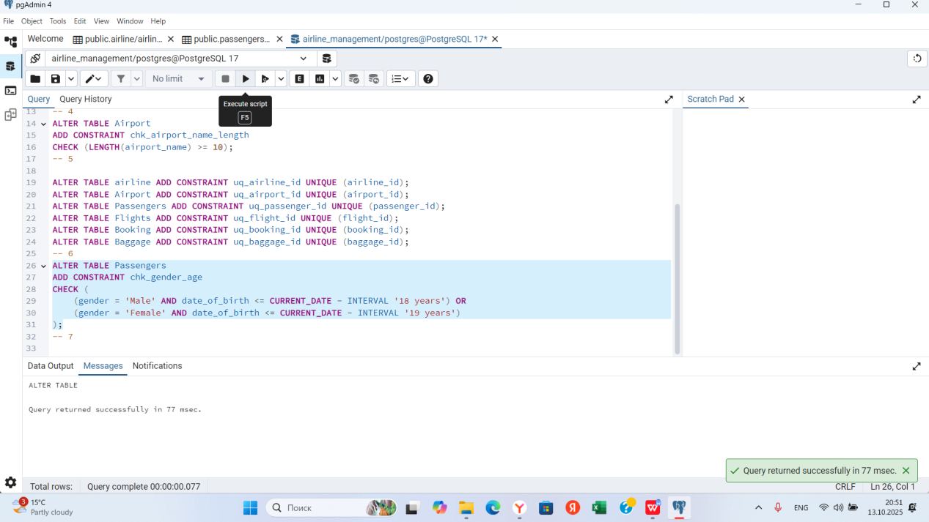

7. Add a CHECK constraint to add rule as follow (use column country_of_citizenship):

· Passengers from Kazakhstan must be at least 18 years old.

· Passengers from France must be at least 17 years old.

· Passengers from other countries must be at least 19 years old.

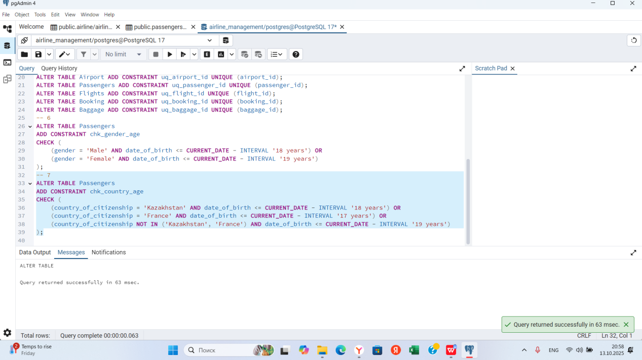

8. Add a ticket_discount column to table booking and a CHECK constraint to apply some discount based on ticket price and created time:

· the constraint applies a 5% discount for tickets created after 2024-01-01,

and 10% discount for tickets created before 2024-01-01.

