
MINISTRY OF EDUCATION, CULTURE AND RESEARCH
OF THE REPUBLIC OF MOLDOVA
Technical University of Moldova
Faculty of Computers, Informatics and Microelectronics
Department of Software and Automation Engineering
Report
Laboratory work nr. 9
Watching System Calls with strace
Course: Operating Systems (Track A: Linux)
Done by:
st. gr. FAF-243, Oberst Eduard
Checked by:
Patricia Reitman, University Assistant
Department of Software and Automation Engineering,
FCIM Faculty, UTM

Purpose of the work
This laboratory work looks at the system call, the point where a program asks the kernel to do something for it. The tool strace runs a program and prints every system call it makes, with the arguments and the value the kernel returns. First strace was used on a real command, ls -l. Then a small C program that calls open, write, read and close directly was written and watched in the same way. In the last part strace -c was used to count the system calls, and one kind of call, write, was counted for different outputs of the same program.
Preparation
All work was done on my own Ubuntu laptop, in the folder ~/OS-2026-OberstEduard/lab9 of my course repository. strace was already installed, and strace -V showed version 6.19. The session of Parts 1 and 2 was recorded with script into lab9-transcript.log, and the session of Part 3 was recorded into lab9.log. The C programs were compiled with gcc -Wall -Wextra.
Part 1. See the calls of a real command
To watch ls -l from the outside, it was run under strace with a filter that shows only the four calls that work with files.
$ strace -f -e trace=openat,read,write,close ls -l
Figure 1.1 – The command of Part 1
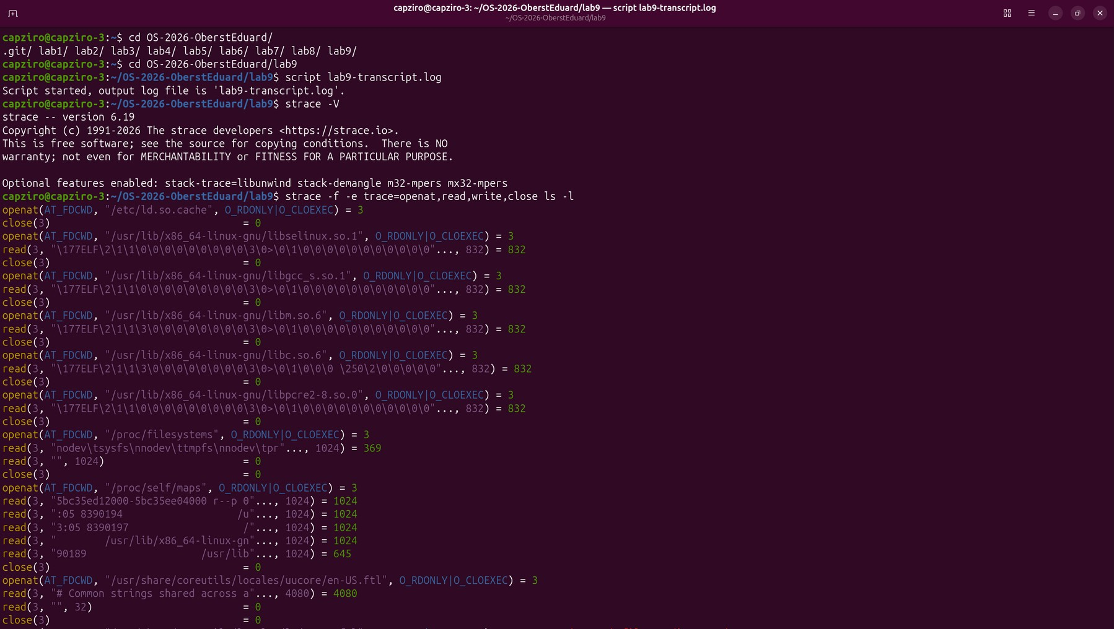
Figure 1.2 – strace -V and the start of the trace, the dynamic linker opens and reads the shared libraries of ls
Before ls does any work of its own, the dynamic linker opens /etc/ld.so.cache and then the libraries libselinux, libc, libpcre2 and others. For each one it calls openat, read and close, and each openat returns descriptor 3, because the previous file was already closed. After this ls reads /proc/filesystems and /proc/self/maps.
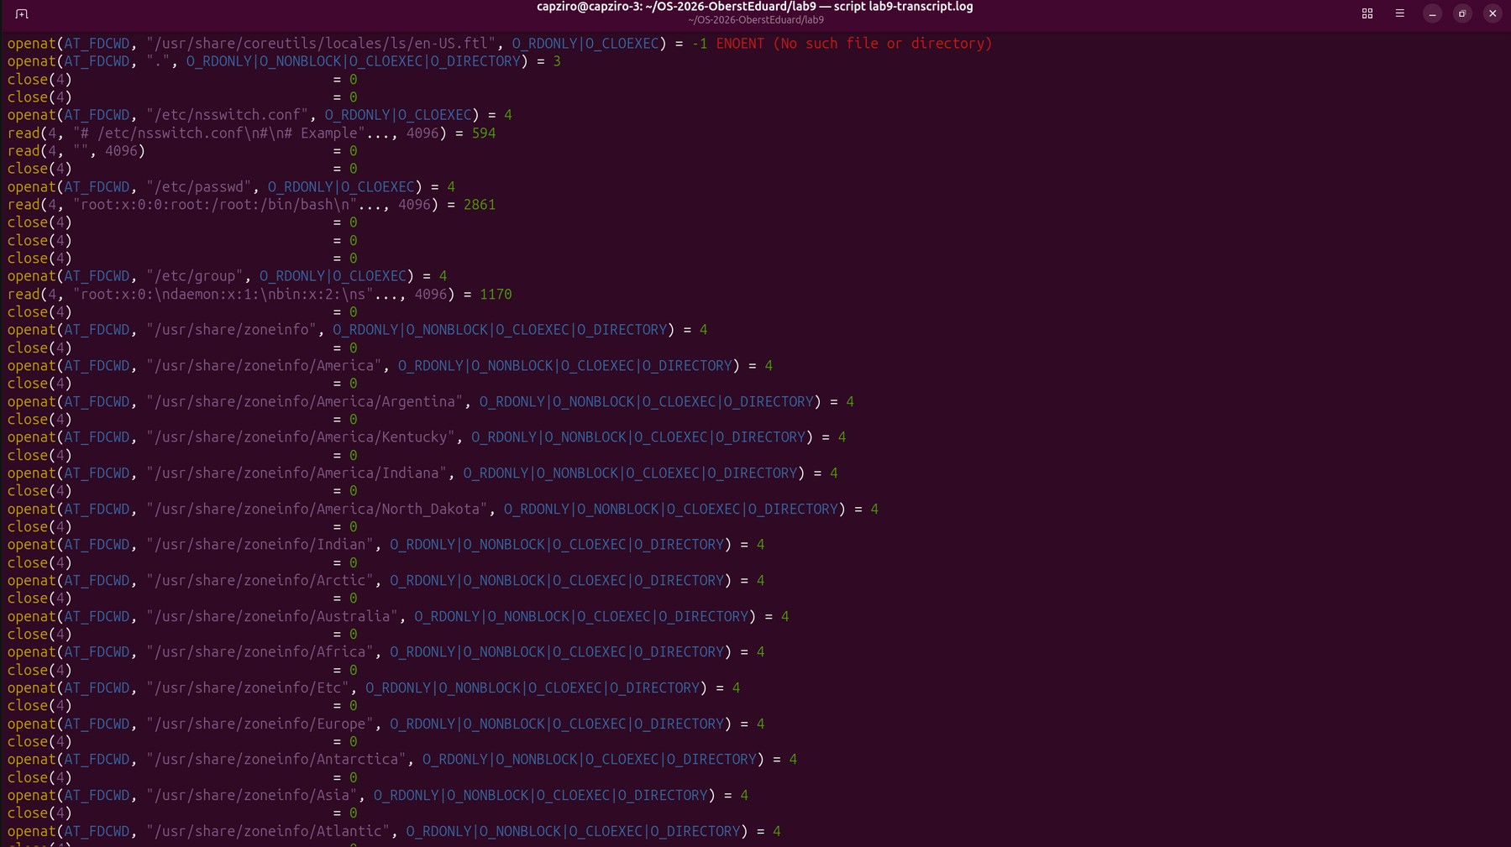
Figure 1.3 – The trace continues with files from /etc and the folders of /usr/share/zoneinfo
Next ls opens the current directory, then /etc/nsswitch.conf, /etc/passwd and /etc/group to turn the user and group numbers into the names "capziro". It also walks many folders of /usr/share/zoneinfo, because it needs the local time zone to print the dates of the files.
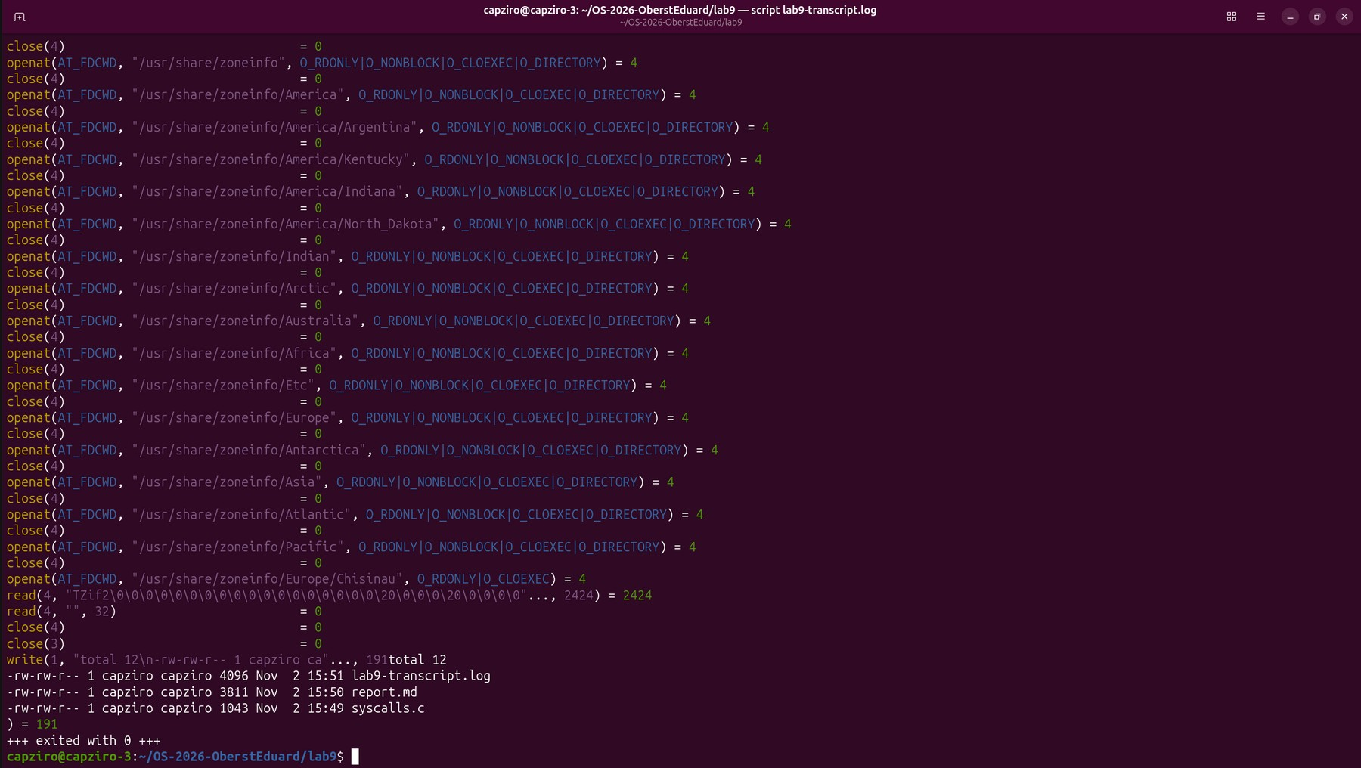
Figure 1.4 – The end of the trace, one write to descriptor 1 prints the whole listing
After all these calls, the whole listing is printed with only one call, write(1, "total 12\n...", 191) = 191, and then the process exits. So dozens of openat, read and close calls were needed to prepare the output, and only one call printed it.
Observe
1. Which system call does ls use to print to the screen? To which descriptor does it write?
ls prints with the system call write, and it writes to descriptor 1, which is the standard output. In Figure 1.4 it is the line write(1, "total 12\n...", 191) = 191, after all the setup calls and right before the process exits. The kernel returned 191, so all 191 bytes of the listing were written in one call.
Part 2. A program that calls the kernel directly
The program syscalls.c from the lab sheet opens the file note.txt, writes the line "hello, kernel" into it, closes it, then opens it again and reads the line back. For the file it uses only open, write, read and close, and printf is used only to show the results on the screen. The program was compiled and run.
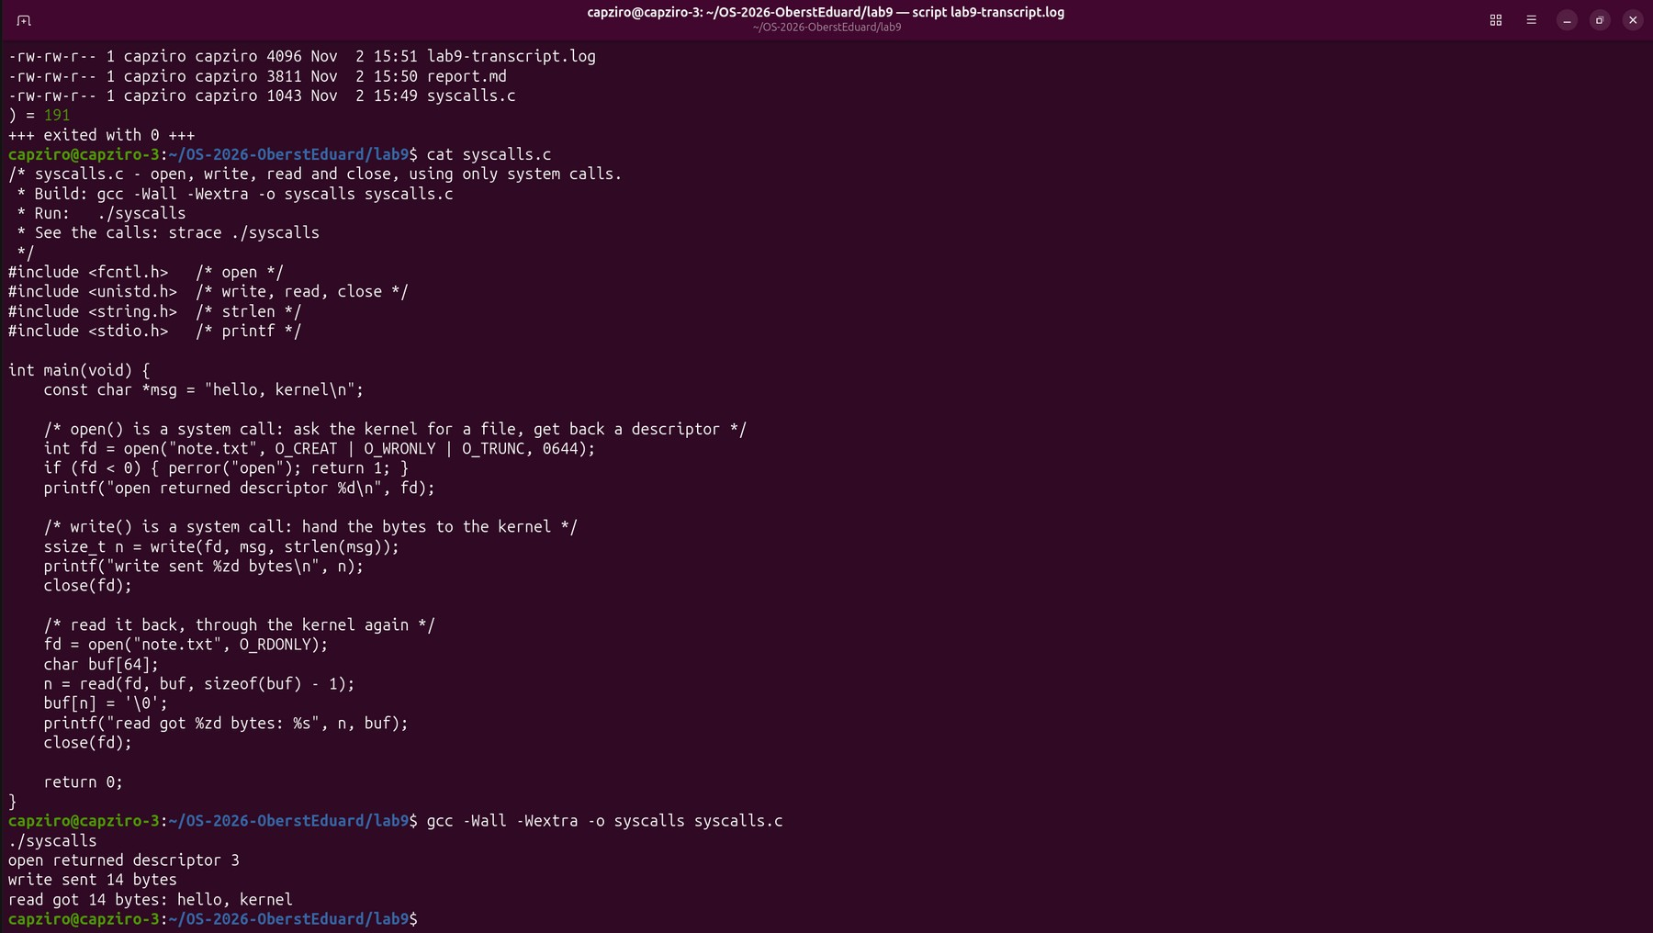
Figure 2.1 – cat syscalls.c, then the build and the output of the program
The output is the same as the expected output in the lab sheet. open returned descriptor 3, write sent 14 bytes, and read got the same 14 bytes back. After this the program was run under strace, with the same filter of four calls.
$ strace -e trace=openat,write,read,close ./syscalls
Figure 2.2 – The command for watching syscalls
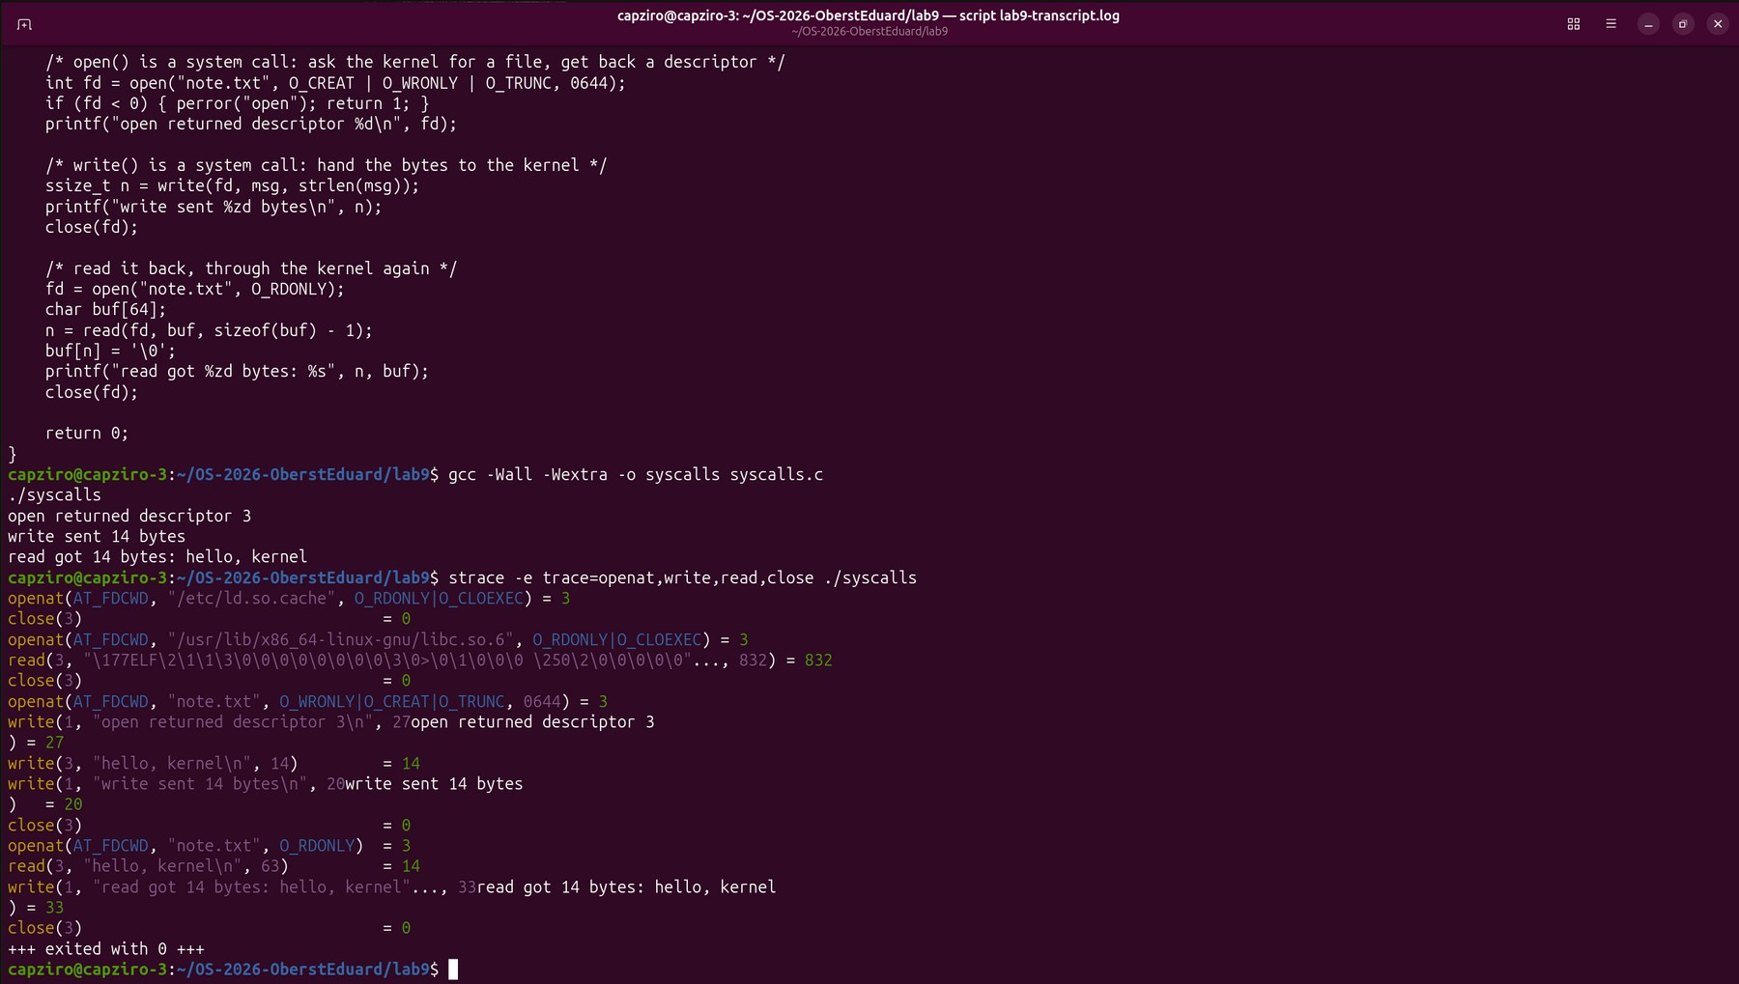
Figure 2.3 – The calls of syscalls.c become real system calls on note.txt
Among the setup lines of the dynamic linker, the calls of the program are easy to find. open became openat(AT_FDCWD, "note.txt", O_WRONLY|O_CREAT|O_TRUNC, 0644) = 3, then write(3, "hello, kernel\n", 14) = 14 and close(3) = 0. The second open returned 3 again, and read(3, ..., 63) returned 14, because the file had only 14 bytes even though the program asked for up to 63. The three printf calls of the program also appear in the trace, as write(1, "open returned descriptor 3\n", 27) = 27 and the same for the other two lines. So printf also ends with a write to descriptor 1, the same as ls in Part 1.
Observe
1. The descriptor returned by the first openat is 3, not 0, 1 or 2. Why are those three already taken?
Every process starts with three descriptors already open, which it gets from the shell that started it. Descriptor 0 is the standard input, 1 is the standard output and 2 is the standard error. The kernel always gives the lowest free number to a new file, so the first file that the program opens gets 3. This happens before main() starts, so it is not because of anything in the code. Also, after close(3) the number 3 is free again, which is why the second openat returned 3 too.
Part 3. Count one kind of call
The lab sheet gives only the title of this part, so I chose the commands myself. strace -c does not print every call. It runs the program and at the end prints a table with how many times each system call was made, how many of them returned an error, and the total. With -e trace= the table can be limited to one kind of call. First the program of Part 2 was compiled and run again, to check that it still works, and then all the calls of ls -l were counted. The normal output of ls was sent to /dev/null, so only the table stays on the screen.
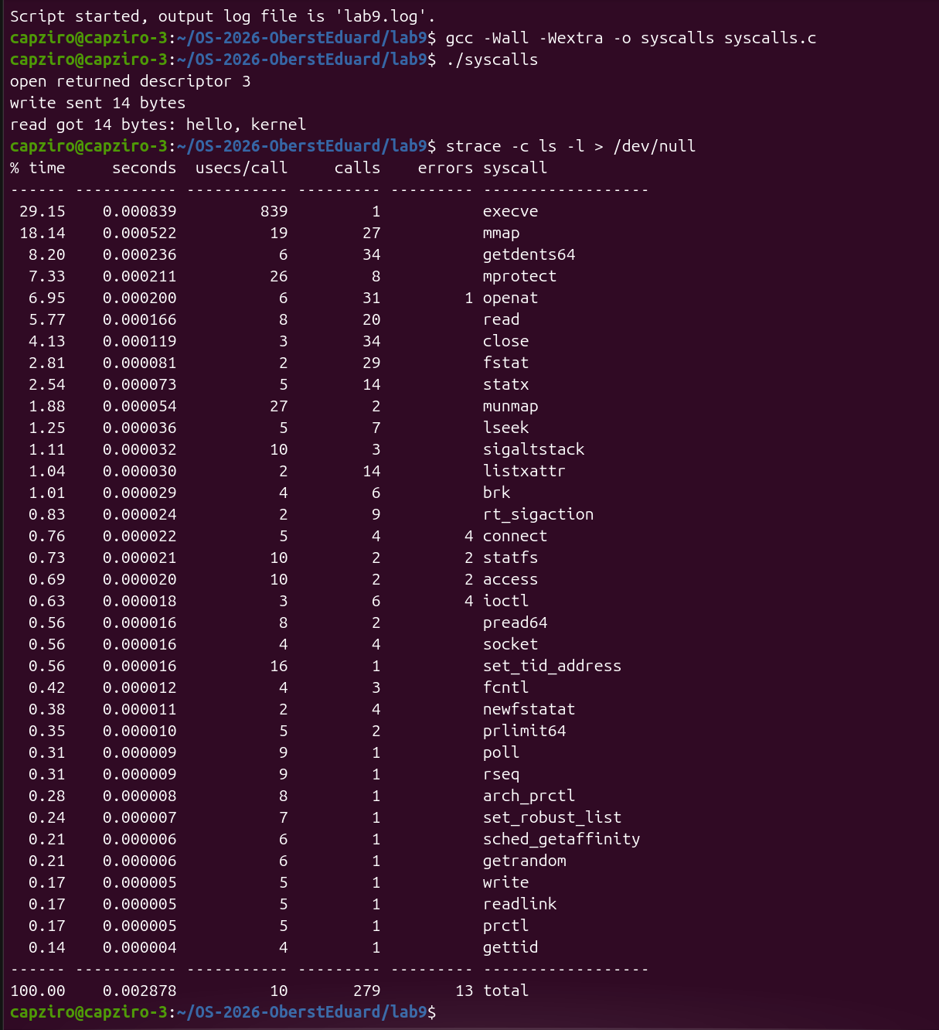
Figure 3.1 – syscalls still works, and strace -c counts all the calls of ls -l
ls -l made 279 system calls of 35 different kinds, and 13 of them returned an error. The most frequent were getdents64 and close with 34 calls each, openat with 31, fstat with 29, mmap with 27 and read with 20. execve, which starts the program, was called once, and write was also called only once. The errors are calls that are allowed to fail, for example openat on a translation file that does not exist, which was already visible in Figure 1.3. After this only the write calls of ls -l were counted, this time with the output on the terminal.
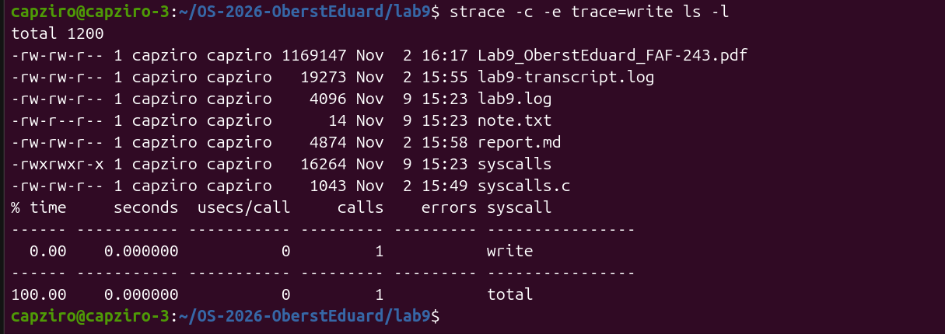
Figure 3.2 – strace -c -e trace=write ls -l
Even with 8 lines on the terminal, ls made only one write. It keeps the whole listing in a buffer and sends it at the end, the same as in Figure 1.4. To see how the number of write calls depends on where the output goes, I wrote a small program, count.c, that prints N lines with printf.
/* count.c - prints N lines with printf; strace counts how many write() calls that costs.
* Build: gcc -Wall -Wextra -o count count.c
* Run: strace -c -e trace=write ./count 20 (to the terminal)
* strace -c -e trace=write ./count 20 > out.txt (to a file)
*/
#include <stdio.h>
#include <stdlib.h>

int main(int argc, char *argv[]) {
int n = (argc > 1) ? atoi(argv[1]) : 20;
for (int i = 1; i <= n; i++)
printf("line %d\n", i); /* printf is a library function, not a system call */
return 0;
}
Figure 3.3 – Contents of count.c
The program was run with 20 lines two times, first with the output on the terminal and then with the output in the file out.txt.
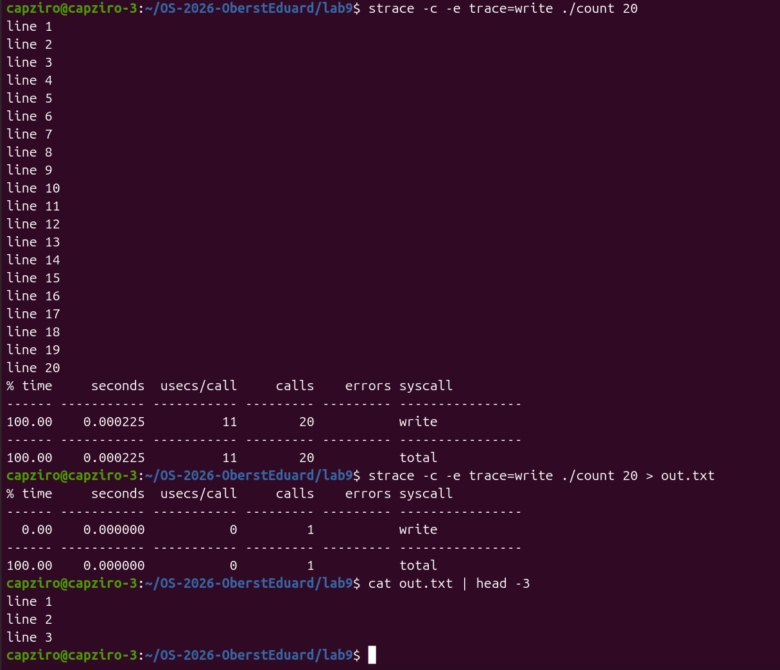
Figure 3.4 – 20 lines to the terminal and the same 20 lines to a file
To the terminal the program made 20 write calls, one for every line. To the file the same 20 lines cost only 1 write, and out.txt still has all the lines. After this the program printed 1000 lines into the file, this time without -c, so every write is shown with its size.
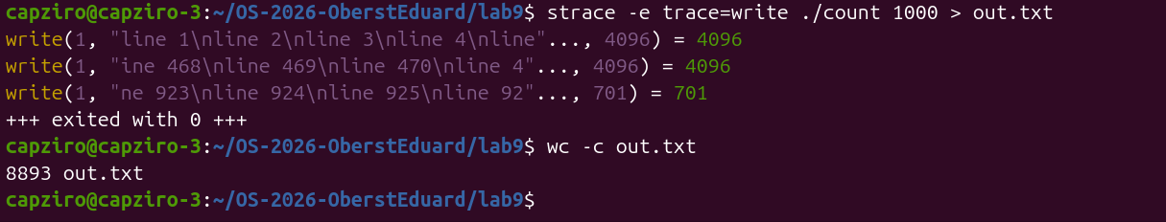
Figure 3.5 – 1000 lines to a file, each write shown, then wc -c
The 1000 lines were written with only 3 calls. The first two wrote 4096 bytes each and the last one wrote 701 bytes, and 4096 + 4096 + 701 = 8893, which is exactly the size of out.txt shown by wc -c. The calls also cut the lines in the middle, for example the second one starts with "ine 468", because the library sends the buffer when it is full and does not care where a line ends.
Command | Output to | Lines | write calls
ls -l | terminal | 8 | 1
./count 20 | terminal | 20 | 20
./count 20 > out.txt | file | 20 | 1
./count 1000 > out.txt | file | 1000 | 3
Table 3.1 – Number of write calls from Figures 3.2, 3.4 and 3.5
Questions
1. How many system calls does ls -l make, and which ones are the most frequent?
In my run ls -l made 279 system calls, as seen in Figure 3.1. Most of them are not for the listing itself. mmap, mprotect and the openat, read and close of the libraries load the program, and the calls on /etc and /usr/share/zoneinfo find the names of the users and the time zone. The calls that really read the directory are the 34 getdents64, and the listing is printed with a single write.
2. Why does count make 20 write calls to the terminal, but only 1 when the output goes to a file?
printf is a function of the C library, not a system call. It puts the text in a buffer in the memory of the program and calls write only when the buffer must be sent. When the standard output is a terminal, the library sends the buffer at every newline, so the user sees every line at once, and 20 lines give 20 calls. When the output is a file, the buffer is sent only when it is full or when the program ends, so the 20 short lines, 151 bytes in total, go out with one call at the end.
3. Why does count 1000 to a file need only 3 write calls, and why is that useful?
The buffer of the standard output is 4096 bytes in my system, which is the size of the first two calls in Figure 3.5. The 8893 bytes of the 1000 lines fill the buffer two times, and the last 701 bytes are sent when the program ends. Every system call goes into the kernel and back, which costs much more time than copying text into a buffer. Without the buffer the same output would cost 1000 calls instead of 3, so the library saves time by making fewer and bigger calls.
Conclusions
In this laboratory work strace showed what happens between a program and the kernel. Every line of its output is one request of the program and the value that the kernel returned. Watching ls -l showed that even a simple command makes many openat, read and close calls before it prints anything, and that the printing itself is only one write to descriptor 1.
The program syscalls.c showed the same thing from the inside. The functions open, write, read and close in C turn almost directly into system calls with the same names, and descriptors 0, 1 and 2 are already taken before the program opens any file. Also, the printf lines of the program appeared in the trace as write calls to descriptor 1.
Counting the calls in Part 3 showed that printf and the system call write are not the same thing. The same program made 20 write calls to the terminal and only 1 to a file, and 1000 lines to a file needed only 3 calls of up to 4096 bytes. ls -l made 279 calls in total, but most of them were for loading the program and finding names and dates, not for printing.
Submitted files are syscalls.c, count.c, report.md with the answers, the terminal logs lab9-transcript.log and lab9.log, and this report, in the folder lab9 of my repository OS-2026-OberstEduard.

