
MINISTRY OF EDUCATION, CULTURE AND RESEARCH
OF THE REPUBLIC OF MOLDOVA
Technical University of Moldova
Faculty of Computers, Informatics and Microelectronics
Department of Software and Automation Engineering
Report
Laboratory work nr. 11
The Race and the Semaphore
Course: Operating Systems (Track A: Linux)
Done by:
st. gr. FAF-243, Oberst Eduard
Checked by:
Patricia Reitman, University Assistant
Department of Software and Automation Engineering,
FCIM Faculty, UTM

Purpose of the work
This laboratory work shows a race condition between two threads on Linux and fixes it with a mutex and with a semaphore. Two threads that change the same variable at the same time lose some of the changes, and the program gives a wrong result. After the fix, the same semaphore is used in three different ways. Started at 1 it works as a lock, started at 0 it works as a signal, and started at N it works as a counter. All programs are written in C with POSIX threads.
Preparation
All work was done on my laptop with Ubuntu, in the folder ~/OS-2026-OberstEduard/lab11 of my course repository. Every program was created in the terminal with cat > file.c << 'EOF', so the code in the files is the same as in the lab sheet. All programs were compiled with gcc -Wall -pthread and without -O2. With -O2 the compiler would keep counter in a register, and the race from Part 1 would not be visible. For the experiments with other start values I made copies of the files with cp and changed one line with sed, so the original files stayed unchanged.
Part 1. See the race
In race.c two threads run the same function add. Each thread adds 1 to the global variable counter one million times, so the correct result is 2 000 000. There is no protection around counter++.
#include <stdio.h>
#include <pthread.h>

#define N 1000000

long counter = 0; /* shared by both threads */

void *add(void *arg) {
for (int i = 0; i < N; i++)
counter++; /* read, add 1, write back: three steps */
return NULL;
}

int main(void) {
pthread_t a, b;
pthread_create(&a, NULL, add, NULL);
pthread_create(&b, NULL, add, NULL);
pthread_join(a, NULL);
pthread_join(b, NULL);
printf("counter = %ld (expected %d)\n", counter, 2 * N);
return 0;
}
Figure 1.1 – Contents of race.c
The program was compiled and run three times.
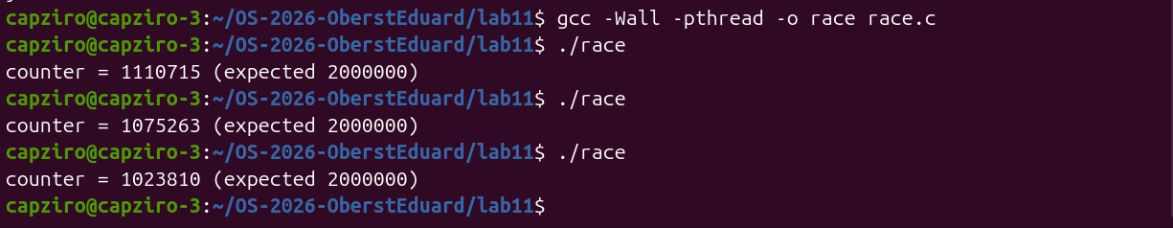
Figure 1.2 – race.c compiled and run three times
None of the three runs gave 2 000 000. The results were 1 110 715, 1 075 263 and 1 023 810, so in every run almost half of the additions were lost. Also, every run gave a different number. To see why this happens, I generated the assembly code of race.c with gcc -S and searched for the lines that use counter.
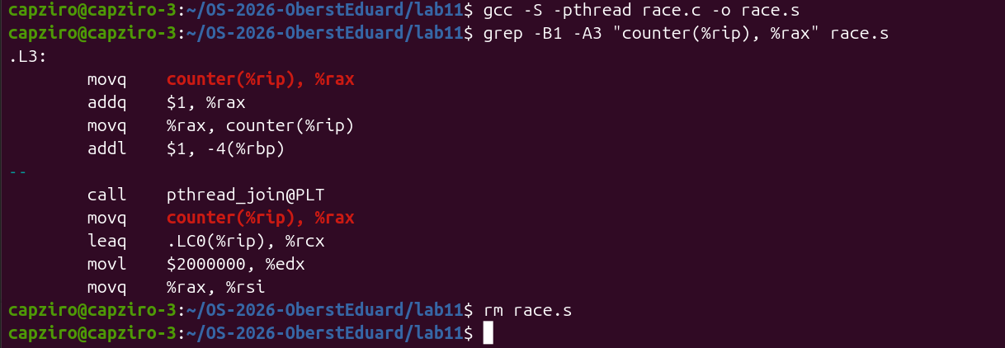
Figure 1.3 – The assembly code of counter++ in the loop .L3
The loop .L3 shows that counter++ is not one instruction but three. The first movq loads the value of counter from memory into the register rax. Then addq $1, %rax adds 1 to the register, and the second movq writes the register back to memory. Between any two of these instructions the other thread can also read or write counter, and this is where the additions are lost. The fourth instruction addl $1, -4(%rbp) is the i++ of the loop.
Observe
1. counter++ looks like one step. Write the three steps the CPU really does.
The CPU loads counter from memory into a register, adds 1 to the register and stores the register back to memory. In my assembly code these are the three instructions movq counter(%rip), %rax, addq $1, %rax and movq %rax, counter(%rip) from Figure 1.3.
2. Describe, with those steps, how two threads can lose one addition.
Suppose counter is 5. Thread A loads 5 into its register. Before A stores the result, thread B also loads 5. A adds 1 and stores 6, and then B adds 1 to its own copy and also stores 6. Two additions were done, but counter grew only by 1, so the addition of A is lost.
3. Why is the result different at every run?
The two threads run on different CPU cores or are switched by the scheduler, and the exact moments when this happens are different at every run. The number of times the threads read the same old value depends on this timing. Because of this the number of lost additions changes from run to run, and in my three runs it was between about 890 000 and 980 000.
Part 2. Fix it: mutex, then semaphore
2.1 A mutex around counter++
In mutex.c the line counter++ is placed between pthread_mutex_lock and pthread_mutex_unlock. This line is the critical section, and only one thread can be inside it at a time. The rest of the program is the same as race.c.
long counter = 0;
pthread_mutex_t lock = PTHREAD_MUTEX_INITIALIZER;

void *add(void *arg) {
for (int i = 0; i < N; i++) {
pthread_mutex_lock(&lock); /* only one thread past this line */
counter++; /* the critical section */
pthread_mutex_unlock(&lock); /* let the other one in */
}
return NULL;
}
Figure 2.1 – The changed part of mutex.c
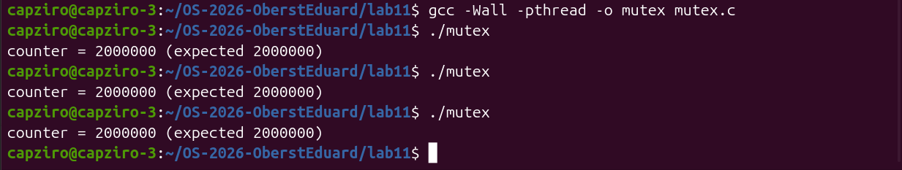
Figure 2.2 – mutex.c compiled and run three times
All three runs gave exactly 2 000 000. When thread A holds the lock, thread B waits at pthread_mutex_lock, so the three steps of counter++ can no longer be mixed between the threads.
2.2 The same lock, made from a semaphore
A semaphore is a number that never goes below 0. sem_wait takes one unit and waits if there is none, and sem_post gives one unit back. In sem.c the semaphore starts at 1, so only one thread can pass sem_wait and the semaphore works like a mutex.
sem_t s;

void *add(void *arg) {
for (int i = 0; i < N; i++) {
sem_wait(&s); /* 1 -> 0: I go in; at 0: wait */
counter++;
sem_post(&s); /* 0 -> 1: the next one may go in */
}
return NULL;
}

int main(void) {
sem_init(&s, 0, 1); /* 0 = shared between threads, 1 = start value */
...
}
Figure 2.3 – The changed part of sem.c
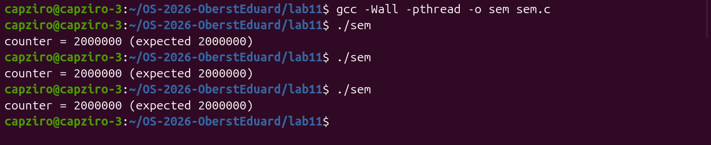
Figure 2.4 – sem.c compiled and run three times
The semaphore version also gave 2 000 000 in all three runs. After this I tried the experiment from the second Observe question. I copied sem.c to sem2.c and changed the start value to 2 with sed, then checked the change with grep.
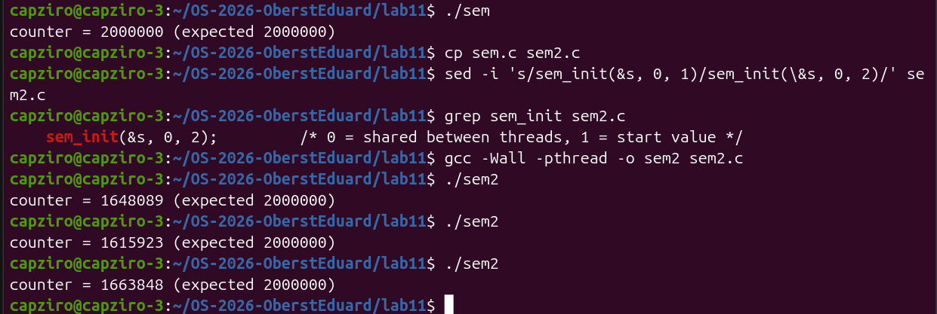
Figure 2.5 – sem2.c with sem_init(&s, 0, 2) gives wrong results again
With the start value 2 the result is wrong again, with 1 648 089, 1 615 923 and 1 663 848. Fewer additions are lost than in race.c, because each thread now spends most of its time in sem_wait and sem_post and less time in counter++. But the result is still not 2 000 000, so the protection does not work.
2.3 The price of the lock
The three programs were run with time to compare how long they take.
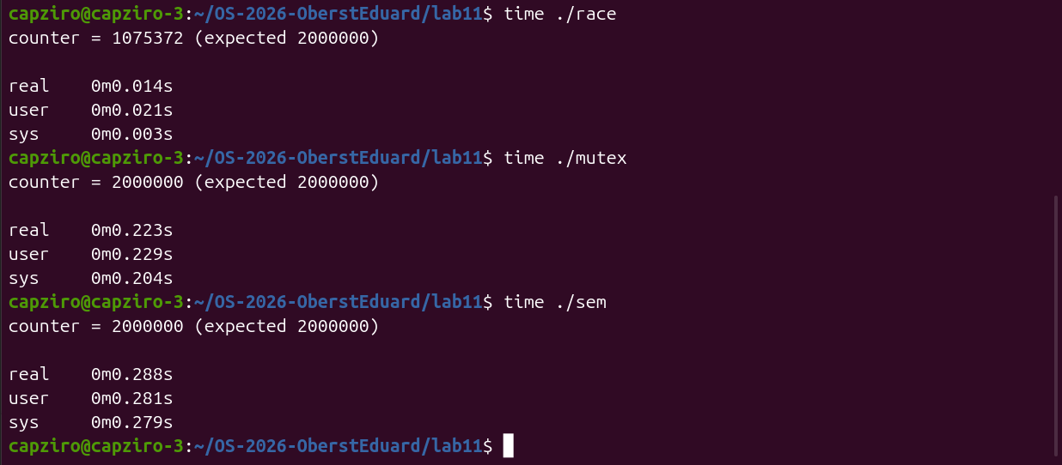
Figure 2.6 – time for race, mutex and sem
Program | Result | real | user | sys
race | 1 075 372 | 0.014 s | 0.021 s | 0.003 s
mutex | 2 000 000 | 0.223 s | 0.229 s | 0.204 s
sem | 2 000 000 | 0.288 s | 0.281 s | 0.279 s
Table 2.1 – Results and times from Figure 2.6
The order is the same as on the reference machine. race is the fastest but wrong, mutex is about 16 times slower, and sem is a bit slower than mutex. The sys time also shows a big difference. For race it is only 0.003 s, but for mutex and sem it is 0.204 s and 0.279 s, so the locked versions spend a lot of time inside the kernel.
Observe
1. Run mutex and sem three times each. Is the answer always 2 000 000?
Yes. Both mutex and sem gave 2 000 000 in all three runs, as seen in Figures 2.2 and 2.4, and also in the runs with time in Figure 2.6.
2. What would happen in sem.c with sem_init(&s, 0, 2)? Try it and explain.
The result becomes wrong again. With the start value 2 the semaphore has two units, so both threads can pass sem_wait at the same time. The value goes from 2 to 1 to 0, and both threads are inside the critical section together. This is the same race as in Part 1, and my three runs gave 1 648 089, 1 615 923 and 1 663 848. A semaphore works as a lock only if it starts at 1.
3. Why is the locked version slower?
In every one of the 2 000 000 iterations the thread has to lock and unlock, and these operations use special atomic instructions that are slower than a normal addition. When one thread holds the lock, the other one cannot just wait in user space for long. It goes to sleep with a futex system call and the kernel wakes it up later. This is why the sys time grew from 0.003 s to 0.204 s for mutex and 0.279 s for sem. Also, the two threads can no longer add in parallel, because only one of them can be in the critical section. The semaphore is a bit slower than the mutex because its operations do more work.
Part 3. A semaphore as a signal
In this part the problem is not two threads at the same time but the order. Thread B must read the message only after thread A has written it. In order.c B is created first on purpose, and A waits one second before it writes "hello" into message.
char message[32];
sem_t ready; /* starts at 0: nothing is ready yet */

void *writer(void *arg) {
sleep(1); /* pretend the work takes a while */
strcpy(message, "hello");
printf("A: message written\n");
sem_post(&ready); /* 0 -> 1: wake up B */
return NULL;
}

void *reader(void *arg) {
printf("B: waiting for the message...\n");
sem_wait(&ready); /* blocks while the value is 0 */
printf("B: I read \"%s\"\n", message);
return NULL;
}

int main(void) {
sem_init(&ready, 0, 0);
pthread_t a, b;
pthread_create(&b, NULL, reader, NULL); /* B starts first, on purpose */
pthread_create(&a, NULL, writer, NULL);
...
}
Figure 3.1 – The main part of order.c
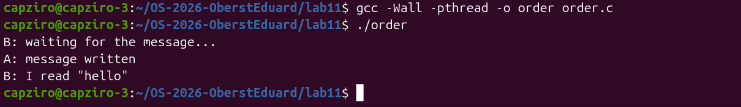
Figure 3.2 – order.c with the semaphore at 0
B printed its first line at once, then nothing happened for one second, then A wrote the message and B read "hello". The semaphore starts at 0, so B stops at sem_wait. It continues only after A calls sem_post, and at that moment the message is already written. After this I changed the start value to 1 in a copy of the file.
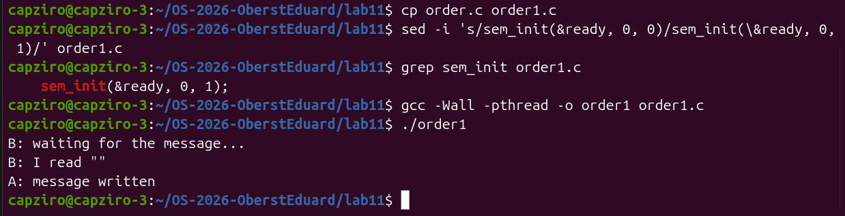
Figure 3.3 – order1.c with the semaphore at 1: B reads an empty message
Observe
1. Change the start value to 1 (sem_init(&ready, 0, 1)), compile, run. What does B read now, and why?
B reads an empty string "" and prints it before A writes the message, as seen in Figure 3.3. With the start value 1 there is already one unit in the semaphore, so sem_wait in B takes it and returns at once without waiting for A. At that moment A is still in sleep(1). message is a global array, so it is filled with zeros at the start, and B prints an empty string. The order between A and B is lost.
2. Put it back to 0. In one sentence: what does a semaphore that starts at 0 mean?
A semaphore that starts at 0 means that the event has not happened yet, so any thread that calls sem_wait waits until another thread signals it with sem_post.
Part 4. A semaphore as a counter: the parking lot
In parking.c six cars, which are six threads, try to use a parking lot with three places. The semaphore places starts at 3 and counts the free places. Each car takes a place with sem_wait, stays parked for one second and gives the place back with sem_post. The mutex is used only so that the change of inside and the printf happen together.
#define PLACES 3
#define CARS 6

sem_t places; /* free places */
pthread_mutex_t lock = PTHREAD_MUTEX_INITIALIZER;
int inside = 0; /* only for printing */

void *car(void *arg) {
long id = (long)arg;

sem_wait(&places); /* take a place, or wait */
pthread_mutex_lock(&lock);
inside++;
printf("car %ld enters (inside: %d)\n", id, inside);
pthread_mutex_unlock(&lock);

sleep(1); /* parked */

pthread_mutex_lock(&lock);
inside--;
printf("car %ld leaves (inside: %d)\n", id, inside);
pthread_mutex_unlock(&lock);
sem_post(&places); /* give the place back */
return NULL;
}
Figure 4.1 – The car function of parking.c
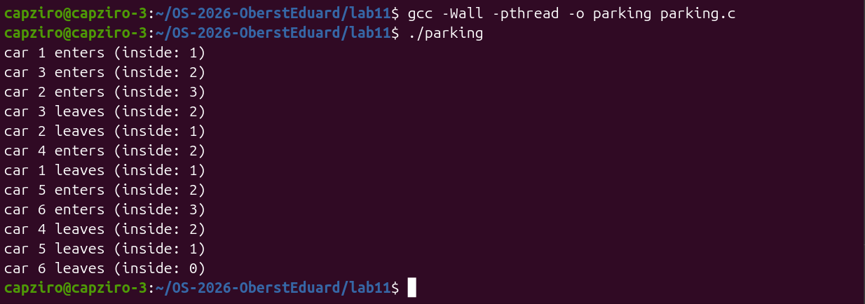
Figure 4.2 – parking.c with 3 places
Cars 1, 3 and 2 entered first and inside reached 3. Car 4 could enter only after cars 3 and 2 left, and cars 5 and 6 entered after car 1 left. The value of inside never went above 3. The order of the cars is not 1, 2, 3, because the scheduler decides which thread runs first. After this I set PLACES to 1 in a copy of the file and ran it with time.
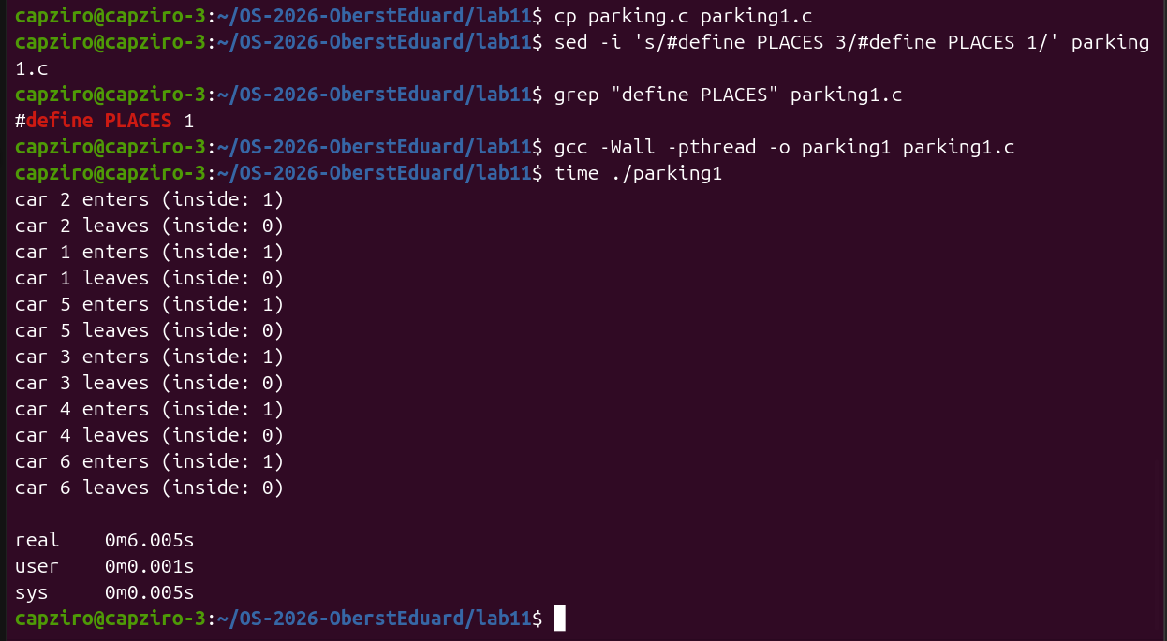
Figure 4.3 – parking1.c with PLACES 1, run with time
With one place the cars entered and left strictly one by one, and inside was only 0 or 1. The program took 6.005 s, which is six cars multiplied by one second of parking. With three places the same six cars need only two turns of one second, because three cars can be parked at the same time.
Observe
1. What is the largest value of "inside" you see? Which line of code guarantees it?
The largest value is 3, and it appears twice in Figure 4.2, for car 2 and for car 6. It is guaranteed by sem_wait(&places); at the start of car, together with sem_init(&places, 0, PLACES); in main. The semaphore starts with 3 units and every car must take one before it enters. When all three are taken, the fourth car waits in sem_wait until a car leaves and calls sem_post.
2. Set PLACES to 1. What does the semaphore become?
It becomes a binary semaphore that starts at 1, which works the same as a mutex from Part 2. Only one car can be in the parking lot at a time, so the cars are fully serialized. This is confirmed by Figure 4.3, where inside never goes above 1 and the program takes six seconds.
Optional. No lock at all: atomic.c
For a single counter there is a third way to fix the race, without any lock. In atomic.c the counter has the type atomic_long, and each thread adds to it with atomic_fetch_add. This function does the load, the add and the store as one indivisible instruction of the CPU, so the other thread cannot read the old value in the middle. The header stdatomic.h comes with gcc, so nothing had to be installed.
#include <stdatomic.h>

atomic_long counter = 0; /* every operation on it is indivisible */

void *add(void *arg) {
for (int i = 0; i < N; i++)
atomic_fetch_add(&counter, 1); /* load, add, store as ONE step */
return NULL;
}
Figure 5.1 – The changed part of atomic.c
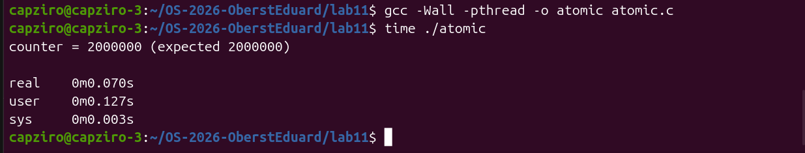
Figure 5.2 – atomic.c compiled and run with time
The program gave the correct result of 2 000 000 in 0.070 s. This is about three times faster than mutex with 0.223 s and four times faster than sem with 0.288 s, but still slower than race with 0.014 s. The sys time is only 0.003 s, the same as for race, so the atomic version does not go to sleep in the kernel like the locked versions. Also, the user time of 0.127 s is bigger than the real time, which means that both threads were really running at the same time on two cores. The atomic version is still slower than race, because every addition is a special instruction and the two cores cannot do it on the same variable at the same time.
Conclusions
In this laboratory work I saw a race condition in practice. Two threads added to the same counter and lost almost half of the additions, with a different result at every run. The assembly code showed the reason. counter++ is three instructions, load, add and store, and the other thread can work with the same variable between them. Both the mutex and the semaphore started at 1 fixed this, and they gave 2 000 000 in every run.
The fix has a price. In my runs the version with the mutex was about 16 times slower than the version without protection, and most of the extra time was spent in the kernel. Also, the experiment with the start value 2 showed that a semaphore protects the critical section only if it starts at 1. The start value decides what the semaphore does. At 1 it is a lock, at 0 it is a signal that keeps the order between threads, and at N it is a counter that lets at most N threads in, like the three places in the parking lot. For one counter there is an even cheaper fix. The optional atomic.c gave the correct result in 0.070 s, about three times faster than the mutex, because a single atomic instruction is enough and no thread has to wait for a lock.
Submitted files are race.c, mutex.c, sem.c, order.c, parking.c, atomic.c and this report, in the folder lab11 of my repository OS-2026-OberstEduard. The answers to the Observe questions are included in this report. The copies sem2.c, order1.c and parking1.c were used only for the experiments and were not submitted.

