
MINISTRY OF EDUCATION, CULTURE AND RESEARCH
OF THE REPUBLIC OF MOLDOVA
Technical University of Moldova
Faculty of Computers, Informatics and Microelectronics
Department of Software and Automation Engineering
Report
Laboratory work nr. 12
Producer, Consumer and the Other Tools
Course: Operating Systems (Track A: Linux)
Done by:
st. gr. FAF-243, Oberst Eduard
Checked by:
Patricia Reitman, University Assistant
Department of Software and Automation Engineering,
FCIM Faculty, UTM

Purpose of the work
This laboratory work uses the synchronization tools from Lab 11 together, to solve the two classic problems of producer and consumer and of readers and writers. In Lab 11 one semaphore was used at a time, as a lock, as a signal or as a counter. Here two semaphores and a mutex work on the same buffer, and the condition variable is used as a second way to make one thread wait for another. At the end of the work a deadlock is built on purpose with two mutexes and then removed. All programs are written in C with POSIX threads.
Preparation
All work was done on my laptop with Ubuntu and gcc 15.2.0, in the folder ~/OS-2026-OberstEduard/lab12 of my course repository. The whole terminal session was recorded with script into the file lab12.log. Every program was created in the terminal with cat > file.c << 'EOF', so the code in the files is the same as in the lab sheet. All programs were compiled with gcc -Wall -pthread. For the experiments I made copies of the files and changed them with perl or sed, so the original files stayed unchanged.
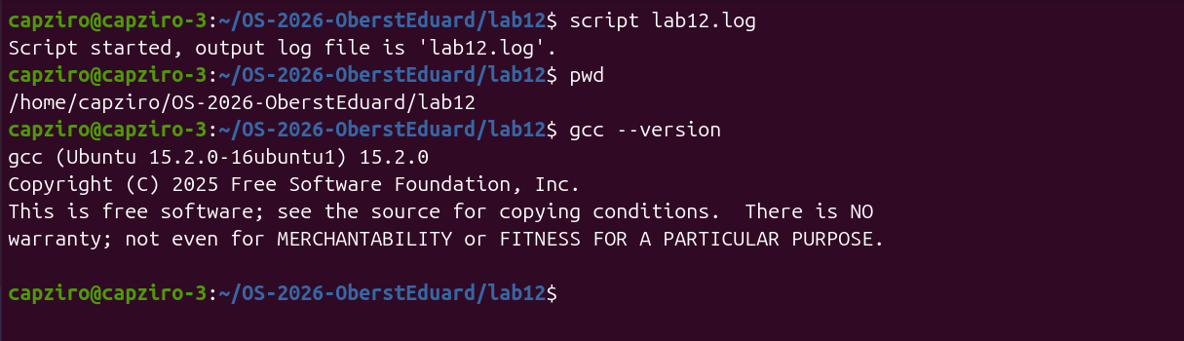
Figure 0.1 – The start of the recorded session, the folder and the gcc version
Part 1. Producer and consumer
In prodcons.c a producer thread puts 8 items into a buffer of 4 slots, and a slow consumer thread takes them out with a pause of 0.3 s after every item. Three tools work together. The semaphore empty counts the free slots and starts at 4, the semaphore full counts the filled slots and starts at 0, and the mutex lock protects the buffer itself and the variables in, out and count.
void *producer(void *arg) {
for (int item = 1; item <= ITEMS; item++) {
sem_wait(&empty); /* wait for a free slot */
pthread_mutex_lock(&lock);
buf[in] = item;
in = (in + 1) % SIZE;
count++;
printf("put %d (in buffer: %d)\n", item, count);
pthread_mutex_unlock(&lock);
sem_post(&full); /* one more filled slot */
}
return NULL;
}

void *consumer(void *arg) {
for (int k = 0; k < ITEMS; k++) {
sem_wait(&full); /* wait for something to take */
pthread_mutex_lock(&lock);
int item = buf[out];
out = (out + 1) % SIZE;
count--;
printf(" take %d (in buffer: %d)\n", item, count);
pthread_mutex_unlock(&lock);
sem_post(&empty); /* one more free slot */
usleep(300000); /* the consumer is slow */
}
return NULL;
}
Figure 1.1 – The producer and the consumer in prodcons.c
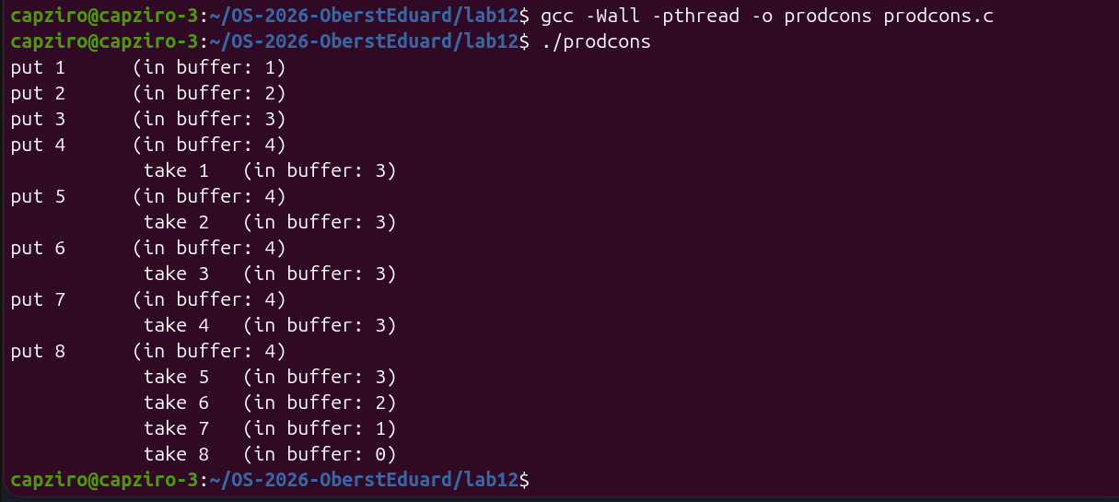
Figure 1.2 – prodcons.c compiled and run
The producer put the first 4 items at once and the buffer was full. After this the two threads alternated. Every time the consumer took one item, the producer put the next one, so the buffer went from 4 to 3 and back to 4. After put 8 the producer was finished, and the consumer took the last four items one by one until the buffer was empty. The value of "in buffer" never went above 4.
For the third Observe question I made a copy prodcons2.c and swapped the first two lines of producer() with perl, so the mutex is locked before sem_wait(&empty). The grep in Figure 1.3 confirms the new order of the two lines.
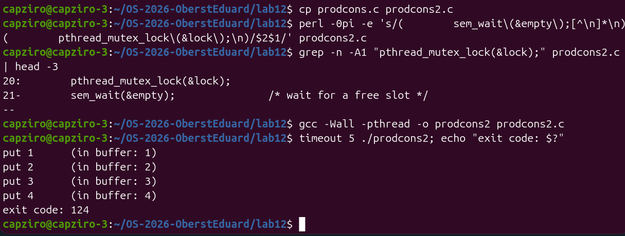
Figure 1.3 – prodcons2.c with the lock before sem_wait hangs and is killed by timeout
The program printed put 1 to put 4 and then stopped. After 5 seconds timeout killed it with the exit code 124. In my run not even take 1 appeared. The producer was faster and took the mutex again every time, so the consumer did not get the lock before the buffer was full.
Observe
1. The producer is fast, yet "in buffer" never goes above 4. Which call stops it?
The call sem_wait(&empty) at the start of the loop in producer(). The semaphore empty starts at 4 and every put takes one unit, so after 4 puts its value is 0 and the producer waits there. It can continue only when the consumer takes an item and calls sem_post(&empty), which gives back one free slot.
2. Who waits at the start: the consumer or the producer? Which call makes it wait?
The consumer waits. It is created first, but full starts at 0, so the consumer stops at sem_wait(&full) because there is nothing to take yet. It continues only after the producer puts the first item and calls sem_post(&full).
3. In producer(), swap the first two lines: lock the mutex BEFORE sem_wait(&empty). Run it. What happens when the buffer is full, and why?
The program hangs forever, which is a deadlock. In my run it printed put 1 to put 4 and then timeout killed it with the exit code 124, as seen in Figure 1.3. When the buffer is full, the producer locks the mutex and then waits in sem_wait(&empty) while it still holds the mutex. The only thread that can free a slot is the consumer, but the consumer needs the same mutex before it can take an item, so it waits in pthread_mutex_lock. Each thread waits for something that only the other one can give. The rule is to wait on the semaphore first and lock the mutex only after it, so a thread never sleeps while it holds the lock.
Part 2. The condition variable
In condvar.c the problem of order.c from Lab 11 is solved in another way. Thread B must read the message only after thread A has written it. The state is a normal variable ready, protected by a mutex, and the condition variable changed is only the place where B sleeps until A tells it that something changed.
void *writer(void *arg) {
sleep(1);
pthread_mutex_lock(&lock);
strcpy(message, "hello");
ready = 1;
printf("A: message written\n");
pthread_cond_signal(&changed); /* wake one waiter */
pthread_mutex_unlock(&lock);
return NULL;
}

void *reader(void *arg) {
pthread_mutex_lock(&lock);
while (!ready) { /* while, not if: re-check after waking */
printf("B: not ready, I sleep\n");
pthread_cond_wait(&changed, &lock); /* unlocks, sleeps, locks again */
}
printf("B: I read \"%s\"\n", message);
pthread_mutex_unlock(&lock);
return NULL;
}
Figure 2.1 – The writer and the reader in condvar.c
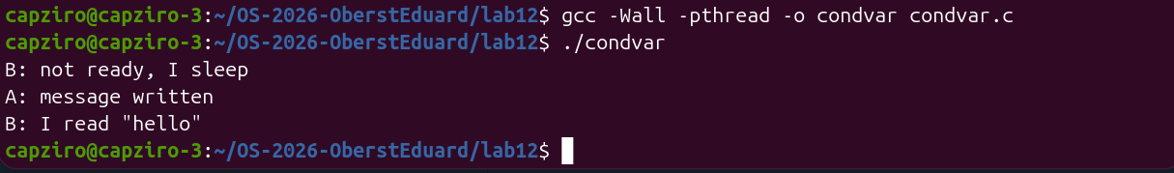
Figure 2.2 – condvar.c compiled and run
B started first, found ready equal to 0 and went to sleep in pthread_cond_wait. This call releases the mutex while B sleeps, so A could lock it after one second, write the message and set ready to 1. A then woke B with pthread_cond_signal, and B took the mutex again, checked ready once more and read "hello". After this I made a copy condvar_if.c where while (!ready) is replaced with if (!ready).
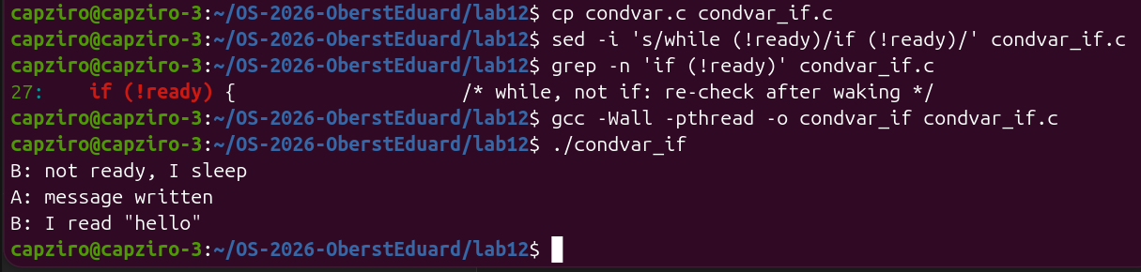
Figure 2.3 – condvar_if.c with if instead of while
Observe
1. In order.c (Lab 11) the semaphore itself remembered that the message was ready. Here, which variable remembers it?
The variable ready. It is a normal global integer protected by the mutex lock, and A sets it to 1 when the message is written. The condition variable changed does not remember anything. If A called pthread_cond_signal when nobody was waiting, the signal would be lost, and only ready would still show that the message is there.
2. Replace "while (!ready)" with "if (!ready)", compile, run. Does it still work here?
Yes. The output in Figure 2.3 is the same as with while. There is only one reader and one writer, and A sets ready to 1 before it sends the signal, so when B wakes up the message is already written.
3. Then why do we write while? Give one reason why a thread can wake up and still find ready == 0.
A thread can return from pthread_cond_wait without any signal, which is called a spurious wakeup, and POSIX allows this. Also, when several threads wait on the same condition, another thread can wake up first, get the mutex and change the state back before this thread gets the mutex. With if the thread would continue and read the message even though ready is still 0. With while it checks the condition again after every wakeup and goes back to sleep if it is not true.
Part 3. Readers and writers
In readers.c three readers and two writers share the variable value. Many readers may read at the same time, but a writer must be alone. Two semaphores are used. room starts at 1 and means that the room is free for a writer, and rlock starts at 1 and protects the counter readers. The first reader that comes in locks the room for all the readers, and the last reader that goes out unlocks it.
void *reader(void *arg) {
long id = (long)arg;
sem_wait(&rlock);
if (++readers == 1) /* the first reader in locks out the writers */
sem_wait(&room);
sem_post(&rlock);

printf("reader %ld reads %d (readers inside: %d)\n", id, value, readers);
usleep(200000);

sem_wait(&rlock);
if (--readers == 0) /* the last reader out lets the writers in */
sem_post(&room);
sem_post(&rlock);
return NULL;
}

void *writer(void *arg) {
long id = (long)arg;
sem_wait(&room); /* alone in the room */
value += 10;
printf("writer %ld writes %d (alone)\n", id, value);
usleep(200000);
sem_post(&room);
return NULL;
}
Figure 3.1 – The reader and the writer in readers.c
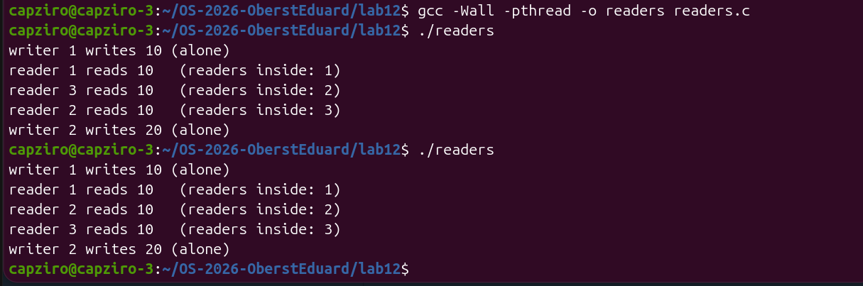
Figure 3.2 – readers.c compiled and run two times
In both runs writer 1 wrote 10 alone, then the three readers read 10 together, with "readers inside" going 1, 2 and 3. Writer 2 wrote 20 only after all three readers had left. The order of the readers was different between the runs, 1, 3, 2 in the first one and 1, 2, 3 in the second one, because the scheduler decides which thread runs first. The result was the same in both runs.
Observe
1. Three readers are inside at the same time, but a writer is always alone. Which two lines of reader() make that possible?
The lines if (++readers == 1) sem_wait(&room); and if (--readers == 0) sem_post(&room);. Only the first reader takes the room, so the other readers do not wait on room and can come in while the first one is still reading. The room is given back only by the last reader that leaves. A writer calls sem_wait(&room) directly, so it waits while any reader is inside, and when the writer holds the room no reader can be the first one in.
2. Why does the counter readers need its own lock (rlock)? What could go wrong without it?
++readers and --readers are three steps, load, add and store, the same as counter++ in Lab 11. Without rlock two readers that come in at the same time can both read 0 and both write 1. Then both think they are the first reader and both call sem_wait(&room), so the second one blocks forever. The counter can also become wrong when readers leave, and then the last reader does not see 0 and never gives back the room, or the room is given back while a reader is still inside and a writer comes in during the reading.
3. Imagine readers that keep arriving without a pause. What happens to writer 2?
Writer 2 never gets in. As long as at least one reader is inside, readers never goes down to 0, so sem_post(&room) is never called and writer 2 waits in sem_wait(&room) forever. This problem is called starvation. In my runs writer 2 already had to wait until all three readers had left, and with an endless stream of readers that moment would never come.
Part 4. Build a deadlock, then remove it
In deadlock.c two threads use two mutexes, A and B, but they take them in opposite order. Thread one locks A and then B, and thread two locks B and then A. The sleep(1) between the two locks gives the other thread time to take its first mutex. The program is run with timeout 5, so the terminal comes back after 5 seconds.
void *one(void *arg) {
pthread_mutex_lock(&A);
printf("one: I have A, I want B\n");
sleep(1);
pthread_mutex_lock(&B); /* waits for two */
...
}

void *two(void *arg) {
pthread_mutex_lock(&B); /* the fix: lock A first here too */
printf("two: I have B, I want A\n");
sleep(1);
pthread_mutex_lock(&A); /* waits for one */
...
}
Figure 4.1 – The two threads in the original deadlock.c
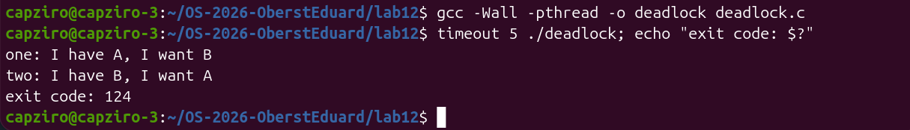
Figure 4.2 – The original deadlock.c is killed by timeout
Both threads printed their first line and then nothing happened. After 5 seconds timeout killed the program with the exit code 124, so done was never printed. For the second Observe question I made a copy deadlock_nosleep.c, removed both sleep(1) lines with sed and ran it 10 times and then 100 times.
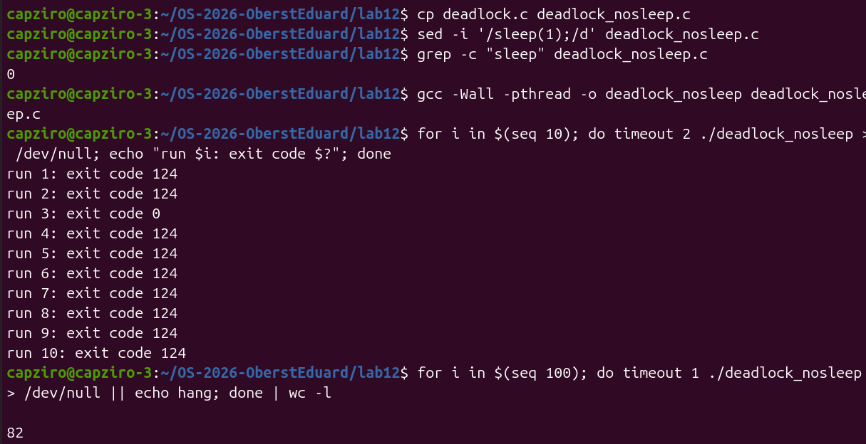
Figure 4.3 – The version without sleep run 10 times and 100 times
Without sleep the program does not hang every time. In the 10 runs 9 hung with the exit code 124 and run 3 finished normally with 0. In the 100 runs 82 hung and 18 finished. After this I fixed deadlock.c so that two() locks A first and B second, the same order as one(). The diff in Figure 4.4 shows the changes against the original version.
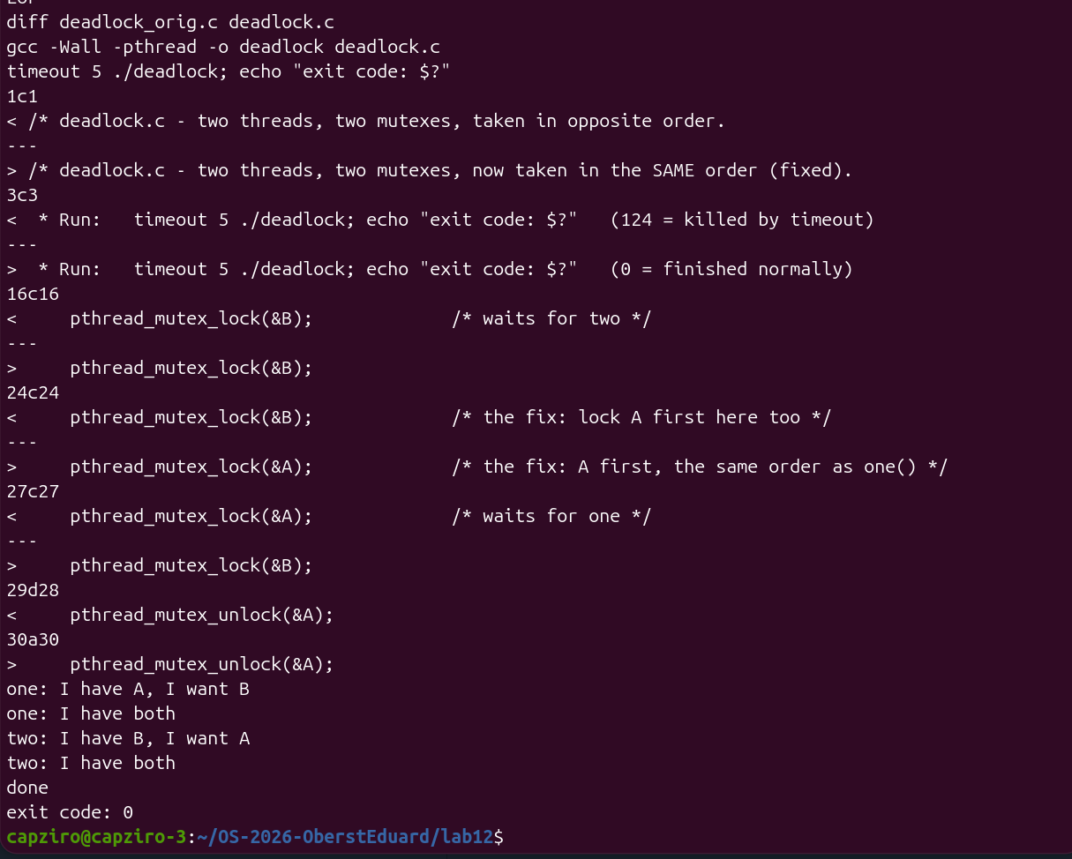
Figure 4.4 – diff between the original and the fixed deadlock.c, then the fixed run
The fixed version finished with done and the exit code 0. Thread one took both mutexes first, and two waited at pthread_mutex_lock(&A) until one had released them. The text of the first printf in two() was left as in the lab sheet, so it still says "I have B, I want A", even though the thread now holds A at that point.
Observe
1. In the stuck run, which thread holds which mutex, and which one is each thread waiting for? Draw the circle.
Thread one holds A and waits for B. Thread two holds B and waits for A. Each thread waits for the mutex that the other one holds, so the waiting goes in a circle and nobody can continue.
holds waits for
one --------> A one ----------> B
two --------> B two ----------> A

one --waits for--> B --held by--> two
^ |
| |
+--held by--- A <--waits for-------+
Figure 4.5 – The circle of waiting in the stuck run
2. Remove both sleep(1) lines from the ORIGINAL version and run it ten times. Does it still always hang? Why is that worse, not better?
No, it does not always hang. On my laptop it hung in 9 of 10 runs and in 82 of 100 runs, as seen in Figure 4.3. Without sleep thread one can sometimes take both A and B before two starts, and then the program finishes normally. This is worse, because the bug is still in the code but it appears only sometimes. A program like this can pass several tests and then hang later for a user, and the error is hard to repeat and to find.
3. In one sentence: why can taking the locks in the same order never deadlock?
If every thread takes A before B, then a thread that waits for B already holds A, so no other thread can hold B and wait for A at the same time, and the circle from Figure 4.5 can never close.
Conclusions
In this laboratory work I used the tools from Lab 11 together on two classic problems. In the producer and consumer program two semaphores counted the free and the filled slots and a mutex protected the buffer, and the buffer never had more than 4 items. The experiment with the swapped lines showed that the order of the calls matters. When the producer locked the mutex before waiting on empty, it slept while holding the lock and the program hung after put 4.
The condition variable solved the problem of order.c in another way. The information that the message is ready is kept in the variable ready, and the condition variable is only the place where the thread sleeps. In the readers and writers program the counter readers let all three readers in together while the writers waited alone, but the same design can starve a writer if readers keep coming.
The last part showed a deadlock with two mutexes taken in opposite order. Without the sleep lines the program still hung in 82 of 100 runs on my laptop, so a bug like this does not always appear and is harder to find. Taking the mutexes in the same order removed the deadlock, and the fixed program finished with the exit code 0.
Submitted files are prodcons.c, condvar.c, readers.c, deadlock.c in the fixed version, report.md with the Observe answers, the terminal log lab12.log and this report, in the folder lab12 of my repository OS-2026-OberstEduard. The copies prodcons2.c, condvar_if.c and deadlock_nosleep.c were used only for the experiments and were not submitted.

