
MINISTRY OF EDUCATION, CULTURE AND RESEARCH
OF THE REPUBLIC OF MOLDOVA
Technical University of Moldova
Faculty of Computers, Informatics and Microelectronics
Department of Software and Automation Engineering
Report
Laboratory work nr. 13
Semaphores in Your Own Kernel
Course: Operating Systems (Track B: xv6)
Done by:
st. gr. FAF-243, Oberst Eduard
Checked by:
Patricia Reitman, University Assistant
Department of Software and Automation Engineering,
FCIM Faculty, UTM

Purpose of the work
In Labs 11 and 12 semaphores were used from the C library on Linux. In this laboratory work they are built inside the xv6 kernel, as three new system calls, sem_init, sem_down and sem_up, with the numbers 24, 25 and 26. A semaphore in the kernel is only a number, a spinlock that protects this number, and the sleep and wakeup functions of the kernel. A process that waits on a semaphore really goes to sleep and uses no CPU. The new calls are tested with two user programs, semtest and mix.
Preparation
All work was done in my ~/xv6-riscv tree on my laptop, the same tree as in Lab 10, with the riscv64-linux-gnu cross compiler and QEMU. The terminal session was recorded with script into lab13-transcript.log. Before starting, the changes from the earlier labs were still not committed, so I committed them as "Lab 10: trace (state before Lab 13)". Because of this the Lab 13 changes can be saved in a separate patch. I also checked that our kernel has the function sleep_prepare in kernel/defs.h and the user call pause in user/user.h, because the code of the lab uses both.
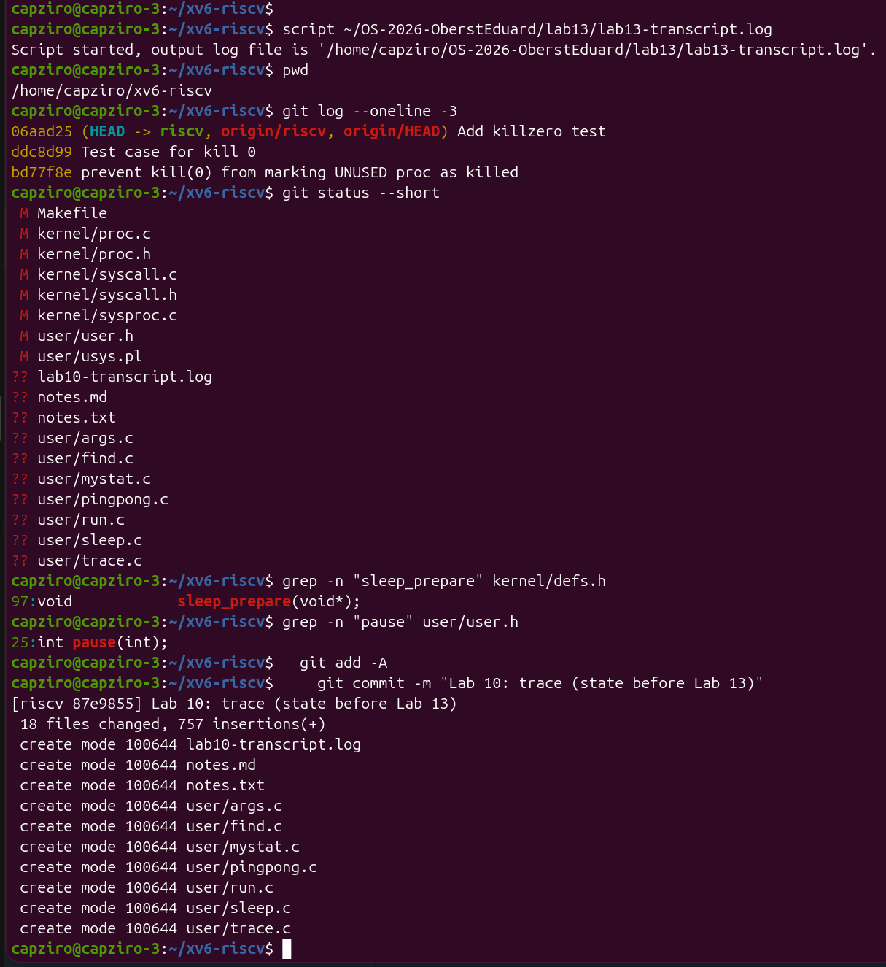
Figure 0.1 – The start of the session, the state of the tree and the commit of the earlier labs
The edits of existing files were made with a small Python script, ~/ins.py, that inserts new lines after a given line and prints an error if it does not find that line. Every edit was then checked with grep or tail.
Part 1. The numbers and the user side
The user side follows the same recipe as trace in Lab 10, three times. The numbers 24, 25 and 26 were added at the end of kernel/syscall.h, after SYS_trace 23. The declarations of the three calls were added in user/user.h after int sync(void);, and the three entry lines were added in user/usys.pl. At build time usys.pl writes for every call a small stub that puts the number in register a7 and runs ecall.
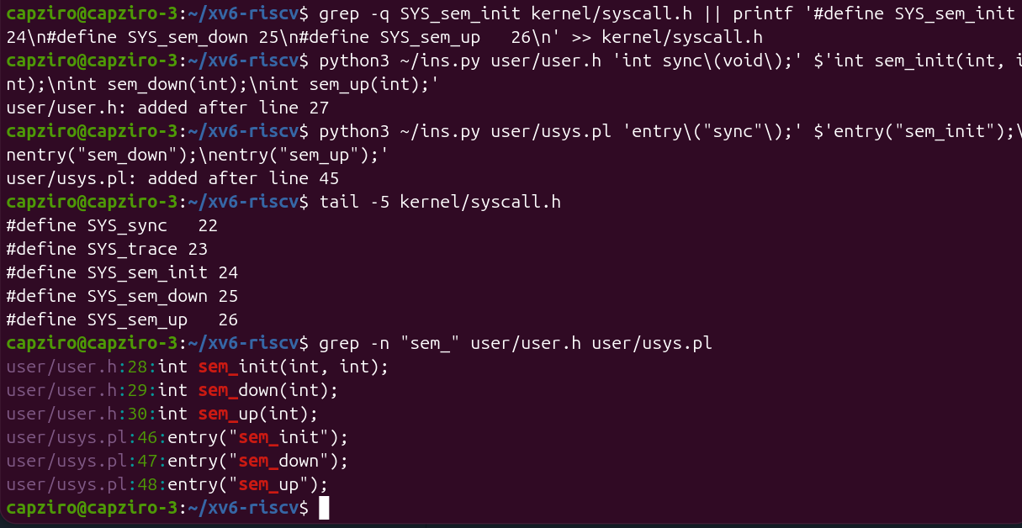
Figure 1.1 – The numbers in syscall.h and the new lines in user.h and usys.pl
After this the two test programs were created, user/semtest.c and user/mix.c. semtest has two tests. In the first one semaphore 0 starts at 0, so the child must wait in sem_down(0) until the parent calls sem_up(0). In the second one semaphores 1 and 2 pass the turn between ping and pong. Semaphore 1 starts at 1, so ping goes first.
// Test 1: order. Semaphore 0 starts at 0, so the child must wait.
sem_init(0, 0);
if (fork() == 0) {
sem_down(0);
printf("child: I ran after the parent\n");
exit(0);
}
pause(10);
printf("parent: done, I let the child go\n");
sem_up(0);
wait(0);

// Test 2: ping-pong. Semaphore 1 = ping's turn, semaphore 2 = pong's turn.
sem_init(1, 1);
sem_init(2, 0);
if (fork() == 0) {
for (int i = 1; i <= 3; i++) {
sem_down(2);
printf(" pong %d\n", i);
sem_up(1);
}
exit(0);
}
for (int i = 1; i <= 3; i++) {
sem_down(1);
printf("ping %d\n", i);
sem_up(2);
}
Figure 1.2 – The two tests in user/semtest.c
Both programs were then added to UPROGS in the Makefile, after $U/_zombie\.
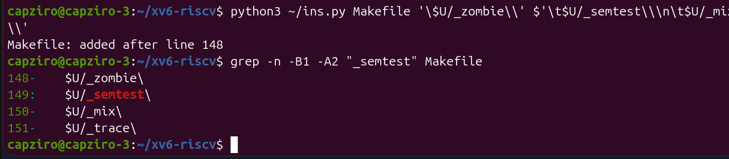
Figure 1.3 – _semtest and _mix in UPROGS
Check 1. Before the kernel side exists, semtest must reach the kernel and be rejected. The figure shows my second run of semtest in the same boot, so the pids are 6 and 7.
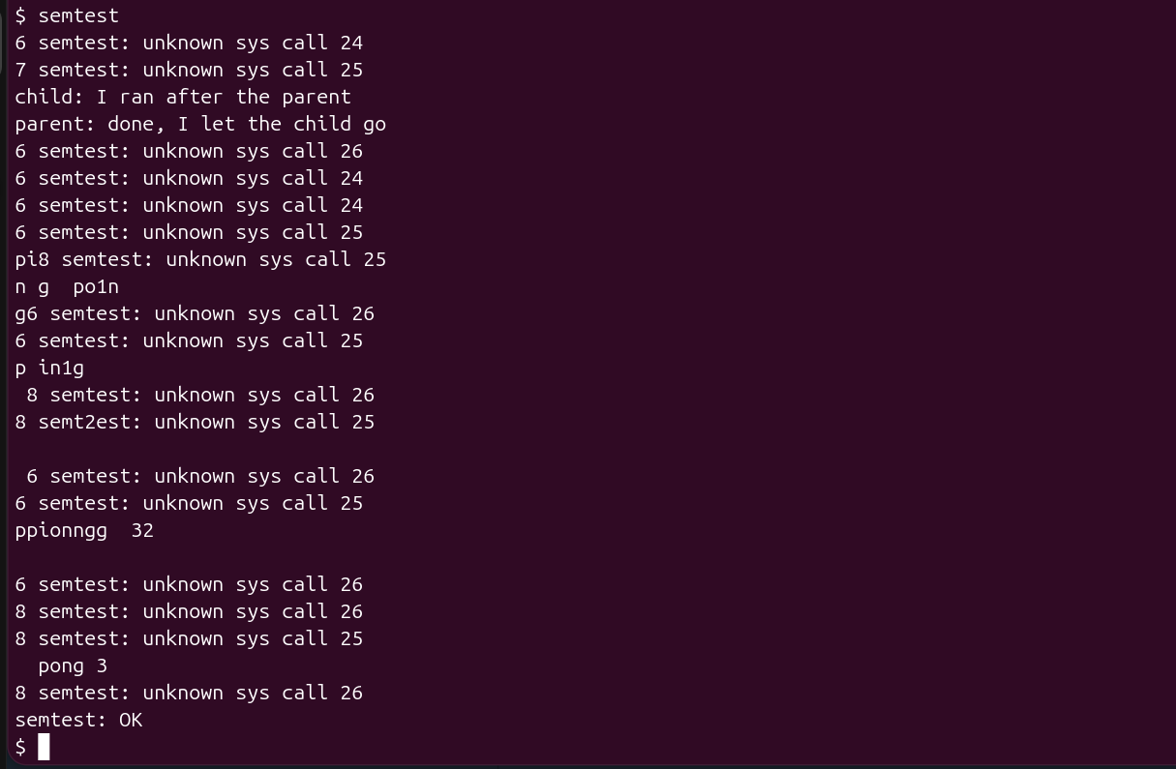
Figure 1.4 – Check 1: unknown sys call 24 and 25, and the child prints before the parent
This is the expected result. The stubs put 24, 25 and 26 in register a7 and ran ecall, and syscall() in the kernel found no function for these numbers, so it printed "unknown sys call" and returned -1. Nothing made the child wait, so the line child: came before the line parent:. The ping and pong lines are also mixed with the error lines and with each other, because the two processes print at the same time.
Part 2. The kernel side
The semaphores are in a new file, kernel/sem.c. It has a table of 8 semaphores shared by all processes, and every semaphore is a spinlock and an integer value. sys_sem_init sets the start value. sys_sem_up adds 1 and wakes up every process that sleeps on the address of the semaphore.
// sem_down(id): take one unit; if there is none, sleep until there is.
uint64
sys_sem_down(void)
{
int id;
argint(0, &id);
if (id < 0 || id >= NSEM)
return -1;
struct sem *s = &sems[id];

acquire(&s->lock);
while (s->value == 0) {
sleep_prepare(s); // I will sleep on the address of s
release(&s->lock); // never sleep holding a spinlock
sleep(); // returns at once if sem_up came in between
acquire(&s->lock);
if (killed(myproc())) { // kill must still work on a waiting process
release(&s->lock);
return -1;
}
}
s->value--;
release(&s->lock);
return 0;
}

// sem_up(id): give one unit back and wake whoever sleeps on s.
uint64
sys_sem_up(void)
{
...
acquire(&s->lock);
s->value++;
wakeup(s);
release(&s->lock);
return 0;
}
Figure 2.1 – sys_sem_down and sys_sem_up in kernel/sem.c
sys_sem_down is the main part. While the value is 0, the process first registers the address of the semaphore as the thing it waits for with sleep_prepare(s), then releases the spinlock, and only then sleeps. If sem_up comes between release and sleep(), the process is already marked as waiting on s, so sleep() returns at once and the wakeup is not lost. After it wakes up, the process takes the spinlock again and checks the value again. When the value is bigger than 0 it takes one unit and returns. Our kernel sleeps in these two steps, so the code does not use sleep(chan, lock) from the xv6 book.
To make the kernel use the new file, $K/sem.o was added to OBJS in the Makefile, after $K/sysproc.o. In kernel/syscall.c I added the three extern declarations and the three entries in the table of system calls. I also added the three names in the table syscallnames[] from Lab 10, so trace can print these calls too.
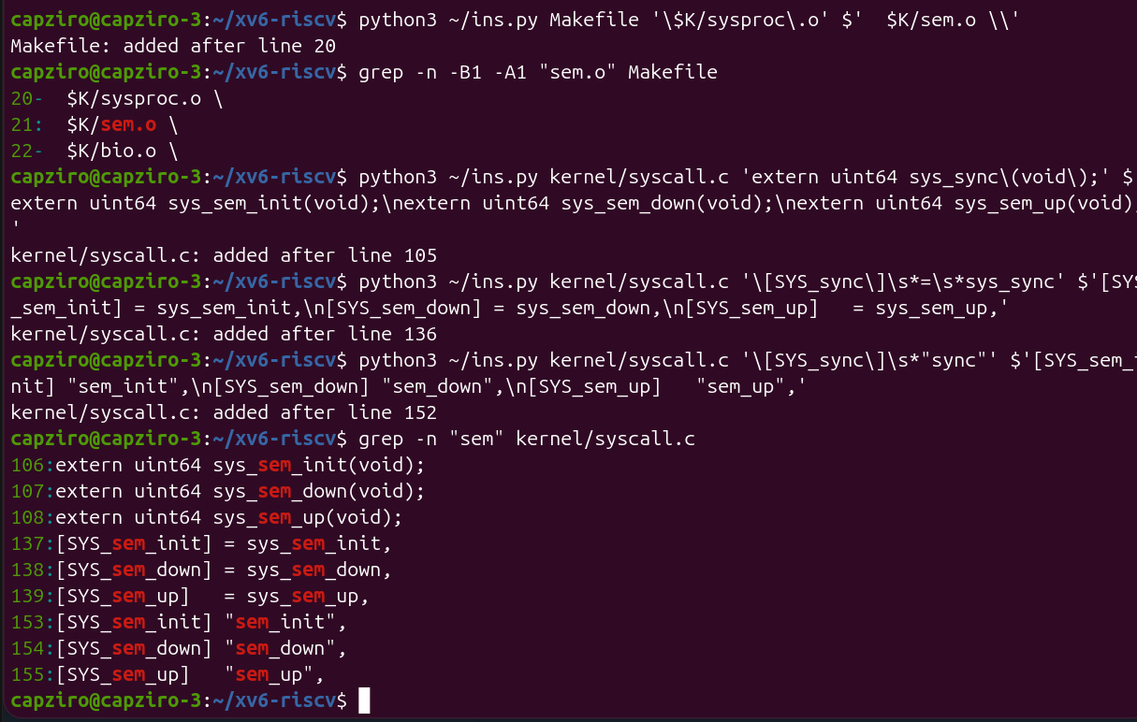
Figure 2.2 – sem.o in OBJS and the new lines in kernel/syscall.c
Check 2. After the rebuild, semtest was run again.
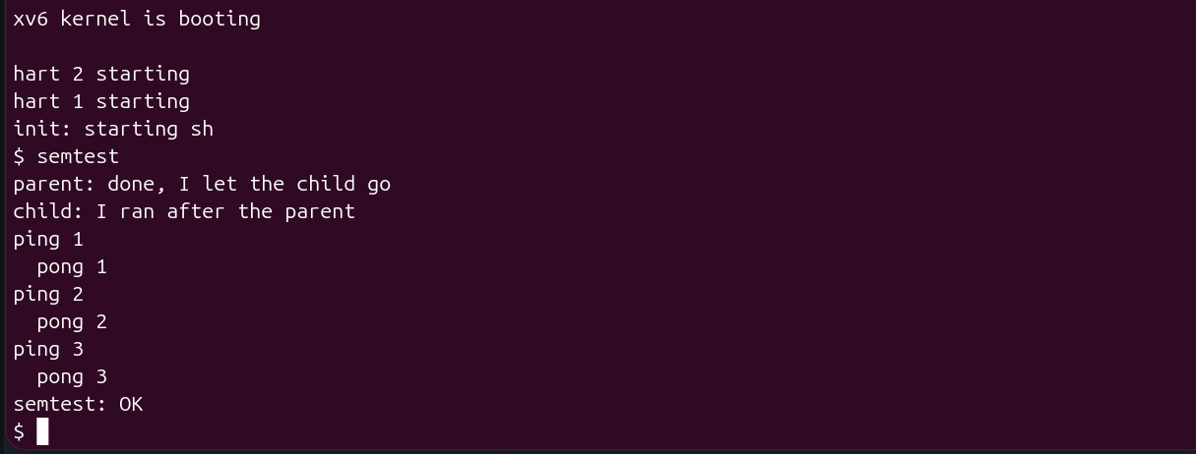
Figure 2.3 – Check 2: semtest prints the child after the parent, ping and pong in turn, then OK
Now the order is correct. The parent waits 10 ticks with pause(10) before it calls sem_up(0), but the child still prints second, because it was asleep in sem_down(0) the whole time. Ping and pong alternate strictly three times, because every process gives the turn to the other one with sem_up and then waits for it with sem_down. At the end semtest printed semtest: OK.
Part 3. A semaphore as a lock: mix
mix starts two processes that print five lines each, one letter per write() system call. The parent prints lines of A and the child prints lines of b. With the argument lock, semaphore 3 started at 1 is used as a lock around every line. make qemu starts xv6 with 3 CPUs, with the option -smp 3, so the two processes really run at the same time. I ran mix two times without the lock.
void
lines(char *s, int uselock)
{
for (int k = 0; k < 5; k++) {
if (uselock)
sem_down(3);
for (char *p = s; *p; p++)
write(1, p, 1);
if (uselock)
sem_up(3);
}
}
Figure 3.1 – The function lines in user/mix.c
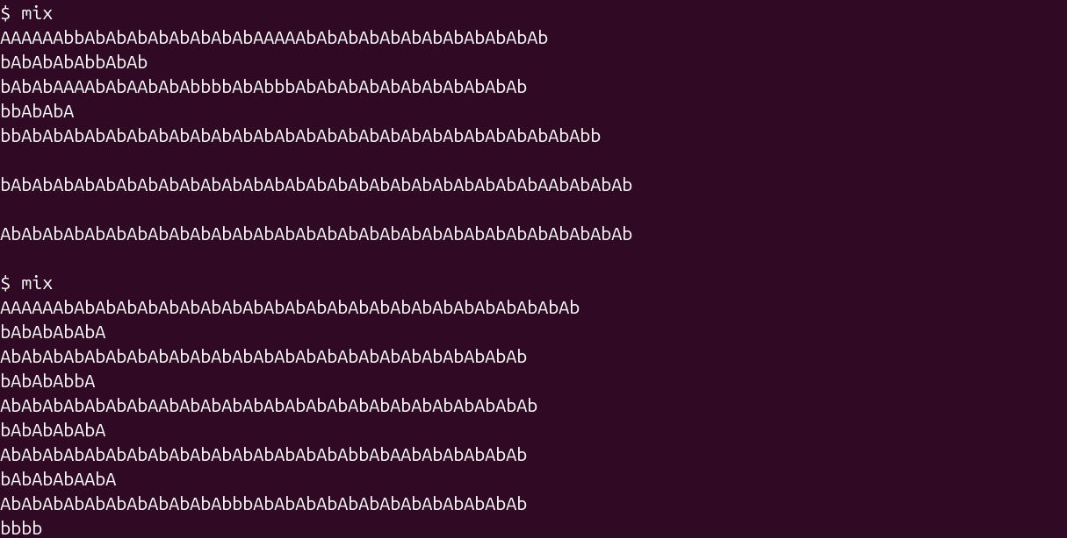
Figure 3.2 – mix without the lock, two runs
In both runs the letters of the two processes are mixed, and long parts of the output are only "AbAbAb", which means the two processes wrote one letter each in turn. Even the newlines are mixed, so the lines have different lengths and some lines are empty. The two runs are also mixed in a different way. After this I ran mix lock two times.
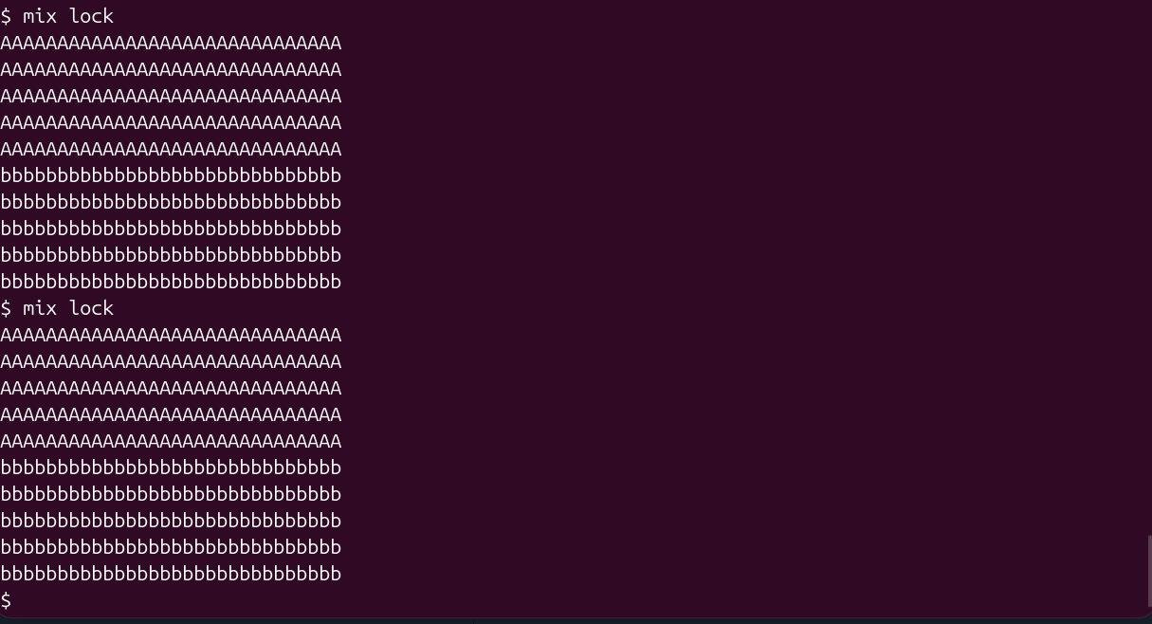
Figure 3.3 – mix lock, two runs
With the lock every line is whole. In both runs the five lines of A came first and then the five lines of b. The parent took the semaphore first. Every time it gave it back with sem_up(3), it took it again with sem_down(3) for its next line before the child could take it. The child was woken up by wakeup, but when it checked the value it found 0 again and went back to sleep. This is also an example of why sem_down uses while and not if.
Observe
1. Without the lock, why do the letters mix? (How many system calls does one line cost?)
Every letter is written with its own write(1, p, 1), so one line costs 31 system calls, 30 for the letters and 1 for the newline. Between any two of these calls the other process can also call write, and with 3 CPUs the two processes really run at the same time. Because of this the console receives the letters of both processes in turn, which is the "AbAbAb" in Figure 3.2. Only one write call is done as one piece, and here one call is only one letter.
2. With the lock every line is whole. Which two lines of mix.c make one line a critical section?
if (uselock) sem_down(3); before the inner for loop and if (uselock) sem_up(3); after it. Semaphore 3 starts at 1, so it works as a lock. The process that passes sem_down(3) writes all 31 letters of its line, and the other process sleeps in sem_down(3) until the line is finished and sem_up(3) gives the unit back.
3. In sem_down the test is "while (s->value == 0)", not "if". Why can a process wake up and still find 0?
wakeup(s) wakes all the processes that sleep on s, but sem_up adds only one unit. The first process that takes the spinlock again takes this unit, and the others find 0 again. Also, a process that was not sleeping can take the unit before the woken process gets the spinlock. This happened in my mix lock runs, where the parent took semaphore 3 again before the child could check it. With if the woken process would decrease the value below 0 and enter together with the other one, so the lock would not work.
4. sem_down calls release(&s->lock) BEFORE sleep(). What would go wrong if it slept holding the spinlock?
The only way to wake the process is sem_up, and sem_up must first take the same spinlock with acquire(&s->lock). If the sleeping process kept the spinlock, sem_up would spin in acquire forever on another CPU, and the sleeping process would never be woken. This is a deadlock between the two processes. Also, xv6 does not allow a process to give up the CPU while it holds a spinlock, because acquire turns off interrupts on that CPU, and the scheduler stops the kernel with a panic in this case.
Optional. sem_trydown
As the optional task, I added a fourth call, sem_trydown, with the number 27. It works like sem_down, but if the value is 0 it returns -1 at once instead of sleeping. It was added in the same places as the other three calls, and the test program user/trytest.c was added to UPROGS.
// sem_trydown(id): like sem_down, but never sleeps: -1 if the value is 0.
uint64
sys_sem_trydown(void)
{
int id;
argint(0, &id);
if (id < 0 || id >= NSEM)
return -1;
struct sem *s = &sems[id];

acquire(&s->lock);
if (s->value == 0) {
release(&s->lock);
return -1;
}
s->value--;
release(&s->lock);
return 0;
}
Figure 4.1 – sys_sem_trydown in kernel/sem.c
sem_init(4, 1);
printf("first try: %d\n", sem_trydown(4)); // 0: the value was 1
printf("second try: %d\n", sem_trydown(4)); // -1: the value is 0, no sleep
sem_up(4);
printf("after up: %d\n", sem_trydown(4)); // 0 again
Figure 4.2 – The main part of user/trytest.c
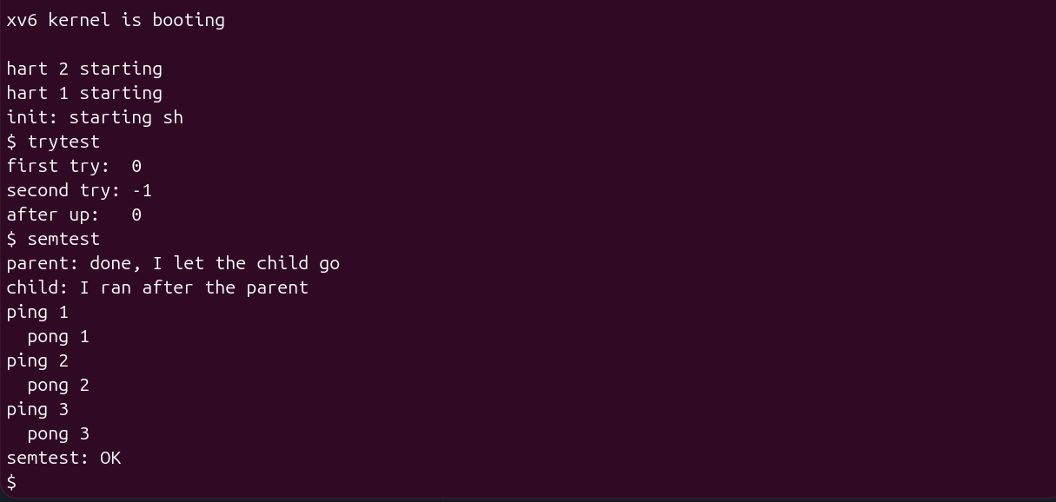
Figure 4.3 – trytest shows both answers, and semtest still works
The first try returned 0, because semaphore 4 started at 1. The second try returned -1 at once, because the value was 0, and the program did not sleep. After sem_up(4) the third try returned 0 again. semtest was run again after this change and still printed semtest: OK.
Conclusions
In this laboratory work I built semaphores inside the xv6 kernel as three new system calls. Before the kernel side existed, Check 1 showed that the numbers 24 and 25 reached the kernel and were rejected, and that without semaphores the child printed before the parent. After Part 2 the same program printed the child after the parent and ping and pong strictly in turn, so the processes really waited for each other.
The work showed that a semaphore is not something complicated. It is only a number, a spinlock that protects this number, and the sleep and wakeup functions of the kernel. The important details are in sem_down. The process must release the spinlock before it sleeps, or sem_up could never wake it, and it must check the value again in a while loop after it wakes up, because another process can take the unit first. My mix lock runs showed this, because the parent kept taking the lock for all five of its lines before the child got it once.
The mix program also showed what the lock is for. Without it the letters of the two processes were mixed in every run, and with semaphore 3 as a lock every line stayed whole. The optional sem_trydown worked as expected and returned -1 at once instead of sleeping.
Submitted files are sem.c, semtest.c, mix.c, trytest.c, kernel-changes.patch with all the Lab 13 changes to the kernel, the user library and the Makefile, the Makefile, lab13-transcript.log, notes.txt with the Observe answers and this report. The full xv6 tree with these changes is committed in my ~/xv6-riscv repository.

