
MINISTRY OF EDUCATION, CULTURE AND RESEARCH
OF THE REPUBLIC OF MOLDOVA
Technical University of Moldova
Faculty of Computers, Informatics and Microelectronics
Department of Software and Automation Engineering
Report
Laboratory work nr. 10
Add Your Own System Call: trace
Course: Operating Systems (Track B: xv6)
Done by:
st. gr. FAF-243, Oberst Eduard
Checked by:
Patricia Reitman, University Assistant
Department of Software and Automation Engineering,
FCIM Faculty, UTM

Purpose of the work
The purpose of this laboratory work is to change the xv6 kernel for the first time, by adding a new system call, trace, that makes a process print the system calls it makes, filtered by a bitmask. In Lab 9 strace did this on Linux from outside the process; here the same idea is built inside the kernel: a new call number (23), a user stub that runs ecall, a handler in the kernel, a table of names for printing, and the inheritance of the mask through fork().
Preparation
All work was done in my ~/xv6-riscv tree (commit 06aad25, the same tree as in Lab 8) on my laptop, with the riscv64-linux-gnu cross compiler and QEMU. The terminal session was recorded with script into lab10-transcript.log. Our xv6 is newer than the MIT 6.1810 version, so the new call uses the number 23 (22 is already sync) and the kernel prints with printk. The Lab 10 changes against the original tree are saved in kernel-changes.patch.
Part 1. The number and the user side
Five edits were made: #define SYS_trace 23 at the end of kernel/syscall.h, the declaration int trace(int); in user/user.h, the line entry("trace"); in user/usys.pl (at build time it writes in user/usys.S the stub li a7, SYS_trace; ecall; ret), the new program user/trace.c, and the line $U/_trace\ in UPROGS in the Makefile. trace.c sets the mask on itself and then becomes the requested command with exec; the mask stays, because exec replaces the program but keeps the same process.
#include "kernel/types.h"
#include "kernel/stat.h"
#include "user/user.h"

int
main(int argc, char *argv[])
{
if (argc < 3) {
fprintf(2, "usage: trace mask command [args...]\n");
exit(1);
}
if (trace(atoi(argv[1])) < 0) {
fprintf(2, "trace: failed\n");
exit(1);
}
exec(argv[2], argv + 2);
fprintf(2, "trace: exec %s failed\n", argv[2]);
exit(1);
}
Figure 1.1 – Contents of user/trace.c
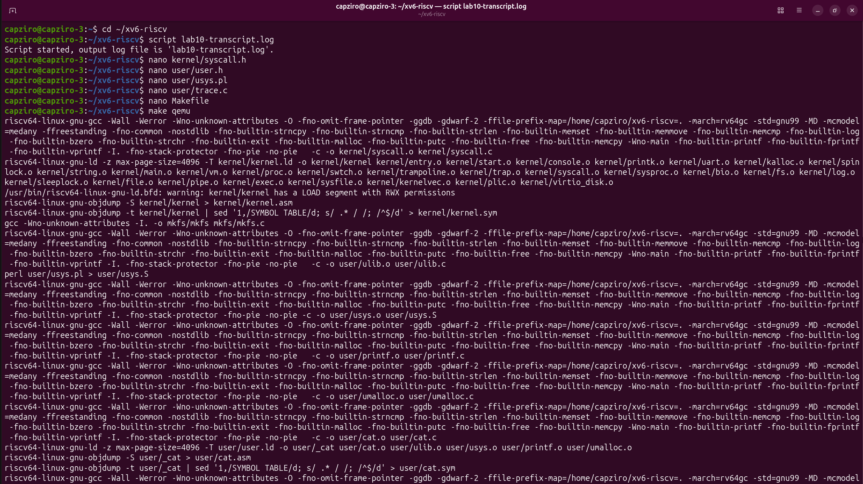
Figure 1.2 – The five Part 1 edits with nano, then the build with make qemu
Check 1. Before the kernel side exists, running trace 32 grep hello README must reach the kernel and be rejected:
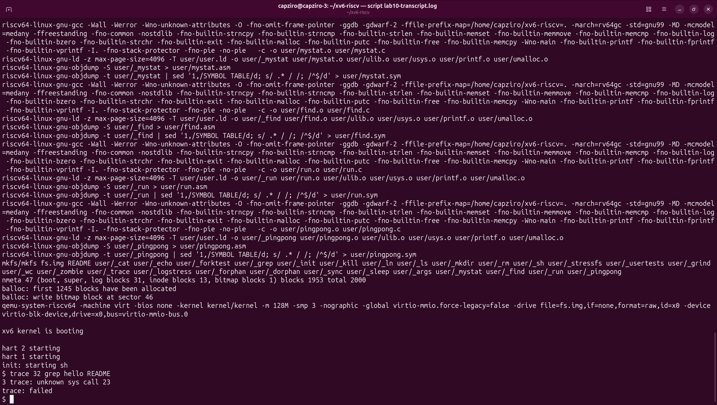
Figure 1.3 – Check 1: “3 trace: unknown sys call 23” and “trace: failed”
This is the expected result: the stub put 23 in register a7 and ran ecall, and syscall() in the kernel received the number, but found no function for it in the table, so it printed the message and returned -1; then trace.c printed trace: failed.
Part 2. The kernel side
Five edits were made in the kernel, with small python3 and cat commands in the terminal, each one checked with grep or tail (Figures 2.1 – 2.4): the field int trace_mask; in struct proc (kernel/proc.h); the handler sys_trace() at the end of kernel/sysproc.c, which reads argument 0 with argint and stores it in myproc()->trace_mask; in kernel/syscall.c the extern declaration and the entry [SYS_trace] = sys_trace in the table of system calls; also in kernel/syscall.c, the table syscallnames[] above syscall() and the two lines that print after the call has run, only if bit num of the mask is 1; and in fork() (kernel/proc.c) the line np->trace_mask = p->trace_mask;, so that children inherit the mask.
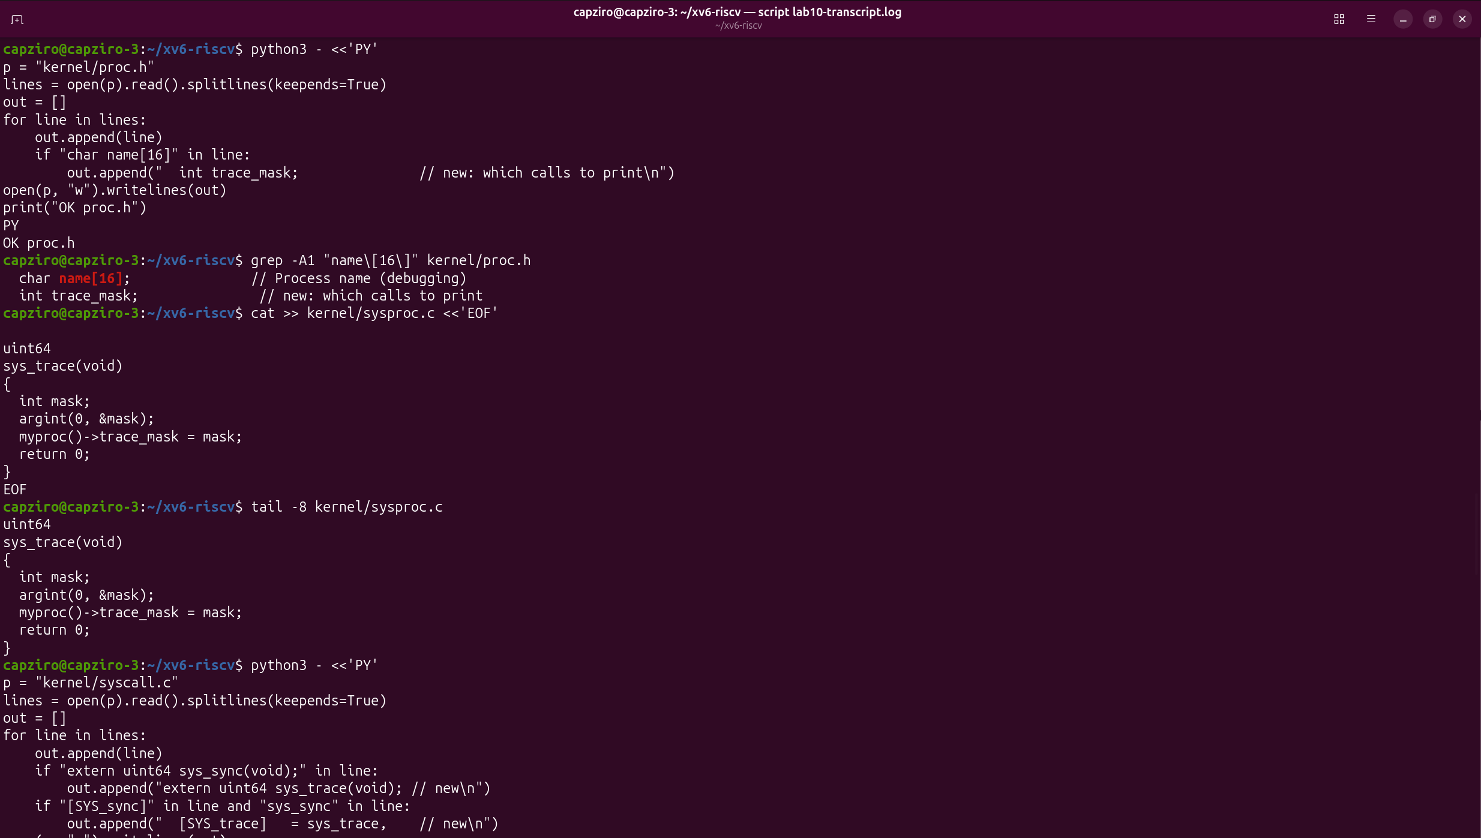
Figure 2.1 – kernel/proc.h: the trace_mask field (checked with grep); kernel/sysproc.c: sys_trace() added at the end (checked with tail)
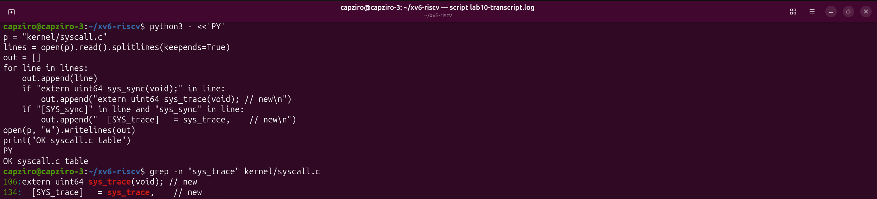
Figure 2.2 – kernel/syscall.c: the extern declaration (line 106) and the [SYS_trace] entry in the table (line 134)
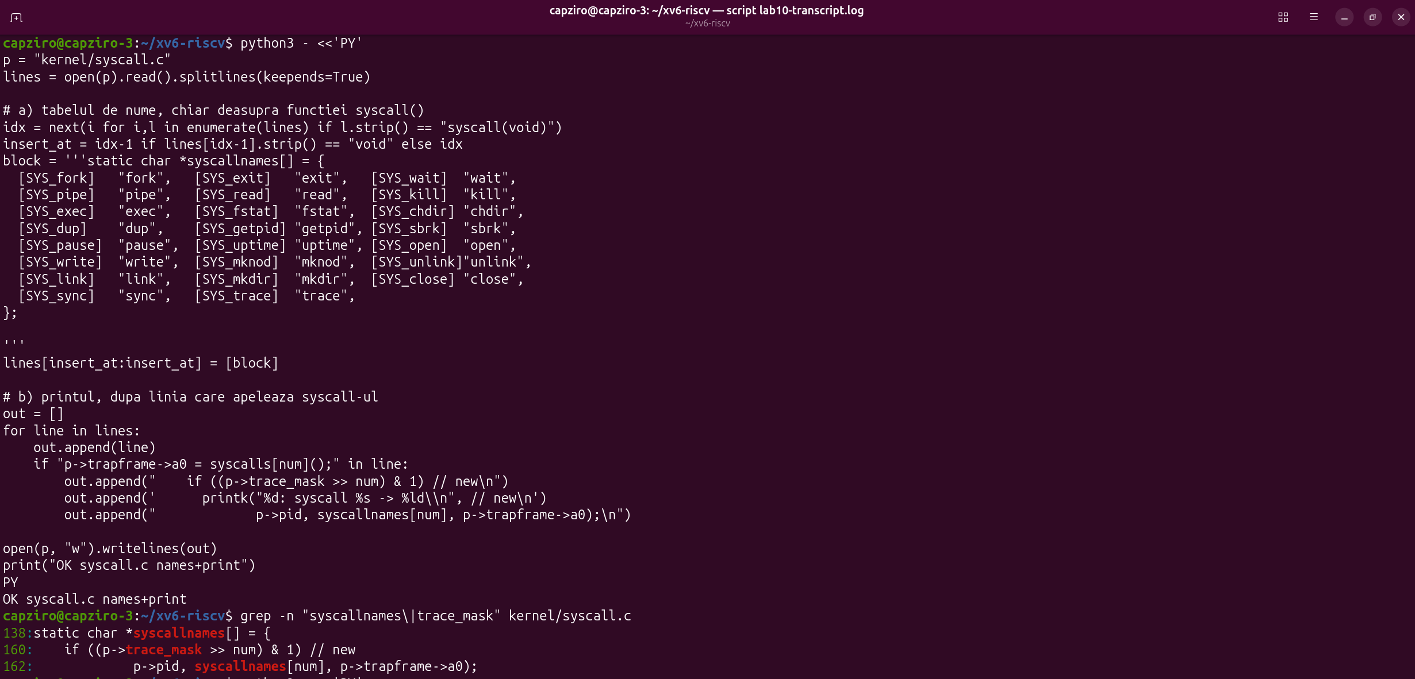
Figure 2.3 – kernel/syscall.c: the syscallnames[] table above syscall() and the print after the call (lines 160 – 162)
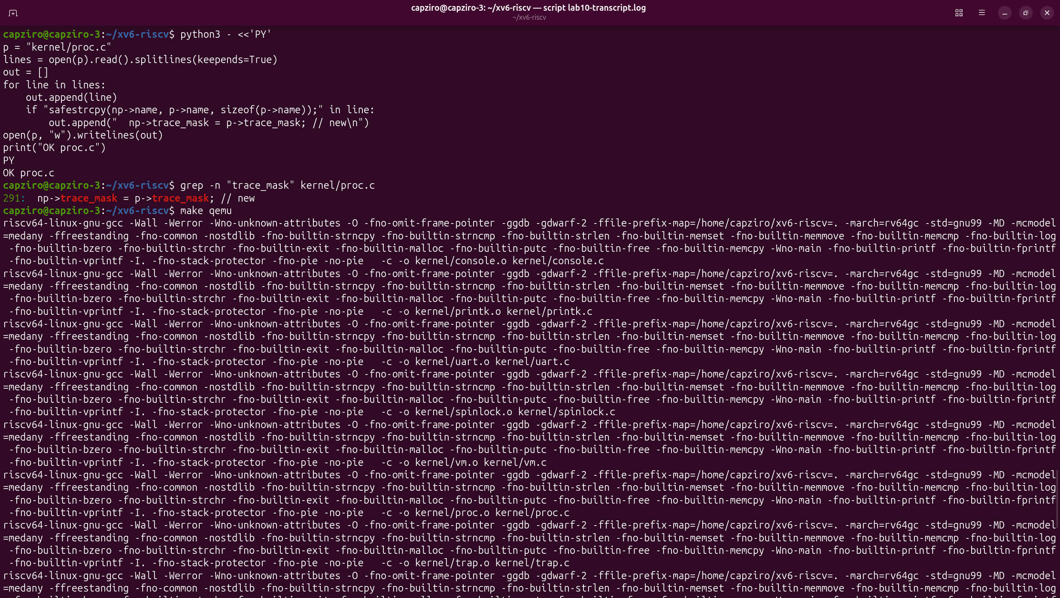
Figure 2.4 – kernel/proc.c: np->trace_mask = p->trace_mask; in fork() (line 291), then the rebuild
Check 2. After the rebuild, the same command printed the read calls of grep with exactly the numbers from the lab sheet: 1023 + 965 + 453 = 2441 bytes, the size of README, read in three pieces, then 0 for the end of the file.
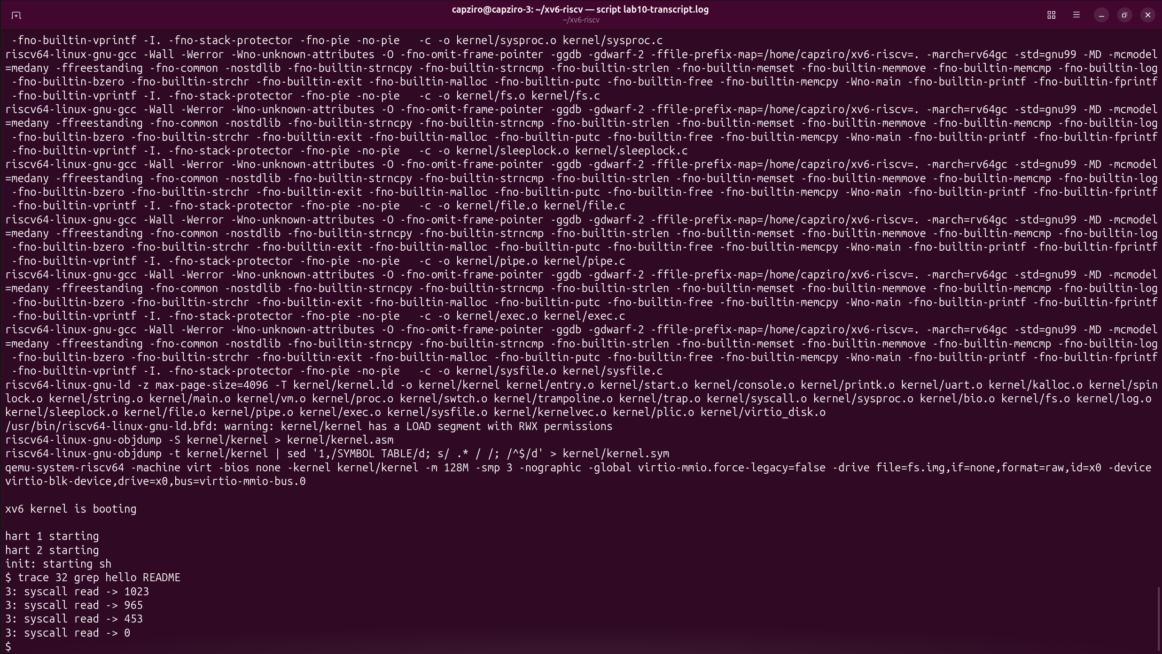
Figure 2.5 – Check 2: trace 32 grep hello README prints the four read lines
Part 3. Play with the mask
The mask is a number read in binary: bit N set means “print system call number N”. 32 = 2⁵ and 5 is SYS_read, which is why Check 2 printed only the reads.
3.1 All the calls (mask 2147483647, all bits on)
With all bits on, every call of the process is printed, in order: trace -> 0 (the call made by trace.c itself), exec -> 3 (in xv6 exec returns argc: grep, hello, README), open -> 3 (the first free file descriptor, after 0, 1 and 2), the four reads and close -> 0. The pid is 3 again because QEMU was restarted before this run.
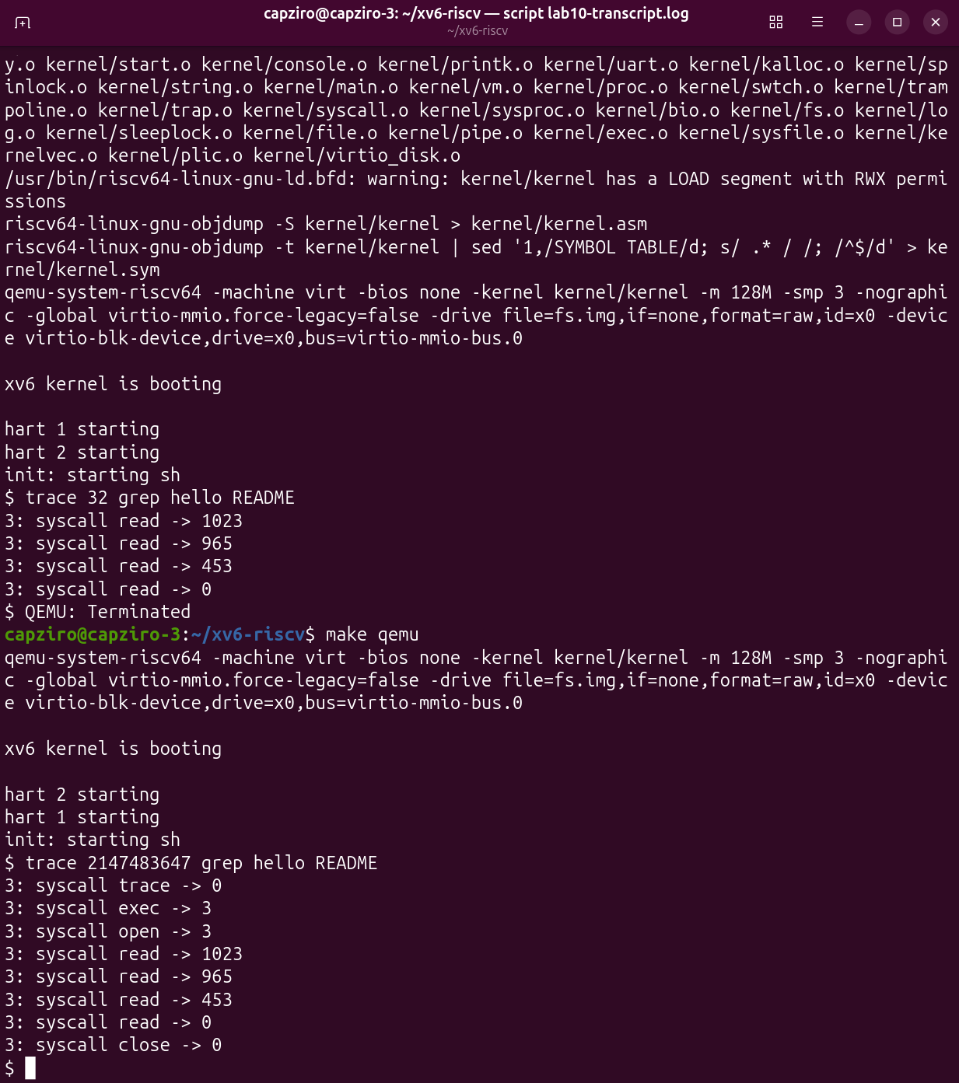
Figure 3.1 – trace 2147483647 grep hello README
3.2 Only fork (mask 2) on usertests forkforkfork
The test forks until the process table is full. When fork starts to return -1, the test creates the file stopforking, all the forking processes exit, and the test ends with OK and ALL TESTS PASSED. The first attempt had a stray key in the command and failed with exec trace failed, so it was typed again (Figure 3.2).
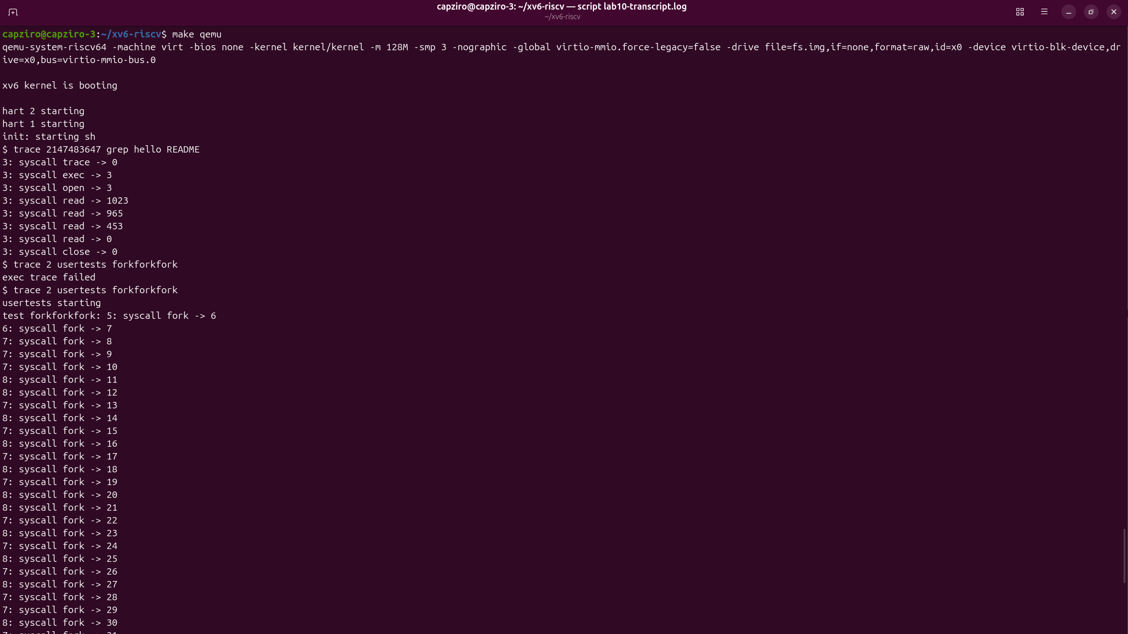
Figure 3.2 – trace 2 usertests forkforkfork: the beginning (pids 5, 6, 7 and 8 print fork lines)
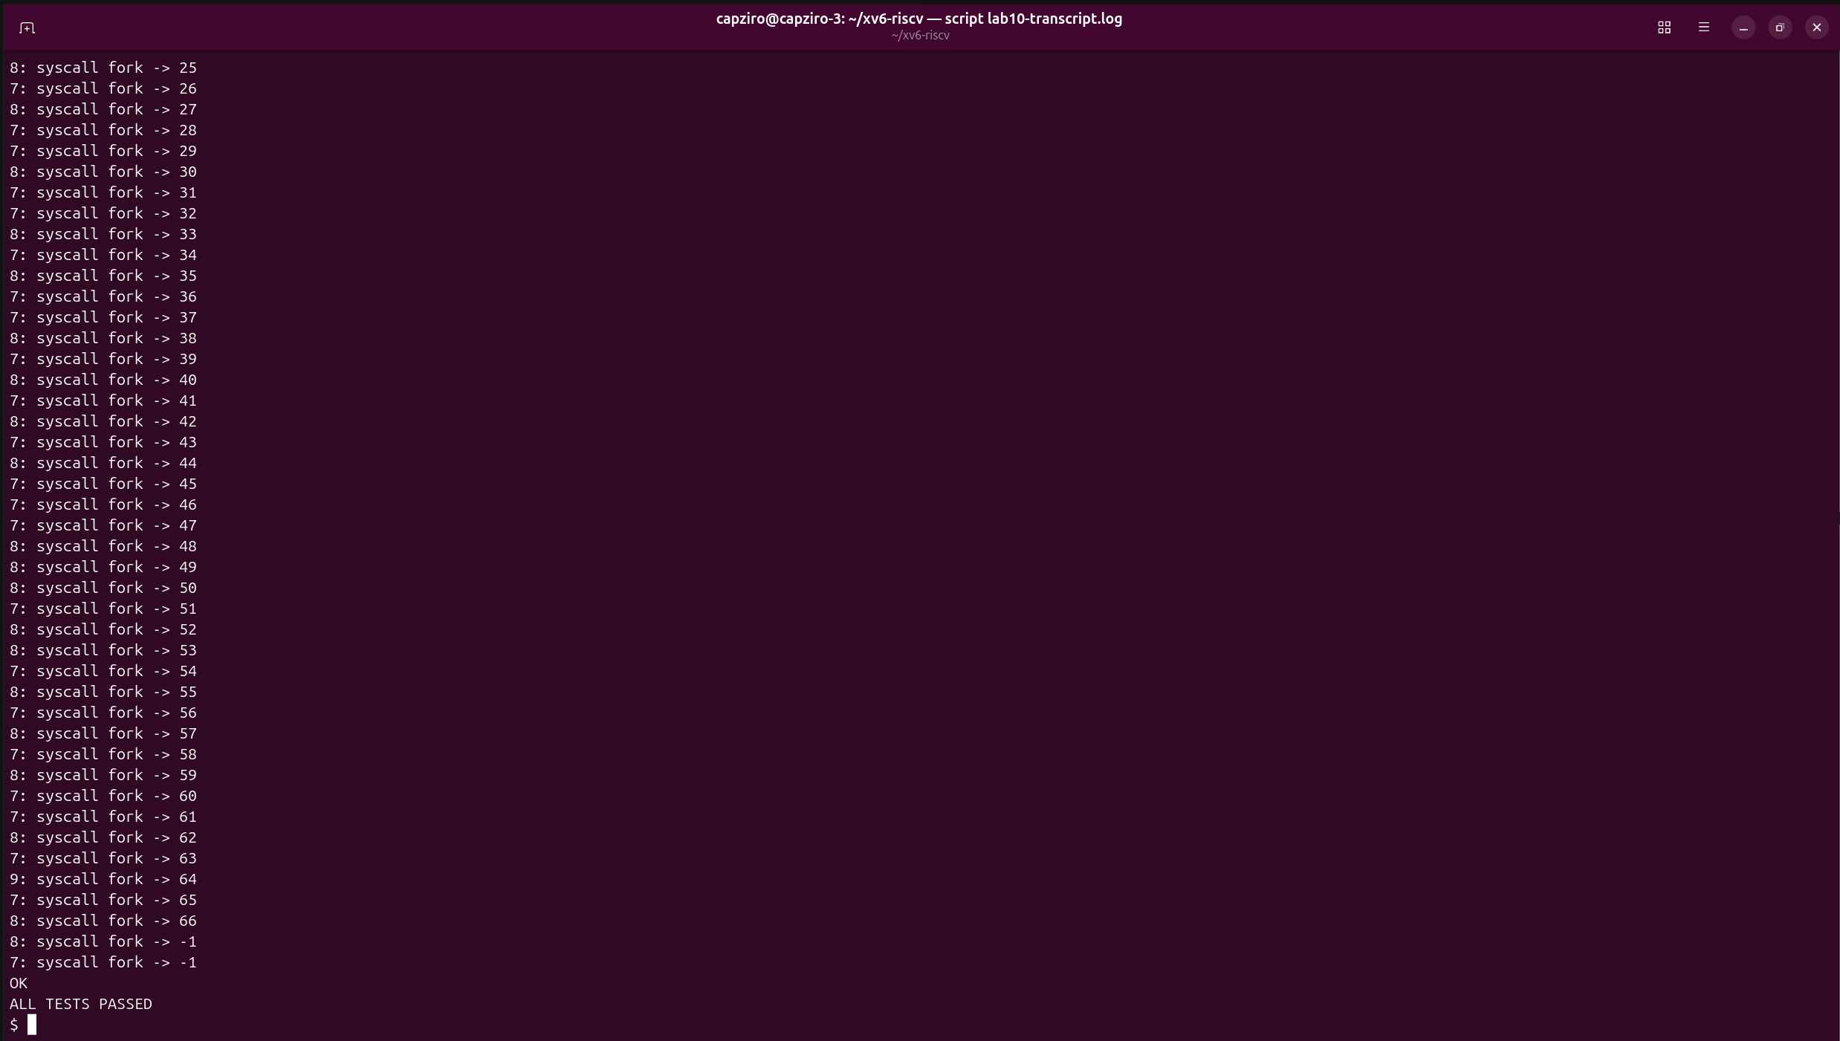
Figure 3.3 – The end of the test: 9: syscall fork -> 64, two forks that return -1, then OK and ALL TESTS PASSED
3.3 Only write (mask 65536)
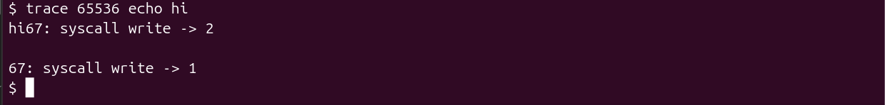
Figure 3.4 – trace 65536 echo hi: the trace line is printed between “hi” and the newline
Observe
1. In trace 32 grep hello README why do you see only read, and not open or close?
Because the mask 32 = 2⁵ has only bit 5 set, and 5 is SYS_read. grep does call open (15) and close (21), but after every call the kernel checks (p->trace_mask >> num) & 1, and for num = 15 and num = 21 that bit is 0, so the call runs normally and nothing is printed. With all the bits on (Figure 3.1) the same grep also shows open -> 3 and close -> 0, and the trace and exec calls before them.
2. In forkforkfork, three different pids print lines. Which line of code from Part 2 makes that possible?
The line np->trace_mask = p->trace_mask; added in fork() in kernel/proc.c (step 2.5). Only one process called trace(2): trace.c, which then became usertests with exec (pid 5 in my run). Every other process gets the mask from its parent when fork copies it, so the mask goes down to the children and grandchildren. In my run five pids printed lines: 5 (usertests, which forks the test process), 6 (the test process, which forks once), and 7, 8 and 9, the processes in the fork loop (Figures 3.2 and 3.3). Each line is printed by the parent, with the pid of the new child as the return value. Without this line the children would not get the mask and would print nothing, so only the first line, 5: syscall fork -> 6, would appear.
3. In trace 65536 echo hi the trace line is printed between “hi” and the new line. Why? (How many times does echo call write?)
echo calls write twice here: in user/echo.c it writes every argument with one call and the space or the final newline with another one, so echo hi does write(1, "hi", 2) and then write(1, "\n", 1); the return values 2 and 1 are the numbers of bytes written. The kernel prints the trace line inside syscall(), right after each write has finished. So the first write puts hi on the console, then the kernel prints 67: syscall write -> 2 (with its own newline at the end), then the second write prints the newline of echo, which appears as the empty line, and then the kernel prints 67: syscall write -> 1. echo and printk write to the same console, so their outputs are mixed in the order in which they happen.
4. Which mask traces both open (15) and close (21), and nothing else?
The mask with only bits 15 and 21 set: 2¹⁵ + 2²¹ = 32768 + 2097152 = 2129920 (0x208000 in hexadecimal). For example, trace 2129920 grep hello README should print only the open -> 3 and close -> 0 lines that are seen in Figure 3.1.
Conclusions
Adding trace showed the whole path of a system call in xv6, by following the number 23: the user stub puts the number in register a7 and runs ecall, the kernel function syscall() uses it as an index in the table of handlers, and the result goes back to the program in register a0. Check 1 showed that the number reached the kernel even before a handler existed, and after Part 2 the kernel printed every selected call with the pid, the name and the return value.
The mask is stored in struct proc, so it belongs to the process: exec keeps it, which is how trace.c can set it and then become grep or usertests, and fork copies it, which is why all the processes created by forkforkfork were traced. The experiments with the mask also made visible details that are normally hidden: grep reads README in three pieces, exec returns argc, open returns the first free file descriptor, and echo makes one write for every word and one for the newline. It is the same kind of information that strace gave on Linux in Lab 9, but this time it comes from a few small changes inside the kernel itself.
Submitted files: trace.c (the file user/trace.c), kernel-changes.patch with the Lab 10 changes to the kernel, the user library and the Makefile, the Makefile with $U/_trace in UPROGS, lab10-transcript.log, notes.txt and this report. In my working tree the Makefile also builds the programs of the earlier labs (they appear in the build output in the transcript); their code is in the folders of those labs, so the Makefile in this folder keeps only the Lab 10 line.

