
MINISTRY OF EDUCATION, CULTURE AND RESEARCH
OF THE REPUBLIC OF MOLDOVA
Technical University of Moldova
Faculty of Computers, Informatics and Microelectronics
Department of Software and Automation Engineering
Report
Laboratory work nr. 3
The Command Line: Shell, Pipes and Text Filters
Course: Operating Systems (Track A: Linux)
Done by:
st. gr. FAF-243, Oberst Eduard
Checked by:
Patricia Reitman, University Assistant
Department of Software and Automation Engineering,
FCIM Faculty, UTM
Purpose of the work
The purpose of this laboratory work is to learn to move fast in bash, to see what the shell does to a command line before the program runs (globbing, quoting, expansions), to redirect standard output and standard error, to chain commands with ;, && and ||, to control a background job, and to answer questions about a data file with one line of small filters joined by pipes. At the end the best one-liners are turned into a small script.
Preparation
All work was done on my Ubuntu laptop in bash, in the folder ~/OS-2026-OberstEduard/lab3. The session was recorded with script into lab3-transcript.log. The data set access.log was generated with the loop from the lab; it has 500 lines.
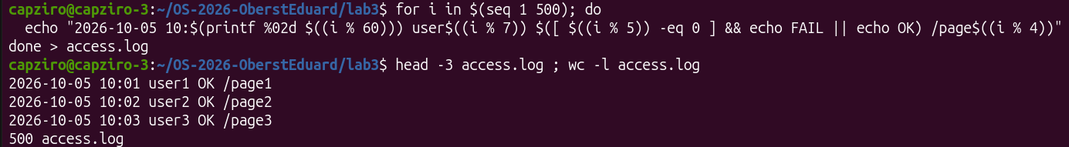
Figure 0.1 – Generating access.log
Part 1. Move fast, find help
ls /usr/sh + Tab Tab and cd /et + Tab were typed and each line was cancelled with Ctrl+C after the completion. There is only one name starting with /usr/sh, so the first Tab already completed it to /usr/share/ and the second Tab had nothing more to show; cd /et was completed to cd /etc/.
Figure 1.1 – Tab completion
Then three commands were run (date, whoami, pwd); Ctrl+R with the letters “dat” found date in the history and Enter ran it again (the second date shows a later time).
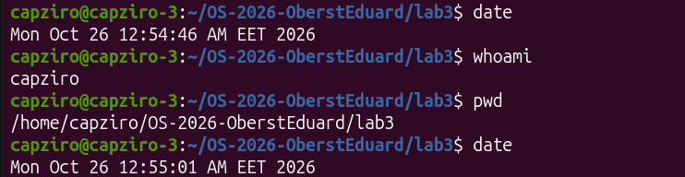
Figure 1.2 – Ctrl+R found and ran date again
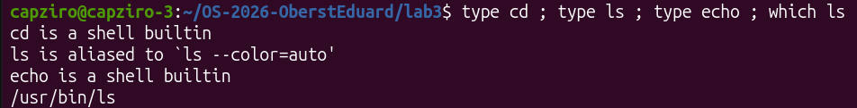
Figure 1.3 – Output of type and which
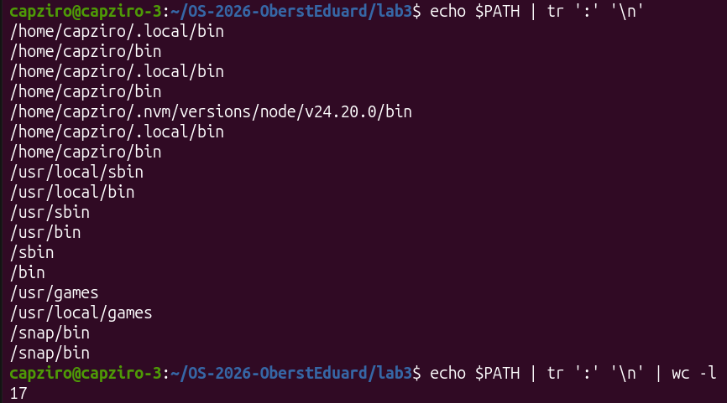
Figure 1.4 – The directories in PATH
Figure 1.5 – Exit code of a missing command
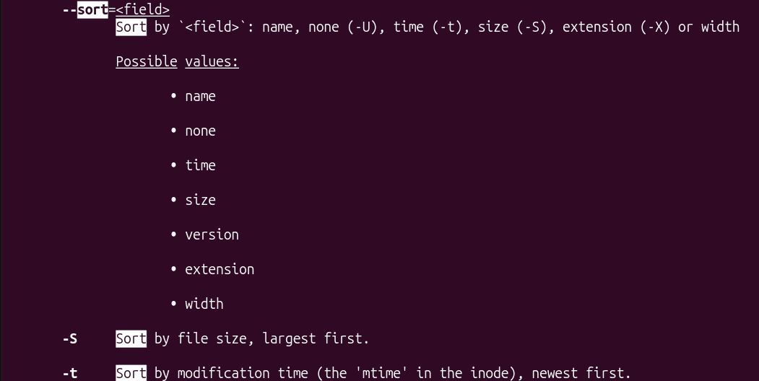
Figure 1.6 – man ls, searched with /sort
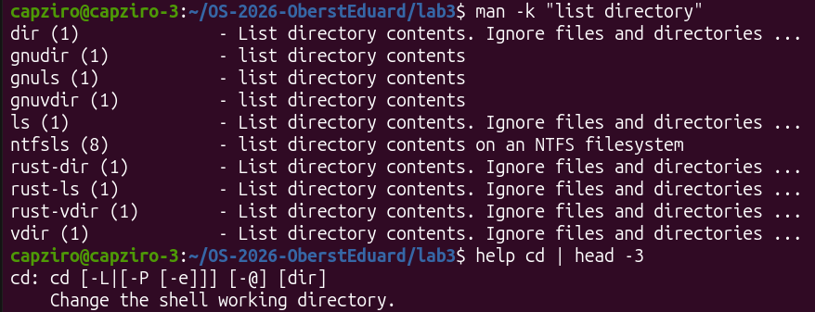
Figure 1.7 – Finding help without a browser: man -k and help
Observe
1. Which of cd, ls, echo are built-ins, and why MUST cd be one?
cd and echo are shell built-ins; ls is an external program, /usr/bin/ls (in my shell it is also an alias for ls --color=auto), see Figure 1.3. cd must be a built-in because the current directory belongs to each process. An external cd would run as a child process, change only its own directory and exit, and the shell would stay where it was.
2. How many directories are in your PATH, and in which one is ls?
PATH has 17 entries (Figure 1.4), but some are repeated (~/.local/bin and ~/bin three times, /snap/bin twice), so there are 12 different directories. ls is found in /usr/bin.
3. What exit code does a command that is not found return?
127 (nosuchprog: command not found, exit code: 127, Figure 1.5).
4. Which option of ls sorts by modification time?
-t – “Sort by modification time (the ‘mtime’ in the inode), newest first” (Figure 1.6).
Part 2. What the shell does to your line
A test directory play was created with the files a.c, b.c, file1.txt, file2.txt, notes.txt and alfa beta.txt. Before running the lines I wrote down my predictions; Table 2.1 compares them with the real output.
Figure 2.1 – Files created in the play directory
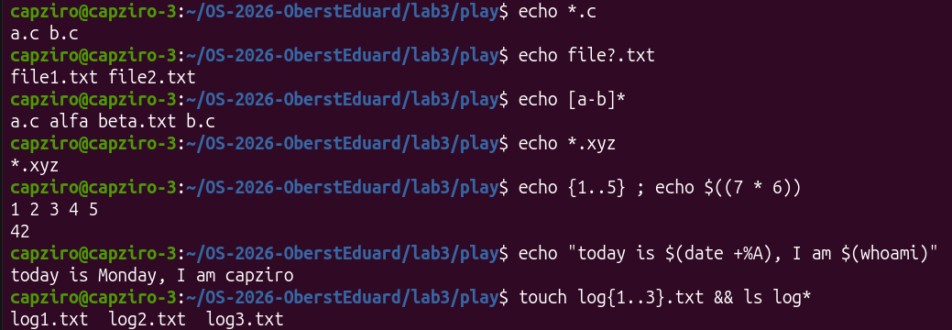
Figure 2.2 – Globbing and expansion results
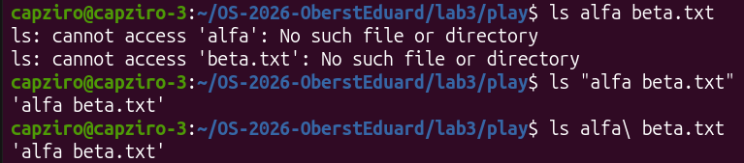
Figure 2.3 – The ls error on a name with a space, and two fixes
Figure 2.4 – Single quotes, double quotes and backslash
Table 2.1 – Predictions versus real output
Command | My prediction | Real output | Explanation
echo *.c | will show files | a.c b.c | Only the files ending in .c; bash replaced *.c with their names.
echo file?.txt | will also show files | file1.txt file2.txt | ? matches exactly one character, so notes.txt does not match.
echo [a-b]* | will show the file names in order a–b | a.c alfa beta.txt b.c | Right; [a-b]* means “first letter a or b”, so “alfa beta.txt” matches too.
echo *.xyz | will show .xyz files | *.xyz | No file matches, so bash leaves the word unchanged and echo prints it literally.
ls alfa beta.txt | will list something | two errors: cannot access 'alfa', 'beta.txt' | Word splitting gives ls two arguments, and neither file exists.
ls "alfa beta.txt" | will list something | 'alfa beta.txt' | The quotes keep the name as one argument, so ls finds the file.
echo '$HOME' "$HOME" \$HOME | will compare something | $HOME /home/capziro $HOME | Single quotes and the backslash stop the expansion; double quotes expand $HOME.
echo {1..5} ; echo $((7 * 6)) | will show some numbers | 1 2 3 4 5 and 42 | Brace expansion makes 1..5, $(( )) computes 7 × 6.
echo "today is $(date +%A), I am $(whoami)" | will show the day and the user | today is Monday, I am capziro | Right; $( ) runs the command and puts its output in the line.
touch log{1..3}.txt && ls log* | lists files | log1.txt log2.txt log3.txt | Right; the braces created three files and log* listed them.

Observe
1. For each line: your prediction, the real output, and one sentence if they differ.
See Table 2.1. My predictions were mostly general (“will show files”, “will list something”); the clearest mistakes were echo *.xyz, which printed the pattern itself and not .xyz files, and ls alfa beta.txt, which gave two errors.
2. echo knows nothing about files, yet echo *.c printed file names. Who produced them?
The shell. Before starting echo, bash does pathname expansion (globbing): it replaces *.c with the list of matching file names, so echo only receives the arguments a.c and b.c and prints them.
3. Why did ls alfa beta.txt fail? Give two different ways to fix it.
Bash splits the line into words at unquoted spaces, so ls got two arguments, alfa and beta.txt, and neither exists. Fixes (Figure 2.3): put the name in quotes, ls "alfa beta.txt", or escape the space with a backslash, ls alfa\ beta.txt.
4. What is the difference between single and double quotes?
Inside single quotes nothing is special: '$HOME' stays the text $HOME. Inside double quotes the text is still one word, but variables and $( ) are expanded, so "$HOME" became /home/capziro (Figure 2.4).
Note: ls shows the file as 'alfa beta.txt', in quotes, because the name contains a space. On a terminal ls uses this quoting style so that the name can be copied back into a command safely and is not mistaken for two files.
Part 3. Redirection, chaining and jobs
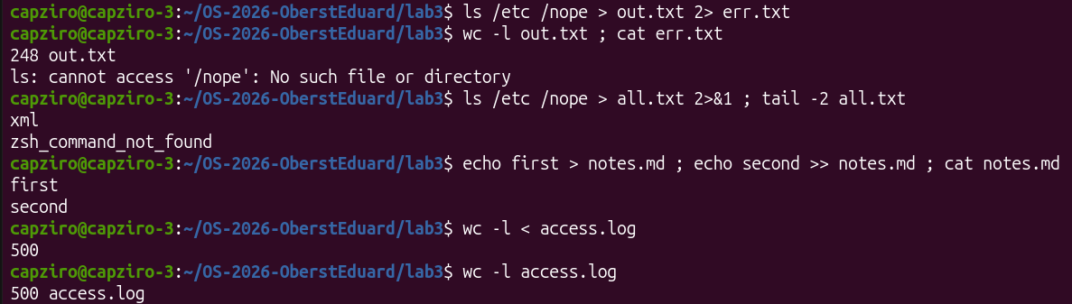
Figure 3.1 – stdout and stderr in separate files
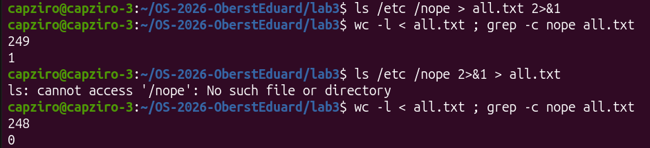
Figure 3.2 – Comparing the order of redirections
Figure 3.3 – The ; && || operators
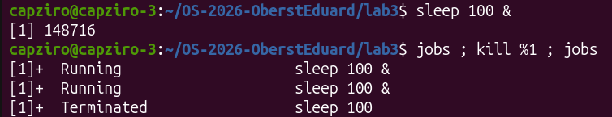
Figure 3.4 – Running a background job and stopping it
Observe
1. Which file got the error message, and which got the listing?
err.txt got the error message (ls: cannot access '/nope'), because 2> redirects standard error (descriptor 2). out.txt got the listing of /etc, 248 lines, because > redirects standard output (descriptor 1). Nothing appeared on the screen.
2. What is the difference between > all.txt 2>&1 and 2>&1 > all.txt?
Redirections are done from left to right, and 2>&1 means “send stderr where stdout goes right now”. With > all.txt 2>&1 stdout goes to the file first and then stderr follows it, so both are in the file: 249 lines, 1 line with “nope”. With 2>&1 > all.txt stderr is copied while stdout is still the terminal, and only then stdout moves to the file: the error appears on the screen and the file has 248 lines, 0 with “nope” (Figure 3.2).
3. Why does wc -l < access.log print only a number, while wc -l access.log also prints the file name?
With < the shell opens the file and connects it to the standard input of wc, so wc never sees a file name and prints only 500. With an argument, wc opens the file itself, knows its name and prints 500 access.log (Figure 3.1).
4. Explain each operator in one sentence: ; && ||
; runs the next command after the previous one, no matter how it ended. && runs the next command only if the previous one succeeded (exit code 0), as in mkdir -p tmp && cd tmp && echo .... || runs the next command only if the previous one failed, as in ls /nope 2> /dev/null || echo "failed with code $?", which printed failed with code 2 (Figure 3.3).
Jobs: sleep 100 & started in the background as job [1] (PID 148716); jobs showed it Running and kill %1 stopped it (Terminated), Figure 3.4.
Part 4. Answer questions with one-liners
Each line of access.log is: date, time, user, result (OK or FAIL), page. Every question is answered with one command line; all lines are saved in oneliners.sh with the question as a comment above (Figure 4.10). The figures below are taken from the full run of the file (Figure 4.9).
Figure 4.1 – Q1: number of failed requests

Figure 4.2 – Q2: number and names of the different pages

Figure 4.3 – Q3: requests per page
Figure 4.4 – Q4: users with the most failed requests
Figure 4.5 – Q5: requests and failures of user3

Figure 4.6 – Q6: the last 3 failed requests (time and user)

Figure 4.7 – Q7: login shells in /etc/passwd
Figure 4.8 – Q8: ls versus ls -l line count
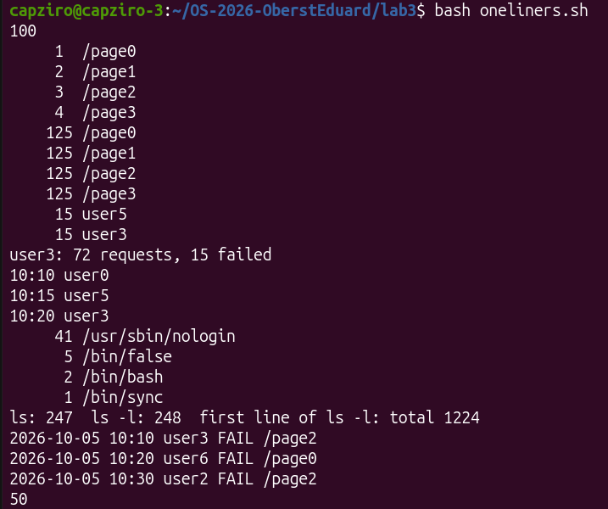
Figure 4.9 – Full run of oneliners.sh
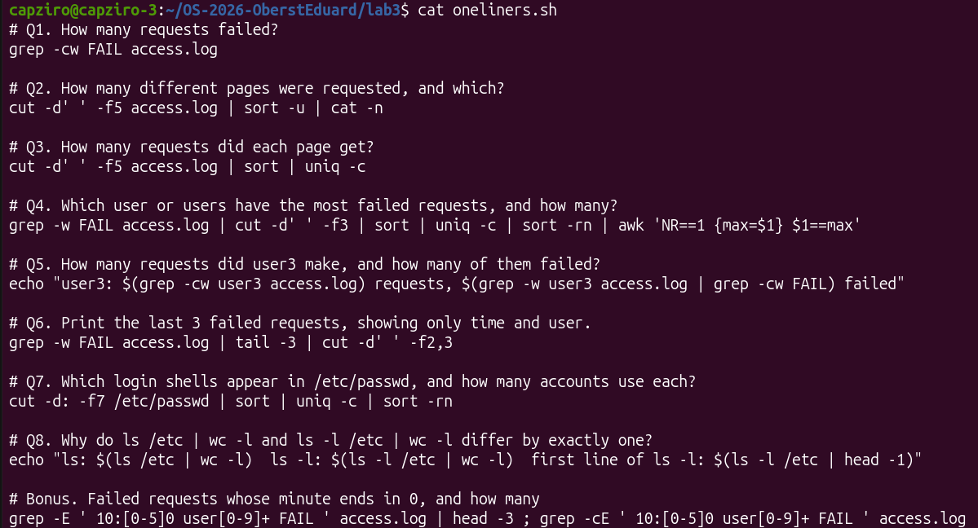
Figure 4.10 – Contents of oneliners.sh
Answers
1. Q1. How many requests failed?
100 requests failed (grep -cw FAIL counts the lines where FAIL is a whole word).
2. Q2. How many different pages were requested, and which?
4 pages: /page0, /page1, /page2, /page3 (sort -u keeps one copy of each, cat -n numbers them).
3. Q3. How many requests did each page get?
Each page got 125 requests; 4 × 125 = 500, the number of lines in the log, so the check is correct.
4. Q4. Which user or users have the most failed requests, and how many?
Two users are tied: user3 and user5, with 15 failed requests each; the others have 14. Because of the tie the last filter prints every line equal to the maximum instead of only the first one. Check: 15 + 15 + 5 × 14 = 100, the same as Q1.
5. Q5. How many requests did user3 make, and how many of them failed?
user3 made 72 requests, 15 of them failed.
6. Q6. Print the last 3 failed requests, showing only time and user.
10:10 user0, 10:15 user5, 10:20 user3.
7. Q7. Which login shells appear in /etc/passwd, and how many accounts use each?
/usr/sbin/nologin – 41 accounts, /bin/false – 5, /bin/bash – 2, /bin/sync – 1. Most accounts are system accounts that are not allowed to log in.
8. Q8. Why do ls /etc | wc -l and ls -l /etc | wc -l differ by exactly one?
ls /etc gives 247 lines and ls -l /etc gives 248. Both print one line per entry, but ls -l starts with one extra summary line, total 1224 (the disk blocks used by the listed files); that line is the difference.
Bonus

Figure 4.11 – Bonus: failed requests at a minute ending in 0
grep -E ' 10:[0-5]0 user[0-9]+ FAIL ' finds 50 such lines. A minute ending in 0 means that the line number is divisible by 10, so it is also divisible by 5, and every such line is a FAIL.
Part 5. Your first script
report.sh was created from the skeleton of the lab; the TODO was completed with a for loop over the users 0–6 that counts the FAIL lines of each user. The per-user numbers add up to 100, the same as the total.
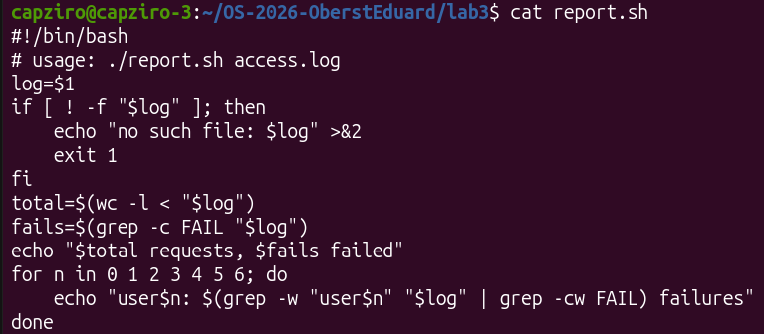
Figure 5.1 – Contents of report.sh
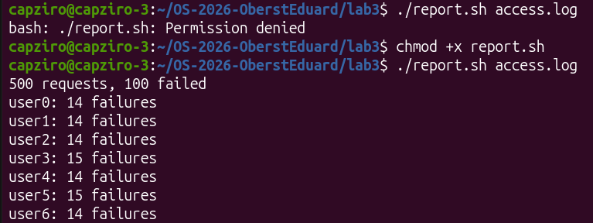
Figure 5.2 – Running the script on access.log (before and after chmod +x)
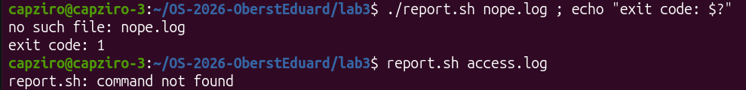
Figure 5.3 – Error handling for a missing file
Observe
1. What does the first line #!/bin/bash do, and what happens if you run ./report.sh before chmod +x?
#!/bin/bash (the shebang) tells the kernel which program must run the file: it starts /bin/bash with the script. Before chmod +x the file has no execute permission, so running it gives bash: ./report.sh: Permission denied (Figure 5.2).
2. Why must you type ./report.sh and not just report.sh?
For a name without a slash the shell looks only in the directories of PATH, and the current directory is not in PATH, so report.sh gives command not found (Figure 5.3). ./report.sh is an explicit path to the file in the current directory.
3. Why does the script write the error with >&2 and end with exit 1?
>&2 sends the message to standard error, so it does not mix with the normal output and is still seen when the output is redirected to a file or a pipe. exit 1 returns a non-zero exit code, so the caller ($?, &&, ||, other scripts) knows that the script failed – Figure 5.3 shows exit code: 1.
Conclusions
In this lab I saw that many things I thought were done by programs are done by the shell before the program even starts: globbing turns *.c into file names, braces and $(( )) make numbers, $( ) puts the output of a command into the line, and unquoted spaces split a name into several arguments. I also saw that standard output and standard error are two separate streams that can be sent to different files, that the order of > and 2>&1 matters, and that ;, && and || use the exit code to decide what runs next. Finally, small filters joined with pipes answered every question about the log in one line, and the best of them became a script with a shebang, execute permission, an error message on stderr and a meaningful exit code.
Submitted files: oneliners.sh, report.sh, access.log, lab3-transcript.log and this report.

