
MINISTRY OF EDUCATION, CULTURE AND RESEARCH
OF THE REPUBLIC OF MOLDOVA
Technical University of Moldova
Faculty of Computers, Informatics and Microelectronics
Department of Software and Automation Engineering
Report
Laboratory work nr. 4
The xv6 Shell from the Outside
Course: Operating Systems (Track B: xv6)
Done by:
st. gr. FAF-243, Oberst Eduard
Checked by:
Patricia Reitman, University Assistant
Department of Software and Automation Engineering,
FCIM Faculty, UTM
Purpose of the work
The purpose of this laboratory work is to understand what a command shell must do and what bash adds on top of it, by using the xv6 shell (user/sh.c, about 500 lines) side by side with bash; to find out with a small program that prints its argv who expands * and who removes the quotes; and, before that, to make the sleep program from Lab 2 build on the current xv6, where the system call sleep() was renamed to pause().
Preparation
The work was done on my Ubuntu laptop, in ~/xv6-riscv (commit 06aad25) for the xv6 parts and in ~/OS-2026-OberstEduard/lab4 for the bash parts. The whole session was recorded with script into lab4-transcript.log. QEMU is left with Ctrl-A followed by X.
Part 1. Fix sleep for the current xv6
user/user.h declares only pause, so the program has to call pause() instead of sleep(). user/sleep.c was written with the code from the lab; $U/_sleep\ (and $U/_args\ for Part 3) are in UPROGS in the Makefile.
Figure 1.1 – The grep result in user.h
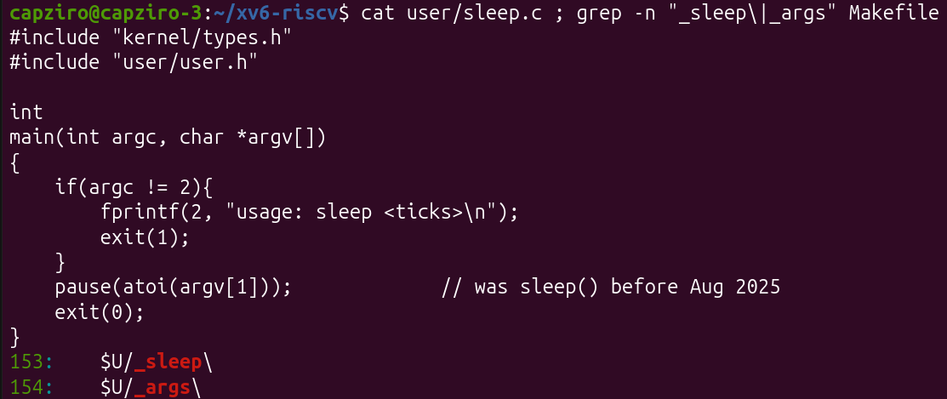
Figure 1.2 – The updated sleep.c and the UPROGS lines
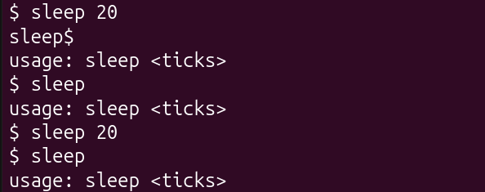
Figure 1.3 – sleep running in xv6, with and without an argument
In the first try I typed sleep while sleep 20 was still running, so the two outputs got mixed; the second try is clean: sleep 20 waits about two seconds and returns to the prompt without output, and sleep without an argument prints usage: sleep <ticks> and exits with status 1.
Part 2. bash versus the xv6 shell
Every command was run twice: in bash, in an empty test folder shtest that contains a file named README, and at the xv6 $ prompt.
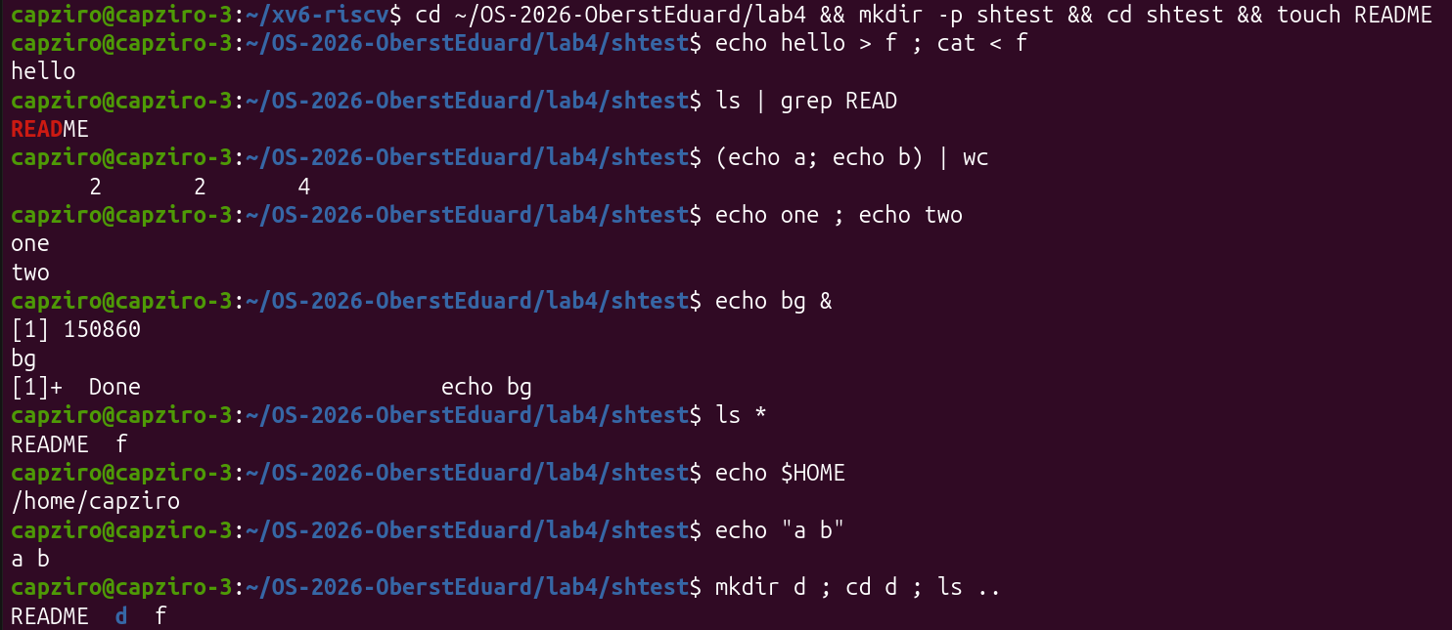
Figure 2.1 – The commands run in bash
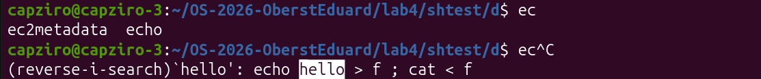
Figure 2.2 – bash: Tab Tab lists the completions, Ctrl+R finds a command in the history
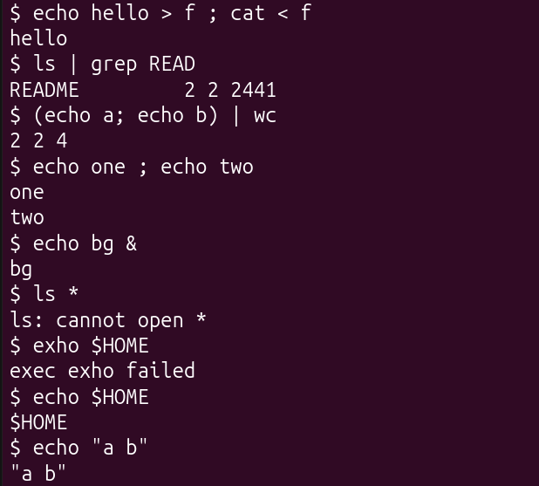
Figure 2.3 – The same commands run in xv6
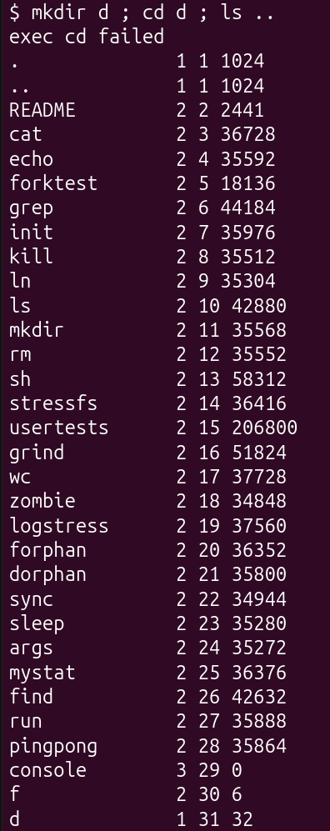
Figure 2.4 – xv6: mkdir d ; cd d ; ls ..
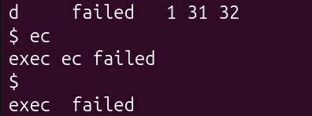
Figure 2.5 – xv6: arrow up, Tab and Ctrl+R
Table 2.1 – Comparison of bash and the xv6 shell
Command | Tests | bash | xv6
echo hello > f ; cat < f | redirection | hello | hello – the same, < and > work.
ls | grep READ | pipe | README | README 2 2 2441 – the pipe works; xv6 ls also prints type, inode and size.
(echo a; echo b) | wc | grouping, list | 2 2 4 | 2 2 4 – the same.
echo one ; echo two | sequence | one / two | one / two – the same.
echo bg & | background | [1] 150860, bg, [1]+ Done | bg – runs in the background, but no job number and no Done message.
ls * | globbing | README f | ls: cannot open * – no globbing, ls gets a literal *.
echo $HOME | variables | /home/capziro | $HOME – no variables, printed as it is.
echo "a b" | quotes | a b | "a b" – the quotes are not removed.
mkdir d ; cd d ; ls .. | PATH | README d f | exec cd failed, then the listing of / – cd is a built-in only at the start of a line.
arrow up, Tab, Ctrl+R | history, completion | previous command; ec2metadata echo; (reverse-i-search) finds the hello command | nothing – the keys go into the line: exec ec failed, exec failed.

After cd d on its own line, ls stops working in xv6; /ls .. still works:
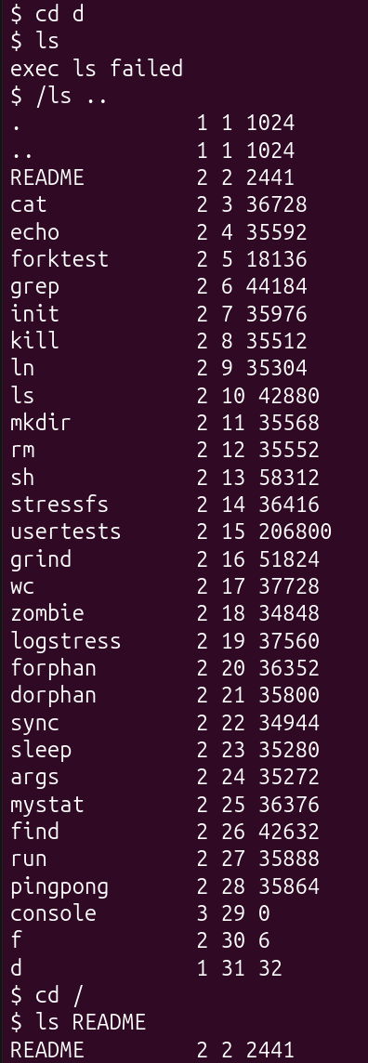
Figure 2.6 – ls failing after cd d, and the working alternative
Observe
1. List the features both shells have, and the ones only bash has.
Both shells can run a program with arguments, redirect input and output with <, > and >>, connect commands with pipes |, run a sequence with ;, group commands with ( ), run a command in the background with &, and both have a built-in cd. Only bash has globbing (*, ?, [ ]), variables, quote removal, searching programs in PATH, history (arrow up, Ctrl+R), Tab completion, job control (job numbers, jobs, kill %1), the operators && and ||, $( ) and a scripting language.
2. In xv6, ls stops working after cd d. Why? Find a way to run ls from inside d anyway.
The xv6 shell has no PATH: it calls exec with the name exactly as typed, so ls is looked up in the current directory. All xv6 programs are in the root directory / (mkfs copies them there from UPROGS). After cd d, ls means d/ls, which does not exist, so the shell prints exec ls failed. The fix is an absolute path: /ls .. works from inside d (Figure 2.6), or cd / to go back. In mkdir d ; cd d ; ls .. there is another detail: cd is not at the start of the line, so the shell does not treat it as a built-in and prints exec cd failed.
3. Which missing feature would you miss most in daily work, and which would be easiest to add?
I would miss history and Tab completion most, because without them every command and file name has to be typed in full. The easiest to add is a PATH fallback: if exec(argv[0]) fails and the name does not start with /, the shell can try again with "/" + argv[0] – a few lines in runcmd(), and ls would work from any directory.
Part 3. Who expands *? A program that prints its argv
user/args.c prints argc and every argv[i] in brackets; its UPROGS line $U/_args\ is visible in Figure 1.2. The same program for Linux, args_linux.c, uses <stdio.h> and return 0, and was compiled with gcc -o args args_linux.c and run in the lab4 folder, which contains three .c files.
#include "kernel/types.h"
#include "user/user.h"

int
main(int argc, char *argv[])
{
printf("argc = %d\n", argc);
for(int i = 0; i < argc; i++)
printf("argv[%d] = [%s]\n", i, argv[i]);
exit(0);
}
Figure 3.1 – Contents of user/args.c
#include <stdio.h>

int
main(int argc, char *argv[])
{
printf("argc = %d\n", argc);
for(int i = 0; i < argc; i++)
printf("argv[%d] = [%s]\n", i, argv[i]);
return 0;
}
Figure 3.2 – Contents of args_linux.c
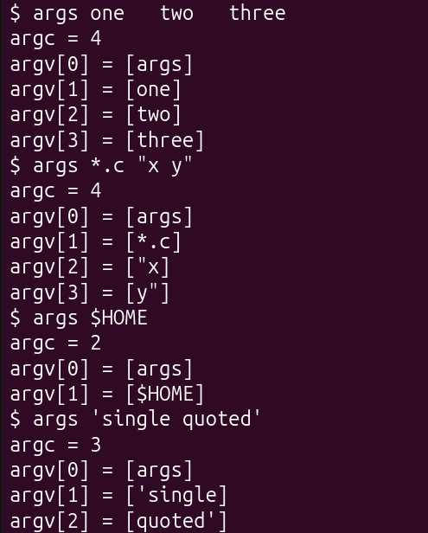
Figure 3.3 – args output in xv6
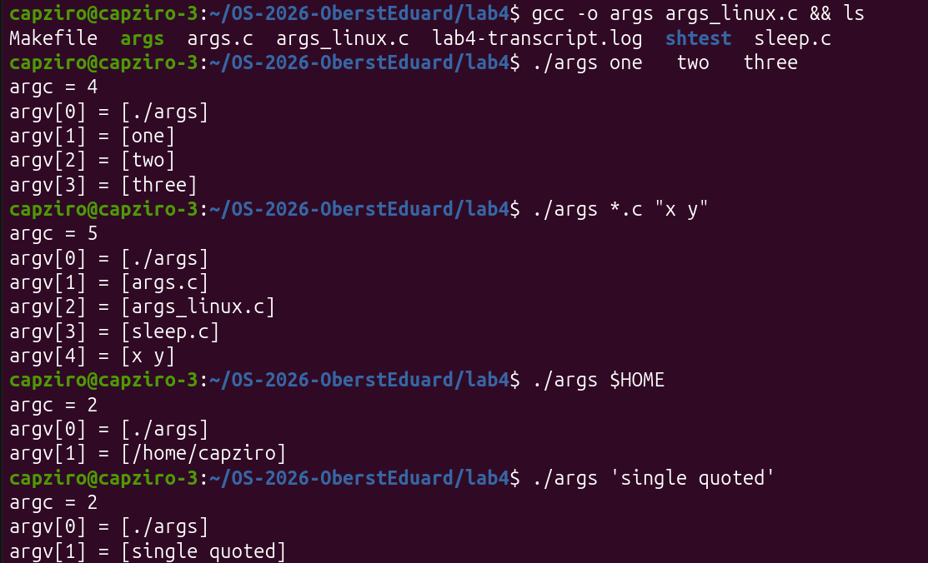
Figure 3.4 – args_linux output in bash
Observe
1. Paste both outputs for args *.c "x y". How many arguments did each program receive?
xv6 (Figure 3.3): argc = 4 – [args] [*.c] ["x] [y"]; the pattern stayed *.c and the quoted text was split at the space with the quote characters still inside. bash (Figure 3.4): argc = 5 – [./args] [args.c] [args_linux.c] [sleep.c] [x y]; *.c became the three file names and "x y" became one argument without quotes.
2. So who turns *.c into file names and removes the quotes: the program, the kernel, or the shell?
The shell. The program is the same in both systems and only prints what it receives, and exec passes the argv array unchanged. Bash does globbing, variable expansion and quote removal before calling exec; the xv6 shell only splits the line at spaces.
3. What happened to the extra spaces in one two three?
They disappeared in both shells. Spaces only separate the words and are not part of any argument, so the program received exactly one, two and three.
Part 4. Read the shell
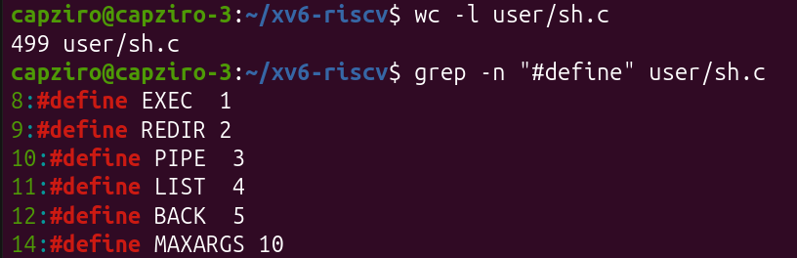
Figure 4.1 – The command kinds defined in sh.c
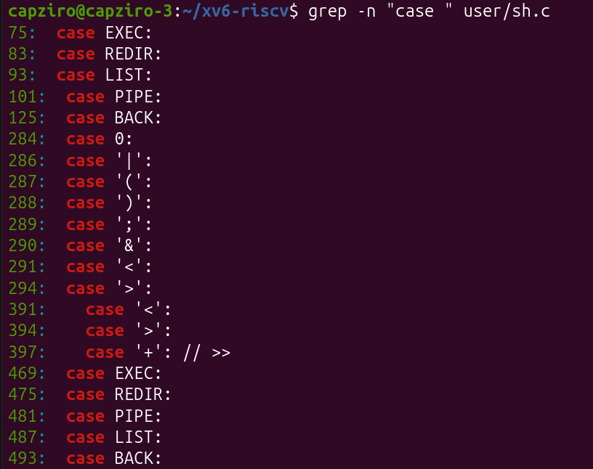
Figure 4.2 – Where each kind is run
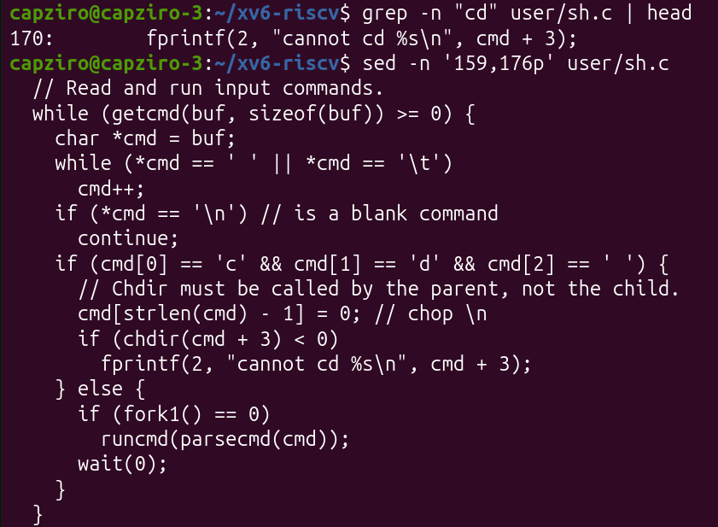
Figure 4.3 – The code that handles cd
Figure 4.4 – The only special characters of the tokenizer; no code for globbing, variables or PATH
sh.c has 499 lines. Lines 75–125 are the switch in runcmd(), which runs each kind of command; lines 284–294 are in gettoken(), which recognises the special characters; lines 391–397 parse redirections, and lines 469–493 are in nulterminate().
Observe
1. Name the five kinds of command the xv6 shell knows and the character that produces each.
EXEC (1) – a plain command with its arguments, no special character; REDIR (2) – redirection, produced by <, > or >>; PIPE (3) – produced by |; LIST (4) – a sequence, produced by ;; BACK (5) – background, produced by &. Parentheses ( ) only group commands and are not a sixth kind.
2. Where is cd handled, and why is it not run as a separate program?
In main() of user/sh.c, lines 166–170 (Figure 4.3): if the line starts with cd , the shell itself calls chdir(cmd + 3) and does not fork; every other command is run in a child made by fork1(). The current directory belongs to each process, so a cd program in a child would change only the child’s directory, which is lost when the child exits – as the comment says, “Chdir must be called by the parent, not the child”.
3. Search sh.c for any code that handles * or $. What does that explain about Part 2?
There is none. The tokenizer knows only the whitespace characters and the symbols <|>&;() (lines 268–269), and grep -c "glob\|getenv\|PATH" finds 0 lines (Figure 4.4). A word is passed to exec exactly as typed. This explains Part 2: ls * gave ls: cannot open *, echo $HOME printed $HOME, echo "a b" kept the quotes, and ls could not be found after cd d.
Conclusions
In this lab I compared the xv6 shell with bash. First I made sleep work on the current xv6 by calling pause(). Running the same commands in both shells showed that the core of a shell is small – splitting the line into words, fork + exec, redirection, pipes, ;, ( ), & and a built-in cd – and the xv6 shell does all of it in about 500 lines. Everything that makes bash comfortable (globbing, variables, quote removal, PATH, history, completion, job control) is added on top. The args program showed that the program and the kernel pass the arguments through unchanged, and that it is the shell that expands *.c and removes the quotes; reading sh.c confirmed it, because it has no code at all for * or $.
Submitted files: sleep.c, args.c, args_linux.c, the Makefile with the UPROGS lines, lab4-transcript.log and this report.

