
MINISTRY OF EDUCATION, CULTURE AND RESEARCH
OF THE REPUBLIC OF MOLDOVA
Technical University of Moldova
Faculty of Computers, Informatics and Microelectronics
Department of Software and Automation Engineering
Report
Laboratory work nr. 8
The Same Calls, Inside Your Own OS
Course: Operating Systems (Track B: xv6)
Done by:
st. gr. FAF-243, Oberst Eduard
Checked by:
Patricia Reitman, University Assistant
Department of Software and Automation Engineering,
FCIM Faculty, UTM
Purpose of the work
The purpose of this laboratory work is to run inside xv6 the same fork + exec + wait program that was run on Linux in Lab 7, and to see that the system calls are the same; and then to make two processes talk to each other through two pipes in pingpong.
Preparation
All work was done in my ~/xv6-riscv tree (commit 06aad25) on my Ubuntu laptop, with the riscv64-linux-gnu cross compiler and QEMU. The terminal session was recorded with script into lab8-transcript.log. Every new program is a file user/NAME.c plus a line $U/_NAME\ in UPROGS in the Makefile. The optional primes program was not done, so its line was removed from UPROGS.
Figure 0.1 – The UPROGS lines for run and pingpong
Part 1. run, inside xv6
user/run.c was created with the code from the lab. The parent prints its pid, fork creates a child, the child prints its pid and becomes echo with exec, and the parent waits for it with wait.
#include "kernel/types.h"
#include "user/user.h"

// the three steps of the shell, inside xv6: echo hello from the child
int
main(int argc, char *argv[])
{
printf("parent: my pid is %d\n", getpid());

int pid = fork(); // step 1: copy myself
if(pid < 0){
printf("fork failed\n");
exit(1);
}

if(pid == 0){ // only the child runs this
printf("child: my pid is %d\n", getpid());
char *args[] = { "echo", "hello", "from", "the", "child", 0 };
exec("echo", args); // step 2: become echo
printf("exec failed\n"); // runs only if exec failed
exit(1);
}

int status;
wait(&status); // step 3: wait for the child
printf("parent: child %d ended with status %d\n", pid, status);
exit(0);
}
Figure 1.1 – Contents of user/run.c
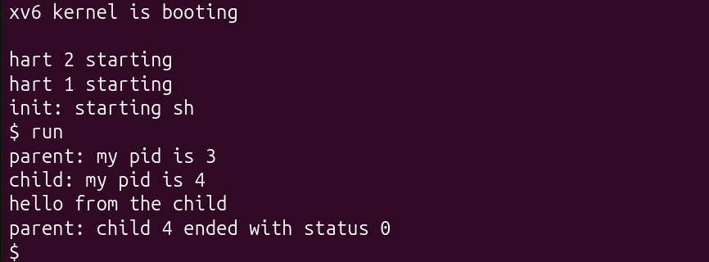
Figure 1.2 – Step 1.2: the child becomes echo
For step 1.3 the two lines with args and exec were changed so that the child runs ls, and for step 1.4 the exec line was changed to exec("nosuchprog", args). After that the echo version was put back (Figure 2.2 shows it running again).
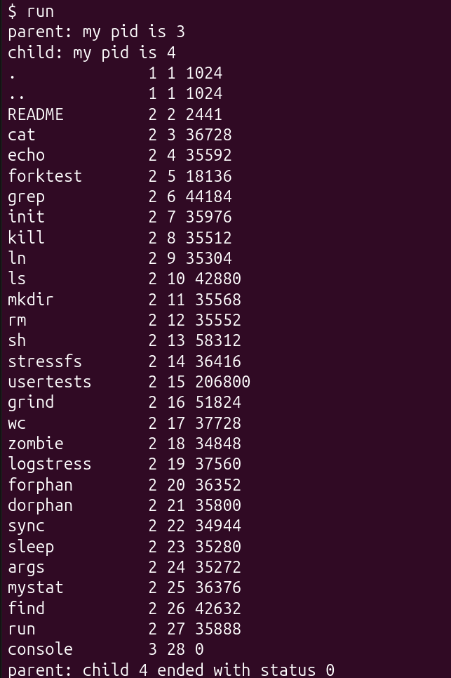
Figure 1.3 – Step 1.3: the child becomes ls
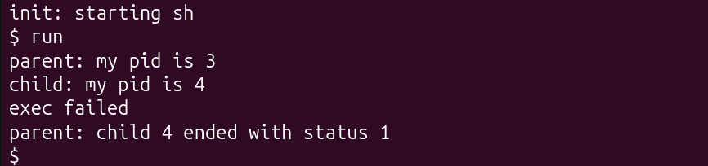
Figure 1.4 – Step 1.4: exec of a program that does not exist
Observe
1. Write the three calls that run.c uses in xv6 and the three calls run.c used on Linux in Lab 7. What is the same?
In xv6: fork(), exec("echo", args) and wait(&status). On Linux in Lab 7: fork(), execlp("ls", "ls", "-l", NULL) and waitpid(pid, &status, 0). The same three steps are done in the same order, and they behave the same way: fork returns twice (here the parent is pid 3 and the child pid 4), exec replaces the program of the child and comes back only if it fails, and wait blocks until the child ends and gives its exit status. Only the details differ: the xv6 exec gets the arguments as an array and does not search a PATH, and the xv6 wait waits for any child.
2. Who prints “hello from the child”: the code of run, or echo?
echo prints it. run.c only gives the words “hello”, “from”, “the”, “child” to exec as arguments; after exec the child process is the echo program, and echo prints its arguments. In step 1.3 the same child printed the ls listing instead (Figure 1.3).
3. Why is the status 1 here and 127 on Linux?
Because this number comes from our own code, not from the system. When exec fails, the child continues with the next lines: in xv6 run.c that is exit(1), so the parent prints status 1 (Figure 1.4); in the Linux run.c of Lab 7 it was exit(127), so the parent printed 127.
Part 2. pingpong
user/pingpong.c was made from the skeleton of the lab. The parent sends one byte to the child through the pipe p2c; the child prints “received ping” and sends the byte back through the pipe c2p; the parent prints “received pong” and waits for the child.
#include "kernel/types.h"
#include "user/user.h"

int
main(int argc, char *argv[])
{
int p2c[2], c2p[2]; // parent-to-child, child-to-parent
char b;

pipe(p2c);
pipe(c2p);
if(fork() == 0){
close(p2c[1]); close(c2p[0]); // the ends the child does not use
read(p2c[0], &b, 1);
printf("%d: received ping\n", getpid());
write(c2p[1], &b, 1);
exit(0);
}
close(p2c[0]); close(c2p[1]); // the ends the parent does not use
write(p2c[1], &b, 1);
read(c2p[0], &b, 1);
printf("%d: received pong\n", getpid());
wait(0);
exit(0);
}
Figure 2.1 – Contents of user/pingpong.c
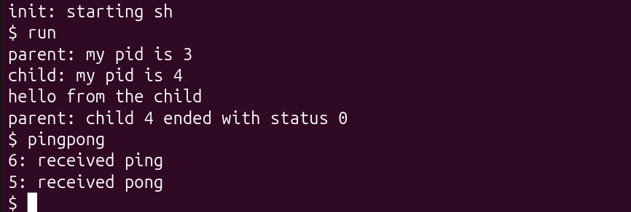
Figure 2.2 – run (echo version again) and pingpong in xv6
Observe
1. Why do you need TWO pipes, and not one for both directions?
A pipe carries data only in one direction, from its write end to its read end. If both processes used the same pipe for the ping and for the pong, the parent could read back its own byte right after writing it, and the child would never get it. With two pipes, p2c goes only from the parent to the child and c2p only from the child to the parent, and each process closes the two ends it does not use.
2. Nothing in your code says “wait until the child has replied”. Which call makes the parent wait?
read(c2p[0], &b, 1) in the parent. A read on an empty pipe blocks until a byte arrives, so the parent stops on that line until the child writes the byte back, and only then prints “received pong”. That is why 6: received ping (the child) comes before 5: received pong (the parent) in Figure 2.2. It is not wait(0), because wait is called only after the pong is printed.
Conclusions
The run program behaved in xv6 exactly like in Linux: fork made a child, exec turned it into echo or ls and came back only when the program did not exist, and wait gave the parent the exit status that the child chose. So these system calls are not something added by Linux or glibc, they are the basic interface of the operating system. In pingpong the two processes were synchronised only by blocking read calls on two pipes, one for each direction, which is the same idea that made wc wait in Lab 7.
Submitted files: user/run.c, user/pingpong.c, the Makefile with the UPROGS lines, lab8-transcript.log, notes.md and this report. The folder also contains sleep.c, args.c, mystat.c and find.c from Labs 4 and 6, because the same Makefile builds them.

