**3) Research plan**

Please make sure your file for submission satisfying followings:

(1) The number of pages for “Research plan” should be up to 4 in A4 size. (2) Use 12pt font. (3) The file size should not exceed 3MB. (4) Convert the file to PDF. (5) Remove security settings or password. (6) Do not delete instructions/examples.

**i) Background of your research project for the proposed experiment (not required in the case of the proprietary use)**

[1] While referring to previous studies related to your research project, please describe a research trend (hot topics etc.) in the research field and a place of your research project. Please also describe the present status and unsolved problems of your research project.

[2] Please give a clear statement to justify why your research project should be performed in the context of the following review criteria: scientific or industrial significance as well as its social or educational merits.

[1] Research trend and a place, present status and unsolved problems of your research project

Hydrogels, which can maintain a large amount of water in the cross-linked polymer networks, have attracted great interest for use in biomedical, engineering, environmental, and energy fields due to its high-water absorptivity and biocompatibility. Although numerous kinds of hydrogels have been developed so far, there is still a strong demand for a new class of hydrogels that are non-toxic, eco-friendly and easy to prepare with the desired properties. Most traditional synthetic hydrogels are weak and fragile~~, unlike biological tissues, which are naturally occurring hydrogels~~. Synthetic hydrogels are mainly fabricated by cross-linking of polymers using chemical~~ly~~ or physical~~ly~~ methods. In recent years, several strategies have been developed through incorporation of strong sacrificial covalent bonds that allow for significant increase of both strength and deformability of hydrogels, including double-network, nanocomposite, and polyampholyte hydrogels. However, the preparation of these hydrogels requires complicated chemical synthetic procedure and toxic reagents to form covalent bonds.

Most recently, we developed a new type cellulose nanofiber (CNF)-based hydrogel with high breaking strength (>1 MPa) and high compression recoverability by a novel gelation method utilizing the freeze concentrating phenomenon (**Fig. 1**). This new crosslinking method and the hydrogel materials are patent pending. CNFs are water dispersible fiber materials composed of dozens of hydrogen-bonded cellulose molecular chains with a diameter of approximately 10 nm and a width of 0.5~2 μm. The water dispersibility of CNF contributes significantly to the effective utilization of cellulose, which is the most abundant natural polymer that can be extracted from wood. In addition, CNFs are non-toxic, and have properties such as high flexibility and large surface area, and thus have high potential as raw materials for medical and environmental applications.

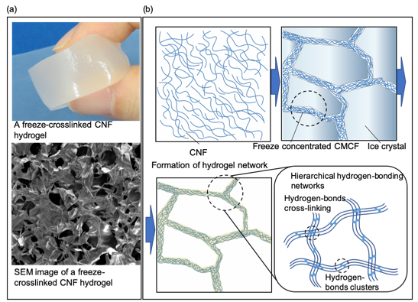

Fig.1 (a) Photo image and SEM image of a freeze cross-linked CNF hydrogel. (b) Schematic illustration of freeze cross-linking.

①微結晶成長時に氷から**析出**したセルロースが微結晶界面に**凝集**する。

②ｘｘ °C では氷が微結晶化する一方で、セルロース凝集体は凝固しない。そこに架橋剤となるCA溶液を流し込みセルロース同士を**架橋することでバンドルして弾性を持つファイバー**にする。

③温めて氷の微結晶を取り除いで出来上がり。

We first found that freeze-concentrated CNF and citric acid (CA) crosslink to provide a rigid porous structure that reflects the ice crystalline structure (**Fig. 1(a)**). A free-standing hydrogel was obtained by simply adding an aqueous solution of CA to a frozen CNF sol, and melting it. ~~A complex of CNF sol and CA provided hydrogels even without the freezing process, however the obtained hydrogel had no porous structure and its mechanical strength was much weaker than that of frozen one.~~ A plausible gelation mechanism of the freeze-crosslinked hydrogels is as below. A freeze concentrated CNF is formed around ice during ice crystallization and its freezing point must be lower than that of ice. Therefore, when an aqueous solution of CA is added to the frozen CNF sol, reaction between concentrated CNF and CA can be proceeded before melting the ice crystals. The CNF contains carboxyl groups. Because the carboxyl groups have a pKa of 3–4, most of carboxy groups of the CNF and CA are in nonionized form during the hydrogel preparation. They can easily form hydrogen-bonds each other. The aligned hydrogen-bonding formed by freeze concentration may contribute to the high mechanical strength of the resulting hydrogel. However, the detailed cross-linking structure is still unclear.

[2] Scientific or industrial significance as well as its social or educational merits

To the best our knowledge, this is the first time a physically cross-linked hydrogel with high breaking strength and high compression recoverability has been developed. The physically cross-linked CNF hydrogels developed here that are non-toxic, non-metal, high-performance, and simple to prepare have a high potential as useful sustainable materials in various fields such as biomedical, environmental, energy, etc. The freeze-crosslinking method may play an important role in providing a new type hierarchical hydrogen-bonding structure that can contribute to the improvement of mechanical strength. Biological tissues exhibit excellent physical properties due to the hierarchical cross-linked structure built by low- and high- density hydrogen-bonding provided by multi region of biomacromolecules. The mechanical properties of the freeze crosslinked hydrogels were quite similar to those of biological tissues. Because CNFs include high density hydroxyl groups, they can act as a reactive hydrogen-bonding cluster when it is aligned by external force (**Fig. 1(b)**). The aligned hydroxyl groups due to freeze concentration may contribute to build hierarchical hydrogen-bonding structure. Thus, investigating the hydrogen-bonding structure of the CNF hydrogels is an important research subject for both designing high mechanical strength hydrogels and elucidation of life phenomena.

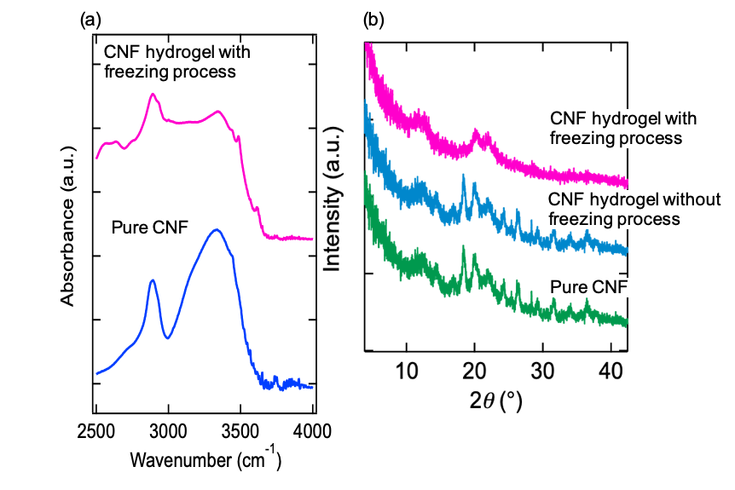

Fig.2 (a) IR spectra of pure CNF and a freeze cross-linked CNF hydrogel. (b) XRD profiles of pure CNF and the CNF hydrogel with and without freezing process.

**ii) Purpose(s) of this proposed experiment**

[1] Please give a specific goal(s) of this experiment in your research project.

(While referring to a data set(s) obtained by previous works and your preliminary experiments, please state clearly what you intend to clarify using a neutron/muon instrument in MLF. If this is one of series of experiments conducted in multiple proposal rounds, please state clearly a difference from the previous experiments at MLF.)

[2] Please state the justification for using the particular neutron/muon instrument of MLF clearly.

[3] Please indicate if you have applied for the long-term proposal. In addition, please indicate if you are applying for another beamline of MLF related to this proposal. If so, please clearly describe the difference.

[1] Specific goal(s) of this experiment

The aim of this proposing project is to investigate the microscopic structures of the CNF hydrogels by using a contrast-variation neutron diffraction via proton spin polarization (DNP). We previously measured IR spectra and XRD patterns of the freeze cross-linked CNF hydrogels. Fig. 2 (a) shows IR spectra of pure CNF and the freeze cross-linked CNF hydrogel in the O-H stretching region. A peak at 3162 cm-1 appeared for the hydrogel although there is no peak at the position for pure CNF. This suggests hydrogen-bonds with relatively strong bond strength formed in the hydrogel. Fig. 2 (b) shows XRD profiles of pure CNF and the CNF hydrogels prepared with or without freezing process. All profiles have several peaks in the 2 range of 5 to 40o. These peaks are due to aligned structure of the CNFs. The profiles of pure CNF and the CNF hydrogels prepared without the freezing process were consistent, but the profile of the freeze-crosslinked CNF hydrogels was different. The result showed the freezing process induced an arrangement of microscopic structure of the CNF hydrogel. These data sets obtained by previous work indicated that an aligned structure via hydrogen-bonding is a key factor governing the high mechanical properties of the hydrogel. However, it is quite difficult to investigate the state of hydrogen-bonding using conventional analytical instruments.

In this study, we determine the hydrogen-bonding structures of the pure, crosslinked, and freeze-crosslinked CNFs using spin-contrast-variation wide-angle neutron scattering (SCV-WANS), which has been developed very recently (2019P0202). SCV-WANS distinguishes diffractions of hydrogen from those of the other nuclei. Scattering power of polarized neutron against proton specifically varies as a function of its polarization (*P*H), whereas scattering power against other nuclei does not. Thus, we can extract the scattering of hydrogens from the difference in the scatterings between positively- and negatively-polarized samples (Fig. 3). The SCV-WANS measurements of the CNF hydrogels will reveal the structure of hydrogen-bonding, which is the key factor governing the excellent mechanical properties of the freeze-crosslinked CNF.



Fig. 3 SCV-WANS of glutamic acid (2019P0202 at BL15). Bars are calculated intensities at *P*H = +15% (Blue), 0 (Black), and -15% (Magenta). Diffractions from hydrogen atoms are extracted from the difference of the data measured at different *P*Hs.

[2] Justification for using the particular instrument of MLF

TAIKAN is the only spectrometer that has a potential to execute our proposing DNP-WANS experiments. *****

[3] Relation of other proposal(s) to this proposal

**iii) Experimental and data analysis methods**

[1] Please describe the details of your experimental method (e.g., measurement condition(s), number of measurements, space group(s) and lattice constant(s) of crystalline sample(s), etc.) to achieve the goals above.

[2] Please describe the way to analyze the data. (Include data analysis protocol. Please describe expected results of this experiment (e.g., change in a lattice parameter, excited energy, film’s thickness, element distribution, etc.) and also how these results would be useful to achieve your research goals.)

* If you plan to perform an experiment with special technique such as isotope labeling, please describe how the experiment and data analysis are conducted in detail.

* Please describe expected difficulties, if any, in conducting this experiment such as a difficulty in sample preparation, in setting up a sample environment, in data analysis, in having high resolution, in reducing background level, etc.)

[3] If you have consulted with technical staff of MLF about this proposal, please write their names.

[1] Details of experimental method

The pure, crosslinked, and frozen-crosslinked CNF hydrogel samples are swollen with d-glycerol/D2O containing 1 wt.% stable free radical, 2,2,6,6-tetramethylpiperidine 1-oxyl (TEMPO), which act as a source of proton polarization. Protons in the CNF samples are polarized using our dynamic nuclear polarization (DNP) apparatus, which is rotated by 19° from the neutron beam path in BL15 in order to cover the scatterings from wide-range of Q using the middle-angle and backward detectors. In addition, nanostructural information such as diameter and persistent length of the bundled fiber is obtained from the small-angle scattering. Each sample is measured at positively- negatively-polarized and unpolarized states.

[2] Way to analyze the data

In the diffraction study in Fig. 3, the structure factors between hydrogen atoms |*F*H(*Q*)|2, that between hydrogen and the other atoms Re[*F*H(*Q*)*F*notH(*Q*)], and that between the other atoms |*F*notH(*Q*)|2 are determined from the differentiation {*I*(*Q*, +*P*H) – *I*(*Q*, -*P*H)}/*P*H and secondary differentiation [*I*(*Q*, +*P*H) – *I*(*Q*, 0)} - *I*(*Q*, 0) – *I*(Q, -*P*H)}]/*P*H2 of the scattering intensities *I*(*Q*, *P*H). In this way, we expect that the WANS peaks of the CNF samples can be attributed from the *P*H-dependence of each peak intensity.

The difficulty of this measurement is to obtain clear *P*H-dependent data, because the analysis of the differentiated and secondary differentiated data are essential to distinguish the |*F*H(*Q*)|2, Re[*F*H(*Q*)*F*notH(*Q*)], and |*F*notH(*Q*)|2.

[3] Name of MLF technical staff whom you consulted about this proposal

**iv) Beamtime request and justification**

Examples:

A: 1 (hour/sample/temperature) x 12 (samples) x 5 (temperatures) + 6 (hours, time for changing temperature) + 6 (hours, time for measuring background and changing a sample, etc.) = 72 hours

B: For time-slicing measurement, 3 (hour/sample/temperature) x 2 (samples) x 5 (temperatures) = 30 hours are required. After that, 0.5 (hour/sample/temperature) x 2 (samples) x 5 (temperatures) = 5 hours are required to confirm each final structure. Consequently, 36 hours are required including 1 hour for measuring background and changing a sample.

In this experiment,

1. a CNF hydrogel prepared by freeze cross-linking method (including lower concentration CNF)

2. a CNF hydrogel prepared by freeze cross-linking method (including higher concentration CNF)

3. a CNF hydrogel prepared without freezing process

4. pure CNF

* Half a day for setting and removing DNP apparatus, and a background measurement.

* 1 day for each sample: {1 h for sample change + 2 h for refilling liquid He + 3 h for polarization change + 6 x 3 h for measurements at 3 polarizations (±*P*H and 0)}
* 3 samples {pure, crosslinked, freeze-crosslinked CNFs}

Consequently, 84 hours (3.5 days) are required.