**NGCP_UGV Vision Team Noob Guide**

Welcome to the NGCP UGV Vision team. This document will help you get started with setting up your NGCP vision team environment! Yaaaaay!

**Downloads**

The following is a list of SDKs, libraries, and what not that you will need to download:

* Flycapture SDK (Full) – needed for the grasshopper 3 point grey camera. You will need to make an account on the website to download the installer.
* OpenCV – It is recommended that you download version 2.4 (unless you want to write new property and debugging files). OpenCV installs by extracting the files at the entered path location. Please use a suitable path, when in doubt extract to C:/ The project is configured for x86 and the vc12 complier.
* Git – if you haven’t already done so please set up your git environment. Don’t use visual studio git environment, because you gunna fuk up.

**Setting Up OpenCV**

In this walkthrough OpenCV 2.4.11 and Visual Studio 2012 is used, but it is almost same for other versions of Visual Studio and if you aren’t using 2.4.- - then you probably wouldn’t be reading this. There are 2 ways to install OpenCV into your computer but this is a noob guide so we will be walking through the most noob suitable method, using the pre-built libraries. The project is configured for x86 and the vc12 complier doing, this guide follows these parameters.

At this point you should have visual studio and OpenCV installed, once both are installed you will need to set up environment variables correctly to be able to use OpenCV.

* Setting up Environment Variables
  1. Go to ‘System’ from the control panel and click ‘Advanced System Settings’

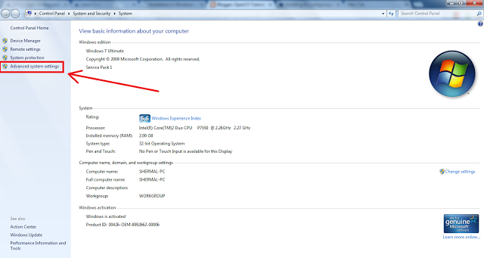

* 1. Once in ‘Advance System Settings’ click on ‘Environment Variables’

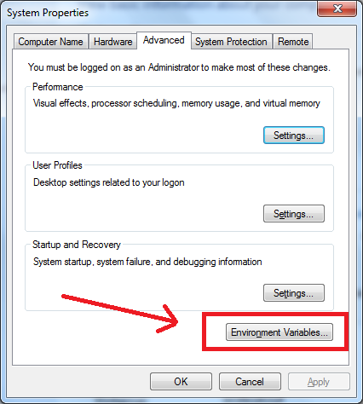

* 1. After the ‘Environment Variables’ window comes up click on the ‘New’ button

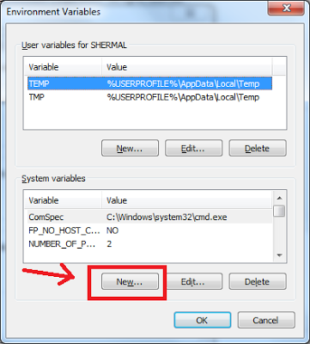

In the ‘New System Variable’ type in **OPENCV_DIR** under variable name and **C:\opencv\build** under variable value. Then press ‘OK’

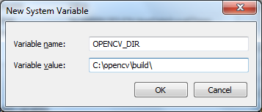

* 1. Now edit the ‘Path’ or ‘PATH’ system variable by selecting the variable and clicking on the ‘Edit..’ button.

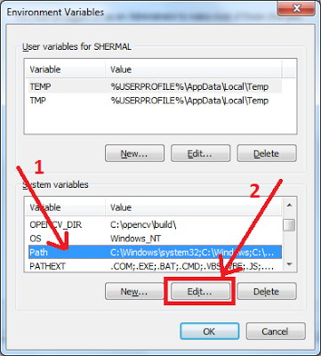

Once the ‘Edit System Variable’ window appears, add **;%OPENCV_DIR%\x86\vc12\bin** to the end of the line, x86 is the system architecture and vc12 is the compiler type. (Don’t delete anything! Just add at the end of the string. Make sure not to forget to add the semicolon at the beginning.)

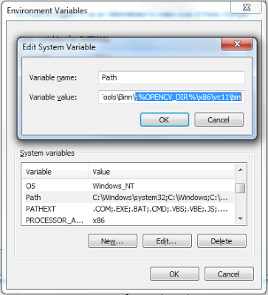

* 1. RESTART YOUR COMPUTER! RESTART YOUR COMPUTER! RESTART YOUR COMPUTER! Pools of blood and tears were shed from not doing so.
* ­­­Configure Visual Studio­­­­­
  1. Create a new C++ Win32 Console Application project. Once the new project is opened go to the ‘Solutions Explorer’ window (If it is not there open it under ‘VIEW’)

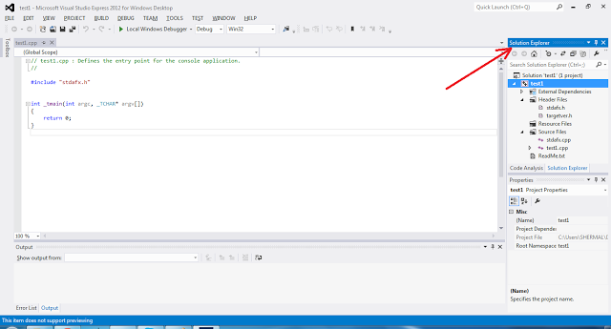

Then right click on the project name and select ‘Properties’.

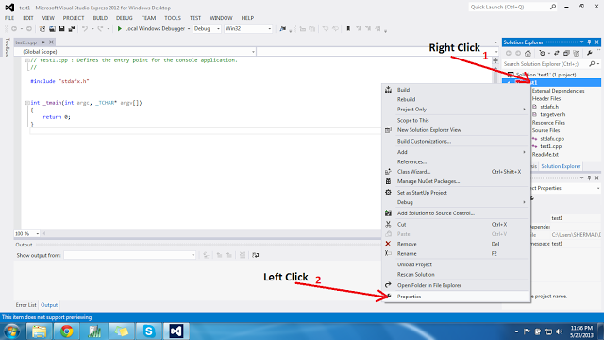

* 1. Once the ‘Property Pages’ window is open select the ‘All Configurations’ entry from the dropdown list. Go to ‘Configuration Properties’ -> ‘C/C++’ -> ‘General’ and add **$(OPENCV_DIR)\include** to ‘Additional Include Directories’.

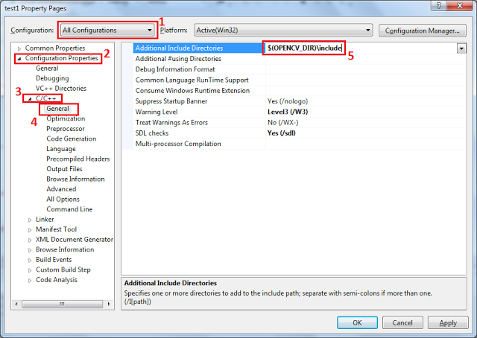

* 1. Then go to ‘Configuration Properties’ -> ‘Linker’ -> ‘General’ and add **$(OPENCV_DIR)\x86\vc12\lib** under ‘Additional Library Directories’.

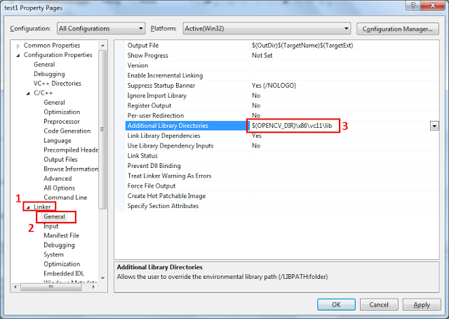

* 1. Navigate to ‘Configuration Properties’ -> ‘Linker’ -> ‘Input’ then under ‘Additional Dependencies’ click on the down arrow and select the ‘<Edit…>’ option.

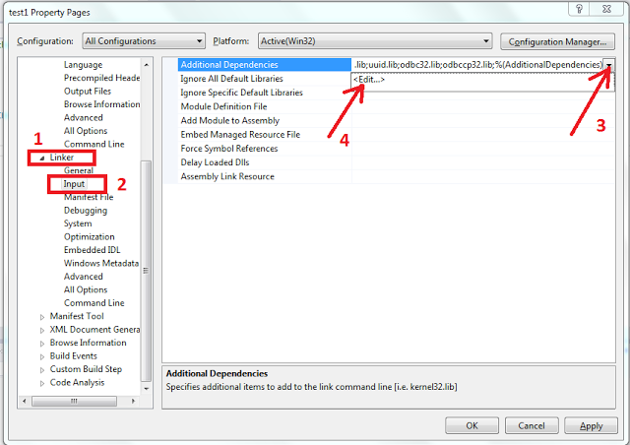

Once the dialog box appears copy and paste the following library file names. These library names are used for OpenCV 2.4.11, if you are using a different version of OpenCV (although we recommend sticking to 2.4) check the file names under ‘C:\opencv\build\x86\vc12\lib’.

opencv_calib3d2411.lib  
opencv_calib3d2411d.lib  
opencv_contrib2411.lib  
opencv_contrib2411d.lib  
opencv_core2411.lib  
opencv_core2411d.lib  
opencv_features2d2411.lib  
opencv_features2d2411d.lib  
opencv_flann2411.lib  
opencv_flann2411d.lib  
opencv_gpu2411.lib  
opencv_gpu2411d.lib  
opencv_highgui2411.lib  
opencv_highgui2411d.lib  
opencv_imgproc2411.lib  
opencv_imgproc2411d.lib  
opencv_legacy2411.lib  
opencv_legacy2411d.lib  
opencv_ml2411.lib  
opencv_ml2411d.lib

opencv_nonfree2411.lib  
opencv_nonfree2411d.lib  
opencv_objdetect2411.lib  
opencv_objdetect2411d.lib  
opencv_ocl2411.lib  
opencv_ocl2411d.lib  
opencv_photo2411.lib  
opencv_photo2411d.lib  
opencv_stitching2411.lib  
opencv_stitching2411d.lib  
opencv_superres2411.lib  
opencv_superres2411d.lib  
opencv_ts2411.lib  
opencv_ts2411d.lib  
opencv_video2411.lib  
opencv_video2411d.lib  
opencv_videostab2411.lib  
opencv_videostab2411d.lib

You are done setting up your OpenCV environment!! Yaaay!!