**The Future of Work: Data Analysis of Glassdoor Jobs**

DA Assignment - 1

The growth of supermarkets in most populated cities is increasing and market competitions are also high. The dataset is one of the historical sales of supermarket company which has

recorded in 3 different branches for 3 months data. Predictive data analytics methods are easy

to apply to this data in supermarket .

|  |  |
| --- | --- |
| Date | 29 APRIL 2023 |
| Team ID | NM2023TMID20356 |
| Project Name | The Future of Work: Data Analysis of  Glassdoor Jobs. |
| Maximum Marks | 4 Marks |

1. **Upload the dataset to Cognos Analytics:**

**DATASET: https://www.kaggle.com/datasets/aungpyaeap/supermarket-sales**

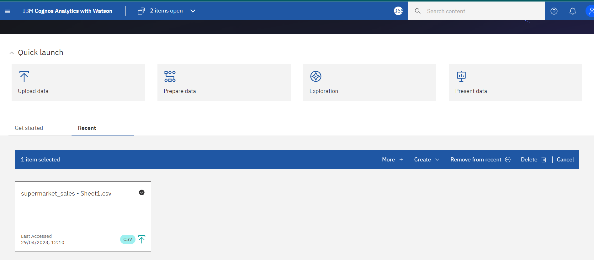

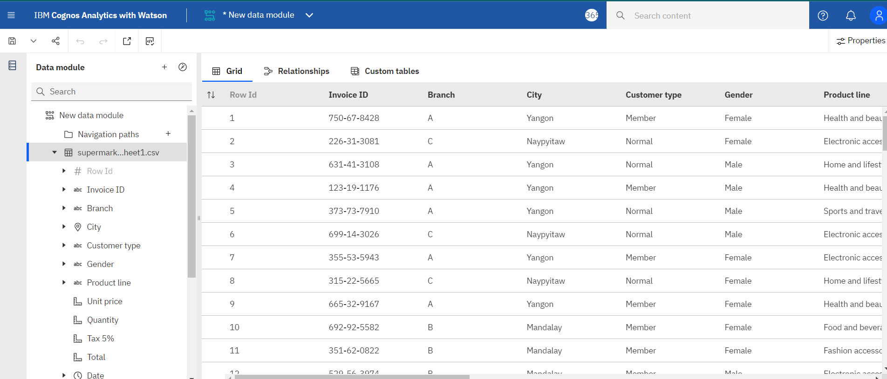**2.Create a data module:**

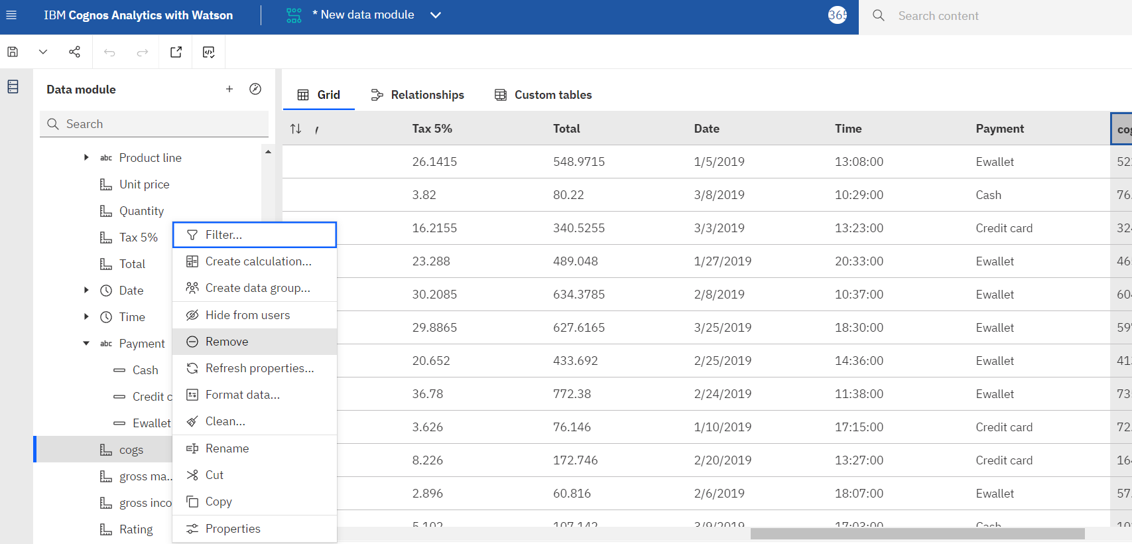**3.Delete the unnecessary columns:**

1. 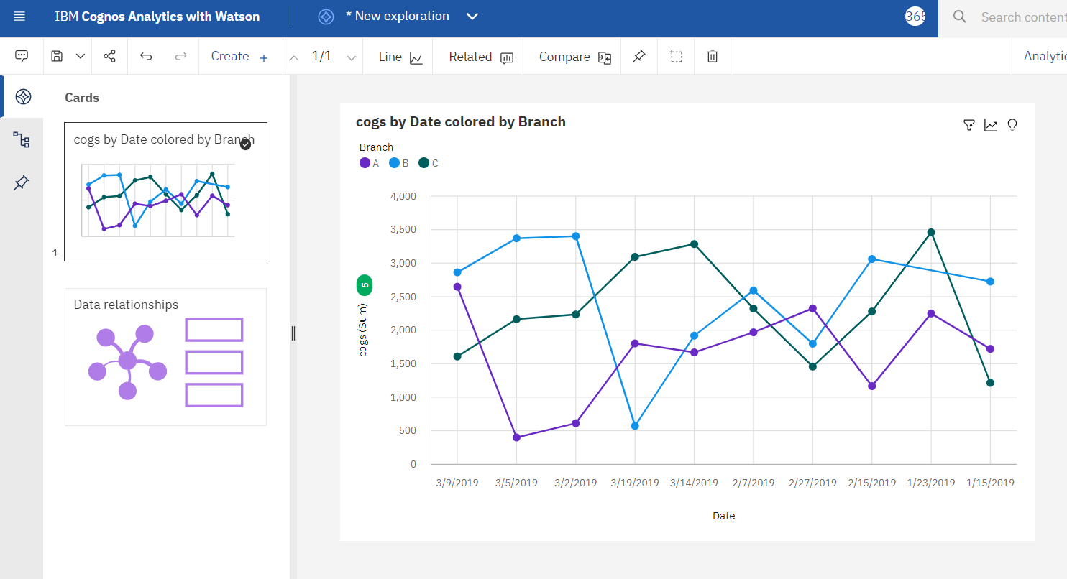 **Explore and visualize the dataset :**