**Test Case Format with Example**

**©** [**https://www.softwaretestinghelp.com**](https://www.softwaretestinghelp.com)

**Check Original Article here:** [**Sample Test Case Template [Download]**](https://www.softwaretestinghelp.com/test-case-template-examples/)

**An ideal test case template**

Below is a template which you can always use for documenting the test cases without bothering with what your application is doing.

|  |  |  |  |  |  |  |  |  |  |  |
| --- | --- | --- | --- | --- | --- | --- | --- | --- | --- | --- |
| **Test Scenario ID** | |  | | | **Test Case ID** | | |  | | |
| **Test Case Description** | |  | | | **Test Priority** | | |  | | |
| **Pre-Requisite** | |  | | | **Post-Requisite** | | |  | | |
| Test Execution Steps: | | | | | | | | | | | |
| **S.No** | **Action** | | **Inputs** | **Expected Output** | | **Actual Output** | **Test Browser** | | **Test Result** | **Test Comments** | |
|  |  | |  |  | |  |  | |  |  | |
|  |  | |  |  | |  |  | |  |  | |
|  |  | |  |  | |  |  | |  |  | |

**Example Scenario**

Based on the above template, below is an example that showcases the concepts in a more understandable way.

Suppose you are testing the login functionality of any web application, say Facebook. Below are the test cases for the same:

|  |  |  |  |  |  |  |  |  |  |  |
| --- | --- | --- | --- | --- | --- | --- | --- | --- | --- | --- |
| **Test Scenario ID** | | Login-1 | | | **Test Case ID** | | | Login-1A | | |
| **Test Case Description** | | Login – Positive test case | | | **Test Priority** | | | High | | |
| **Pre-Requisite** | | A valid user account | | | **Post-Requisite** | | | NA | | |
| Test Execution Steps: | | | | | | | | | | | |
| **S.No** | **Action** | | **Inputs** | **Expected Output** | | **Actual Output** | **Test Browser** | | **Test Result** | **Test Comments** | |
| 1 | Launch application | | https://www.facebook.com/ | Facebook home | | Facebook home | IE -11 | | Pass | [Priya 12/17/2016 11:44 AM]: Launch successful | |
| 2 | Enter correct Email & Password and hit login button | | Email id : test@xyz.com  Password: ****** | Login success | | Login success | IE -11 | | Pass | [Priya 12/17/2016 11:45 AM]: Login successful | |
|  |  | |  |  | |  |  | |  |  | |

|  |  |  |  |  |  |  |  |  |  |  |
| --- | --- | --- | --- | --- | --- | --- | --- | --- | --- | --- |
| **Test Scenario ID** | | Login-1 | | | **Test Case ID** | | | Login-1B | | |
| **Test Case Description** | | Login – Negative test case | | | **Test Priority** | | | High | | |
| **Pre-Requisite** | | NA | | | **Post-Requisite** | | | NA | | |
| Test Execution Steps: | | | | | | | | | | | |
| **S.No** | **Action** | | **Inputs** | **Expected Output** | | **Actual Output** | **Test Browser** | | **Test Result** | **Test Comments** | |
| 1 | Launch application | | https://www.facebook.com/ | Facebook home | | Facebook home | IE -11 | | Pass | [Priya 12/17/2016 11:44 AM]: Launch successful | |
| 2 | Enter invalid Email & any Password and hit login button | | Email id : invalid@xyz.com  Password: ****** | The email address or phone number that you've entered doesn't match any account. [Sign up for an account.](https://www.facebook.com/r.php) | | The email address or phone number that you've entered doesn't match any account. [Sign up for an account.](https://www.facebook.com/r.php) | IE -11 | | Pass | [Priya 12/17/2016 11:45 AM]: Invalid login attempt stopped | |
| 3 | Enter valid Email & incorrect Password and hit login button | | Email id : valid@xyz.com  Password: ****** | The password that you've entered is incorrect. [Forgotten password?](https://www.facebook.com/recover/initiate?lwv=120&lwc=1348092) | | The password that you've entered is incorrect. [Forgotten password?](https://www.facebook.com/recover/initiate?lwv=120&lwc=1348092) | IE -11 | | Pass | [Priya 12/17/2016 11:46 AM]: Invalid login attempt stopped | |

**Samples from a Live Project**

Below is an example from a live project that demonstrates how all the above listed tips and tricks are actually implemented:

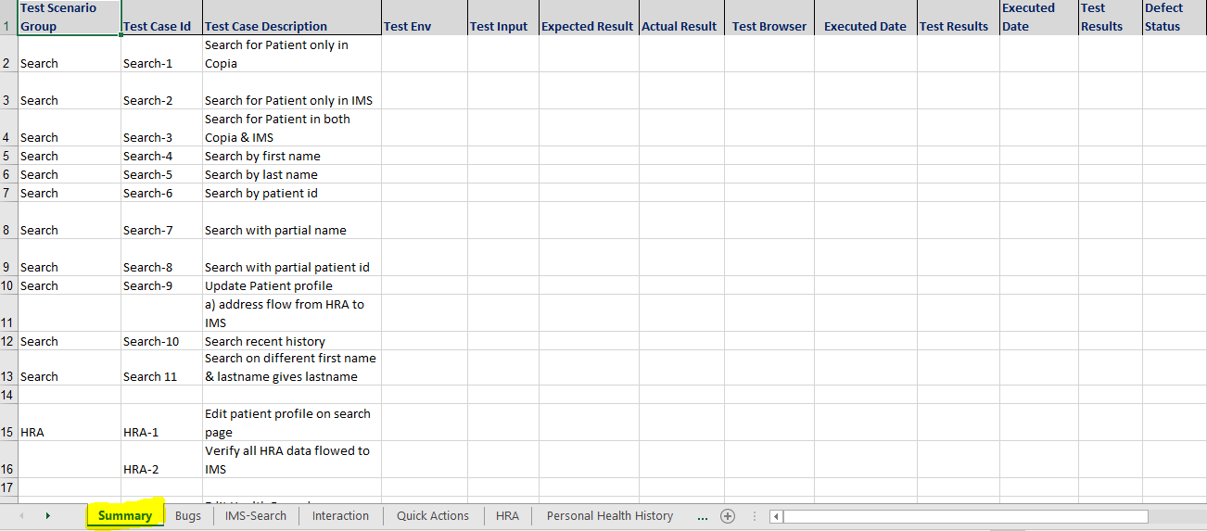

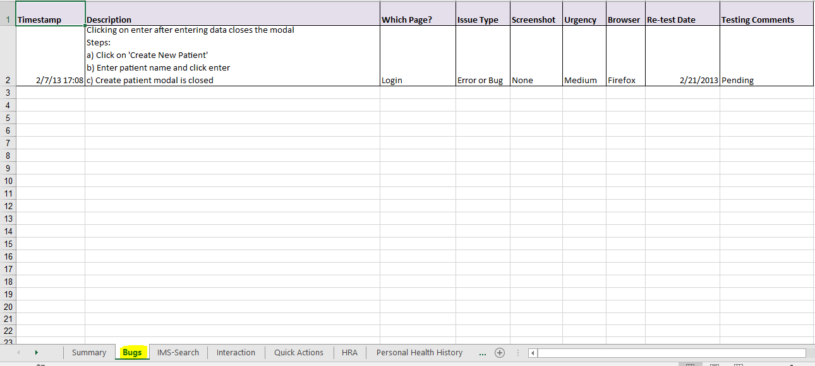

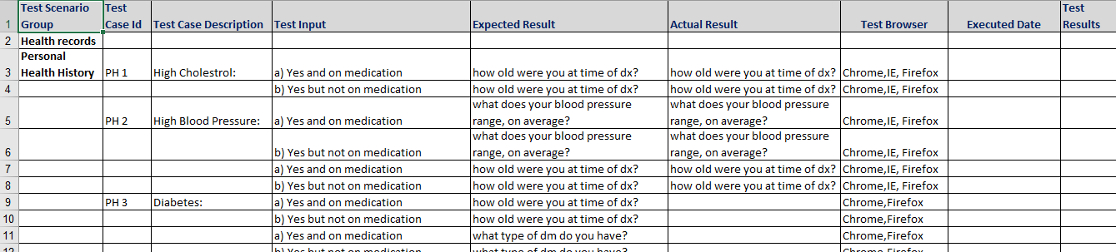

**Suggested Articles**

**Below are recommended readings for you:**

* [How to write effective Test cases, procedures and definitions](https://www.softwaretestinghelp.com/how-to-write-effective-test-cases-test-cases-procedures-and-definitions/)
* [180+ Sample Test Cases for Testing Web and Desktop Applications](https://www.softwaretestinghelp.com/sample-test-cases-testing-web-desktop-applications/)
* [Writing Test Cases from SRS Document (Download Live Project Sample Test Cases)](https://www.softwaretestinghelp.com/writing-test-cases-from-srs-software-testing-qa-training-day-4/)

**©** [**https://www.softwaretestinghelp.com**](https://www.softwaretestinghelp.com)

**Check Original Article here:** [**Sample Test Case Template [Download]**](https://www.softwaretestinghelp.com/test-case-template-examples/)