How far is cold fusion from known physics? A validated rate calculation, a two-sided bound on anomalous screening at rest, and a bound on the heat-only channel
[Author names and affiliations to be added]
Draft, October 2026
Abstract
We compute deuterium–deuterium (and other hydrogen-isotope) fusion rates for nuclei at rest with a log-grid Numerov solver for the relative-motion ground state, Γ = A|ψ(0)|². The solver reproduces the D₂, HD and H₂ binding energies to ≤ 0.001 eV and the Koonin–Nauenberg molecular rates (d+d: 2.5×10⁻⁶⁴ vs 3×10⁻⁶⁴ s⁻¹; p+d: 10⁻⁵⁵·² vs ∼10⁻⁵⁵ s⁻¹). For deuterons at the PdD lattice spacing the rate is ∼10⁻¹²⁴ s⁻¹, about 114 orders of magnitude below the ∼6×10⁻¹¹ s⁻¹ per pair needed for 1 W cm⁻³. Compressing a pair, every hydrogen-isotope fuel except p+p reaches that level at a common spacing of 7–8 pm. We then model the anomalous electron screening reported in low-energy beam experiments on deuterated metals (165–800 eV) as a profile of strength fixed by the beam data and unknown range ℓ. As ℓ grows, the rate jumps once the extra attraction binds a new short-range d–d state. Combining the beam constraint with the null neutron limit for loaded Pd and Ti at rest (<2×10⁻²⁶ s⁻¹ per pair) bounds ℓ to ≈ 0.01–0.3 Å across 40+ model variants. In every variant, rates approaching 1 W cm⁻³ occur only at ranges already excluded by the neutron limit. Finally, we bound the “heat-only” channel, in which fusion energy goes directly to the lattice. Suppressing neutrons by even 10⁻³ requires a lattice decay width exceeding the 23.85 MeV transition energy. Electromagnetic, multi-phonon and coherent many-nucleus mechanisms fall short by ∼11, ∼10⁹ and ≳ 12 orders of magnitude, and coherent transfer is additionally excluded by causality. We propose three experiments that test the remaining assumptions: a 5.5 MeV gamma search for p+d fusion in H/D co-loaded Pd at rest, beam screening in a heavy-fermion compound with a temperature switch, and same-target p+d vs d+d screening.

1. Introduction
Claims of nuclear fusion in deuterium-loaded metals at room temperature [Fleischmann–Pons 1989; Jones et al. 1989] were followed within months by calculations of the molecular d+d fusion rate [Koonin & Nauenberg 1989], by general bounds on barrier penetration in many-body systems at equilibrium [Leggett & Baym 1989], and by null neutron searches [e.g. Aberdam et al. 1990]. A large Google-funded re-examination found no evidence for the effect [Berlinguette et al. 2019].
One genuine anomaly has since been established by accelerator experiments. Low-energy d(d,p)t cross-sections in deuterated metals imply electron screening energies U_{e} ≈ 200–800 eV [Raiola et al. 2002, 2004; Czerski et al.], an order of magnitude above the ≈ 25 eV measured with gas targets and the ≈ 28 eV adiabatic limit. Recent work reports a 15% increase in beam-driven fusion with electrochemical loading [Chen et al. 2025] and a sub-keV yield plateau in Pd and Ti deuterides [Karahadian et al. 2026]. Whether such effects persist for nuclei at rest, and how far they could go towards practical rates, has not been quantified jointly with the null searches.
This paper asks a narrow question: how far, in orders of magnitude, is room-temperature fusion in metals from known physics, and which variables can close the gap? We use one validated solver throughout. All code, notebooks and figures are public [repository].

2. Method
For a bound pair, the fusion rate is
Γ = A |ψ(0)|², A = (S(0) c)/(πα μ c²),
where S(0) is the zero-energy astrophysical S-factor and ψ the s-wave ground state of the relative motion in potential V(R). For d+d with S(0) = 109.3 keV b (Bosch–Hale, both branches), A = 1.52×10⁻¹⁶ cm³ s⁻¹. We solve u’’ = 2μ(V-E)u on a logarithmic grid from 0.5 fm, starting from the regular repulsive-Coulomb solution u≃ R(1+μ R). The energy comes from node-counting bisection, and amplitudes are tracked in log space (ψ(0) is ∼10⁻³⁷ of its peak).
Potentials. Molecular: the H₂ Born–Oppenheimer curve [Kolos & Wolniewicz 1965], splined to the He united-atom limit; heavier screening particles (mass m*) via the exact scaling V_{m*}(R)=m*V₁(m*R). Lattice: Thomas–Fermi-screened repulsion (0.57 Å for Pd) plus a harmonic restoring force on the separation set by the PdD optical phonon (37 meV). Anomalous screening: Δ V(R) = -Δ U g(R/ℓ) with g exponential, Gaussian, step or Yukawa-type. Δ U is fixed by requiring Δ V = -U_{meas} at the beam turning point ( ≈ 0.004 Å). When Δ V creates a bound state at short range, we take the effective rate as the smaller of the bound-state fusion rate and the WKB tunneling rate into it.
Validation (Table 1). The solver reproduces D₂, HD and H₂ binding energies to ≤ 0.001 eV, the D₂ zero-point energy to <1%, and the Koonin–Nauenberg rates for d+d and p+d. It is converged to 0.002 decades in step size and starting radius. The main systematic is the short-range potential: a 0.05 Ha error below 0.3 Å shifts the rate by 0.7 decades. We adopt ±1 decade as the working uncertainty.
Quantity | This work | Reference
D₂ binding D₀ | 4.5556 eV | 4.5562 eV
HD / H₂ binding | 4.5129 / 4.4771 eV | 4.5139 / 4.4781 eV
d+d rate in D₂ | 2.5×10⁻⁶⁴ s⁻¹ | 3×10⁻⁶⁴ [KN89]; 5.7×10⁻⁶⁴ [2025]
p+d rate in HD | 10⁻⁵⁵·² s⁻¹ | ∼10⁻⁵⁵ [KN89]
Thermal reactivity (Gamow integral) | within 1–2% | Bosch–Hale fit, 0.2–50 keV

3. Results

3.1 The gap
1 W cm⁻³ in PdD requires ∼6×10⁻¹¹ fusions per pair per second. A d–d pair at the lattice spacing (2.75 Å) gives 10⁻¹²⁴ s⁻¹, a gap of ~114 orders of magnitude. The often-quoted ~53 orders is against a D₂ molecule (0.74 Å), which the lattice does not provide. Varying spacing (1.5–2.75 Å), phonon energy and Thomas–Fermi length moves the lattice rate by at most tens of orders.
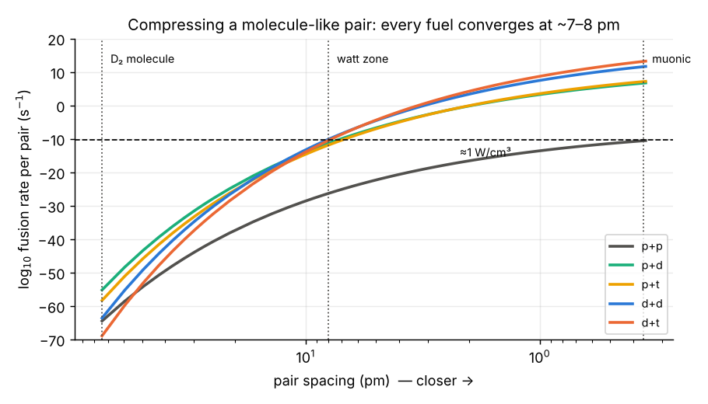
Fusion rate per pair vs pair spacing for each hydrogen-isotope fuel. All fuels except p+p reach 1 W/cm³ at 7–8 pm.

3.2 Closer and lighter
Scaling the molecular potential by a heavier screening particle compresses the pair. Watt-level rates need m* ≈ 9.2 for d+d (Koonin & Nauenberg: 5–10), i.e. a pair spacing of 8.0 pm. Repeating this for all hydrogen-isotope pairs, p+d, p+t, d+d and d+t all reach watt level at 7.3–8.2 pm; p+p never does (weak-interaction S-factor). Lighter pairs lead at long range (p+d is 10⁸ above d+d in a molecule, 10¹⁷ at lattice spacing), but larger S-factors win near the watt zone. An independent calculation for a lattice-type pair held at fixed spacing by an external force gives the same 7.3 pm, at an energy cost of ~170 eV per pair (Boltzmann factor 10⁻²⁹⁰⁰ at 300 K). Deuterium clusters in a Pd vacancy (N = 2–6) do not help: mutual repulsion places the nearest pair at 2.8–3.8 Å.

3.3 Anomalous screening at rest: a two-sided bound
The figure below shows the effective rate for a lattice pair along the beam-consistent curve. If the screening reaches only the few-hundredths of an ångström the beam data probe, the rate stays below 10⁻¹⁰⁰ s⁻¹. As ℓ increases, the rate jumps when Δ V binds a new d–d state at 0.07–0.24 Å (deeper and closer for larger U_{meas}). It is then limited by tunneling into that state and by fusion within it.
The null neutron limit for Pd and Ti at rest, <2×10⁻²⁶ s⁻¹ per pair [Aberdam et al. 1990], then bounds ℓ. For an exponential profile, ℓ < 0.154 Å (300 eV), 0.137 Å (575 eV) and 0.129 Å (800 eV). Across 40 variants (profile shape, harmonic vs barrier-capped lattice, spacing, Thomas–Fermi length, phonon energy, attempt frequency ×10^{±3}, weaker null limit) plus the 800 eV case, the bound spans 0.012–0.315 Å (median 0.137 Å). It is dominated by profile shape and screening length; lattice stiffness and tunneling kinetics hardly matter. At 165 eV and for step profiles the static limit does not constrain ℓ, but those cases never come within 20 orders of watt level.
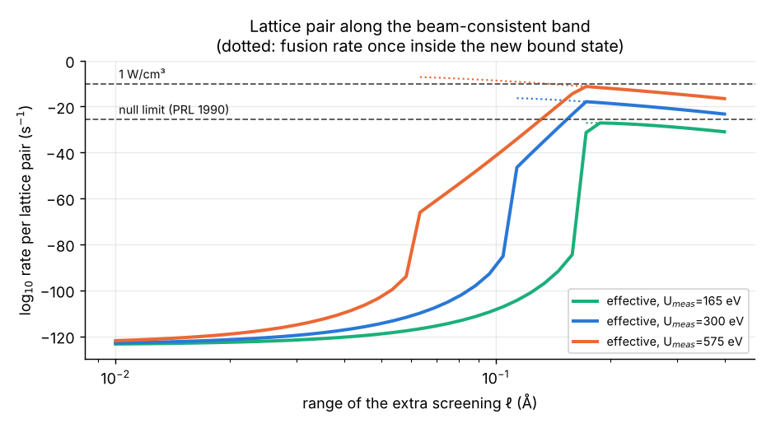
Effective lattice-pair rate along the beam-consistent screening band (exponential profile) for three measured screening strengths. Dotted: fusion rate inside the new short-range bound state.
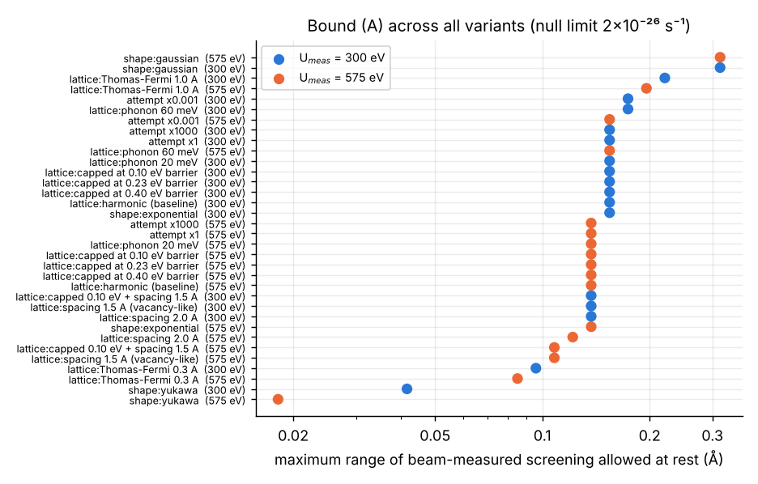
Maximum range of the beam-measured screening allowed at rest by the 1990 neutron limit, across model variants.
Watts imply neutrons. Several variants reach ≥ 1 W cm⁻³ at U_{meas}≥ 575 eV. In every one, the rate crosses the neutron limit at a shorter range than it reaches watt level (e.g. Yukawa profile at 800 eV: 0.012 Å vs 0.016 Å). No variant jumps from below the limit to watt level.

3.4 p+d in mixed H/D lattices
p+d → ³He + γ (5.49 MeV) has no neutron branch. With the same beam-consistent screening, the p+d lattice rate peaks at 10⁻¹²·³ s⁻¹ (575 eV), so even at a 50/50 H/D mix it is ~2.5 orders short of watt level. Past the bound-state jump, d+d and p+d converge to within an order of magnitude, so the coexisting d+d pairs would still violate the neutron limit first. p+d also cannot be “heat-only”: 1 W would emit ∼10¹² gammas per second.

3.5 The heat-only channel
The d+d compound state ⁴He* (23.85 MeV) decays strongly with widths Γ_{strong}∼0.5–6 MeV (lifetimes 10⁻²²–10⁻²¹ s), and radiatively with Γ_{γ}/Γ_{p} ≈ 10⁻⁷ [Zhou et al. 2006]. Suppressing neutrons by s_{n} needs a lattice width Γ_{lat} ≳ Γ_{strong}/s_{n}, which is already 20–260× the transition energy at s_{n}=10⁻³ and 10¹⁰–10¹¹× at 10⁻¹². A state that wide is not a state, so any heat-only process cannot go through ⁴He*. For mechanisms that do:
- electromagnetic (internal conversion, pair creation) falls short by ~11–20 orders;
- direct multi-phonon emission (Englman–Jortner energy-gap law, 6.4×10⁸ phonons) gives rates ~10^(−4×10⁹) s⁻¹ for any plausible coupling;
- coherent many-nucleus coupling needs ∼10¹⁵–10³³ phase-locked nuclei (vs ∼10³ in coherent domains).
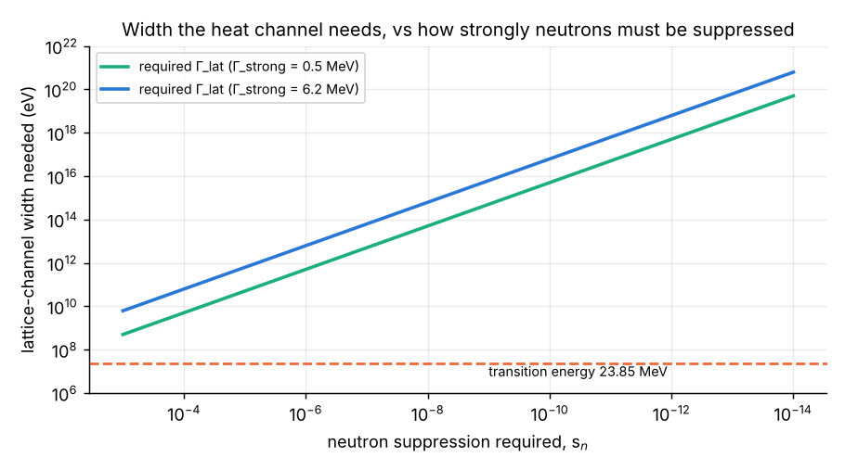
Lattice-channel width needed for the heat-only channel vs the required neutron suppression, compared with the 23.85 MeV transition energy.
It is also causally excluded: in the compound-nucleus lifetime, light travels <0.003 Å, far less than the distance to the nearest neighbouring deuteron.

3.6 Other levers
Cold metallic deuterium reaches 1 W cm⁻³ pycnonuclearly only at ∼1.6×10⁴ g cm⁻³. Coherent resonant tunneling through an intermediate well adds nothing beyond sequential tunneling once energies are spread over more than the resonance width (≲10⁻³¹ eV vs ∼10⁻² eV). Muon-catalysed d–t fusion, the one room-temperature route that works, is ~1.5× from scientific breakeven and ~9× from net electricity, a gap that depends on sticking and cycling measurements now being made at high density (MuFusE).

4. Proposed experiments
E1: p+d gamma search at rest. A 10 g Pd foil co-loaded with H and D (0.45/0.45), steady and cycled loading, a shielded HPGe/LaBr₃ detector with muon veto, run for 30 days, with H-only, D-only and unloaded controls. With assumed backgrounds this reaches ∼10⁻²⁶ (surface) and 4×10⁻²⁸ (underground) per p–d pair per s, extending the range bound to a neutron-free channel.
E2: heavy-fermion screening with a temperature switch. d(d,p)t at E_{d} = 5–30 keV on a deuterium-implanted heavy-fermion compound (Ce- or Yb-based) and its non-f analogue, at 4 K and 300 K, with in-situ ERDA depth profiling. “Heavy-electron” screening predicts a large rise only below the coherence temperature; standard theory predicts no change. About 6 h per point at 10 μA.
E3: same-target p+d vs d+d screening. Alternating H⁺/D⁺ beams matched in stopping range on one deuterated target. This separates true screening (equal U_{e}), depth-profile artifacts (range-dependent) and a d+d-specific nuclear resonance (U_{e}^{dd}>U_{e}^{pd}). A 5σ answer needs ~2.6% p+d statistics, about 1.5 days per point at 1 mA.

5. Discussion and limitations
Relation to prior work. Leggett & Baym [1989] bounded barrier penetration for any many-body system at equilibrium; our static-screening conclusion agrees. The contribution here is to use the measured beam screening, model its unknown range, and confront it with the null neutron data, which gives a numerical bound on the range at rest and the “watts imply neutrons” result across model variants. Czerski, Heide & Huke [2006] extrapolated effective screening energies to cold-fusion energies and compared with positive claims. Their full text should be compared in detail before any novelty claim is made.
Limitations. (i) The short-range H₂ potential uses recalled Kolos–Wolniewicz values. They are supported by the binding-energy and Koonin–Nauenberg checks but were not re-read from the original table. (ii) Several literature inputs were verified only at abstract level (see VERIFICATION.md). (iii) The lattice model is a single radial pair; anisotropy, many-body exchange and defects beyond a spherical vacancy are not modelled. (iv) The screening profiles are phenomenological. (v) The heat-only analysis uses order-of-magnitude internal-conversion and pair-creation coefficients and the weak-coupling energy-gap law.

6. Conclusions
Within standard physics and the stated assumptions:
- Room-temperature fusion in metals is ~114 orders of magnitude from 1 W cm⁻³.
- Every fuel needs pairs held at ~7–8 pm, costing ~170 eV per pair.
- The anomalous screening seen in beam experiments cannot extend beyond ~0.01–0.3 Å at rest without having produced neutrons already excluded in 1990, and any configuration approaching watts would have produced them.
- A heat-only channel cannot dispose of the energy of any process that forms excited ⁴He.
The remaining open questions are experimental and well posed (E1–E3).
Data and code availability. All notebooks, the solver (cfsolve.py), the claim-checking tool and figures: https://github.com/m1110/cold-fusion-gap
Acknowledgements. Analysis code and drafting were assisted by an AI model (Claude, Anthropic); all results are reproducible from the repository.

References (to be completed and checked against primary sources)
- Aberdam D. et al., Phys. Rev. Lett. 65, 1196 (1990).
- Berlinguette C. P. et al., Nature 570, 45 (2019).
- Bosch H.-S. & Hale G. M., Nucl. Fusion 32, 611 (1992) (and erratum).
- Chen K.-Y. et al., Nature 644, 640 (2025).
- Ciuchi S. et al., Eur. Phys. J. C 72, 2193 (2012).
- Czerski K., Heide P. & Huke A., in Condensed Matter Nuclear Science (ICCF11), 228 (2006).
- Czerski K. et al., EPL 113, 22001 (2016).
- Englman R. & Jortner J., Mol. Phys. 18, 145 (1970).
- Huke A., Czerski K. & Heide P., arXiv:0805.4538 (2008).
- Jones S. E. et al., Nature 338, 737 (1989).
- Karahadian M. et al., Nat. Commun. 17, 8845 (2026).
- Kolos W. & Wolniewicz L., J. Chem. Phys. 43, 2429 (1965).
- Koonin S. E. & Nauenberg M., Nature 339, 690 (1989).
- Leggett A. J. & Baym G., Phys. Rev. Lett. 63, 191 (1989); Nature 340, 45 (1989).
- Raiola F. et al., Eur. Phys. J. A 13, 377 (2002); 19, 283 (2004).
- Tilley D. R., Weller H. R. & Hale G. M., Nucl. Phys. A 541, 1 (1992).
- Zhou J. et al., Chin. Phys. Lett. (2006), d(d,γ)⁴He branching at 20 keV.

