Closing the muon-catalysed fusion energy gap: direct levers and a subcritical blanket
[Author names to be added]
Technical note, October 2026
Abstract
Muon-catalysed d–t fusion (μCF) is the only established route to fusion at room temperature. With ~150 fusions per muon and ~5 GeV per muon, it reaches a scientific gain of ~0.53–0.67 and an electric gain of ~0.11, i.e. ~9× short of net electricity. We quantify two ways to close that gap. Directly: cheaper muons (/2.5), halved sticking, a 3× faster cycle and better conversion together reach an electric gain of ~1.1. Indirectly: using the 14.1 MeV fusion neutrons to drive a subcritical fission blanket gives electric gains of several units even with today’s μCF numbers. But today μCF yields ~30 neutrons per GeV of beam, the same as proton spallation (20–35 n/GeV), which accelerator-driven systems already use. A μCF hybrid is therefore worth building only when muons cost ≲4–8 GeV or catalyse ≳100–175 fusions each. With all direct levers it would reach ~170 n/GeV, 5–8× spallation. With sourced muon-cost scenarios (2–3 GeV) and the fusions-per-muon values of recent polarisation studies, net electricity is reached only at the threshold (gain ≈ 1.0–1.1), and only with 50%/60% conversion efficiencies. Either way, muon production cost and alpha-sticking are the deciding quantities, and high-density measurements now under way (MuFusE, PSI) bear directly on the second.

1. Starting point
A muon in a d–t mixture catalyses fusions at the cycling rate φλ_{c} until it decays or sticks to an alpha particle (probability ω_{s} per fusion), so the number of fusions per muon is X = 1/(λ₀/φλ_{c} + ω_{s}). Calibrated to the measured X ≈ 150 at ω_{s} = 0.45%, the cycle model reproduces the published gains: Q ≈ 0.53 from fusion alone, 0.67 with lithium-blanket breeding heat, and an electric gain of ≈ 0.11 at 40% thermal and 40% accelerator efficiency (published: ~14%).
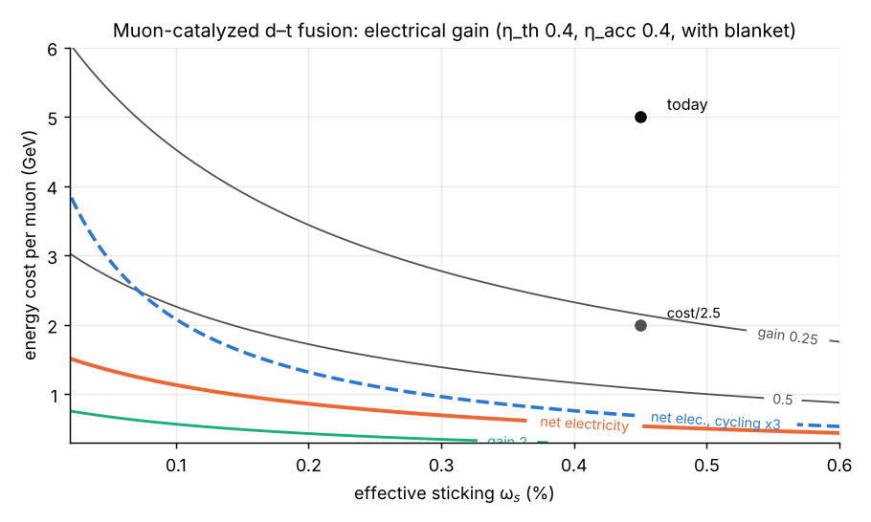
Electric gain of pure μCF vs effective sticking and muon cost (40% thermal and accelerator efficiency, lithium blanket).

2. Direct levers
Scenario | Fusions per muon | Scientific Q | Electric gain
Today (5 GeV/μ, ω_s = 0.45%) | 150 | 0.67 | 0.11
Muon cost /2.5 (2 GeV/μ) | 150 | 1.68 | 0.27
Sticking halved | 226 | 1.01 | 0.16
Cycling ×3 | 191 | 0.86 | 0.14
Cost /2.5 + sticking /2 + cycling ×3 | 336 | 3.77 | 0.60
… + better conversion (η_th 0.5, η_acc 0.6) | 336 | 3.77 | 1.13
No single lever is enough. Net electricity needs all four at once.

3. Subcritical blanket
Each fusion emits a 14.1 MeV neutron. In a blanket with k_{eff}<1, a source neutron triggers k/(ν(1-k)) fissions (3.6 at k=0.90, 7.6 at 0.95, 19.6 at 0.98), each releasing ~200 MeV. At k_{eff}=0.95, a typical accelerator-driven-system design value, the electric gain becomes:
Neutron source | Neutrons per GeV of beam | Electric gain at k_eff = 0.95
Proton spallation on lead (ADS) | 20–35 | ~4–9
μCF today | 30 | 7.4
μCF, muon cost /2.5 | 75 | 18.5
μCF, all direct levers | 168 | 41.3
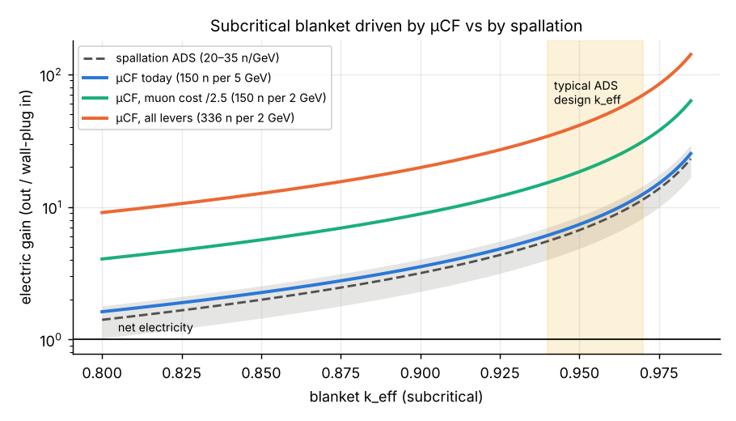
Electric gain of a subcritical blanket driven by μCF or by spallation, vs k_eff.
Absolute gains are optimistic (the multiplication formula ignores (n,2n), parasitic capture and leakage), but the comparison between sources is robust because the same blanket multiplies every source’s neutrons equally. At k_{eff}=0.95 the fusion itself supplies only ~1.1% of the heat. Tritium is not a constraint: each source neutron produces ~12 spare neutrons beyond those absorbed in fission, while breeding needs ~1 per fusion.

3.1 How cheap must muons get? (notebook 16)
We turn the question around and ask what beam energy per stopped muon, E_{μ}, each goal allows. With today’s cycle (X ≈ 150), net electricity needs E_{μ} ≈ 0.54–0.62 GeV, 8–9× cheaper than today’s ~5 GeV. That would take 1.6 stopped muons per GeV of beam, 23% of the ceiling set by the π⁻ rest mass. Cheaper muons alone are not a realistic route.
Using sourced scenarios: muon cost 5 GeV today, 2 GeV for Kelly et al. (2021) and 3.0 GeV for a simulated active-target source. Fusions per muon follow Yin et al. (2026): 148 unpolarised, 193 polarised and 300–350 for their “multi-technology synergy” case. At today’s conversion efficiencies (0.4/0.4), no scenario reaches net electricity; the best supported case gives 0.58. With 0.5/0.6, a 2 GeV source at X ≈ 325 reaches gain 1.09, and a 3.0 GeV active target with beam-heat recovery reaches 0.97. Both are at the threshold. Clear margin needs the extrapolated engineering-limit cycle (X ≈ 550; gain 1.85 at 2 GeV).
Recovering beam heat from the pion-production target raises a 5 GeV source from 0.11 to 0.23. This is one ingredient of Kelly et al.’s 2.5× reduction, not an extra lever on top of it.
As a neutron source, μCF ties spallation today (break-even 5.4 GeV per muon). With polarised fuel it wins below 7.0 GeV per muon, so for waste burning the cycle measurements matter more than muon cost.

4. Conclusions
- Pure μCF is ~9× from net electricity. Closing it directly needs cheaper muons, lower sticking, faster cycling and better conversion together.
- A subcritical blanket gives net electricity with today’s μCF numbers, but so does spallation, at the same neutrons per GeV. μCF earns its place only once it out-produces spallation: muons below ~4–8 GeV, or ≳100–175 fusions per muon.
- The two numbers to watch are muon production cost (accelerator, pion-production target and capture design) and effective sticking at high density (MuFusE).
- A μCF hybrid is a neutron-source technology. It carries the waste, licensing and safety profile of any accelerator-driven fission system.
Reproducibility. Notebooks 09, 10 and 16 at https://github.com/m1110/cold-fusion-gap. Inputs and their verification status: VERIFICATION.md (μCF data and muon cost at secondary/abstract level; spallation yield from GEANT4 studies, abstract-level).
Acknowledgements. Analysis and drafting assisted by an AI model (Claude, Anthropic).

References (to be checked against primary sources)
- Jones S. E. et al., Phys. Rev. Lett. 56, 588 (1986): LAMPF μCF measurements.
- Kelly K. et al., J. Phys. Energy 3, 035003 (2021): muon production cost and μCF energy balance.
- Yin X., Kou W., Chen X., Muon-catalyzed nuclear fusion: physical mechanism, bottleneck breakthroughs and an engineering pathway, arXiv:2605.26432 (2026) (read in full).
- Parisi J. F., Rutkowski A., Isotope production in muon-catalyzed-fusion systems, arXiv:2511.20951 (2025) (read in full).
- Jändel M., Design principles for efficient muon production in muon-catalyzed fusion reactors, J. Fusion Energy 8, 81 (1989).
- MuFusE collaboration, arXiv:2606.05333 (2026): diamond-anvil cell for μCF at high density and temperature.
- GEANT4 studies of spallation neutron yield for ADS targets, Proc. IPAC 2016, TUPOY019.

