Beyond fusion at rest: energetic deuterons in metals, ignition, and low-waste nuclear options
[Author names to be added]
Technical note, October 2026
Abstract
Fusion of deuterons at rest in metals is 98–114 orders of magnitude below practical rates, and the anomalous screening seen in beam experiments cannot close the gap without producing neutrons that null searches exclude (companion preprint). This note surveys the remaining paths. (1) Energetic deuterons inside metals (lattice confinement fusion, beam-loaded PdD): a slowing-down calculation gives an energy return of at most ~3×10⁻⁵ per deuteron in PdD (~6×10⁻⁴ for an idealised pure-deuterium target), 3–4.5 orders below breakeven. Screening of up to 1.7 keV does not change the best case, because electronic stopping, not the Coulomb barrier, dominates. (2) Catalysis: muons remain the only physical catalyst, ~9× from net electricity. (3) Hot fusion: laser ignition is established (target gain ≈ 4.1 in 2025), and the remaining gap to a power plant is under one order of magnitude in target gain, plus driver efficiency. (4) Waste: fission always produces fission products. Partitioning and transmutation can shorten the hazard from ~300,000 to ~300 years. d–t fusion leaves activated structure (limited by carbon-14 in steels), and only aneutronic p–¹¹B would come close to “deposit-free”, but its power balance against bremsstrahlung is marginal.

1. Energetic deuterons in deuterated metals
A deuteron of energy E₀ entering deuterated metal fuses with probability P(E₀)=∫₀^{E₀} n_{D}σ(E)/|dE/dx| dE before stopping, and returns G = P⟨ Q⟩/E₀ of its energy (⟨ Q⟩ = 3.65 MeV). With Bosch–Hale cross-sections, a screening shift of up to 1.7 keV, and a Bethe-plus-low-energy stopping model for Pd (uncertain to ~2×):
Case | Best energy return G | Orders below breakeven
PdD, no screening | 2.9×10⁻⁵ (at 3 MeV) | 4.5
PdD, U_e = 1.7 keV (Karahadian et al. 2026) | 2.9×10⁻⁵ | 4.5
PdD, 1.7 keV, stopping ×0.5 | 5.9×10⁻⁵ | 4.2
Pure deuterium target (optimistic) | 5.7×10⁻⁴ | 3.2
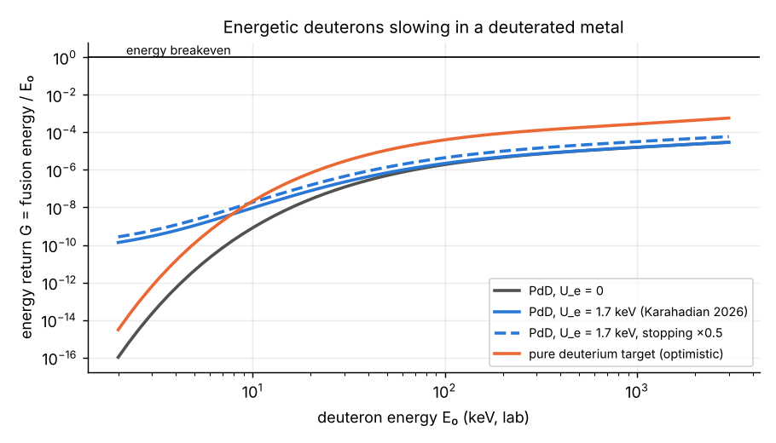
Energy return of an energetic deuteron slowing in a deuterated metal.
Screening multiplies the yield ×240 at 5 keV, but there G ~ 10⁻⁹. A deuteron loses its energy to electrons long before it is likely to fuse. NASA’s lattice confinement fusion (2020) and beam-loaded metals are therefore neutron sources and screening laboratories, not energy sources. Avoiding electronic stopping requires recycling the energy in a hot plasma, which is thermonuclear fusion.

2. Catalysis
Muons work (~150 fusions per muon) but are ~9× from net electricity; the route to closing that gap is in the companion muon note. Pions and kaons decay too fast. A hypothetical long-lived heavy negative particle would catalyse fusion without decay losses, but none has been found.

3. Hot fusion and ignition
Path | Status | Remaining gap
Laser ICF, d–t (NIF) | 8.6 MJ from 2.08 MJ laser, target gain 4.13 (2025) | ~3.6× in target gain to a facility with zero net demand (LLNL estimate ~15), plus laser efficiency and repetition rate
D–³He (Helion) | Polaris reported d–t fusion at 150 million °C (Feb 2026); D–³He needs ~200 million °C; ³He to be bred from d–d | D–³He plasma not yet reported
p–¹¹B, thermal | Fusion power exceeds bremsstrahlung by only a few % at best; alpha channeling could reduce the required confinement 2.6–6.9×; <2% ash prevents ignition | Marginal power balance
p–¹¹B, inertial | Breakeven needs ~100× current areal density at ~1000× pressure, with trapped bremsstrahlung | Far
p–¹¹B, laser-driven non-thermal | ~10¹¹ alphas per 600 J pulse; fusion energy ≈ 8×10⁻⁵ of laser energy | ~4 orders
p–¹¹B, dense plasma focus | >200 keV ion energies (deuterium); decaborane runs began 2025 | No p–¹¹B yield published

4. Waste
Option | Long-term hazard | Status
Once-through fission | Above uranium-ore radiotoxicity for ~300,000 years | Operating
Plutonium recycling | ~10,000 years | Operating
Partitioning and transmutation (fast reactors / ADS) | ~300 years | MYRRHA first phase slipped to 2027–2038 (reports of a freeze unconfirmed)
Thorium molten salt | Far fewer transuranics; fission products remain | TMSR-LF1 critical 2023; thorium→uranium conversion 2025; larger units ~2030
d–t fusion | Activated structure; EU DEMO: ~10⁴ t intermediate-level waste 100 years after shutdown, mainly ¹⁴C | Design studies
D–³He / p–¹¹B fusion | Little / almost no activation | Not demonstrated
Fission cannot be made free of harmful products: it always makes fission products. The best route shortens the hazard to centuries. Among nuclear options, only aneutronic fusion approaches “no harmful deposits”, and it is the least developed.

4.1 Waste-burning budget (notebook 12)
Energy bookkeeping fixes the burn rate: fissioning 0.394 t of transuranics (TRU) releases 1 GWth-year (200 MeV per fission). Inventory figures below are secondary and unverified.
- An assumed world stock of ~4,800 t TRU (~4×10⁵ t of spent fuel at ~1.2% TRU) is ~12,200 GWth-years of heat.
- ~370 GWe of light-water reactors add ~92 t TRU per year. Holding the stock level takes ~235 GWth of burners; 300 GWth clears it in ~190 years and 1,000 GWth in ~16 years.
- In a subcritical (accelerator-driven) burner, the neutron driver takes 17% of the electrical output at k = 0.95 with spallation, falling to 7–10% at k = 0.97–0.98. Muon-catalysed fusion today (30 n/GeV) is no better (16%). With the muon-catalysis levers of the companion muon note, the share falls to 3–6%.
- Transmuting the ⁹⁹Tc and ¹²⁹I made per fission takes ~0.07 neutrons. A subcritical burner at k ≤ 0.97 supplies 1.3–4.7 times that as source neutrons (an upper bound, since not all reach targets); at k = 0.98 it does not.
Clearing the waste is limited by fleet size and neutrons, not by physics. A better neutron source cuts the driver penalty roughly six-fold but does not change the fleet size that energy bookkeeping sets.

5. Conclusions
- No room-temperature path closes the gap within known physics. Energetic deuterons in metals fall 3–4.5 orders short of breakeven, independent of screening.
- The paths with gaps of ~10× or less are hot fusion (laser and magnetic) and muon catalysis.
- For low waste: partitioning and transmutation (fission, ~300-year hazard) is the nearest-term option; p–¹¹B is the cleanest but the furthest.
Reproducibility. Notebooks 11 and 12 at https://github.com/m1110/cold-fusion-gap. Status levels of the literature inputs: hot-fusion and waste figures are from secondary sources and press releases (2025–2026) unless noted, to be checked against primary publications before citation.
Acknowledgements. Analysis and drafting assisted by an AI model (Claude, Anthropic).

Sources (secondary unless noted; to be checked)
- Karahadian M. et al., Nat. Commun. 17, 8845 (2026), arXiv:2512.06212 (read in full).
- NASA Glenn lattice confinement fusion, Phys. Rev. C 101 (2020), two papers.
- LLNL NIF announcements (2025): 8.6 MJ, target gain 4.13.
- Helion Energy announcements (Feb 2026).
- Putvinski S. et al., Nucl. Fusion (2019), p–¹¹B power balance; Ochs I. E. et al., Phys. Plasmas (2024, 2026).
- Giuffrida L. et al., Phys. Rev. E 101 (2020): laser-driven p–¹¹B alphas.
- LPPFusion, Front. Phys. (2024); workshop presentation (2025).
- UKAEA studies of DEMO waste (Bailey et al., Nucl. Fusion 61, 036010, 2021).
- MYRRHA / SCK CEN publications (EPJ-N 2019, 2020); SINAP announcements on TMSR-LF1 (2025).

