Assignment 3: Data Exploration

Masha Edmondson

## OVERVIEW

This exercise accompanies the lessons in Environmental Data Analytics on Data Exploration.

## Directions

1. Change “Student Name” on line 3 (above) with your name.
2. Work through the steps, **creating code and output** that fulfill each instruction.
3. Be sure to **answer the questions** in this assignment document.
4. When you have completed the assignment, **Knit** the text and code into a single PDF file.
5. After Knitting, submit the completed exercise (PDF file) to the dropbox in Sakai. Add your last name into the file name (e.g., “Salk_A03_DataExploration.Rmd”) prior to submission.

The completed exercise is due on Tuesday, January 28 at 1:00 pm.

## Set up your R session

1. Check your working directory, load necessary packages (tidyverse), and upload two datasets: the ECOTOX neonicotinoid dataset (ECOTOX_Neonicotinoids_Insects_raw.csv) and the Niwot Ridge NEON dataset for litter and woody debris (NEON_NIWO_Litter_massdata_2018-08_raw.csv). Name these datasets “Neonics” and “Litter”, respectively.

#Set up your working directory  
getwd()

## [1] "/Users/mashaedmondson/Desktop/Environmental_Data_Analytics_2020/Assignments"

#Load packges  
library(tidyverse)  
  
#Import datasets  
Neonics.data <- read.csv("../Data/Raw/ECOTOX_Neonicotinoids_Insects_raw.csv")  
Litter.data <- read.csv("../Data/Raw/NEON_NIWO_Litter_massdata_2018-08_raw.csv")

## Learn about your system

1. The neonicotinoid dataset was collected from the Environmental Protection Agency’s ECOTOX Knowledgebase, a database for ecotoxicology research. Neonicotinoids are a class of insecticides used widely in agriculture. The dataset that has been pulled includes all studies published on insects. Why might we be interested in the ecotoxicologoy of neonicotinoids on insects? Feel free to do a brief internet search if you feel you need more background information.

Answer: Neonicotinoid is a common inseciticide used in agirculture that resembles nicotine. There has been research that shows neonicotinoid insecticide is linked to declining bee populations. Therefore, it is important to know what types of insects are located in agricultural areas that use this inseciticide. There have not been an abundance of long term studies on the impacts of neonicotinoids on local insect populations, which is important to know. Some insects provide necessary pollination of crops, which could be adversly affected by the inseciticide. It would also be helpful to know what insects are in the areas, and if there are any drastic declines in the populations that could be linked to the use of Neonicotinoids.

1. The Niwot Ridge litter and woody debris dataset was collected from the National Ecological Observatory Network, which collectively includes 81 aquatic and terrestrial sites across 20 ecoclimatic domains. 32 of these sites sample forest litter and woody debris, and we will focus on the Niwot Ridge long-term ecological research (LTER) station in Colorado. Why might we be interested in studying litter and woody debris that falls to the ground in forests? Feel free to do a brief internet search if you feel you need more background information.

Answer: Litter is an important factor in ecosystem dynamics, as it is indicative of ecological productivity and may be useful in predicting regional nutrient cycling and soil fertility. This detritus organic material and its constituent nutrients can be absorbed into the top layer of soil. The amount of litter can also inform us about the primary production of forests. It could also indicates areas that could be more susceptible to fires. Litterfall and fine woody debris data may be used to esimate annual Aboveground Net Primary Productivity (ANPP) and aboveground biomass at plot, site, and conƟnental scales. They also provide essential data for understanding vegetative carbon fluxes over time.

1. How is litter and woody debris sampled as part of the NEON network? Read the NEON_Litterfall_UserGuide.pdf document to learn more. List three pieces of salient information about the sampling methods here:

Answer: Litter is defined as material that is dropped from the forest canopy and has a butt end diameter <2cm and a length <50 cm. This material is collected in elevated 0.5m2 PVC traps. Fine woody debris is defined as material that is dropped from the forest canopy and has a butt end diameter <2cm and a length >50 cm. This material is collected in ground traps or elevated PVC litter traps. Litter and fine woody debris sampling is executed at terrestrial NEON sites that contain woody vegetaƟon >2m tall. The litter sampling is targeted to take place in 40m x 40m plots that range in amounts from 4-20 samples. One litter trap pair is deployed for every 400 m2 plot area. Trap placement within plots may be either targeted or randomized, depending on the vegetation. The NEON network has specific protocols that must be adhered to in order to correctly sample litter fall given different areas and climates. Three pieces of salient information about the sampling methods are: * Defining litter to be a material that is dropped from the forest canopy and has a butt end diameter <2cm and a length <50 cm. * Larger rectangular ground traps may be more appropriate to collect litterfall samples that are specifically 3 m x 0.5 m rectangular area. *Litter and fine woody debris sampling is executed at terrestrial NEON sites that contain woody vegetation >2m tall.

## Obtain basic summaries of your data (Neonics)

1. What are the dimensions of the dataset?

dim(Neonics.data) # rows: 4623 columns: 30

## [1] 4623 30

1. Using the summary function, determine the most common effects that are studied. Why might these effects specifically be of interest?

summary(Neonics.data)

## CAS.Number   
## Min. : 58842209   
## 1st Qu.:138261413   
## Median :138261413   
## Mean :147651982   
## 3rd Qu.:153719234   
## Max. :210880925   
##   
## Chemical.Name   
## (2E)-1-[(6-Chloro-3-pyridinyl)methyl]-N-nitro-2-imidazolidinimine :2658   
## 3-[(2-Chloro-5-thiazolyl)methyl]tetrahydro-5-methyl-N-nitro-4H-1,3,5-oxadiazin-4-imine: 686   
## [C(E)]-N-[(2-Chloro-5-thiazolyl)methyl]-N'-methyl-N''-nitroguanidine : 452   
## (1E)-N-[(6-Chloro-3-pyridinyl)methyl]-N'-cyano-N-methylethanimidamide : 420   
## N''-Methyl-N-nitro-N'-[(tetrahydro-3-furanyl)methyl]guanidine : 218   
## [N(Z)]-N-[3-[(6-Chloro-3-pyridinyl)methyl]-2-thiazolidinylidene]cyanamide : 128   
## (Other) : 61   
## Chemical.Grade  
## Not reported :3989   
## Technical grade, technical product, technical formulation: 422   
## Pestanal grade : 93   
## Not coded : 53   
## Commercial grade : 27   
## Analytical grade : 15   
## (Other) : 24   
## Chemical.Analysis.Method  
## Measured : 230   
## Not coded : 51   
## Not reported : 5   
## Unmeasured :4321   
## Unmeasured values (some measured values reported in article): 16   
##   
##   
## Chemical.Purity Species.Scientific.Name  
## NR :2502 Apis mellifera : 667   
## 25 : 244 Bombus terrestris : 183   
## 50 : 200 Apis mellifera ssp. carnica : 152   
## 20 : 189 Bombus impatiens : 140   
## 70 : 112 Apis mellifera ssp. ligustica: 113   
## 75 : 89 Popillia japonica : 94   
## (Other):1287 (Other) :3274   
## Species.Common.Name  
## Honey Bee : 667   
## Parasitic Wasp : 285   
## Buff Tailed Bumblebee: 183   
## Carniolan Honey Bee : 152   
## Bumble Bee : 140   
## Italian Honeybee : 113   
## (Other) :3083   
## Species.Group   
## Insects/Spiders :3569   
## Insects/Spiders; Standard Test Species : 27   
## Insects/Spiders; Standard Test Species; U.S. Invasive Species: 667   
## Insects/Spiders; U.S. Invasive Species : 360   
##   
##   
##   
## Organism.Lifestage Organism.Age Organism.Age.Units  
## Not reported:2271 NR :3851 Not reported :3515   
## Adult :1222 2 : 111 Day(s) : 327   
## Larva : 437 3 : 105 Instar : 255   
## Multiple : 285 <24 : 81 Hour(s) : 241   
## Egg : 128 4 : 81 Hours post-emergence: 99   
## Pupa : 69 1 : 59 Year(s) : 64   
## (Other) : 211 (Other): 335 (Other) : 122   
## Exposure.Type Media.Type   
## Environmental, unspecified:1599 No substrate:2934   
## Food :1124 Not reported: 663   
## Spray : 393 Natural soil: 393   
## Topical, general : 254 Litter : 264   
## Ground granular : 249 Filter paper: 230   
## Hand spray : 210 Not coded : 51   
## (Other) : 794 (Other) : 88   
## Test.Location Number.of.Doses Conc.1.Type..Author.  
## Field artificial : 96 2 :2441 Active ingredient:3161   
## Field natural :1663 3 : 499 Formulation :1420   
## Field undeterminable: 4 5 : 314 Not coded : 42   
## Lab :2860 6 : 230   
## 4 : 221   
## NR : 217   
## (Other): 701   
## Conc.1..Author. Conc.1.Units..Author. Effect   
## 0.37/ : 208 AI kg/ha : 575 Population :1803   
## 10/ : 127 AI mg/L : 298 Mortality :1493   
## NR/ : 108 AI lb/acre: 277 Behavior : 360   
## NR : 94 AI g/ha : 241 Feeding behavior: 255   
## 1 : 82 ng/org : 231 Reproduction : 197   
## 1023 : 80 ppm : 180 Development : 136   
## (Other):3924 (Other) :2821 (Other) : 379   
## Effect.Measurement Endpoint Response.Site   
## Abundance :1699 NOEL :1816 Not reported :4349   
## Mortality :1294 LOEL :1664 Midgut or midgut gland: 63   
## Survival : 133 LC50 : 327 Not coded : 51   
## Progeny counts/numbers: 120 LD50 : 274 Whole organism : 41   
## Food consumption : 103 NR : 167 Hypopharyngeal gland : 27   
## Emergence : 98 NR-LETH: 86 Head : 23   
## (Other) :1176 (Other): 289 (Other) : 69   
## Observed.Duration..Days. Observed.Duration.Units..Days.  
## 1 : 713 Day(s) :4394   
## 2 : 383 Emergence : 70   
## NR : 355 Growing season : 48   
## 7 : 207 Day(s) post-hatch : 20   
## 3 : 183 Day(s) post-emergence: 17   
## 0.0417 : 133 Tiller stage : 15   
## (Other):2649 (Other) : 59   
## Author   
## Peck,D.C. : 208   
## Frank,S.D. : 100   
## El Hassani,A.K., M. Dacher, V. Gary, M. Lambin, M. Gauthier, and C. Armengaud: 96   
## Williamson,S.M., S.J. Willis, and G.A. Wright : 93   
## Laurino,D., A. Manino, A. Patetta, and M. Porporato : 88   
## Scholer,J., and V. Krischik : 82   
## (Other) :3956   
## Reference.Number  
## Min. : 344   
## 1st Qu.:108459   
## Median :165559   
## Mean :142189   
## 3rd Qu.:168998   
## Max. :180410   
##   
## Title   
## Long-Term Effects of Imidacloprid on the Abundance of Surface- and Soil-Active Nontarget Fauna in Turf : 200   
## Reduced Risk Insecticides to Control Scale Insects and Protect Natural Enemies in the Production and Maintenance of Urban Landscape Plants: 100   
## Effects of Sublethal Doses of Acetamiprid and Thiamethoxam on the Behavior of the Honeybee (Apis mellifera) : 96   
## Exposure to Neonicotinoids Influences the Motor Function of Adult Worker Honeybees : 93   
## Toxicity of Neonicotinoid Insecticides on Different Honey Bee Genotypes : 88   
## Chronic Exposure of Imidacloprid and Clothianidin Reduce Queen Survival, Foraging, and Nectar Storing in Colonies of Bombus impatiens : 82   
## (Other) :3964   
## Source Publication.Year  
## Agric. For. Entomol.11(4): 405-419 : 200 Min. :1982   
## Environ. Entomol.41(2): 377-386 : 100 1st Qu.:2005   
## Arch. Environ. Contam. Toxicol.54(4): 653-661: 96 Median :2010   
## Ecotoxicology23:1409-1418 : 93 Mean :2008   
## Bull. Insectol.66(1): 119-126 : 88 3rd Qu.:2013   
## PLoS One9(3): 14 p. : 82 Max. :2019   
## (Other) :3964   
## Summary.of.Additional.Parameters   
## Purity: \xca NR - NR | Organism Age: \xca NR - NR Not reported | Conc 1 (Author): \xca Active ingredient NR/ - NR/ AI kg/ha | Duration (Days): \xca NR - NR NR | Conc 2 (Author): \xca NR (NR - NR) NR | Conc 3 (Author): \xca NR (NR - NR) NR : 389   
## Purity: \xca NR - NR | Organism Age: \xca NR - NR Not reported | Conc 1 (Author): \xca Active ingredient NR - NR AI lb/acre | Duration (Days): \xca NR - NR NR | Conc 2 (Author): \xca NR (NR - NR) NR | Conc 3 (Author): \xca NR (NR - NR) NR : 138   
## Purity: \xca NR - NR | Organism Age: \xca NR - NR Not reported | Conc 1 (Author): \xca Active ingredient NR - NR AI kg/ha | Duration (Days): \xca NR - NR NR | Conc 2 (Author): \xca NR (NR - NR) NR | Conc 3 (Author): \xca NR (NR - NR) NR : 136   
## Purity: \xca NR - NR | Organism Age: \xca NR - NR Not reported | Conc 1 (Author): \xca Active ingredient NR/ - NR/ AI lb/acre | Duration (Days): \xca NR - NR NR | Conc 2 (Author): \xca NR (NR - NR) NR | Conc 3 (Author): \xca NR (NR - NR) NR: 124   
## Purity: \xca NR - NR | Organism Age: \xca NR - NR Not reported | Conc 1 (Author): \xca Active ingredient NR - NR AI ng/org | Duration (Days): \xca NR - NR NR | Conc 2 (Author): \xca NR (NR - NR) NR | Conc 3 (Author): \xca NR (NR - NR) NR : 94   
## Purity: \xca NR - NR | Organism Age: \xca NR - NR Not reported | Conc 1 (Author): \xca Formulation NR - NR ml/ha | Duration (Days): \xca NR - NR NR | Conc 2 (Author): \xca NR (NR - NR) NR | Conc 3 (Author): \xca NR (NR - NR) NR : 80   
## (Other) :3662

summary(Neonics.data$Effect)

## Accumulation Avoidance Behavior Biochemistry   
## 12 102 360 11   
## Cell(s) Development Enzyme(s) Feeding behavior   
## 9 136 62 255   
## Genetics Growth Histology Hormone(s)   
## 82 38 5 1   
## Immunological Intoxication Morphology Mortality   
## 16 12 22 1493   
## Physiology Population Reproduction   
## 7 1803 197

summary(Neonics.data$Effect.Measurement)

## Abundance   
## 1699   
## Mortality   
## 1294   
## Survival   
## 133   
## Progeny counts/numbers   
## 120   
## Food consumption   
## 103   
## Emergence   
## 98   
## Search/explore/forage behavior   
## 96   
## Feeding behavior, general   
## 92   
## Chemical avoidance   
## 65   
## Weight   
## 48   
## Distance moved, change in direct movement   
## 38   
## Feeding behavior   
## 36   
## Flying behavior   
## 30   
## Accuracy of learned task, performance   
## 28   
## Sex ratio   
## 27   
## Fecundity   
## 26   
## Stimulus avoidance   
## 26   
## Righting response   
## 24   
## Lifespan   
## 23   
## Acquired task   
## 22   
## Hatch   
## 21   
## Predatory behavior   
## 21   
## Acetylcholinesterase   
## 20   
## Walk   
## 19   
## Freezing behavior   
## 18   
## Reproductive success (general)   
## 17   
## Slowed, Retarded, Delayed or Non-development   
## 17   
## Grooming   
## 16   
## Diameter   
## 14   
## Residue   
## 12   
## Activity, general   
## 11   
## Food avoidance   
## 11   
## Control   
## 9   
## Developmental changes, general   
## 9   
## Intrinsic rate of increase   
## 9   
## Pollen collected   
## 9   
## Size   
## 9   
## Esterase   
## 8   
## Intoxication, general   
## 8   
## Mortality/survival, general   
## 8   
## Population change (change in N/change in time)   
## 8   
## Smell/Sniff   
## 8   
## Biomass   
## 7   
## Catalase mRNA   
## 7   
## Generation time   
## 7   
## Infected   
## 7   
## Orientation   
## 7   
## Population doubling time   
## 7   
## Population growth rate   
## 7   
## Sealed brood   
## 7   
## Vitellogenin mRNA   
## 7   
## Ali esterase   
## 6   
## Apoptosis, programmed cell death, DNA fragmentation   
## 6   
## Carboxylesterase   
## 6   
## Hemocyte   
## 6   
## Knockdown   
## 6   
## Viability   
## 6   
## Extinction   
## 5   
## Net Reproductive Rate   
## 5   
## Polyphenol oxidase   
## 5   
## Prey penetration   
## 5   
## Pupation   
## 5   
## Reproducing organisms   
## 5   
## Amount or percent animals infested with parasites   
## 4   
## Continual reinforcement task performed   
## 4   
## Defensin 1 mRNA   
## 4   
## Diversity, Evenness   
## 4   
## Encapsulation or Melanization Response   
## 4   
## General biochemical effect   
## 4   
## Glutathione S-transferase   
## 4   
## Histological changes, general   
## 4   
## Life expectancy   
## 4   
## Thioredoxin peroxidase mRNA   
## 4   
## Vanin-like protein 1-like mRNA   
## 4   
## Bees wax produced   
## 3   
## Behavioral changes, general   
## 3   
## Catalase   
## 3   
## Cell turnover   
## 3   
## Cytochrome P-450   
## 3   
## Feeding time   
## 3   
## Length   
## 3   
## Protein, total   
## 3   
## Respiration   
## 3   
## Response time to a stimulus   
## 3   
## Stage   
## 3   
## Time to first progeny   
## 3   
## Trehalase mRNA   
## 3   
## Alkaline phosphatase   
## 2   
## Carboxylesterase clade I, member 1 mRNA   
## 2   
## Centractin mRNA   
## 2   
## Chitinase 5 mRNA   
## 2   
## Colony maintenance (bees)   
## 2   
## COX2 mRNA   
## 2   
## Endoplasmin-like mRNA   
## 2   
## Gamete production   
## 2   
## Glucose dehydrogenase 2 mRNA   
## 2   
## Glucosinolate sulphatase mRNA   
## 2   
## Glutathione peroxidase-like 1 mRNA   
## 2   
## Glutathione peroxidase-like 2 mRNA   
## 2   
## (Other)   
## 77

Answer: The most common effects that are studied in this dataset are abundance and mortality. The summary reveals 1699 abundance and 1294 mortality recorded. In a study that is researching the impacts of the incesticide on insects, it is important to know abundance estimations and also noted mortalities. This could help determine what effect Neonicotinoids have on insect populations.

1. Using the summary function, determine the six most commonly studied species in the dataset (common name). What do these species have in common, and why might they be of interest over other insects? Feel free to do a brief internet search for more information if needed.

summary(Neonics.data$Species.Common.Name)

## Honey Bee Parasitic Wasp   
## 667 285   
## Buff Tailed Bumblebee Carniolan Honey Bee   
## 183 152   
## Bumble Bee Italian Honeybee   
## 140 113   
## Japanese Beetle Asian Lady Beetle   
## 94 76   
## Euonymus Scale Wireworm   
## 75 69   
## European Dark Bee Minute Pirate Bug   
## 66 62   
## Asian Citrus Psyllid Parastic Wasp   
## 60 58   
## Colorado Potato Beetle Parasitoid Wasp   
## 57 51   
## Erythrina Gall Wasp Beetle Order   
## 49 47   
## Snout Beetle Family, Weevil Sevenspotted Lady Beetle   
## 47 46   
## True Bug Order Buff-tailed Bumblebee   
## 45 39   
## Aphid Family Cabbage Looper   
## 38 38   
## Sweetpotato Whitefly Braconid Wasp   
## 37 33   
## Cotton Aphid Predatory Mite   
## 33 33   
## Ladybird Beetle Family Parasitoid   
## 30 30   
## Scarab Beetle Spring Tiphia   
## 29 29   
## Thrip Order Ground Beetle Family   
## 29 27   
## Rove Beetle Family Tobacco Aphid   
## 27 27   
## Chalcid Wasp Convergent Lady Beetle   
## 25 25   
## Stingless Bee Spider/Mite Class   
## 25 24   
## Tobacco Flea Beetle Citrus Leafminer   
## 24 23   
## Ladybird Beetle Mason Bee   
## 23 22   
## Mosquito Argentine Ant   
## 22 21   
## Beetle Flatheaded Appletree Borer   
## 21 20   
## Horned Oak Gall Wasp Leaf Beetle Family   
## 20 20   
## Potato Leafhopper Tooth-necked Fungus Beetle   
## 20 20   
## Codling Moth Black-spotted Lady Beetle   
## 19 18   
## Calico Scale Fairyfly Parasitoid   
## 18 18   
## Lady Beetle Minute Parasitic Wasps   
## 18 18   
## Mirid Bug Mulberry Pyralid   
## 18 18   
## Silkworm Vedalia Beetle   
## 18 18   
## Araneoid Spider Order Bee Order   
## 17 17   
## Egg Parasitoid Insect Class   
## 17 17   
## Moth And Butterfly Order Oystershell Scale Parasitoid   
## 17 17   
## Hemlock Woolly Adelgid Lady Beetle Hemlock Wooly Adelgid   
## 16 16   
## Mite Onion Thrip   
## 16 16   
## Western Flower Thrips Corn Earworm   
## 15 14   
## Green Peach Aphid House Fly   
## 14 14   
## Ox Beetle Red Scale Parasite   
## 14 14   
## Spined Soldier Bug Armoured Scale Family   
## 14 13   
## Diamondback Moth Eulophid Wasp   
## 13 13   
## Monarch Butterfly Predatory Bug   
## 13 13   
## Yellow Fever Mosquito Braconid Parasitoid   
## 13 12   
## Common Thrip Eastern Subterranean Termite   
## 12 12   
## Jassid Mite Order   
## 12 12   
## Pea Aphid Pond Wolf Spider   
## 12 12   
## Spotless Ladybird Beetle Glasshouse Potato Wasp   
## 11 10   
## Lacewing Southern House Mosquito   
## 10 10   
## Two Spotted Lady Beetle Ant Family   
## 10 9   
## Apple Maggot (Other)   
## 9 670

Answer: The six most commonly studied insects are Honey Bees (667 reports), Parasitic Wasp (285 reports), Buff Tailed Bumblebees (183 reports), the Carniolan Honey Bee (152 reports), Bumble bee (140 reports), and the Italian Honeybee (113 reports). These species are all types of bees and pollinators that play an important role in every aspect of the ecosystem. They support the growth of trees, flowers, and other plants, which serve as food and shelter for other organisms. Bees contribute to complex, interconnected ecosystems that allow a diverse number of different species to co-exist. The are responsible for pollianting and distrubting plants that aids biodiveristy and productivity. Parasitic wasps are increasingly used in agricultural pest control as they themselves do little or no damage to crops. Farmers buy these parasitic wasps for insect control in their fields. Not only are parasitic wasps important for pest control, but they are also necessary as pollinators in agriculture and home gardens.

1. Concentrations are always a numeric value. What is the class of Conc.1..Author. in the dataset, and why is it not numeric?

class(Neonics.data$Conc.1..Author.)

## [1] "factor"

Answer:The class of Conc.1..Author is a factor. It is not numeric classification because it is missing some numerical values in the columns or the numerica data appears to be incomplete.

## Explore your data graphically (Neonics)

1. Using geom_freqpoly, generate a plot of the number of studies conducted by publication year.

ggplot(Neonics.data)+  
geom_freqpoly(aes(x = Publication.Year))

## `stat_bin()` using `bins = 30`. Pick better value with `binwidth`.

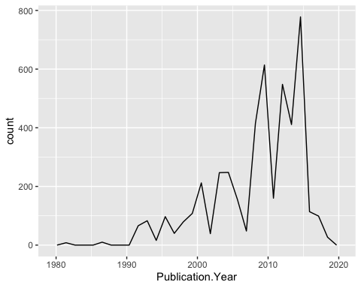

1. Reproduce the same graph but now add a color aesthetic so that different Test.Location are displayed as different colors.

ggplot(Neonics.data)+  
geom_freqpoly(aes(x = Publication.Year, color=Test.Location))

## `stat_bin()` using `bins = 30`. Pick better value with `binwidth`.

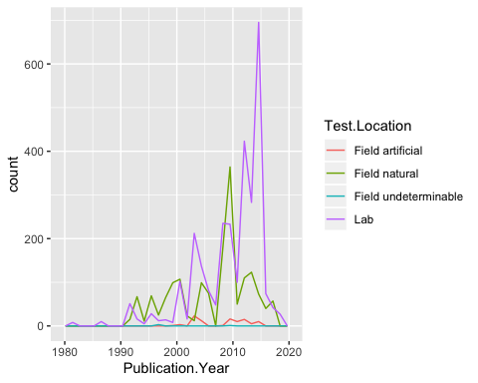

Interpret this graph. What are the most common test locations, and do they differ over time?

Answer: The lab appears to be the most common test location starting around early 2000s until the present. “Field natural” test location was more common beginning early 1990s, but have fluctuated since 2000s. The “artifical field” test locations were rarely used throughout the whole time spand from 1980-2020.

1. Create a bar graph of Endpoint counts. What are the two most common end points, and how are they defined? Consult the ECOTOX_CodeAppendix for more information.

ggplot(Neonics.data, aes(x = Endpoint)) +  
 geom_bar()

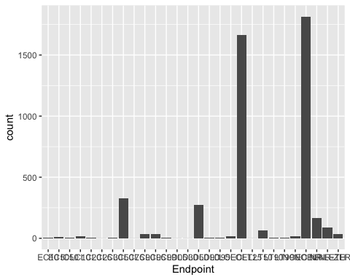

summary(Neonics.data$Endpoint)

## EC10 EC50 IC50 LC10 LC20 LC25 LC30 LC50 LC75 LC90   
## 6 11 6 15 5 1 6 327 1 37   
## LC95 LC99 LD05 LD30 LD50 LD90 LD95 LOEC LOEL LT25   
## 36 2 1 1 274 6 7 17 1664 1   
## LT50 LT90 LT99 NOEC NOEL NR NR-LETH NR-ZERO   
## 65 7 2 19 1816 167 86 37

Answer: The two most common end points are NOEL and LOEL. NOEL is defined by their count, or the number of times they appeared in the dataset. NOEL had a count of 1816, and LOEL had a count of 1664.

## Explore your data (Litter)

1. Determine the class of collectDate. Is it a date? If not, change to a date and confirm the new class of the variable. Using the unique function, determine which dates litter was sampled in August 2018.

class(Litter.data$collectDate) #factor

## [1] "factor"

Litter.data$collectDate <- as.Date(Litter.data$collectDate, format = "%Y-%m-%d")   
class(Litter.data$collectDate)

## [1] "Date"

#Litter was collected August 2nd and August 30th in 2018

1. Using the unique function, determine how many plots were sampled at Niwot Ridge. How is the information obtained from unique different from that obtained from summary?

unique(Litter.data$plotID)

## [1] NIWO_061 NIWO_064 NIWO_067 NIWO_040 NIWO_041 NIWO_063 NIWO_047 NIWO_051  
## [9] NIWO_058 NIWO_046 NIWO_062 NIWO_057  
## 12 Levels: NIWO_040 NIWO_041 NIWO_046 NIWO_047 NIWO_051 NIWO_057 ... NIWO_067

Answer: 12 different plots were sampled at Niwot Ridge. The information obtained from the “unique” function eliminates duplicate elements/rows from a vector, data frame or array. The summary function produces a summary of all records in the found in the dataset which can include duplicates.

1. Create a bar graph of functionalGroup counts. This shows you what type of litter is collected at the Niwot Ridge sites. Notice that litter types are fairly equally distributed across the Niwot Ridge sites.

ggplot(Litter.data, aes(x = functionalGroup)) +  
 geom_bar()

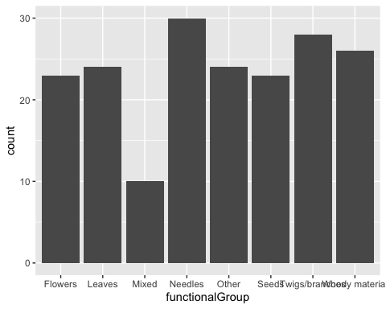

summary(Litter.data$functionalGroup)

## Flowers Leaves Mixed Needles Other   
## 23 24 10 30 24   
## Seeds Twigs/branches Woody material   
## 23 28 26

1. Using geom_boxplot and geom_violin, create a boxplot and a violin plot of dryMass by functionalGroup.

ggplot(Litter.data) +  
 geom_boxplot(aes(x = functionalGroup, y = dryMass)) #box plot

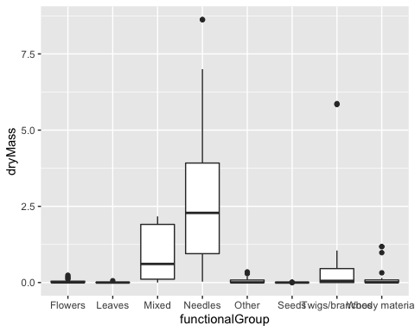

ggplot(Litter.data) +  
 geom_violin(aes(x = functionalGroup, y = dryMass)) #violin plot

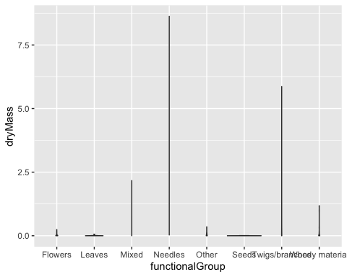

Why is the boxplot a more effective visualization option than the violin plot in this case?

Answer: The boxplot is a more effective visualization option than the violin plot becuase it better visualizes the data provided. It illustrates the the interquartile range, median, variabilities, and statistical outliers clearly. It also provides some indication of the data’s symmetry and skewness. The violin plot, which displays density distributions, illustrated very little for the data provided. It could not clearly show information about sample counts, medians, interquartile ranges, and lower/upper values. It makes the data appear incomplete.

What type(s) of litter tend to have the highest biomass at these sites?

Answer: Needles and woody material litter tend to have the highest biomass at these sites.