C Sc 335 Analysis and Design Artifacts for the Final Project, Spring 2014
Due: 11:00pm Friday 11-April to the common repository in BitBucket as part of your Java project
1. Team Name: ______Spaceballs______________
2. Team Members: ___Mark Gardner_________ ____Ethan Mangosing_____
____Luis Teran_________ ______Devin Birtciel_________
3. Project Chosen: Circle your team's choice of final project
TRPG MUD Tower Defense Settlement Management

4. Candidate Objects or Class Hierarchies

List the seven most important objects, or the name of a hierarchy, and the main responsibility of each

Candidate Object | Single Responsibility in 1 or 2 sentences
1 Level | Holds the map, units, and UI, and runs most of the game logic.
2 Map | Holds an array of Tiles that represents the spaces on the map, also does path finding.
3 Tile | A square on the map that can be some type of terrain or can hold a unit.
4 Ship | A unit on the map, keeps track of stats and items, can move around, attack, etc
5 Item | An item that can be held by a Ship and used during a turn. Items have different effects on the ship or the map.
6 GameObject | Class that most things inherit from, has a list of children that it updates and draws every frame, so you can have a tree of GameObjects and just update the root at the start of each frame.
7 Input | Keeps a list of Buttons and notifies a button when the user has clicked it.

5. Class Diagram:
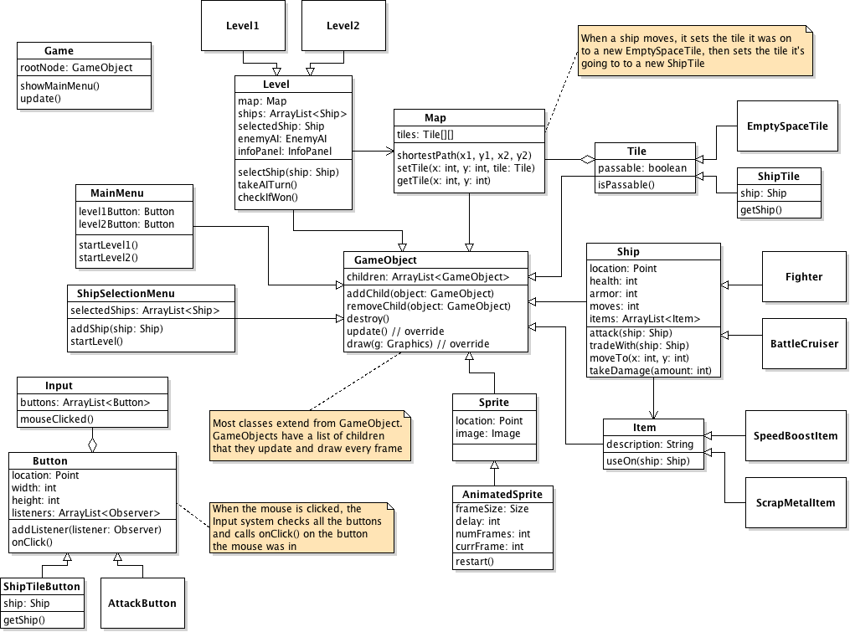
6. Sequence Diagram:
