实验九、配置 RIP路由协议

9.1、实验目的
掌握在路由器上配置RIP2，实现网络的互连互通，从而实现信息的共享和传递。

9.2、实验背景
假设校园网通过1台三层交换机连接到校园网出口路由器，路由器连接到校园外的另1台路由器上，现要在路由器上做适当配置，实现校园网内部主机与校园网外部的相互通信。
本案例以两台路由器、1台三层交换机为例。S3760E上划分有VLAN10和VLAN50，其中VLAN10用于连接Router1,VLAN50用于连接校园网主机。路由器分别命名为Router1和Router2，路由器之间用过串口采用V35 DCE/DTE电缆连接，DCE端连接到Router1上。PC1的IP地址和缺省网关分别为172.16.5.11和172.16.5.1，PC2的IP地址和缺省网关分别为172.16.3.22和172.16.3.1，网络掩码都是255.255.255.0.

9.3、实验设备
设备类型 | 设备名称 | 设备数量
三层交换机 | Switch | 1
路由器 | router | 2
双绞线跳线 |  | 4
计算机 | pc | 2

9.4、实验拓扑
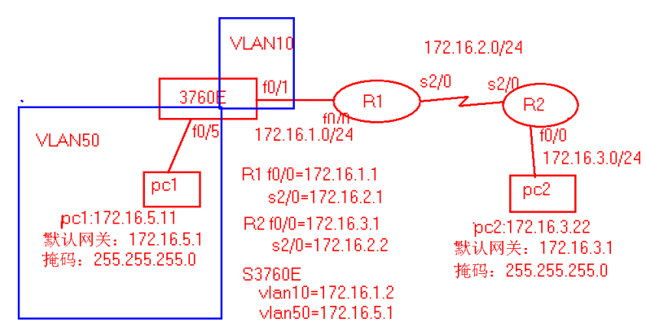

9.5、实验内容

9.5.1三层交换机的基本配置
1、配置命令
Switch#configure terminal
Switch(config)#hostname S3760E
S3760E(config)#VLan 10
S3760E(config-vlan)#exit
S3760E(config)#Vlan 50
S3760E(config-vlan)#exit
S3760E(config)#interface fastEthernet 0/1
S3760E(config-if)#switchport access vlan 10
S3760E(config-if)#exit
S3760E(config)#interface fastEthernet 0/5
S3760E(config-if)#switchport access vlan 50
S3760E(config-if)#exit
S3760E(config)#interface vlan 10
S3760E(config-if)#ip address 172.16.1.2 255.255.255.0
S3760E(config-if)#no shutdown
S3760E(config-if)#exit
S3760E(config)#interface vlan 50
S3760E(config-if)#ip address 172.16.5.1 255.255.255.0
S3760E(config-if)#no shutdown
S3760E(config-if)#ip routing
S3760E(config-if)#exit

2、验证测试:
S3760E#show vlan
写出结果（截屏或拷贝）
S3760E#show ip interface
写出相关部分的截屏或拷贝

9.5.2路由器基本配置
1、配置命令
以下ROUTER1代表我们使用的第一个路由器
router1(config)#interface fastEthernet 0/0
router1(config-if)#ip address 172.16.1.1 255.255.255.0
router1(config-if)#no shutdown
router1(config-if)#exit
router1(config)#interface serial2/0(如果使用第一个和第三个路由器则是S3/0)
router1(config-if)#ip address 172.16.2.1 255.255.255.0
router1(config-if)#no shutdown

router2(config)#interface serial 2/0
router2(config-if)#ip address 172.16.2.2 255.255.255.0
router2(config-if)#no shutdown
router2(config-if)#exit
router2(config)#interface fastEthernet 0/0
router2(config-if)#ip address 172.16.3.1 255.255.255.0
router2(config-if)#no shutdown
router2(config-if)#exit
2、验证测试:验证接口的配置和状态
router1#show ip interface brief
写出或截屏结果
router2#show ip interface brief
写出或截屏结果

9.5.3 配置RIP协议
1、 S3760E配置RIP协议
S3760E(config)#router rip !开启rip协议进程
S3760E(config-router)#network 172.16.1.0 !申明本设备的直连网段
S3760E(config-router)#network 172.16.5.0
S3760E(config-router)#version 2 !定义rip协议v2
S3760E(config-router)#no auto-summary
2、 router1配置RIP协议
router1(config)#router rip
router1(config-router)#network 172.16.1.0
router1(config-router)#network 172.16.2.0
router1(config-router)#version 2
router1(config-router)#no auto-summary !关闭路由信息的自动汇总
3、 router2配置RIP协议
router2(config)#router rip
router2(config-router)#network 172.16.2.0
router2(config-router)#network 172.16.3.0
router2(config-router)#version 2
router2(config-router)#no auto-summary

9.5.4 验证三台路由设备的路由表,查看是否学习了其它网段的路由信息
1、查看结果
S3760E#show ip route
写出结果或截屏（以下是其它交换机的结果，供参考）
Type: C - connected, S - static, R - RIP, O - OSPF, IA - OSPF inter area
N1 - OSPF NSSA external type 1, N2 - OSPF NSSA external type 2
E1 - OSPF external type 1, E2 - OSPF external type 2
Type Destination IP Next hop Interface Distance Metric Status
---- ------------------ --------------- --------- -------- -------- -------
C 172.16.1.0/24 0.0.0.0 VL10 0 0 Active
R 172.16.2.0/24 172.16.1.1 VL10 120 2 Active
R 172.16.3.0/24 172.16.1.1 VL10 120 3 Active
C 172.16.5.0/24 0.0.0.0 VL50 0 0 Active
router1#show ip route
写出结果或截屏（以下是其它路由器的结果，供参考）

Codes: C - connected, S - static, R - RIP
O - OSPF, IA - OSPF inter area
E1 - OSPF external type 1, E2 - OSPF external type 2
Gateway of last resort is not set
172.16.0.0/24 is subnetted, 4 subnets
R 172.16.5.0 [120/1] via 172.16.1.2, 00:00:04, FastEthernet0
C 172.16.1.0 is directly connected, FastEthernet0
C 172.16.2.0 is directly connected, Serial0
R 172.16.3.0 [120/1] via 172.16.2.2, 00:00:02, Serial0
router2#show ip route
写出结果或截屏（以下是其它路由器的结果，供参考）

Codes: C - connected, S - static, R - RIP
O - OSPF, IA - OSPF inter area
E1 - OSPF external type 1, E2 - OSPF external type 2
Gateway of last resort is not set
172.16.0.0/24 is subnetted, 4 subnets
R 172.16.5.0 [120/2] via 172.16.2.1, 00:00:26, Serial0
R 172.16.1.0 [120/1] via 172.16.2.1, 00:00:26, Serial0
C 172.16.2.0 is directly connected, Serial0
C 172.16.3.0 is directly connected, FastEthernet0
2、验证结果
C:\Documents and Settings\Administrator>ping 172.16.2.22
!从PC1 ping PC2
写出结果或截屏（以下是其它路由器的结果，供参考）

Pinging 172.16.2.22 with 32 bytes of data:
Reply from 172.16.2.22: bytes=32 time<1ms TTL=126
Reply from 172.16.2.22: bytes=32 time<1ms TTL=126
Reply from 172.16.2.22: bytes=32 time=358ms TTL=126
Reply from 172.16.2.22: bytes=32 time<1ms TTL=126
Ping statistics for 172.16.2.22:
Packets: Sent = 4, Received = 4, Lost = 0 (0% loss),
Approximate round trip times in milli-seconds:
Minimum = 0ms, Maximum = 358ms, Average = 89ms
3、参考配置
S3760E#show running-config
写出结果或截屏（以下是其它路由器的结果，供参考）

System software version : 2.41(4) Build Nov 23 2005 Rele
Building configuration...
Current configuration : 383 bytes!
version 1.0!
hostname S3760E
vlan 1!
vlan 10!
vlan 50!
interface FastEthernet 0/1
switchport access vlan 10!
interface FastEthernet 0/5
switchport access vlan 50!
interface Vlan 10
ip address 172.16.1.2 255.255.255.0!
interface Vlan 50
ip address 172.16.5.1 255.255.255.0!
router rip
version 2
network 172.16.0.0 mask 255.255.0.0!
end
router1#show running-config
写出结果或截屏（以下是其它路由器的结果，供参考）

Building configuration...
Current configuration:!
version 6.14(9coll)!
hostname "router1"!
ip subnet-zero!
interface FastEthernet0
ip address 172.16.1.1 255.255.255.0!
interface FastEthernet1
no ip address
shutdown!
interface FastEthernet2
no ip address
shutdown!
interface FastEthernet3
no ip address
shutdown!
interface Serial0
ip address 172.16.2.1 255.255.255.0!
interface Serial1
no ip address
shutdown!
interface Serial2
no ip address
shutdown!
interface Serial3
no ip address
shutdown!
router rip
version 2
network 172.16.0.0
no auto-summary!
ip classless!
line con 0
line aux 0
line vty 0 4
login
line vty 5 19
login!
end
router2#show running-config
写出结果或截屏（以下是其它路由器的结果，供参考）

Building configuration...
Current configuration:!
version 6.14(9coll)!
hostname "router2"!
ip subnet-zero!
interface FastEthernet0
ip address 172.16.3.1 255.255.255.0!
interface FastEthernet1
no ip address
shutdown!
interface FastEthernet2
no ip address
shutdown!
interface FastEthernet3
no ip address
shutdown!
interface Serial0
ip address 172.16.2.2 255.255.255.0
clock rate 64000!
interface Serial1
no ip address
shutdown!
router rip
version 2
network 172.16.0.0
no auto-summary!
ip classless!
line con 0
line aux 0
line vty 0 4
login
line vty 5 19
login!
end

6.6、实验结论和总结
（参考部分，自己总结）RIP协议是一个简单的距离矢量的动态的路由选择协议，它的特点是原理简单，易于构建简单的小型局域网。但它并不支持超过15跳的节点数，这极大地制约了RIP协议所能驾驭的网络规模，此外，定时的冗余的路由更新信息也极大浪费了链路的带宽资源。
体总括了本学期所学的所有知识点，相当于一次综合复习。

