UCSB.sapflow Sensor Manual
Mike Burnett
mburnett@ucsb.edu

Sensor Overview
UCSB.sapflow sensors are versatile temperature measurement and logging devices that can be used for a wide range of sapflow measurement techniques. In their present configuration, the sensors feature two 2-4” steel probes with four thermistors each, an identical steel probe with a heater wire, and the ability to log temperature data from eight thermistors at sub-second resolution as programmed by the user.
These sapflow sensors are based on the “Js5” design of (Beslity et al., 2022), whose schematics and code are available online. The Js5 PCB design has been altered substantially for UCSB.sapflow to minimize its size, but its circuitry is virtually unchanged, so the schematics provided in (Beslity et al., 2022) may still be used as a helpful reference. In this implementation of the Js5 design, the largest differences are the use of a more efficient step-up/step-down voltage regulator that can accommodate batteries in the ~6-7V range and that operates the sensor at 5V rather than 6V to improve power efficiency, different wire terminals to save space, large LiFePO4 batteries to replace the original NiMH power system, and consolidated wires to reduce entry points into the plastic outer case.
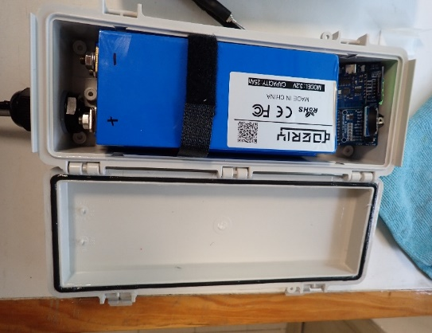
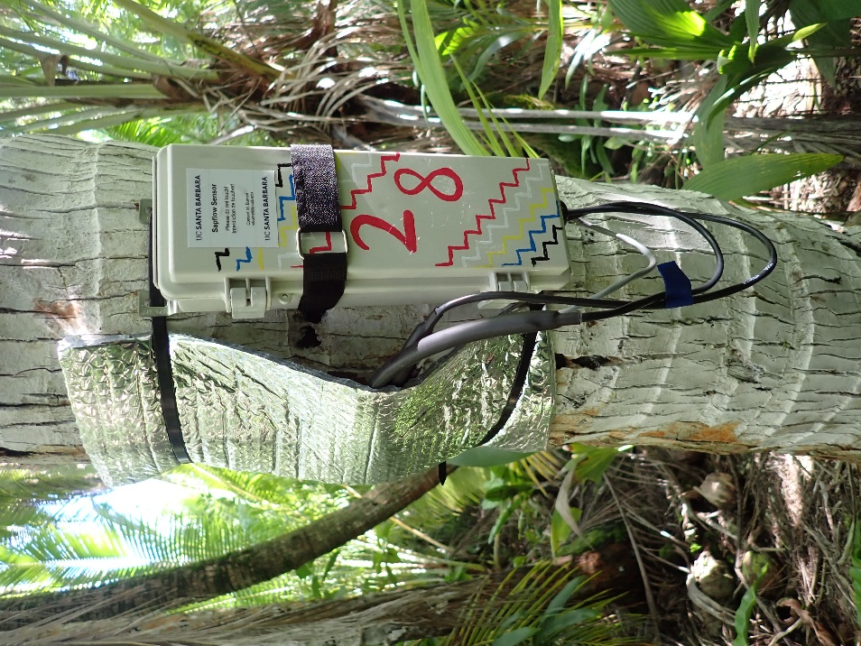
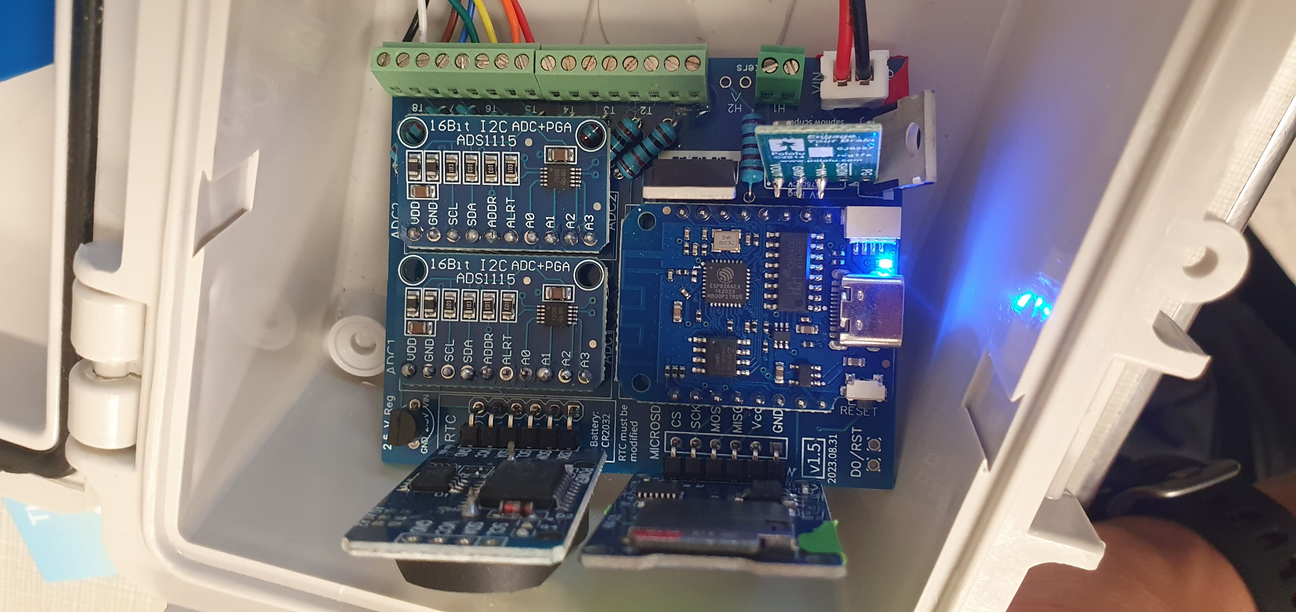
Many aspects of the design can be altered for a specific application. This manual includes information regarding the construction, programming, deployment, and data analysis of the UCSB.sapflow v1.5 sensors I deployed on Tetiaroa Atoll in January 2024.

Sensor Components
Almost all of the UCSB.sapflow parts can be purchased from online vendors without manufacturing delays. The one exception may be the tiny thermistors used in the probes. Models available on electronics storefront websites have become very expensive (~$20 each) recently, so I have been custom ordering them from Northstar Sensors LLC, a US manufacturer based in Oceanside, for ~$8 each. They are also available from Jingpu Semicoductor, a manufacturer based in China, for a similar price and lead-time. Note that when ordering from Northstar I have had to use private credit cards because UCSB’s procurement department refuses to agree to Northstar’s terms and conditions. It’s worth checking to see if thermistor prices go back down on the big electronics vendor websites (Mouser, Newark, Digikey).
I order my PCBs from JLCPCB, a Chinese manufacturer that has a direct interface with EasyEDA, an online PCB designer website. I can share my EasyEDA designs with you, or share them as Gerber files that can be uploaded to JLCPCB.
The following parts list includes most of the components needed to build a four-inch UCSB.sapflow sensor, with prices as of March 2024. See (Beslity et al., 2022) for the Js5’s original parts list, including the thermistors available ready-made from electronics vendors like Mouser. Probes of different lengths can be used (I have done 1, 2, and 4-inch) and the construction is fundamentally the same.
Dataloggers:
Part | Model | Number | Cost per unit - USD | Distributer
PCB | UCSB.sapflow.v1.5 | 1 | $1.10 | JLCPCB
Microcontroller | Lolin Wemos D1 Mini | 1 | $4.50 | https://www.aliexpress.us/item/2251832342786284.html?gatewayAdapt=glo2usa4itemAdapt
ADC | ADS1115 | 2 | $3.00 | https://www.amazon.com/ADS1115-Digital-Converter-Precised-Amplifier/dp/B082QX1RDV/ref=sr_1_4?keywords=ads1115&sr=8-4
RTC | DS3231SN | 1 | $3.00 | https://www.amazon.com/HiLetgo-AT24C32-Arduino-Without-Battery/dp/B00LX3V7F0/ref=asc_df_B00LX3V7F0/?hvadid=312400581241&hvpos=&hvnetw=g&hvrand=17769834166378412929&hvpone=&hvptwo=&hvqmt=&hvdev=c&hvdvcmdl=&hvlocint=&hvlocphy=9060098&hvtargid=pla-576374083857&psc=1
2.5 V Reference | LT1460GIZ-2.5#PBF | 1 | 5.2 | https://www.digikey.com/en/products/detail/analog-devices-inc/LT1460GIZ-2-5-PBF/961429?s=N4IgTCBcDaIDIBUCMAWAbABgOIEkBaAtGAHQCsAxAAoBCAYiALoC%2BQA
5 V Regulator | L7806CV-DG | 1 | $0.74 | https://www.digikey.com/en/products/detail/stmicroelectronics/L7806CV-DG/2832884?utm_adgroup=STMicroelectronics&utm_term=
P-Channel MOSFET | IRF9540NPBF | 1 | 1.49 | https://www.newark.com/infineon/irf9540npbf/p-channel-mosfet-100v-23a-to-220ab/dp/63J7431?mckv=s_dc|pcrid|502555683523|plid||kword|irf9540npbf|match|p|slid||product||pgrid|118241811733|ptaid|kwd-10793027907|&CMP=KNC-GUSA-GEN-SKU-Semiconductors-Semiconductors-Discretes--TROAS-S30&cmp=KNC-GUSA-GEN-SKU-Semiconductors-Semiconductors-Discretes--TROAS-S30&gad=1
N-Channel MOSFET | IRLZ34PBF | 1 | $2.15 | https://www.newark.com/vishay/irlz34pbf/n-channel-mosfet-60v-30a-to-220/dp/63J7707?CMP=e-email-sys-orderconfirmed-NA-Product
MicroSD Card Adapter | MicroSD Card Adapter (HW-125) | 1 | $1.20 | https://www.amazon.com/HiLetgo-Adater-Interface-Conversion-Arduino/dp/B07BJ2P6X6/ref=pd_vtp_h_vft_med_pd_vtp_h_vft_med_sccl_5/132-7027435-9995705?pd_rd_w=xjFj6&content-id=amzn1.sym.a5610dee-0db9-4ad9-a7a9-14285a430f83&pf_rd_p=a5610dee-0db9-4ad9-a7a9-14285a430f83&pf_rd_r=0F8R6NVEY7DFY3FHX0E9&pd_rd_wg=5hQEN&pd_rd_r=23c9a1fa-87e2-4dae-ab51-fb73043c55dc&pd_rd_i=B07BJ2P6X6&psc=1
MicroSD Card | Lexar 633x 32GB microSDHC (caution- don’t buy on Amazon!) | 1 | $4.99 | https://www.bhphotovideo.com/c/product/1274659-REG/lexar_lsdmi32gbbnl633a_32gb_high_performance_633x_microsdhc.html
Lithium Coin Cell Batteries | Lithium CR2032 3 V batteries | 1 | $0.80 | https://www.amazon.com/Panasonic-Lithium-Battery-20-Batteries/dp/B015JR47T8/ref=sr_1_15?keywords=cr2032&sr=8-15&th=1
Terminal block connectors (heater probes) | 2-Pin 2.54mm Pitch Screw Terminal Block Connector | 1 | $0.45 | https://www.amazon.com/dp/B07WKL6MRM
Terminal block connectors (thermistor probes) | 8-Pin 2.54mm Pitch Screw Terminal Block Connector | 2 | $0.80 | https://www.amazon.com/dp/B07WR6LM92
1K ohm Resistors | 1K ohm resistors | 1 | $0.11 | Amazon
10K ohm Resistors | 10K ohm resistors | 9 | $0.11 | Amazon
100k ohm Resistors | 100K ohm resistors | 1 | $0.11 | Amazon
Heater and Thermistor Probes:
Heater Wire | TFCC-005 PFA insulated wire | < 2 ft | $1.10 | Omega
Thermistors | 10K NTC Thermistor (3BT103R44T1A) | 8 | $8.17 | Northstar Sensors
Stainless Steel Dispensing Needle | 6710A43 (16-gauge, 4-inch) | 3 | $4.28 | https://www.mcmaster.com/products/needles/needle-length~4/
LiFePO4 batteries | 25 Ah 3.2v LiFePO4 prismatic cells | 2 | $17.10 | https://srikobatteries.com/product/new-25-pack-3-2v-25ah-lifepo4-topband-prismatic-cell-lithium-battery-12v-24v-48v/
Battery cables and board connectors | 2.54mm JST 22AWG pre-crimped wire set | 1 | $1.50 | https://www.amazon.com/dp/B0BW67LHS3?ref_=ppx_hzsearch_conn_dt_b_fed_asin_title_1
Thermal paste | Generic CPU thermal paste (1 g luer-slip syringe) | 1 | $0.40 | https://www.amazon.com/dp/B0BKPV85WF
Thermal epoxy | MG Chemicals 8329TFS |  |  | https://www.amazon.com/MG-Chemicals-Thermally-Conductive-milliliters/dp/B0721JXVL6/ref=sr_1_1_pp?sr=8-1
Heat shrink tubing for thermistor probe exteriors | 3/8" Heat Shrink Tubing - 3:1 Ratio - Adhesive Lined - Marine Grade Heat Shrink | 24” | $1.40 | Amazon
Heat shrink tubing for thermistor probe interiors | Heat Shrink Tubing - 1/16” Inch - Clear Polyolefin - 2:1 Industrial Shrink Tube & Cable Sleeve | 18” | $0.20 | https://www.amazon.com/dp/B079C1Y9MT
Heater probe cable | 2C cable | 3’ |  | https://www.digikey.com/en/products/detail/alpha-wire/M13302-SL005/3839010
Thermistor probe cable | 8C cable | 6’ |  | https://www.newark.com/pro-power/8c-alarm-black-100m/alarm-cable-8-core-black-100m/dp/50AC8143?CMP=e-email-sys-orderconfirmed-NA-Product
Case and Battery:
Cable gland | 3 Hole Nylon Cable Gland M20 (CGO-6103) | 1 | $1.20 | https://cableglandsonline.com/3-hole-gland-m20?search=CGO-6103
Battery nuts | M6-1.0 serrated flange hex nuts | 4 |  | (usually included with batteries)
Battery bar |  | 1 |  | (usually included with batteries)
Battery connectors | M6 wire crimp ring terminals | 2 | $0.08 | https://www.amazon.com/Hilitchi-Insulated-Terminals-Electrical-Connectors/dp/B01D8C5HTA/ref=sr_1_5?sr=8-5
Waterproof case | Polycase WH-08 | 1 | $13.97 | https://www.polycase.com/wh-08
Velcro battery straps | Sew-on non-adhesive Velcro tape | 6” | $0.50 | https://www.amazon.com/dp/B0BPDGN973
Velcro cinch strap (sensor exterior) | 18-inch velcro cable strap | 1 | $0.57 | https://www.amazon.com/dp/B0775TH4RV?ref_=ppx_hzsearch_conn_dt_b_fed_asin_title_1
O-ring grease |  |  |  | Amazon
Desiccant packs | Dry & Dry 10 gram indicating desiccant packs | 1 | $0.30 | https://www.amazon.com/dp/B06X3SP3J6
Installation:
Probe insulation | Reflectix |  |  | Amazon
Probe thermal grease | Super Lube 98003 Silicone Heat Sink |  |  | https://www.amazon.com/dp/B0044NI2M2

A note on component sourcing/quality: some of our modules are coming from Amazon, where they are priced very cheaply. They may not be built with the advertised components or quality—many webpages examine how the chips on these Amazon boards are often counterfeit. In my anecdotal experience, the D1 mini microprocessor and the RTC module seemed to have higher failure rates when purchased cheaply on Amazon, so in the list above I am ordering them from more official sources.
DO NOT BUY MICROSD CARDS ON AMAZON OR OTHER MARKETPLACE SITES, THEY MAY BE COUNTERFEIT. I now buy from B&H Photo.
The RTC in particular is probably more accurate when purchased from Jameco because it uses a real DS3231SN chip as opposed to the DS3231M chips found on a lot of the Amazon RTCs (details). The MicroSD adapters have seemed reliable enough from Amazon, so I’ve included those in the parts list above, but I recommend doing a lot of testing to make sure they’re good before you put them in the field.
The ADS1115 ADC boards from Amazon seem reliable enough in terms of the signals they read, but I’ve run into problems with their compatibility with other components. I highly recommend breadboarding each logger’s specific set of D1 Mini, RTC, SD Adapter, and ADC together to make sure they’re compatible and can be programmed. Sometimes specific combinations of them don’t work, but swapping the positions of the two ADCs makes it work, or swapping one of the ADCs out works. It’s strange.
Some of the MOSFET-Ns I’ve gotten from Amazon are duds. I recommend testing the heater with a thermocouple device to make sure it’s heating up. If it’s not (and the heater probe is reading out an appropriate number of ohms), replacing the MOSFET-N usually fixes it and is not hard.

Power options
As currently configured, the UCSB.sapflow sensors should be able to operate with 1.7 to 11.8 V of input power, as determined by the 5V regulator. This could be supplied by a number of battery options, with or without solar power, or by any other DC power supply. The Pololu S7V7F5 regulator was chosen mostly because it is a drop-in replacement for typical 6V linear regulators and didn’t necessitate a PCB redesign, but it also has the advantage of higher effeciency and flexible input voltages. It is a step-up/step-down regulator, so theoretically it could run on less than 5V but I haven’t tested this and have stuck with 6.4V input for high efficiency. In theory, the two LiFePO4 batteries could be run in parallel to double capacity with only modest declines in effeciency, but I still need to look into this. Maximum output current and effeciency at different input voltages can be seen in the plots below. Note that according to my logging multimeter, 300 mA is the maximum current draw of the datalogger with a 25-ohm, 4” heater, but that this amperage would be higher with a shorter heater (which has less resistance if less heater wire is used).
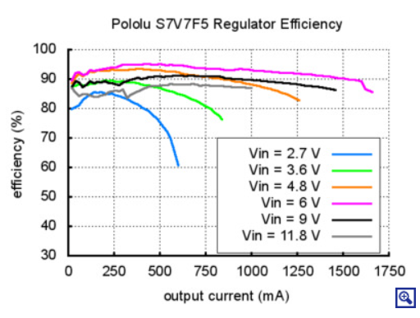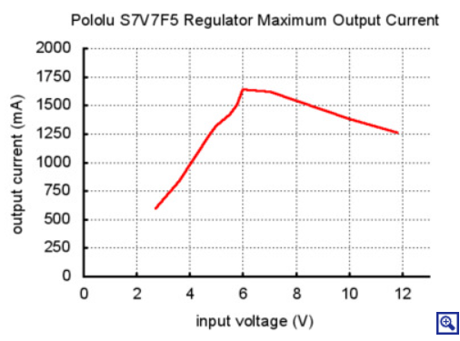
Power options could potentially be even wider with a different voltage regulator. I like the Pololu regulators listed above because they’re efficient and small, but anything that outputs enough volts for the Lolin D1 and the SD card adapter (which I think may require more than 3.3v) would work in place of the Pololu unit. If you use a different voltage regulator, be conscious of dropout voltages and make sure you’ve got enough volts going in.

Construction: dataloggers
Required tools:
- Soldering iron
- Wire snips
Recommended tools:
- Solder sucker
- Solder wick
To build the dataloggers, I recommend soldering in the following order (lowest components to tallest components, so they can be rested upside-down against the table):
- All resistors
- Both ADCs
- Lolin D1 Mini
- Power connecter terminal (white)
- All wire terminal blocks
- 2.5v regulator
- Both MOSFETs
- 5v regulator (Tip: trim the leads from the 90-degree riser after you solder it to the regulator or orient them away from the exposed pins of the D1 mini to avoid accidental shorts)
- RTC module (must be modified first, see below)
- MicroSD module
Trim wire leads as needed to avoid shorts and make assembly easier.
Some important construction notes:
- It’s really, really critical to make good solder joints! Unreliable or faulty loggers can almost always be fixed by cleaning up the solder joints. Make sure you’re melting the solder all the way into the hole and getting 360-degree coverage.
- If you print PCBs with my Gerber files (or those of the Js5), the MOSFET stencil outlines printed on the PCB surface are drawn backward. Refer to the pictures in this manual or Fig. 17 in (Beslity et al., 2022) to see what I mean.
- The RTC module needs to have three little surface-mounted components removed in order to remove its battery charging circuit. The picture below shows what you need to carefully desolder. For the lower component with eight pads, try not to leave any residual solder bridging the pads. Sometimes that causes the RTC to malfunction.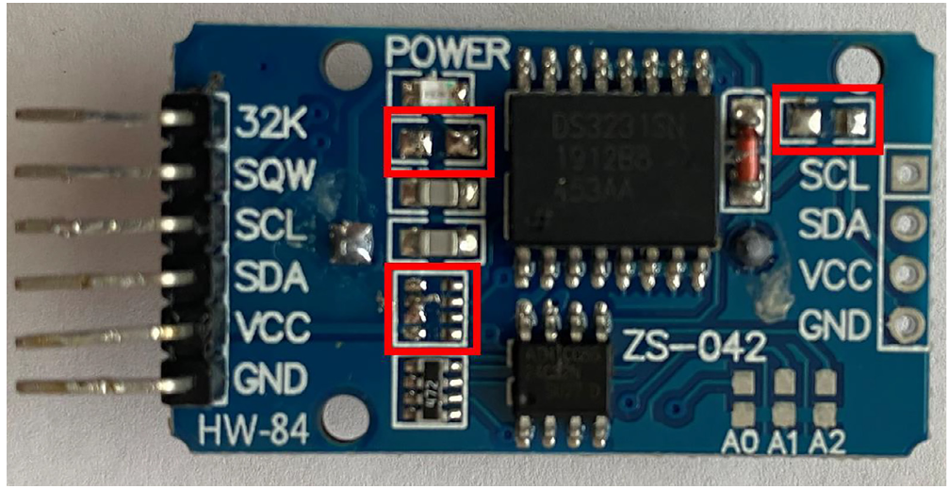

Construction: probes
Required tools:
- Soldering iron
- Wire strippers (as fine as 24 AWG)
- Luer-slip syringes
- Plastic mixing trays
- Lighter
- Heat gun
Recommended tools:
- Digital multimeter, preferable with alligator clip probes

Coming soon…

Construction: assembling the sensor
Required tools:
- Wire crimper
- Pliers (for tightening battery terminal nuts)
- Super glue
- O-ring grease
- Cordless drill with step-drill bit for drilling plastic
Recommended tools:
- Super glue accelerant spray

Once you’ve got the datalogger soldered and the probes built, there are a few more steps:
- Using the 20cm wires (see parts list), install a male JST plug on one red and one black wire (be mindful of which one will lead to Vin and which one will lead to GND! I think I actually mostly do it reverse of convention, so be careful if following my pictures). On the other ends, crimp ring bolts to the stripped wires. Tip: double the wires up on themselves to give the crimp more material to hold onto. But don’t reduce the length of the wire by too much—it’s a pretty tight fit already from the battery leads (positioned at the bottom of the case to separate them from the dataloggers) up to the white plug in the corner of the logger.
- Assemble a battery pack using two of the LiFePO4 batteries and an included battery bar + two nuts. Make sure you’re connecting them in series. Attach the wire rings from step 1 to the remaining two battery terminals, being mindful of polarity. Tip: I recommend using a sharpie to label both sides of every battery cell with – or +, it makes life a lot easier.
- Glue some velcro straps into the interior sides of the case where the battery will sit (see pictures). This will allow you to open the sensor while it’s installed on a tree without everything falling out.
- Drill a hole in the bottom of the box using a plastic step-drill. It should be just big enough for the cable gland—I don’t remember exactly what size that is, but just go step by step until the gland fits in.
- Install the gland with a generous amount of O-ring grease on all surfaces, including the inner surfaces of the rubber piece with three holes.
- Run all three cables through the cable gland’s holes, making sure grease soaks generously through all the holes.
- Insert the heater wires into the H1 or H2 2-hole wire terminal block and screw them in. Polarity does not matter.
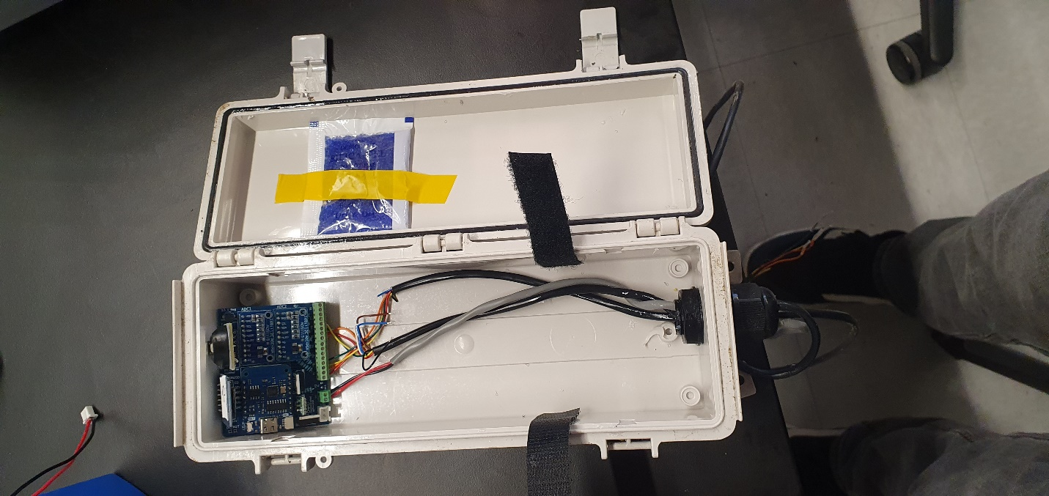
- Insert the sixteen thermistor wires into the two 8-hole wire terminal blocks and screw them in. Make sure you don’t have too much exposed metal, and that there aren’t any wire strands deflecting out of the holes. Remember the order—red, orange, yellow, green, blue, brown, white, black, going from the left to right if the datalogger is in its final position on a tree (see pictures for clarification). Technically, each pair of colors can have their positions swapped as polarity for each individual thermistor does not matter. The way my code currently works, the wire terminal block closer to the center of the datalogger is the bottom (upstream) probe (T1-T4) and the other block is the upper (downstream) probe (T5-T8). Tip: mark the bottom (upstream) probe with some tape after you screw all the wires in so it’s easy to keep track of.
- Once everything is screwed in, you can do whatever testing you want to do with the battery.
- I recommend taping one or two desiccant packs to the door, positioned so they don’t interfere with the velcro once the box is closed (see right)
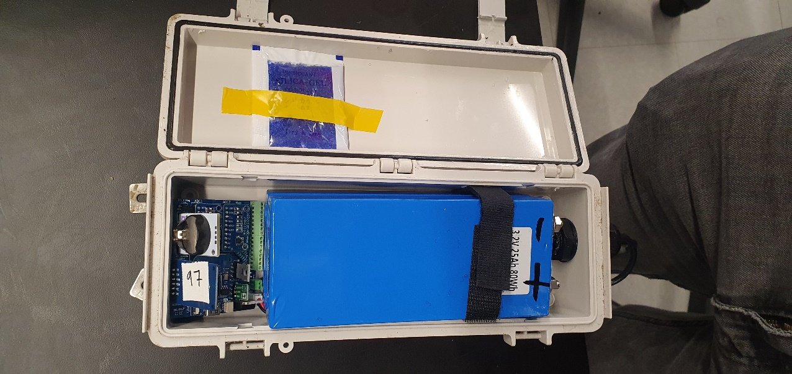
- To put the battery in, keep the cable gland loose so the wires can move around as needed. Plug in the battery and carefully lower it down into the sensor with the battery terminals facing away from the datalogger (precaution to prevent shorts). Run the wire up the left-hand side of the box on the shortest route to the white power input. Make sure the battery is not sitting on top of the green wire terminal blocks, but just below them on the wires. It’s okay if the datalogger tilts upward, it should still fit.
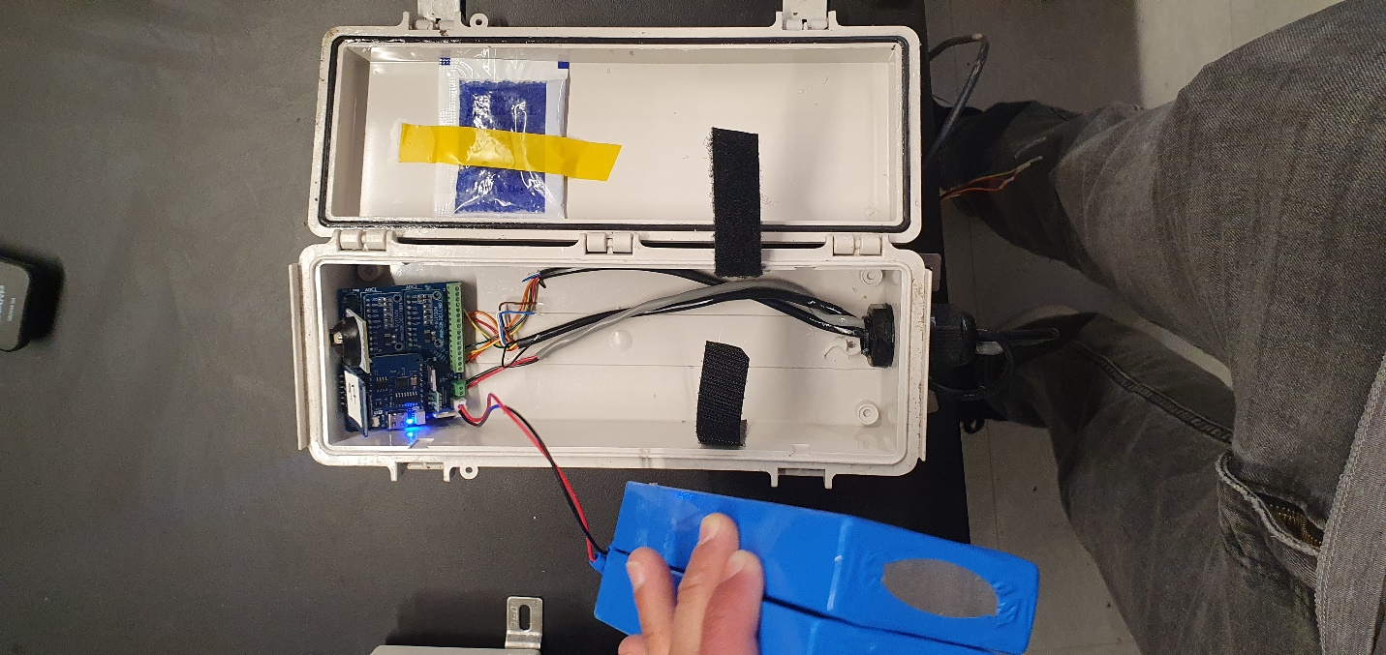
- Velcro in the battery and carefully close the lid.
- I recommend tightly strapping a velcro strap around the box for extra security. Make sure the strap is oriented so that when the box is on a tree, the strap can be undone and the datalogger accessed.

Programming the Sensor
Required tools:
- Computer with ArduinoIDE
- USB-C data cable
- MicroSD card reader
- Male-to-male breadboard jumper cable
Recommended tools:
- Thermocouple thermometer

WARNING: DO NOT PLUG IN BATTERY AND USB CORD AT THE SAME TIME!
WARNING: HEATERS CAN GET VERY HOT WHEN RUNNING THE BOARD ON USB POWER! UNPLUG HEATERS OR KEEP D1 MINI’s D3 BRIDGED TO GND (use holes by 5V reg) TO PREVENT.
Plug the logger in via USB and set up the Arduino IDE to communicate with it. Note that there are some drivers you need to download; see Beslity et al. 2022 for more info. As of June 2024 some of the links in that paper are out of date, but the appropriate packages and drivers can easily be located with Google. As of now, the URL for the Board Manager is: http://arduino.esp8266.com/stable/package_esp8266com_index.json
Program the sensor first with the Board_Configuration_SD.ino script. Make sure there is a microSD card and watch battery inserted. After it uploads the script, go to the Serial Monitor and set the baud to 115200. You should see:
Initializing SD card...initialization done.
17:44:49.286 -> Writing to test.txt...done.
17:44:49.328 -> Current time:
17:44:49.328 -> 2024/6/13 (Thursday) 17:44:3

Note: As of April 2025, sometimes an error along the lines of “A fatal error occurred: Timed out waiting for packet header" pops up when uploading a script. This is just a software issue and can be solved by changing the MD5_TIMEOUT_PER_MB value to 60 in esptool.py, which is buried within the Arduino15 folder. See here for more information. On my PC, the file is found at: "C:\Users\swb_1\AppData\Local\Arduino15\packages\esp8266\hardware\esp8266\3.1.2\tools\esptool\esptool.py"
If that all worked, use a jumper cable to bridge the two open holes by the 5V regulator. Press the D1 Mini’s reset button. Now upload the actual sapflow script. Once it’s done, you can unplug the USB first, remove the jumper cable, and run it directly off battery. Sometimes if it doesn’t seem to work on battery power, repeating the upload and running it off of the opposite power source fixes it. Also you might just need to be patient, as it may take up to half an hour to reach a read time.
The script is currently written so that the D1 Mini’s blue LED lights up during the first 10 seconds of data logging (this corresponds to the baseline measurement phase; the LED turns off once heating begins).

Board troubleshooting: I wrote a script called write-sapflow-test.ino that runs a short measurement cycle on the minute, so you can make sure it’s recording data properly.

Heater probe testing: I prefer to run the sensor on battery with a thermocouple thermometer attached to the heater probe to ensure it is heating up. Failure to heat up may indicate a MOSFET-N failure, but the resistance of the heater wire should be tested first (probably 10-25 ohms is good).

Installing the Sensor:
Required tools:
- Drill guide block (I had this custom-machined)
- Chisel and hammer to remove bark
- Ratchet strap, bungee cord, or screws to secure drill guide block
- Thermal lubricant
- Cordless drill with sufficiently long 1.7 mm drill bit (for 16-gauge needles)
- Zip-ties or screws to secure sensor to tree
Coming soon…

