Statistic Descriptive:Student Exam scores

Michael Zidane(20254920002)

2025-10-15



This is the result of my data analysis using R studio regarding the test scores of twenty students

[link dataset](https://www.kaggle.com/datasets/grandmaster07/student-exam-score-dataset-analysis?resource=download)

library(readr)  
library(tidyverse)

## ── Attaching core tidyverse packages ──────────────────────── tidyverse 2.0.0 ──  
## ✔ dplyr 1.1.4 ✔ purrr 1.1.0  
## ✔ forcats 1.0.1 ✔ stringr 1.5.2  
## ✔ ggplot2 4.0.0 ✔ tibble 3.3.0  
## ✔ lubridate 1.9.4 ✔ tidyr 1.3.1  
## ── Conflicts ────────────────────────────────────────── tidyverse_conflicts() ──  
## ✖ dplyr::filter() masks stats::filter()  
## ✖ dplyr::lag() masks stats::lag()  
## ℹ Use the conflicted package (<http://conflicted.r-lib.org/>) to force all conflicts to become errors

UTS_Mike_Zidane <- read_csv("C:/Users/Michael Zidane/Downloads/UTS Mike Zidane.csv")

## Rows: 20 Columns: 6  
## ── Column specification ────────────────────────────────────────────────────────  
## Delimiter: ","  
## chr (1): student_id  
## dbl (5): hours_studied, sleep_hours, attendance_percent, previous_scores, ex...  
##   
## ℹ Use `spec()` to retrieve the full column specification for this data.  
## ℹ Specify the column types or set `show_col_types = FALSE` to quiet this message.

View(UTS_Mike_Zidane)  
  
print(UTS_Mike_Zidane)

## # A tibble: 20 × 6  
## student_id hours_studied sleep_hours attendance_percent previous_scores  
## <chr> <dbl> <dbl> <dbl> <dbl>  
## 1 S001 8 8.8 72.1 45  
## 2 S002 1.3 8.6 60.7 55  
## 3 S003 4 8.2 73.7 86  
## 4 S004 3.5 4.8 95.1 66  
## 5 S005 9.1 6.4 89.8 71  
## 6 S006 8.4 5.1 58.5 75  
## 7 S007 10.8 6 54.2 88  
## 8 S008 2 4.3 75.8 55  
## 9 S009 5.6 5.9 81.6 84  
## 10 S010 1.3 8.9 66.8 70  
## 11 S011 3.4 5.3 90.9 81  
## 12 S012 6.6 7.9 87.6 85  
## 13 S013 1.3 6.3 83.6 71  
## 14 S014 3.2 6.1 61.2 68  
## 15 S015 8.1 8.8 60 90  
## 16 S016 7 9 51.2 41  
## 17 S017 3.4 6.8 62.2 45  
## 18 S018 7.5 7.6 73.8 58  
## 19 S019 9.9 4.8 92.5 54  
## 20 S020 1.1 5.5 53.6 65  
## # ℹ 1 more variable: exam_score <dbl>

# Hours Studied

summary(UTS_Mike_Zidane)

## student_id hours_studied sleep_hours attendance_percent  
## Length:20 Min. : 1.100 Min. :4.300 Min. :51.20   
## Class :character 1st Qu.: 2.900 1st Qu.:5.450 1st Qu.:60.52   
## Mode :character Median : 4.800 Median :6.350 Median :72.90   
## Mean : 5.275 Mean :6.755 Mean :72.25   
## 3rd Qu.: 8.025 3rd Qu.:8.300 3rd Qu.:84.60   
## Max. :10.800 Max. :9.000 Max. :95.10   
## previous_scores exam_score   
## Min. :41.00 Min. :17.10   
## 1st Qu.:55.00 1st Qu.:29.20   
## Median :69.00 Median :34.05   
## Mean :67.65 Mean :31.77   
## 3rd Qu.:81.75 3rd Qu.:35.73   
## Max. :90.00 Max. :41.10

mean(UTS_Mike_Zidane$hours_studied)

## [1] 5.275

median(UTS_Mike_Zidane$hours_studied)

## [1] 4.8

names(sort((-table(UTS_Mike_Zidane$hours_studied))))[1]

## [1] "1.3"

# Sleep Hours

summary(UTS_Mike_Zidane)

## student_id hours_studied sleep_hours attendance_percent  
## Length:20 Min. : 1.100 Min. :4.300 Min. :51.20   
## Class :character 1st Qu.: 2.900 1st Qu.:5.450 1st Qu.:60.52   
## Mode :character Median : 4.800 Median :6.350 Median :72.90   
## Mean : 5.275 Mean :6.755 Mean :72.25   
## 3rd Qu.: 8.025 3rd Qu.:8.300 3rd Qu.:84.60   
## Max. :10.800 Max. :9.000 Max. :95.10   
## previous_scores exam_score   
## Min. :41.00 Min. :17.10   
## 1st Qu.:55.00 1st Qu.:29.20   
## Median :69.00 Median :34.05   
## Mean :67.65 Mean :31.77   
## 3rd Qu.:81.75 3rd Qu.:35.73   
## Max. :90.00 Max. :41.10

mean(UTS_Mike_Zidane$sleep_hours)

## [1] 6.755

median(UTS_Mike_Zidane$sleep_hours)

## [1] 6.35

names(sort(-table(UTS_Mike_Zidane)))[1]

## NULL

# Attendance Percent

summary(UTS_Mike_Zidane)

## student_id hours_studied sleep_hours attendance_percent  
## Length:20 Min. : 1.100 Min. :4.300 Min. :51.20   
## Class :character 1st Qu.: 2.900 1st Qu.:5.450 1st Qu.:60.52   
## Mode :character Median : 4.800 Median :6.350 Median :72.90   
## Mean : 5.275 Mean :6.755 Mean :72.25   
## 3rd Qu.: 8.025 3rd Qu.:8.300 3rd Qu.:84.60   
## Max. :10.800 Max. :9.000 Max. :95.10   
## previous_scores exam_score   
## Min. :41.00 Min. :17.10   
## 1st Qu.:55.00 1st Qu.:29.20   
## Median :69.00 Median :34.05   
## Mean :67.65 Mean :31.77   
## 3rd Qu.:81.75 3rd Qu.:35.73   
## Max. :90.00 Max. :41.10

mean(UTS_Mike_Zidane$attendance_percent)

## [1] 72.245

median(UTS_Mike_Zidane$attendance_percent)

## [1] 72.9

names(sort(-table(UTS_Mike_Zidane)))[1]

## NULL

# Previous Score

summary(UTS_Mike_Zidane)

## student_id hours_studied sleep_hours attendance_percent  
## Length:20 Min. : 1.100 Min. :4.300 Min. :51.20   
## Class :character 1st Qu.: 2.900 1st Qu.:5.450 1st Qu.:60.52   
## Mode :character Median : 4.800 Median :6.350 Median :72.90   
## Mean : 5.275 Mean :6.755 Mean :72.25   
## 3rd Qu.: 8.025 3rd Qu.:8.300 3rd Qu.:84.60   
## Max. :10.800 Max. :9.000 Max. :95.10   
## previous_scores exam_score   
## Min. :41.00 Min. :17.10   
## 1st Qu.:55.00 1st Qu.:29.20   
## Median :69.00 Median :34.05   
## Mean :67.65 Mean :31.77   
## 3rd Qu.:81.75 3rd Qu.:35.73   
## Max. :90.00 Max. :41.10

mean(UTS_Mike_Zidane$previous_scores)

## [1] 67.65

median(UTS_Mike_Zidane$previous_scores)

## [1] 69

names(sort(-table(UTS_Mike_Zidane)))[1]

## NULL

# Exam Score

summary(UTS_Mike_Zidane)

## student_id hours_studied sleep_hours attendance_percent  
## Length:20 Min. : 1.100 Min. :4.300 Min. :51.20   
## Class :character 1st Qu.: 2.900 1st Qu.:5.450 1st Qu.:60.52   
## Mode :character Median : 4.800 Median :6.350 Median :72.90   
## Mean : 5.275 Mean :6.755 Mean :72.25   
## 3rd Qu.: 8.025 3rd Qu.:8.300 3rd Qu.:84.60   
## Max. :10.800 Max. :9.000 Max. :95.10   
## previous_scores exam_score   
## Min. :41.00 Min. :17.10   
## 1st Qu.:55.00 1st Qu.:29.20   
## Median :69.00 Median :34.05   
## Mean :67.65 Mean :31.77   
## 3rd Qu.:81.75 3rd Qu.:35.73   
## Max. :90.00 Max. :41.10

mean(UTS_Mike_Zidane$exam_score)

## [1] 31.775

names(sort(-table(UTS_Mike_Zidane)))[1]

## NULL

# Relationship between sleep hours and exam score

sleep_hours <- c(UTS_Mike_Zidane$sleep_hours)  
exam_score <- c(UTS_Mike_Zidane$exam_score)  
barplot(sleep_hours, names.arg = exam_score, col = "pink" ,main = "Relationship between sleep hours and exam score")

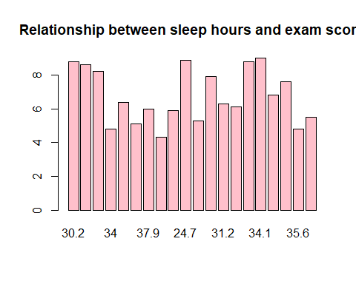 # Relationship between Hours Studied and exam score

hours_studied <- c(UTS_Mike_Zidane$hours_studied)  
exam_score <- c(UTS_Mike_Zidane$exam_score)  
barplot(hours_studied, names.arg = exam_score, col = "green" ,main = "Relationship between hours studied and exam score")

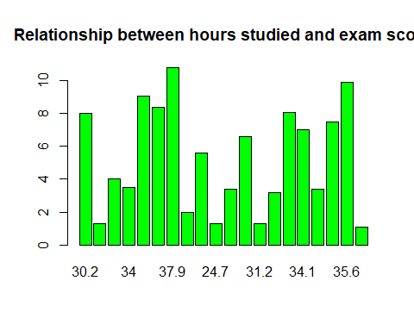 # Relationship between Attendance Percent and exam score

attendance_percent <- c(UTS_Mike_Zidane$attendance_percent)  
exam_score <- c(UTS_Mike_Zidane$exam_score)  
barplot(attendance_percent, names.arg = exam_score, col = "red", main = "Relationship between attendance percent and exam score")

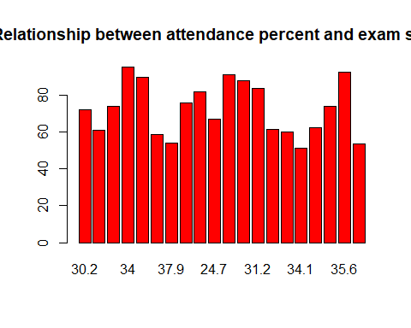 # # Relationship between Previous score and exam score

previous_score <- c(UTS_Mike_Zidane$attendance_percent)  
exam_score <- c(UTS_Mike_Zidane$exam_score)  
barplot(previous_score, names.arg = exam_score, col = "blue" ,main = "Relationship between Previous Score and exam score")

