Class-04.R

doradeng

2025-01-16

x <- 1:50  
plot (x, sin(x))

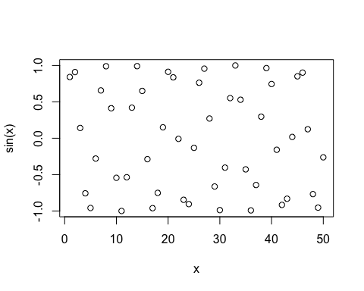

# Make this better  
plot(x, sin(x), col = "blue", type = "l", lwd=3)

