ePortfolio Enhancement Plan

Matthew Dunfe
Department of Computer Science
CS-499-12004-m01
Joseph Conlan
1/8/2026

I. Self-Introduction
a. Time in Program
I have been studying computer science for nearly a decade, beginning in 2015. My academic path has been non-linear due to life constraints, but this has resulted in repeated exposure to core computer science concepts across multiple contexts, allowing for deeper conceptual mastery rather than surface-level familiarity.
b. Three Most Important Concepts or Skills Learned
- Abstraction and Modeling
I have learned to reason about real-world systems as compositions of objects, interfaces, data flows, and constraints. This skill underpins software design, database modeling, and system architecture.
- Logic as a Universal Constraint System
Computer Science formalized my understanding that logic governs all deterministic systems. Whether expressed through algorithms, mathematics, or physics, logical consistency is the foundation of correct software.
- Automation Through Algorithmic Normalization
By combining structured data with algorithmic logic, complex workflows can be normalized, automated, and scaled. This principle appears repeatedly across DevOps, backend systems, and data-driven
c. Skills Demonstrated to Reach Course Outcomes
Course Outcome | Planned Demonstration
Collaborative environments | Public GitHub repositories, issues, documentation, and live deployed ePortfolio
Professional communication | Deployed full-stack application with coherent UI, architecture diagrams, and written narratives
Algorithmic problem solving | Search, sort, and data retrieval optimizations implemented server-side
Modern tools and techniques | React, Express, MongoDB, Docker, Docker Compose, Cloudflare Tunnel
Security mindset | Dependency audits, least-privilege API design, container isolation, removal of client-side data storage

d. Alignment With Career Plans
My career goal is to work in advanced computing research and development. This ePortfolio serves as a living technical proof of competency rather than a static resume. It allows employers and graduate committees to directly evaluate my reasoning, design decisions, and implementation quality.
e. Contribution to Specialization
This project demonstrates breadth across:
- Web engineering
- Algorithms and data structures
- Databases
- DevOps and deployment
This breadth supports both industry roles and future MS/PhD work, where projects will continue to integrate into this platform.

II. ePortfolio Setup
- Platform: GitHub Pages
- URL: https://www.multiversal.space
- Status: Live React-based portfolio with ongoing enhancements
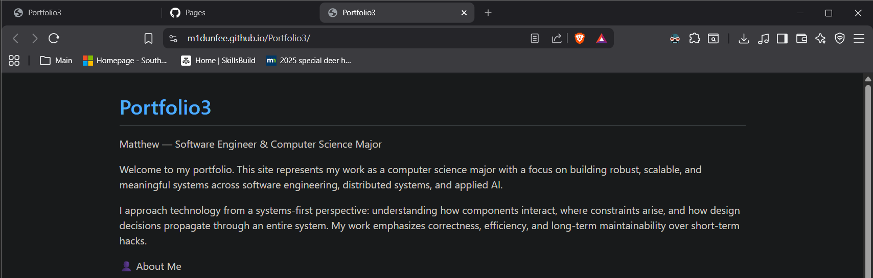

III. Enhancement Plan
Category One: Software Engineering and Design
a. Artifact and Origin
- Artifact: Portfolio Web Application
- Repository: https://github.com/m1dunfee/Portfolio3
- Origin: Originally created ~6 years ago; currently a React frontend consuming local JSON files.
b. Enhancement Plan
The portfolio will be refactored into a full-stack MERN application using containerized services. The system will be deployed from a Raspberry Pi using Docker Compose and exposed securely via Cloudflare Tunnel.
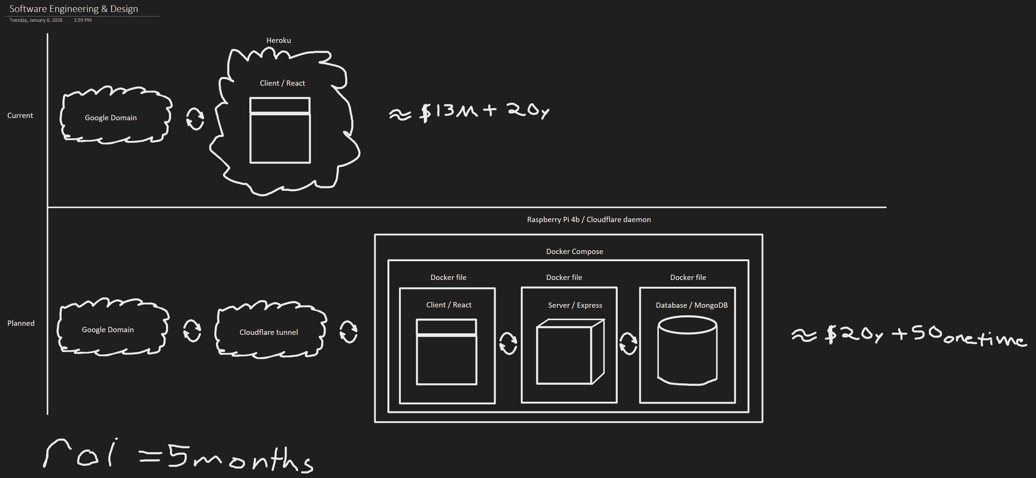
Planned Architecture
- React frontend
- Express REST API
- MongoDB database
- Docker + Docker Compose
- Cloudflare Tunnel (no public IP exposure)

c. Skills and Course Outcome Alignment
- Modular system design
- DevOps pipeline construction
- Secure deployment strategy
- Professional-quality visual and written communication
- Industry-aligned architectural patterns

Category Two: Algorithms and Data Structures
a. Artifact and Origin
- Artifact: Portfolio project listing and navigation system
- Extension of: Portfolio3 repository
b. Enhancement Plan
Currently, project data is loaded as static JSON and processed client-side. This will be replaced with database-backed queries supporting searching, sorting, and filtering at the API level.
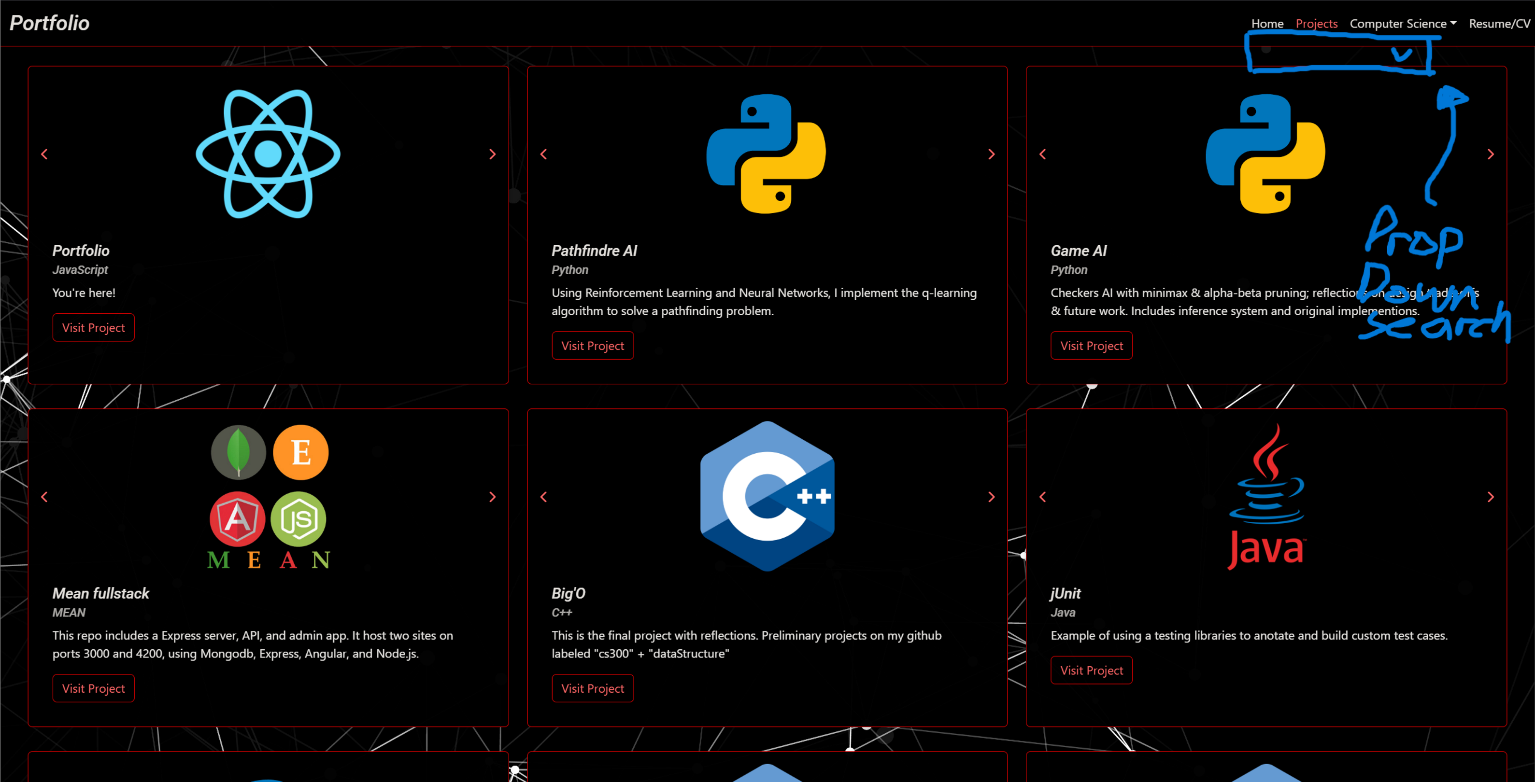

Algorithmic Improvements
- Design MongoDB classes to replace client-side JSON data files.
- Create server-side filtering to reduce payload size
- Model extensible query parameters language and technology for optimal retrieval.
Corrected Complexity Discussion
- Client-side rendering remains O(n) for display (unavoidable)
- Search and filter operations move from O(n) client scans to O(log n) or better via indexed database queries
- Reduces client workload and improves scalability
c. Skills and Course Outcome Alignment
- Application of algorithmic reasoning to real systems
- Data structure selection (indexed collections)
- Performance-aware design trade-offs
- Secure API surface design

Category Three: Databases
a. Artifact and Origin
- Artifact: Project data storage and retrieval
- Extension of: Portfolio3 repository
b. Enhancement Plan
All project data currently stored in frontend files will be migrated to MongoDB. Express routes connected.

API Interaction Flow
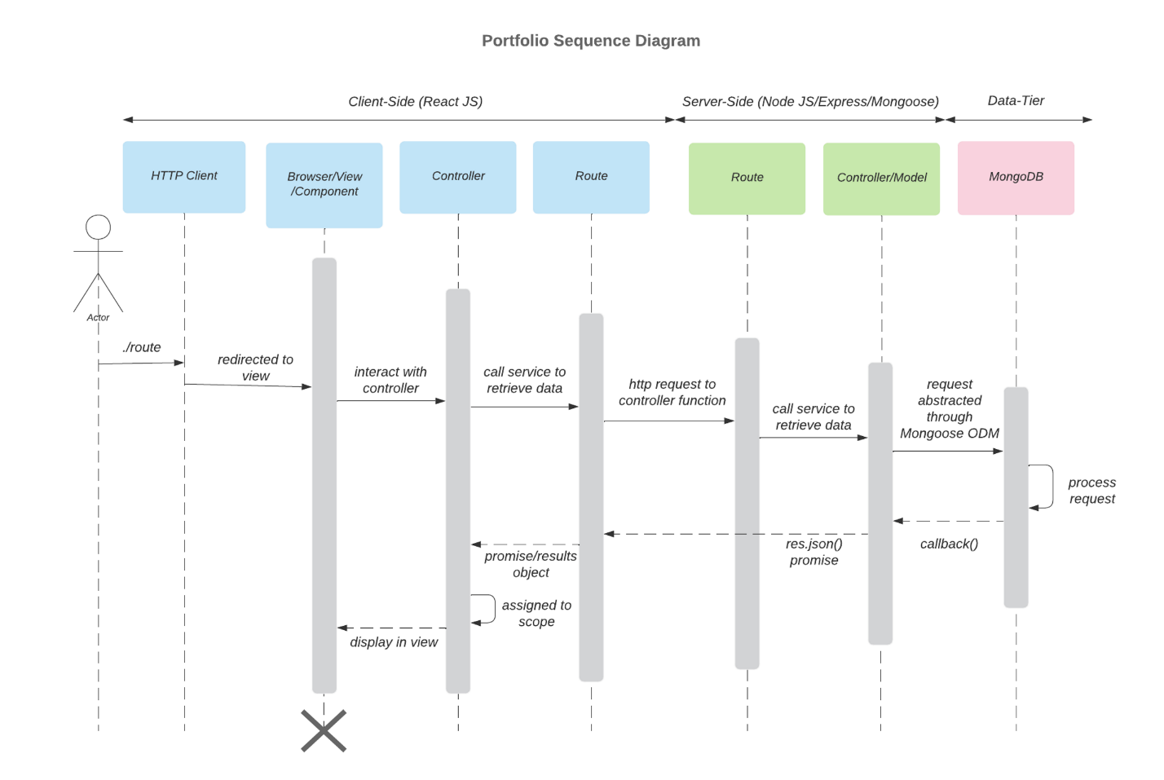
Database Design
- Projects collection
- Indexed fields: language, technology, date
- Controlled schema evolution
c. Skills and Course Outcome Alignment
- RESTful API design and implementation
- Database modeling and normalization
- Separation of concerns
- Data integrity and security

IV. ePortfolio Overall Skill Set
a. Skills Demonstrated in Code Review
- Full-stack system design
- Dockerized deployment
- REST API construction
- Database indexing and query optimization
b. Skills Demonstrated in Narratives
- Architectural reasoning
- Trade-off analysis
- Security considerations
- Professional technical communication
c. Skills Demonstrated in Professional Self-Assessment
- Long-term growth trajectory
- Reflection on design decisions
- Alignment with industry and research goals

