Journal 3: Computer Science Trends

Matthew Dunfee
Department of Computer Science
CS-499-12004-M01
Joseph Conlan
Feb 2, 2026

Part One:
- What is the significance of each trend?
Two long-run trends in computer science are deeply intertwined and often feel opposed: (1) automation through abstraction, and (2) the growth of system complexity as the domain and requirements expand. Abstraction is one of the field's core methods for scaling capability (building "higher-level" tools that compress detail), but it does not eliminate the essential difficulty of software. As Fred Brooks argues, there is a hard core of "essential complexity" that cannot be removed by better tools alone; abstraction can hide complexity locally while the overall problem space continues to grow (Brooks, 1987). Relatedly, Lehman's laws of software evolution describe a structural tendency: systems that remain useful must continually change, and as they evolve, their complexity increases unless active work is done to reduce it (Lehman, 1980; Lehman & Ramil, 1996).
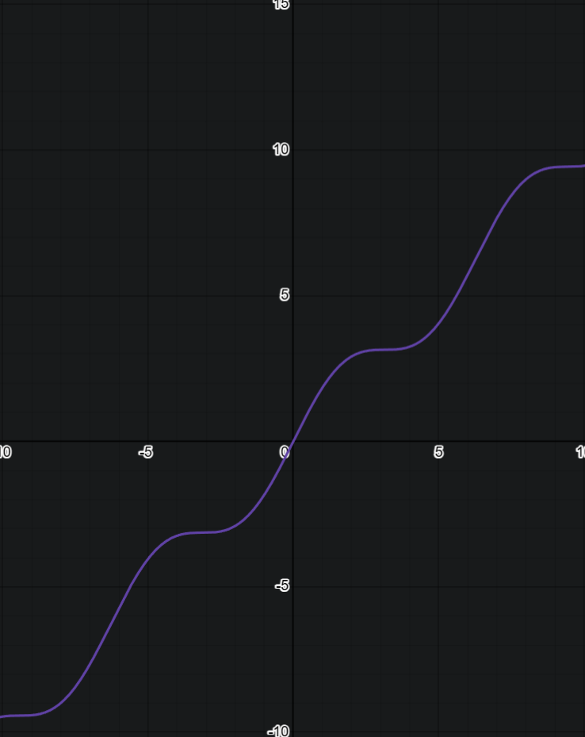
If we let x = time and y = a spectrum from "technical mastery required" to "automation available," we can often observe an arms race: new abstractions reduce the skill barrier for common tasks, but they also expand what is feasible to build, pulling the frontier outward. Computing functions as a general purpose technology that enables downstream innovation across many sectors (Bresnahan & Trajtenberg, 1995). That breadth is why the field never stabilizes: the domain keeps expanding.

- How will each trend change the field of computer science?
These trends create recurring waves: new abstractions and platforms open markets, capital floods in, organizations race to capture the productivity advantage, and then the hype corrects when timelines, adoption, or profitability fail to match expectations. This is the "boom-bust" pattern often associated with major technological revolutions, where finance can over-invest during an early installation phase and later consolidate during deployment (Perez, 2002). More generally, the literature on financial crises emphasizes how speculative manias can form around perceived transformative opportunities, followed by correction when expectations outrun fundamentals (Kindleberger & Aliber, 2015).
In computer science terms, each wave temporarily raises demand for specialized labor (engineers, security, infrastructure, data, compliance), then shifts demand again as the technology becomes standardized and productized. The long-run direction still points toward more automation and broader scope, but the short-run labor market can behave cyclically.

- How will each trend change the experience of consumers, workers, or citizens?
For consumers, abstraction and automation usually mean cheaper, faster, more convenient services; for workers and citizens, the distribution of gains is less automatic. Modern labor economics frames this through tasks: technology substitutes for some tasks and complements others, reshaping who benefits (Acemoglu & Restrepo, 2019). When automation replaces tasks disproportionately done by mid-skill workers while complementing high-skill work, it can contribute to job polarization and inequality (Autor & Dorn, 2013; Goos, Manning, & Salomons, 2014). Empirically, researchers have argued that task automation can be linked to changes in wage structure and inequality, even when productivity rises (Acemoglu & Restrepo, 2022).
This is one defensible interpretation of the saying "in computer science you never stop learning": the frontier shifts constantly, and workers are pushed into continuous reskilling to remain complementary to the new abstractions. In a capitalist political economy, the outcomes are not just technical; they depend on who owns the tools and how bargaining power, wages, and rents are distributed.

- How will each trend fit in with your career interests or aspirations?
My aspiration is research-oriented rather than purely commercial. The same mechanisms that produce innovation can also produce short-term incentive structures: intense competition for market dominance, speculative investment cycles, and distributional outcomes that can worsen inequality or concentrate rents. The labor economics work on automation gives a grounded way to argue that technological progress is not automatically socially progressive; it can increase inequality depending on what tasks are automated, how markets adapt, and how institutions distribute gains (Acemoglu & Restrepo, 2019; 2022). The techno-finance framing (Perez, 2002; Kindleberger & Aliber, 2015) also supports skepticism about hype-driven periods that prioritize rapid capitalization over long-term social benefit.
That is why I prefer research: the goal is to shape the direction of these tools (and the institutions around them) toward long-run human outcomes, not only short-run shareholder outcomes.

- Which course outcomes have you achieved so far, and which ones remain?
My time has been spent studying the core logic in computer science, not focusing on the syntax or flow of surface layer skills, but rather the math and science behind it. I have applied to 3 different PhD programs, and I am researching MS programs that could suit as intermediate steppingstones into research as a career path.

Part Two:
Provide an update to your instructor on your progress with each category of artifacts for the ePortfolio:
- Software design and engineering
I have had multiple revisions. My site has been rehauled from the front to the back. That includes removing nginx and just using Cloudflare and reworking docker files.
- Algorithms and data structures
I have connected the frontend to the back with restful services and removed old data files.
- Databases
I reworked all data to fit into one schema and indexed on three fields which allow for receival based on technology, skills, and discipline.

Category | Software Design and Engineering | Algorithms and Data Structures | Databases
Name of Artifact Used | Portfolio3 | Portfolio3 | Portfolio3
Status of Initial Enhancement | finished | finished | finished
Submission Status | complete | complete | complete
Status of Final Enhancement | reworking | complete | refining
Uploaded to ePortfolio | Git main (not prod) | Git main (not prod) | Git main (not prod)
Status of Finalized ePortfolio | No | No | No

References (APA-ish)
- Acemoglu, D., & Restrepo, P. (2019). Automation and new tasks: How technology displaces and reinstates labor. Journal of Economic Perspectives, 33(2), 3-30.
- Acemoglu, D., & Restrepo, P. (2022). Tasks, automation, and the rise in U.S. wage inequality. Econometrica, 90(5), 1973-2016.
- Autor, D. H., & Dorn, D. (2013). The growth of low-skill service jobs and the polarization of the U.S. labor market. American Economic Review, 103(5), 1553-1597.
- Bresnahan, T. F., & Trajtenberg, M. (1995). General purpose technologies: Engines of growth? Journal of Econometrics, 65(1), 83-108.
- Brooks, F. P., Jr. (1987). No silver bullet: Essence and accidents of software engineering. Computer, 20(4), 10-19.
- Goos, M., Manning, A., & Salomons, A. (2014). Explaining job polarization: Routine-biased technological change and offshoring. American Economic Review, 104(8), 2509-2526.
- Kindleberger, C. P., & Aliber, R. Z. (2015). Manias, panics, and crashes: A history of financial crises (7th ed.). Palgrave Macmillan.
- Lehman, M. M. (1980). Programs, life cycles, and laws of software evolution. Proceedings of the IEEE, 68(9), 1060-1076.
- Lehman, M. M., & Ramil, J. F. (1996). Software evolution and software evolution processes. Annals of Software Engineering, 1, 3-30.
- Perez, C. (2002). Technological revolutions and financial capital: The dynamics of bubbles and golden ages. Edward Elgar.

