Testing different stuff
Testing different stuff
Testing different stuff
Testing different stuff

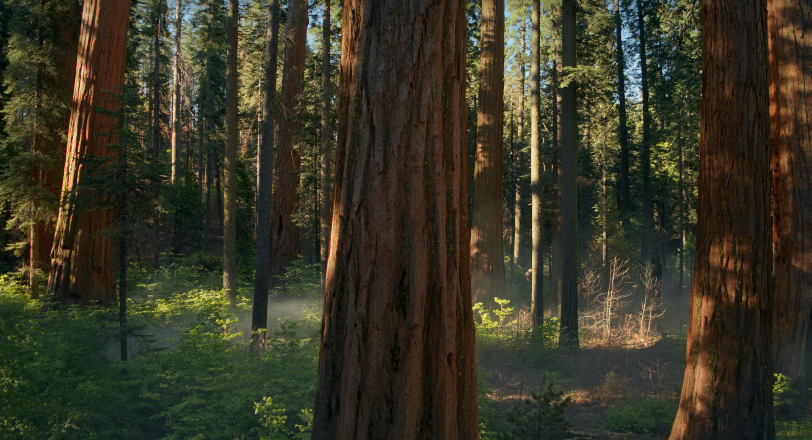
https://ruilisi.github.io/fortune-sheet-demo/?path=/story/features--basic

Dad | Dad | Dd | D
Dadd | D | D | D
D | D | D | D
Dd | D | D | D

