1. Decode the Base32 string

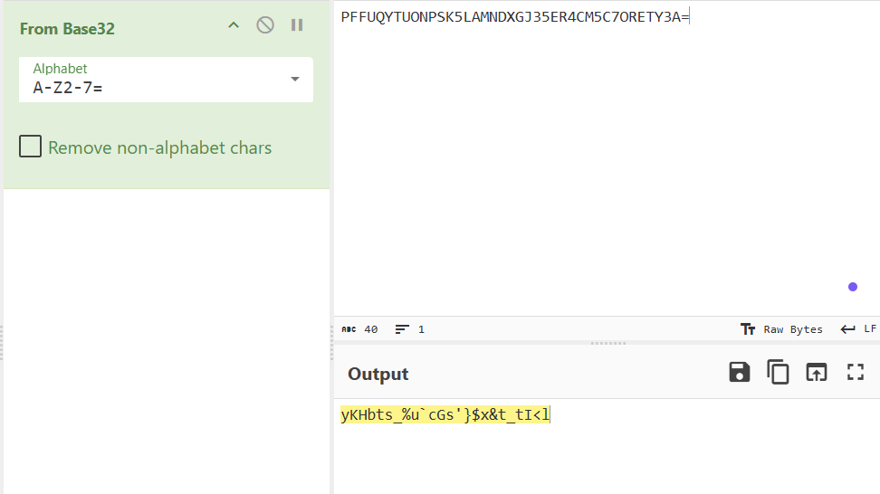

1. Use [dCode Cipher Identifier](https://www.dcode.fr/cipher-identifier) to identify the cipher used. The result is a ROT47 cipher.

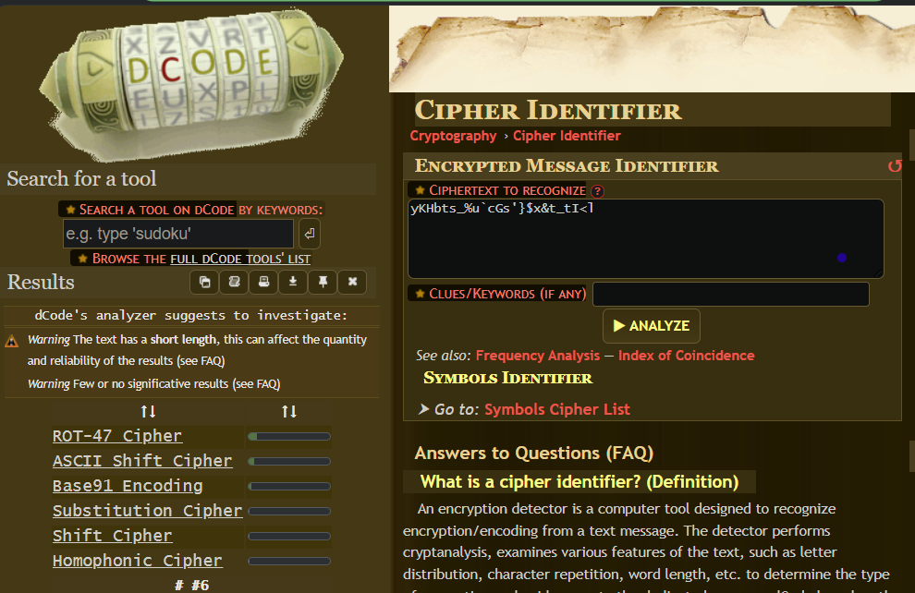

1. Decode the string using ROT47 cipher. The result is a Base64 string.

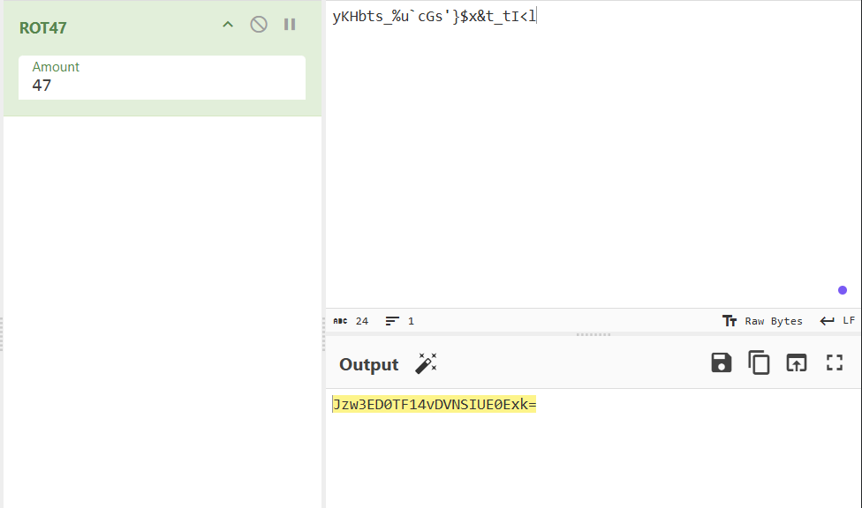

1. Decode the Base64 string. The result is a gibberish string.

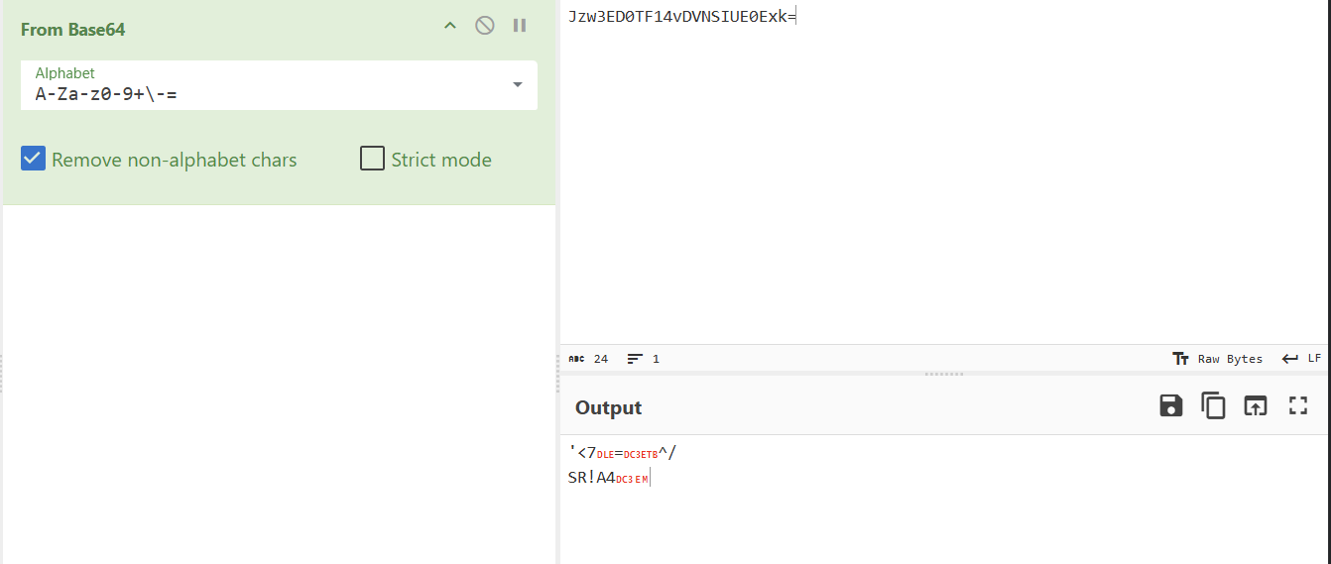

1. Find the pattern in the gibberish string use XOR with the flag format CIT{. It will reveal the key used to XOR the string, which is "duck"

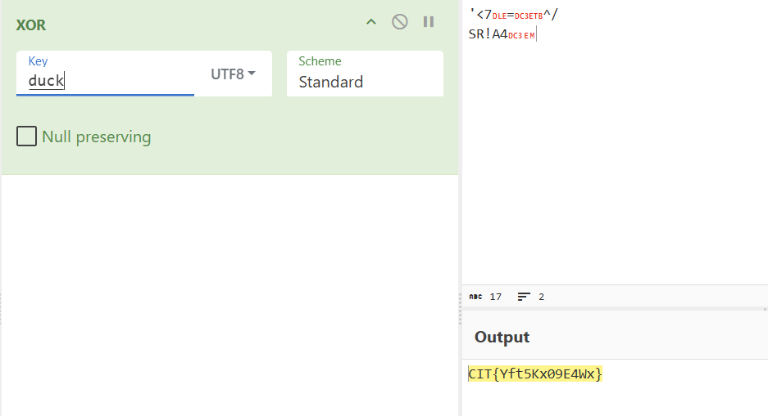

CÁCH LÀM NHANH

