|  |  |  |
| --- | --- | --- |
| **NAME** | **:** | Muhammad Al-Amin Bin Mohd Zaini |
| **STUDENT NO.** | **:** | 2018280578 |
| **GROUP** | **:** | RCS1104B |

|  |
| --- |
| **PART A** |
| Shades the best answer. |
|  |
| 1. Which of the following is NOT a type of linked list?  |  |  |  |  | | --- | --- | --- | --- | | Circular linked list | Doubly linked list | Singly linked list | Hybrid linked list |  1. Each node in a linked list contains a minimum of two fields, one field is called data field; to store data and another field is a _____.  |  |  |  |  | | --- | --- | --- | --- | | pointer to a node | pointer to a class | pointer to an integer | pointer to a character |  1. Given the following diagram:  |  |  |  |  |  |  |  |  |  |  |  |  |  |  |  |  | | --- | --- | --- | --- | --- | --- | --- | --- | --- | --- | --- | --- | --- | --- | --- | --- | |  | 12 |  |  |  | 55 |  |  |  | 2 |  |  |  | 11 |  |  |   This diagram shows a Circular linked list.   |  |  |  |  | | --- | --- | --- | --- | | Circular linked list | Doubly linked list | Reversed linked list | Singly linked list |  1. When user creates a reference to a linked list, it _____.  |  |  |  |  | | --- | --- | --- | --- | | must refer to the first link | must refer to the link pointed by current node | must refer to the link pointed by the next node | can refer to any link user wants | |
|  |
| **PART B** |
|  |
| Listed in the given table are the nodes in a linked list name ‘Beautiful’:   |  |  |  |  | | --- | --- | --- | --- | | Name of the node | Address of the node | Data of the node | Next address | | Makeup_1 | P0087L | Lipstick | K5467P | | Makeup_2 | K5467P | Blusher | L3217M | | Makeup_3 | L3217M | Mascara | P1237B | | Makeup_4 | P1237B | Brush | G7804H | | Makeup_5 | G7804H | Eyeliner | W3426M | | Makeup_6 | W3426M | Foundation | NULL |  1. Draw the initial diagram of ‘Beautiful’.        1. Remove the node named ‘Makeup_4’ from ‘Beautiful’.      1. Make the node given in table below as the last node of ‘Beautiful’:  |  |  |  |  | | --- | --- | --- | --- | | Name of the node | Address of the node | Data of the node | Next address | | Makeup_7 | P1007L | Primer | NULL |      1. Insert the given node below between node named ‘Makeup_2’ and ‘Makeup_3’:  |  |  |  |  | | --- | --- | --- | --- | | Name of the node | Address of the node | Data of the node | Next address | | Makeup_8 | M0007J | Bronzer |  |      1. Draw the final diagram for ‘Beautiful’. |
|  |

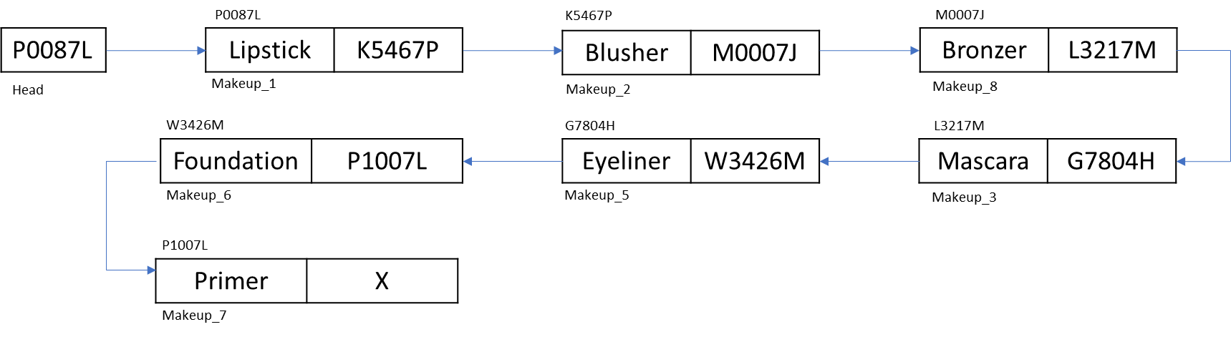

*Show clearly all the steps involved.