# ME2 Computing- Coursework summary

## Students: (Surname-CID): Joshua Chong (02125958) Path: B, Words: 984 /1000

## Michael Pan (01853189)

## 

A) What physics are you trying to model and analyse? (Describe clearly, in words, what physical phenomenon you wish to analyse)

We have chosen to model the price of derivatives on a financial market, which can be modelled with the Black-Scholes equation. This model is used by financial institutions and traders to more accurately hedge their positions to reduce risk exposure to the market. Options are contracts between the holder and issuer that gives the holder the to buy (call option) or sell (put option) a stock at a set strike price () at a specified time in the future (expiration date). The value of the option contract is therefore derived from the price of the underlying stock and the time left till expiration, assuming the variation of stock price with time follows a geometric Brownian motion with drift. To reduce complexity, we will model the value of a European call option where it can only be exercised on the expiration date.

B) What PDE are you trying to solve, associated with the Physics described in A? (write the PDE)

The Black-Scholes Equation is given by

|  |  |  |
| --- | --- | --- |
|  |  | () |

Where *V* represents option price, *S* is underlying stock price, *r* is risk-free interest rate, *σ* is volatility of the underlying stock price, and *t* is the time elapsed. This PDE is a parabolic equation that is first-order in time and second-order in stock price.

C) Boundary value and/or initial values for my specific problem: (be CONSISTENT with what you wrote in A)

As the PDE is first order in time and second order in stock price, one temporal condition and two boundary conditions are needed to model the problem.

Boundary condition 1:

|  |  |  |
| --- | --- | --- |
|  |  | (2) |

When the stock price is 0, the option value will also be 0 as there will be no payoff if the option is exercised.

Boundary condition 2:

|  |  |  |
| --- | --- | --- |
|  |  | (3) |

As , the payoff from exercising the option also approaches infinity, thus making it increasingly like for the option to be exercised. The value is thus the expected payoff of the option at the current stock price with a time dependent discount on the strike price, as more time till expiration increases the likelihood of the stock price and thus payoff to keep increasing.

Terminal condition:

|  |  |  |
| --- | --- | --- |
|  |  | (4) |

At the expiration date (T), the option is either not exercised for 0 payoff or exercised for a profit, the terminal condition is the maximum of the two.

D) What numerical method are you going to deploy and why? (Describe, in words, which method you intend to apply and why you have chosen it as opposed to other alternatives)

The explicit finite difference method and Crank-Nicolson implicit method were used to model the equation. The explicit method used a forward difference in time and central difference in price. The Crank-Nicolson method was chosen as it is commonly used to model this equation in literature, and also used for the heat equation which we transformed into in a later section.

E) I am going to discretise my PDE as the following (show the steps from continuous to discrete equation and boundary/initial conditions:

To simplify the solving process, we transformed the equation into the form of the heat equation. First, the time variable *t* was substituted with time to expiry *τ* to change the problem into a forward problem with initial condition at *T*.

|  |  |  |
| --- | --- | --- |
|  |  | (5) |
|  |  | (6) |

A suitable transformation for *S* is chosen to remove *S2* from the equation.

|  |  |  |
| --- | --- | --- |
|  |  | (7) |
|  |  | (8) |
|  |  | (9) |

Where a negative value of x indicates that the stock price is lower than the exercise price, and vice versa for a positive value of x.

Equations 7, 9 and 10 were substituted into equation 1 to give:

|  |  |  |
| --- | --- | --- |
|  |  | (10) |

To remove and from equation 11, the following transformation for was used.

|  |  |  |
| --- | --- | --- |
|  |  | (11) |
|  |  | (12) |
|  |  | (13) |
|  |  | () |

Equations 12 to 15 were substituted into equation 11 to give

|  |  |  |
| --- | --- | --- |
|  |  | () |

To obtain the heat equation, the coefficients of both and *u* must equal to 0. The constants α and β are hence:

|  |  |  |
| --- | --- | --- |
|  |  | () |
|  |  | () | |

The Black-Scholes equation can thus be expressed in the form of the heat equation as:

|  |  |  |
| --- | --- | --- |
|  |  | () |

The transformed equation now has the following boundary conditions for and .

|  |  |  |
| --- | --- | --- |
|  |  | () |
|  |  | () |
|  |  | () | |

Central difference and forward difference approximations w used in stock price and time respectively.

|  |  |  |
| --- | --- | --- |
|  |  | (22) |
|  |  | (23) | |

Where is the time step and is the mesh size in *x*. Substituting these approximations into equation (19) allows us to solve the equation explicitly:

|  |  |  |
| --- | --- | --- |
|  |  | () |
|  |  | () | |

Crank-Nicholson Method

The Crank-Nicholson method was used to solve the PDE implicitly. An average of the space quotients is taken at the present and subsequent time steps:

|  |  |  |
| --- | --- | --- |
|  |  | () |

Substituting the average in:

|  |  |  |
| --- | --- | --- |
|  |  | () |

Equation (28) is rearranged to have terms of the same time steps on each side:

|  |  |  |
| --- | --- | --- |
|  |  | () |

The above equation is now implicit as is dependent on values from both the previous and current time step. A system of linear equations can be constructed and solved at each time step to find the values of .

F) Plot the numerical results comprehensively and discuss them (discuss how the results describe the physics and comment on any discrepancies or unexpected behaviours). Use multiple types of visual graphs. Present and discuss any outcomes of the grid analysis, as requested in Task 9, too.

A fine grid of time step k = 0.001 and space step, h = 0.05 was used to visualise the plots. The plots for both explicit and implicit methods are shown below in Figures 1 and 2. A surface plot, option value against price and contour plot were used to demonstrate the results in various forms.

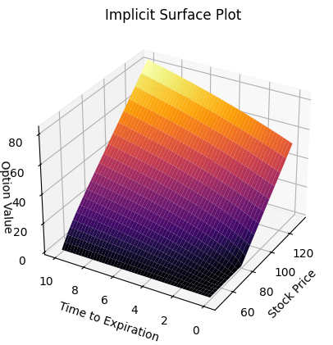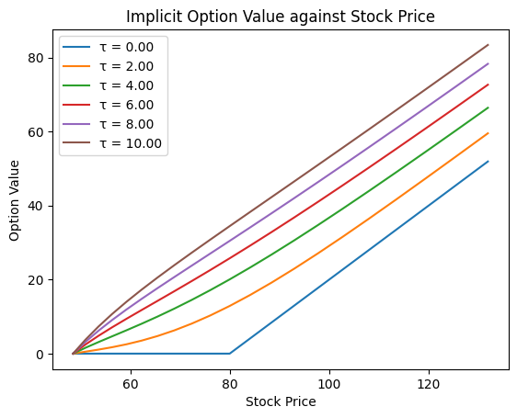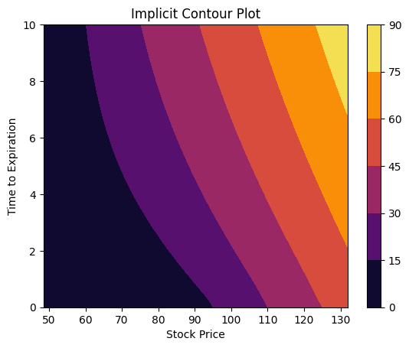

Figure 1: Plots of explicit solutions

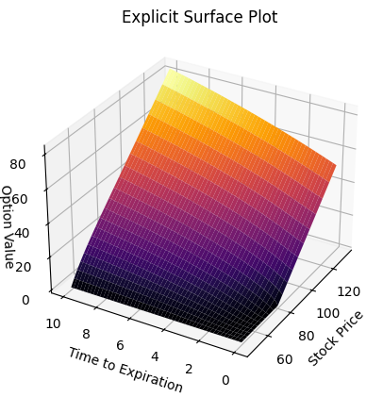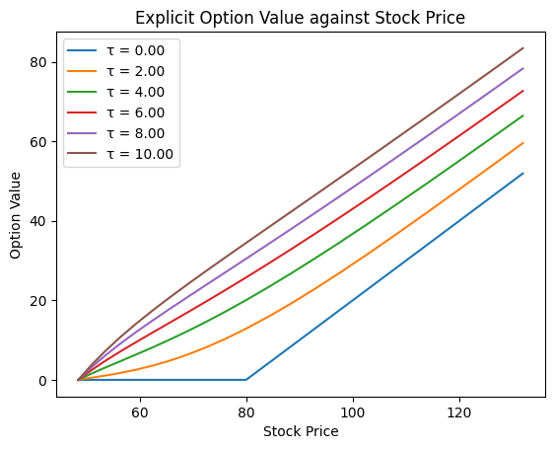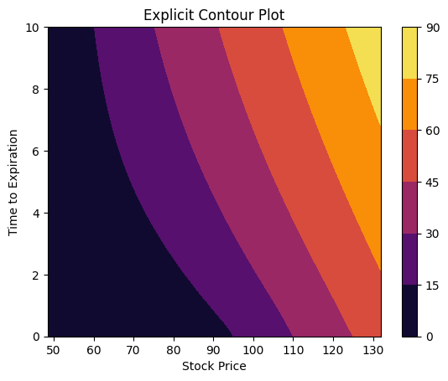

Figure 2: Plots of implicit solutions

Both explicit and implicit plots show the same solution and accurately describes how options value varies with time and stock price. At 0 stock price, the options value can be seen to be 0, agreeing with the boundary condition in equation 2. As stock price approaches infinity, options value also increases and approaches the actual payoff as it approaches the expiration date. On the expiration date, the option value can be seen to be the maximum of the payoff and 0, agreeing with the terminal condition in equation 4.

From the plot of option value against stock price at different time steps, options value decrease as the expiration date approaches. This is due to the range of possible stock prices at expiration decrease as time to expiration decreases.

A coarser grid is then used with time step, and space step, . The plots for both explicit and implicit methods when the coarser grid is used is shown below in Figures 3 and 4.

Figure 3: Explicit solutions with coarse grid

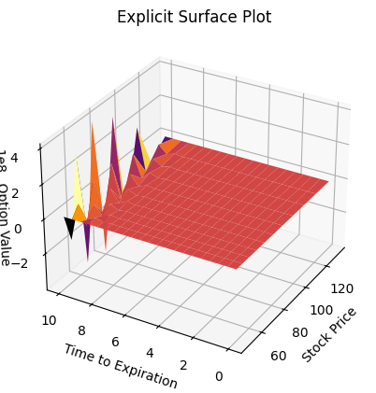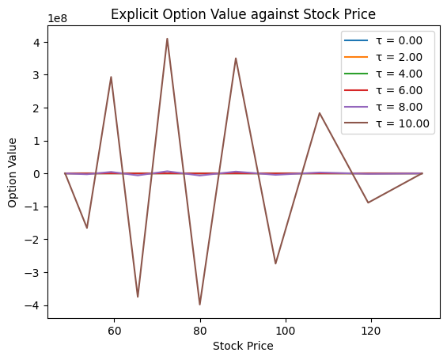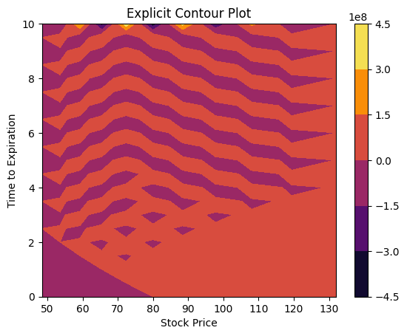

Explicit methods have a strict convergence criterion and become unstable when mesh sizes get too large. From equation (26), the coefficient of the previous node must be greater than 0:

|  |  |  |
| --- | --- | --- |
|  |  | (29) |
|  |  | (30) |
|  |  |  | |

The steps used in the coarse mesh therefore results in instability for the explicit method and did not yield useful results.

Figure 4: Implicit solutions with coarse grid

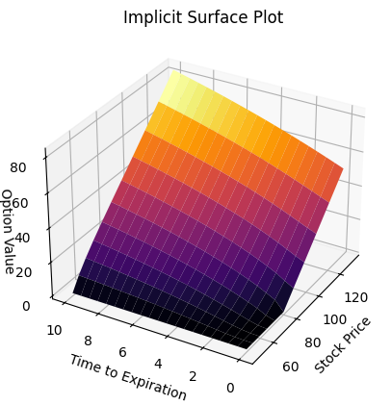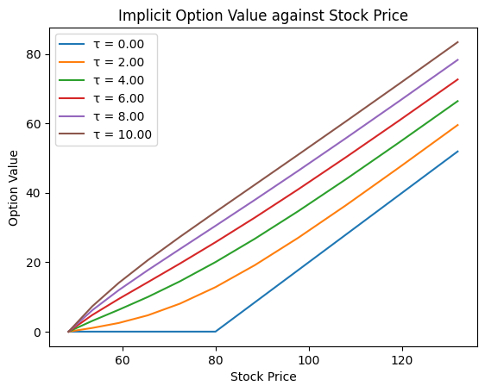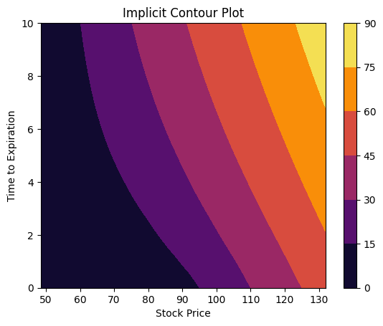

The implicit method on the other hand has no constraints on mesh size, but smaller mesh sizes would have higher precision. A disadvantage of finer mesh sizes is computational inefficiency, as the implicit methods require solving a system of linear equations at every time step and would require greater computational time to generate results.

G) Other remarks (limits of the model, convergence problems, possible alternative approaches, anything you find relevant and important to mention):

The equation could have been numerically solved without transformation into the heat equation, however the discretisation would be more complicated and prone to errors while coding.

This model only models European call options, where the buyer can only exercise the option to buy the underlying stock at the strike price on the expiration date. European put options can also be modelled using this equation, but with the boundary conditions being altered and essentially the inverse of call options. American options that can be exercised at any point in time up to the strike price will require modification to the Black-Scholes equation, namely becoming a variational inequality in equation 32.

|  |  |  |
| --- | --- | --- |
|  |  | (31) |