STUDENT USE |  | STAFF USE
Module Name | Database Systems Development, | First Marker’s  (acts as signature)
Module Code | 5BUIS009C | Second Marker’s  (acts as signature)
Lecturer Name | Dmitriy Pochitaev | Agreed Mark
UoW Student IDs |  | For Registrar’s office use only (hard copy submission)
WIUT Student IDs | 00016532, 00016117, 00016119
Deadline date | 07.04.2025
Assignment Type | Group

Introduction
This report shows the design and implementation of a Gym Management System meant to effectively regulate the specifics of gym members and related membership plans. The system tries to improve access by means of biometric integration, automatic member data monitoring, and administrative work simplification including membership categorizing and duration management. Using two tables: memberships and members, the program focuses on offering a scalable, orderly solution.
Comprising simply two tables—memberships and members—the system is set up using a star schema architecture. Every member in these two tables is related to a single membership type, even if a membership may be connected to multiple members via a one-to- many connection.
Among memberships, fields ranging from Membership ID, Name, Type, Description, PricePerMonth, and Duration abound. Fields included among members Member ID, First Name, Last Name, Email, Phone Number, Date of Birth, Join Date, Membership ID (FK), and Face Image. Standardizing methods guaranteed little duplication. Both tables have primary keys; a foreign key constraint ensures referential integrity between Members and Memberships. Including the FaceImage field helps to include face recognition in further developments.

Implementation.
Microsoft SQL Server was used in setup of the database. The schema's design contained SQL DDL instructions generating two tables with suitable data types and restrictions.
These were SQL scripts housed in SQL Server Management Studio (SSMS). Main keys consisted in auto-increasing identity fields. Through simple integration of future entities like trainers, courses, and attendance monitoring, the database architecture promotes scalability.
Data was inserted into the tables using INSERT INTO queries, while default values (like current date for JoinDate) were handled through SQL constraints. Image data for facial recognition was stored using the VARBINARY(MAX) type.

Testing was conducted by inserting sample records, querying data using SELECT, and verifying relationships through JOIN operations. Examples include:
Listing all members with their membership type
Filtering members by price category
Updating member details and verifying successful data changes

JOIN queries successfully retrieved meaningful data showing how members are distributed across different membership types. Aggregate queries confirmed the average pricing and duration statistics.
DELETE and UPDATE statements were also executed to validate database integrity constraints. Referential actions like deleting a membership that’s still in use were restricted, as expected.

Evaluation
The created system satisfactorily meets basic needs for a tool used in gym administration. It guarantees data integrity, reduces duplication, and enables necessary activities like price and duration monitoring feasible. It is: simple, scalable architecture, everything geared for a biometric development, clear divisions of entities. Limitations: user authentication, integration between front-ends is lacking, face data require manual picture inclusion.
Adding more entities (e.g., payments, trainers), speeding searches for bigger datasets, and connecting with a web-based interface for simplicity of use might help the system to be strengthened even further.
To conclude,This research on database design and implementation provided one to have important knowledge in data integrity enforcement, SQL creation, and schema planning. Complementing effective membership data processing and fundamental business process automation, the Gym Management System is useful, flexible, and rewarding.

Appendices:

ERD Diagram
One-to-many relationship 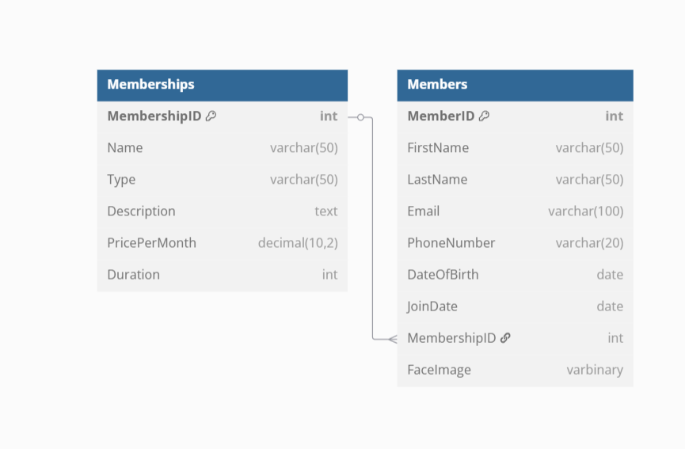

Table Structures
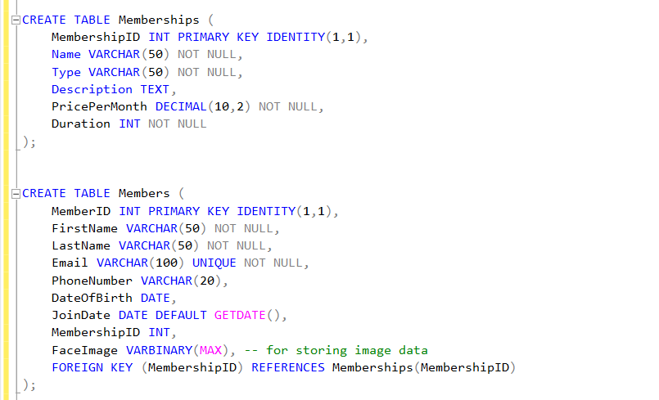

Sample Queries
