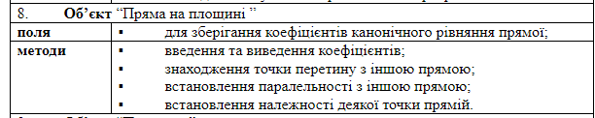class Straight_on_the_set:
def __init__(self, guide_vector, dot):
self.guide_vector = guide_vector
self.dot = dot
def input_data(self):
self.guide_vector = list(input("input guide vector").split(","))
self.dot = input("input dot").split(",")
def print_data(self):
print("guide vector: {0}; dot: {1};".format(self.guide_vector, self.dot))
def point_of_intersection(self, other):
m = self.guide_vector[0]
n = self.guide_vector[1]
m1 = other.guide_vector[0]
n1 = other.guide_vector[1]
x0 = self.dot[0]
y0 = self.dot[1]
x01 = other.dot[0]
y01 = other.dot[1]
x = (m*x01*n1-y01*m1*m+y0*m*m1-x0*n*m1)/(m*n1-n*m1)
y = (x*n-x0*n+y0*m)/m
return [x, y]
def is_paralel(self, other):
return self.guide_vector[0]/other.guide_vector[0] == self.guide_vector[1]/other.guide_vector[1]
def is_dot_belong(self, other_dot):
return (other_dot[0] - self.dot[0])/self.guide_vector[0] == (other_dot[1] - self.dot[1])/self.guide_vector[1]
test1 = Straight_on_the_set([1, 1], [3, 7])
test2 = Straight_on_the_set([2, 4], [2, 9])
print(test1.is_dot_belong([0, 6]))

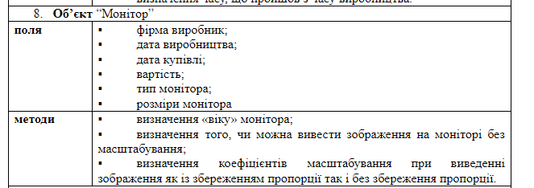
import datetime
class Monitor:
def __init__(self, firm_name, date_of_made, date_of_purchase, price, type, size):
self.firm_name = firm_name
self.date_of_made = datetime.date(*list(map(int, date_of_made.split("."))))
self.date_of_purchase = datetime.date(*list(map(int, date_of_purchase.split("."))))
self.price = price
self.type = type
self.size = size
def get_age(self):
return datetime.date.today() - self.date_of_made
def is_display_the_image(self, img_size):
return img_size[0] < self.size[0] and img_size[1] < self.size[1]
def get_img_scale(self, img_size):
x_scale = 1
y_scale = 1
scale_without_bad_quality = 1
if img_size[0] > self.size[0]:
x_scale = self.size[0]/img_size[0]
if img_size[1] > self.size[1]:
y_scale = self.size[1]/img_size[1]
if x_scale < y_scale:
scale_without_bad_quality = x_scale
elif x_scale > y_scale:
scale_without_bad_quality = y_scale
return [[x_scale, y_scale], scale_without_bad_quality]
test1 = Monitor(1, "2017.5.17", "2014.11.18", 1, 2, [1028, 960])
print(test1.get_img_scale([2256, 1261]))

