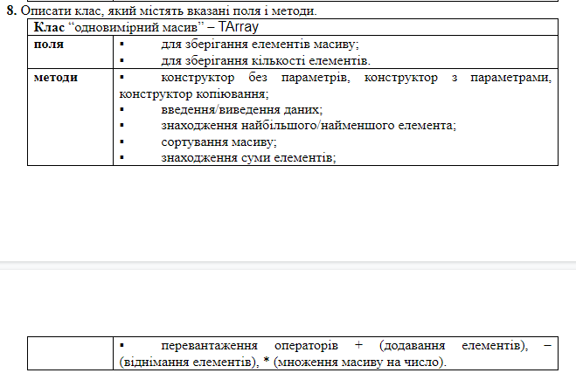

class TArray:
def __init__(self, array):
self.array = array
self.array_elem_count = len(array)+1
def input_data(self):
self.array = list(input("input new array").split(","))
self.array_elem_count = len(self.array)+1
def print_data(self):
print("array: {0}; elem count: {1};".format(self.array, self.array_elem_count))
def get_min(self):
return min(self.array)
def get_max(self):
return max(self.array)
def sort_arr(self):
self.array.sort()
def get_sum(self):
return sum(self.array)
def __add__(self, other):
return [self.array[i] + other.array[i] for i in range(len(self.array))]
def __sub__(self, other):
return [self.array[i] - other.array[i] for i in range(len(self.array))]
def __mul__(self, other):
return [el*other for el in self.array]
test1 = TArray([1, 2, 4, 5])
test2 = TArray([1, 3, 2, 12])
print(test1*2)

