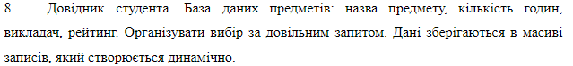
student_base = []
def add_to_base(subject_title, number_of_hours, teacher, rating):
infos = {
"subject_title": subject_title,
"number_of_hours": number_of_hours,
"teacher": teacher,
"rating": rating
}
def delett(inf):
del student_base[inf[0]["id"]]
if search_in_base(infos):
search_in_base(infos, delett)
student_base.append(infos)
return infos
def search_in_base(data, callback=None):
res = []
for id in range(len(student_base)):
flag = 1
for param in data:
if student_base[id][param] != data[param]:
flag = 0
if flag:
inf = student_base[id].copy()
inf.update({"id": id})
res.append(inf)
if callback:
callback(res)
else:
return res
add_to_base("alg", 10, "Olga", 4)
add_to_base("algfd", 103, "Olga", 4)
add_to_base("algfd", 103, "Olga", 4)
add_to_base("algfd", 103, "Olga", 4)
add_to_base("algfd", 103, "Olga", 5)
search_in_base({
"teacher": "Olga",
"rating": 4
}, lambda data: print(data))
search_in_base({
}, lambda data: print(data))

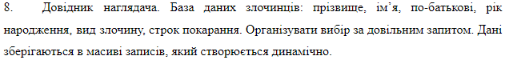
import datetime
base = []
def add_to_base(last_name, first_name, patronymic, year_of_birth, type_of_crime, term_of_punishment):
infos = {
"last_name": last_name,
"first_name": first_name,
"patronymic": patronymic,
"year_of_birth": year_of_birth,
"type_of_crime": type_of_crime,
"term_of_punishment": term_of_punishment,
"__date_of_update": datetime.date.today(),
"__date_of_create": datetime.date.today()
}
def delete_and_upd(inf):
del base[inf[0]["__id"]]
infos["__date_of_create"] = inf[0]["__date_of_create"]
if search_in_base(infos):
search_in_base(infos, delete_and_upd)
base.append(infos)
return infos
def search_in_base(data, callback=None):
res = []
for id in range(len(base)):
flag = 1
for param in data:
if base[id][param] != data[param]:
flag = 0
if flag:
inf = base[id].copy()
inf.update({"__id": id})
res.append(inf)
if callback:
callback(res)
else:
return res
add_to_base("alg", 10, "Olga", 4, "Olga", 4)
add_to_base("algfd", 103, "Olga", 4, "Olga", 4)
add_to_base("algfd", 103, "Olga", 4, "Olga", 4)
add_to_base("algfd", 103, "Olga", 4, "Olga", 4)
add_to_base("algfd", 103, "Olga", 5, "Olga", 4)
search_in_base({
"patronymic": "Olga",
"year_of_birth": 4
}, lambda data: print(data))
search_in_base({
}, lambda data: print(data))
# як оновити данні
# search_in_base({нараметри пошуку}, lambda data: add_to_base(змінений об'єкт))

