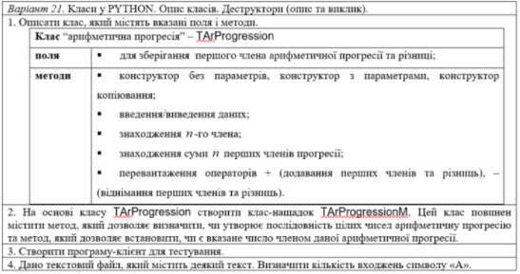

1-2-3.
import numbers
class TArProgression:
def __init__(self, first_elem, d_value):
self.first_elem = first_elem
self.d_value = d_value
@property
def first_elem(self):
return self.__first_elem
@first_elem.setter
def first_elem(self, value):
if isinstance(value, numbers.Number):
self.__first_elem = float(value)
else:
raise Exception('first elem value must be number')
@property
def d_value(self):
return self.__d_value
@d_value.setter
def d_value(self, value):
if isinstance(value, numbers.Number):
self.__d_value = float(value)
else:
raise Exception('value of d must be number')
def input_value_of_first_elem(self):
self.first_elem = float(input("input first elem value: "))
def input_value_of_d(self):
self.d_value = float(input("input d value: "))
def print_values(self):
print("first elem: {0}, d value: {1};".format(self.first_elem, self.d_value))
def get_value_of_elem(self, n):
return self.first_elem + (n-1)*self.d_value
def get_sum_of_elements(self, n):
return ((self.first_elem + self.get_value_of_elem(n))/2)*n
def __add__(self, other):
return TArProgression(self.first_elem+other.first_elem, self.d_value+other.d_value)
def __sub__(self, other):
return TArProgression(self.first_elem - other.first_elem, self.d_value - other.d_value)
class TArProgressionM(TArProgression):
def __init__(self, first_elem, d_value):
super().__init__(first_elem, d_value)
def is_sequence_of_numbers_arithmetic_progression(self, sequence):
d_val = sequence[1]-sequence[0]
prev_val = sequence[1]
for elem in sequence[2:]:
if(elem-prev_val != d_val):
return False
prev_val = elem
return True
def is_number_in_sequence(self, value):
n_val = (value-self.first_elem+self.d_value)/self.d_value
if int(n_val) == n_val:
return True
else:
return False
firstSeq = TArProgression(5, 3)
secondSeq = TArProgression(1, 2)
subSeq = firstSeq - secondSeq
sumSeq = firstSeq + secondSeq
sumSeq.print_values()
subSeq.print_values()
testNewSeq = TArProgressionM(1, 2)
print(testNewSeq.is_sequence_of_numbers_arithmetic_progression([1, 2, 3, 4]))
print(testNewSeq.is_number_in_sequence(2))
print(firstSeq.first_elem, firstSeq.d_value, firstSeq.get_sum_of_elements(5))

4.
with open("text.txt") as data:
res = 0
for row in data:
res += row.count("A")
print(res)

