EPAM University Programs
DevOps external course
Module 4 DevOps Introduction
TASK 4.2
1. Set up Linux Virtual Machine in VirtualBox.
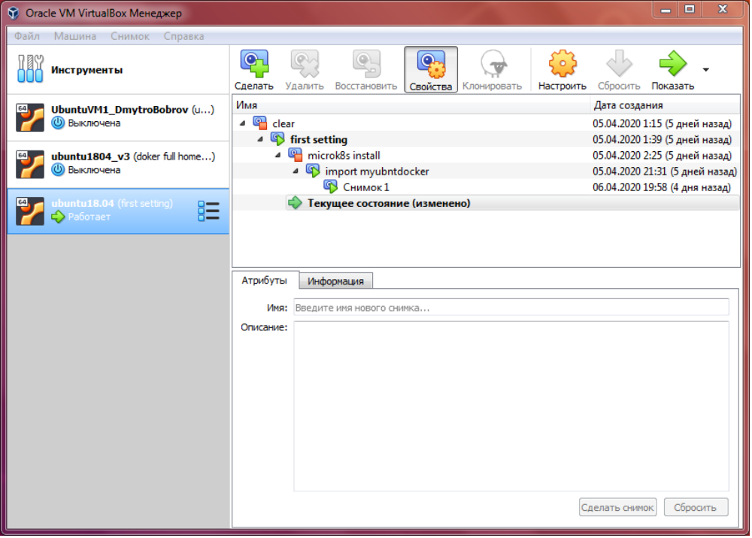
2. Familiarize yourself with the commands and utilities listed in the presentation (switching between virtual terminals (consoles); printenv; content of /etc/profile and ~/.bash_profile, $echo $HISTFILE $HISTSIZE $HISTFILESIZE, who, w, whoami, id). Make 5 screenshots.
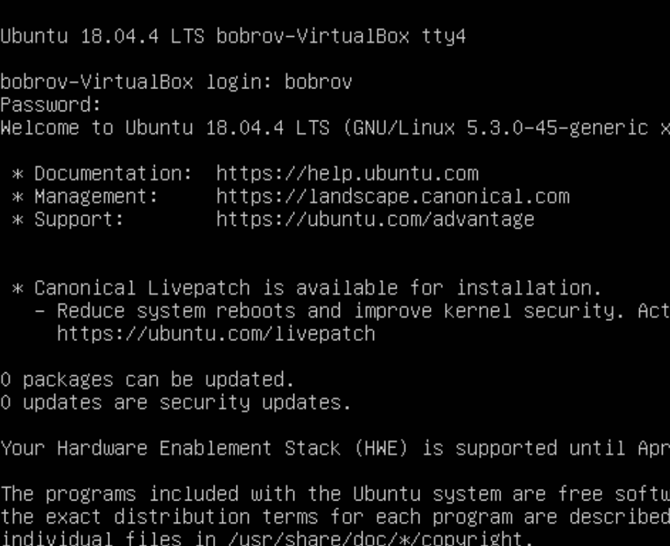

3. Familiarize yourself with the commands (uname, hostname, uptime, shutdown, halt, reboot, init…). Make 5 screenshots.
4. Familiarize yourself with the help commands (man, info, find, locate, whereis, less|zless in /usr/share/doc). Make 5 screenshots.

