const fs = require('fs');

const csv = require('csv-parser');

results = [];

var canada = 'country, year, population \n';

var usa = 'country, year, population \n';

countryRemaining = [];

var myFile = 'input_countries.csv';

fs.stat(myFile, (err, stat) => {

if (err == null) {

console.log('File eaists!! \n');

readWrite();

} else if (err.code === 'ENOENT') {

console.log('File error');

}

});

function readWrite() {

fs.createReadStream(myFile)

.pipe(csv())

.on('error', (err) => {

console.log('Error in reading the file', err);

})

.on('data', (line) => results.push(line))

.on('end', () => {

results.forEach((a) => {

if (a.country === 'Canada') {

canada += a.country + ', ' + a.year + ', ' + a.population + '\n';

} else if(a.country === 'United States') {

usa += a.country + ', ' + a.year + ', ' + a.population + '\n';

}

});

filterAndWrite(canada, 'Canada');

filterAndWrite(usa, 'Usa');

});

}

function filterAndWrite(line, country) {

var fileName = country + '.txt';

fs.writeFile(fileName, line, (err) => {

if (err) {

console.log('Error creating ', country);

} else {

console.log("Successfully created");

}

});

}

=================================================================

country, year, population

Canada, 1952, 14785584

Canada, 1957, 17010154

Canada, 1962, 18985849

Canada, 1967, 20819767

Canada, 1972, 22284500

Canada, 1977, 23796400

Canada, 1982, 25201900

Canada, 1987, 26549700

Canada, 1992, 28523502

Canada, 1997, 30305843

Canada, 2002, 31902268

Canada, 2007, 33390141

=================================================================

country, year, population

United States, 1952, 157553000

United States, 1957, 171984000

United States, 1962, 186538000

United States, 1967, 198712000

United States, 1972, 209896000

United States, 1977, 220239000

United States, 1982, 232187835

United States, 1987, 242803533

United States, 1992, 256894189

United States, 1997, 272911760

United States, 2002, 287675526

United States, 2007, 301139947

=================================================================

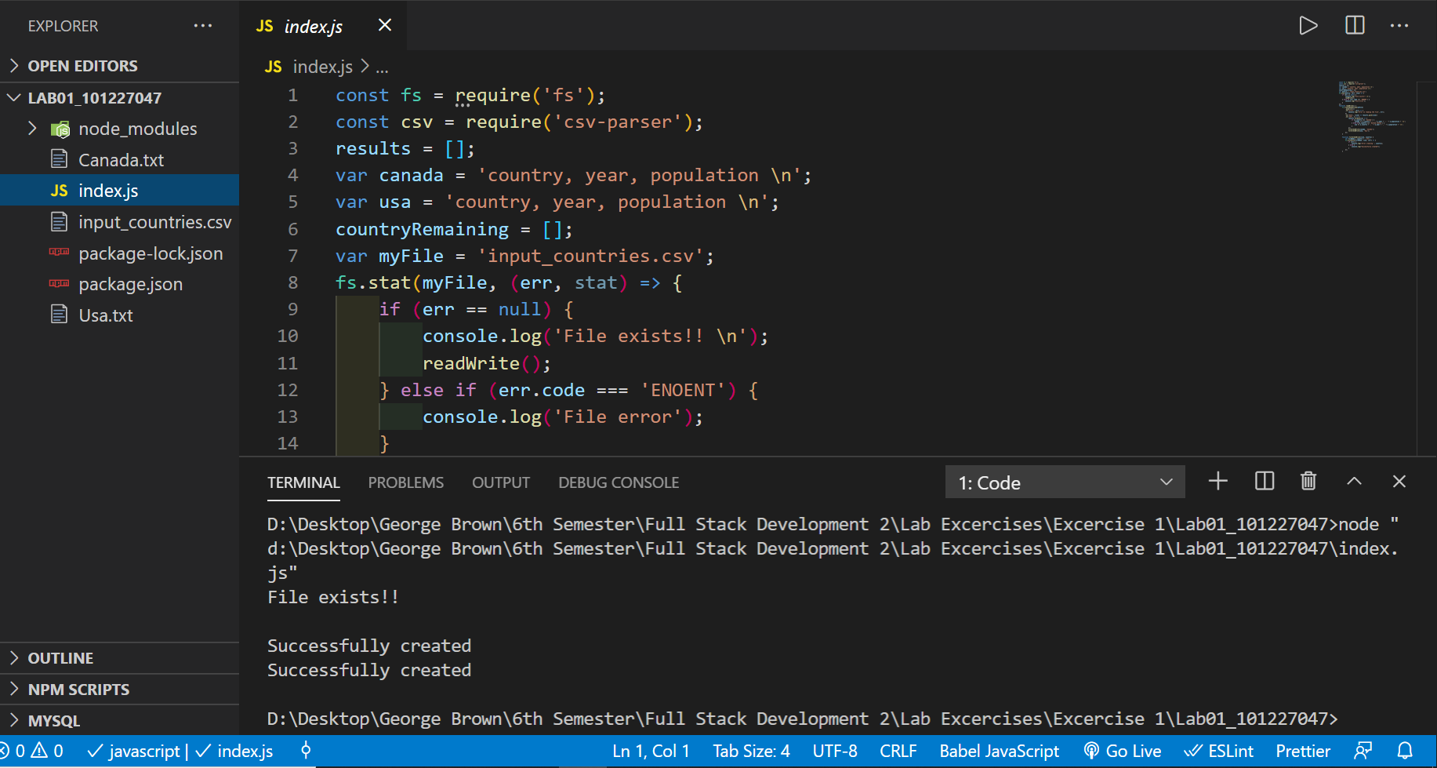

=================================================================

https://github.com/3cch3/comp3133-101227047.git