# Fluid Dynamics

## Problem Definition / Theory

The main purpose of this study was to determine the overall drag caused by the system. This would ensure how efficiently the ROV would move under water. This was done through SolidWorks Flow Simulation and computing the results with the ROV assembly. SolidWorks governing equation for any viscous fluid simulation is Navier-Stokes, based on Newton’s second law and applying the concept to fluid flow Equation 1 [1].

|  |  |
| --- | --- |
| $$ρ\left[\frac{∂V}{∂t}+\left(V*∇\right)V\right]= -∇P+ρg+μ∇^{2}V$$ | Equation 1 |

From this equation, the mass, momentum and energy conservation laws are applied for the CFD analysis [1]. For the purpose of this simulation the fluid was considered Newtonian, incompressible, the flow consisted of laminar flow and prior to reaching the ROV itself the flow is being considered fully developed. SolidWorks Flow simulation uses the $k-ε$ model presented by Lam and Bremhorst [1]. This model takes care of laminar, transitional and turbulent flows, using equation from transport theorem for turbulent kinetic energy and its dissipation rate [1].

|  |  |
| --- | --- |
| $$\frac{∂ρk}{∂t}+\frac{∂ρku_{i}}{∂x_{i}}=\frac{∂}{∂x_{i}}\left(\left(μ+\frac{μ_{t}}{σ_{k}}\right)\frac{∂k}{∂x_{i}}\right)+τ_{ij}^{R}\left(\frac{∂u_{i}}{∂x_{i}}\right)-ρε+μ_{t}P_{B'}$$ |  |
| $$\frac{∂ρε}{∂t}+\frac{∂ρεu_{i}}{∂x_{i}}=\frac{∂}{∂x_{i}}\left(\left(μ+\frac{μ_{t}}{σ_{ε}}\right)\frac{∂ε}{∂x_{i}}\right)+C_{ε1}\frac{ε}{k}\left(f_{1}τ_{ij}^{R}\frac{∂u_{i}}{∂x_{j}}+C_{B}μ_{t}P_{B}\right)-f_{2}C_{ε2}\frac{ρε^{2}}{k}$$ |  |
| $$τ_{ij}=μs_{ij},τ_{ij}^{R}= μ_{t}s_{ij}-\frac{2}{3}ρkδ_{ij}, s_{ij}=\frac{∂u_{i}}{∂x_{j}}+\frac{∂u_{i}}{∂x_{i}}-\frac{2}{3}δ_{ij} \frac{∂u_{k}}{∂x_{k}},$$ $$P_{B}=-\frac{g_{i}}{σ_{B}}\frac{1}{ρ}\frac{∂ρ}{∂x_{j}}$$ | Equation 2,3,4 |

where, $Cμ =0.09, Cε1 = 1.44, Cε2 =1.92, σk =1, σε =1.3, σВ =0.9, CВ =1 if PВ > 0, CВ = 0 if PВ < 0$

## Simulation Setup

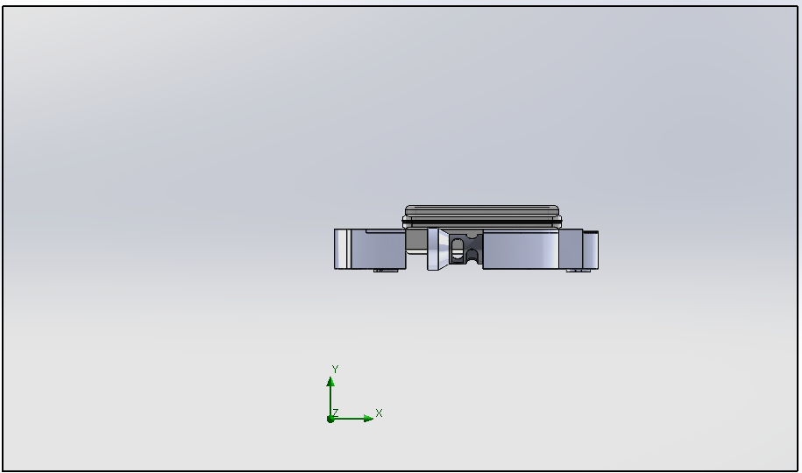

Inlet

Velocity = 1m/s

No Slip Wall

Outlet

Fluid - Water

Image:1

The setup for the simulation was kept simple to make the computation time faster. The conditions for the fluid being Newtonian, incompressible, and in laminar flow. The wall pertain to have no slippage hence, neglecting the shear loss at the walls.

## Results

After running the simulation the results were to be found as:

|  |  |
| --- | --- |
| Top View | C:\Users\Maharshi\Desktop\380-Case\380  cCAD\top.PNG |
| Bottom View | C:\Users\Maharshi\Desktop\380-Case\380  cCAD\bottom.PNG |
| Front View | C:\Users\Maharshi\Desktop\380-Case\380  cCAD\front.PNG |
| Side View | C:\Users\Maharshi\Desktop\380-Case\380  cCAD\side.PNG |

Top/Bottom View:

From the velocity contours in the top view, it can be seen that flow starts develop in be beginning however due to the break in the geometry form the side fines the flow disrupts and causes the turbulent behavior near the back. This causes vortices form at the back and create induced drag on the ROV. Though, the fluid particles in the red circle of top view indicate that the fluid is starting to come back in wake field indicating the separation losses could be negligible for the purpose of the simulation. In the bottom view, behind the front and side containers there is a lot of induced drag due to the fact that there is suction/vacuum created between the three parts, hence vortices are also formed in this area.

Front/Side View:

From the front view, it can be justified that the flow movement is as expected as the streamlines are going smoothly overt the top or the ROV as well as the sides, not creating a significant amount of drag from the fluid-solid interaction. As well as the side view, the flow is behaving as it should, going under and about the motor mount towards the back container.

## Measuring Drag

Measuring drag is important, since it is one of the main performance characteristic on how efficient will the ROV be in water. Drag can be measured from using Equation 5.

|  |  |
| --- | --- |
| $$F_{d}=\frac{1}{2}C_{d}ρV^{2}A$$ | Equation 5 |

where, $Fd=Drag Force, Cd=Drag Coefficient, V=Velocity, A=cross-sectional area$

Using the force generated form simulation which is $Fd=3.72 N$, the drag coefficient can be found to be $Cd= 0.41$. This is reasonable value for the reason that many aerodynamic machines have a value of under 0.5.

[1] A. Sobachkin and G. Dumnov, “Numerical Basis of CAD-Embedded CFD,” *NAFEMS World Congr. 2013*, no. February, pp. 1–20, 2013.