**A major project report on**

**VOICE ASSISTIVE SMART STICK FOR BLINDS**



**BIRLA INSTITUTE OF TECHNOLOGY, MESRA**

**JAIPUR CAMPUS**

**Submitted by:-**

**MANIMAY RAJ (BE/25112/16)**

**ECE – 8TH Semester**

**Session – Spring 2020**

**Under the Guidance of  
 Mr. Deepak Chaturvedi  
 Assistant Professor  
 Department of ECE  
 BIT, Jaipur**

**STUDENT DECLARATION**

I MANIMAY RAJ (BE/25112/16) hereby, declare that the project entitled VOICE ASSISTIVE SMART STICK FOR BLINDS submitted in partial fulfillment of the requirements for the award of the degree of Bachelors in Engineering in Electronics and Communication of Birla Institute of Technology, Mesra, Ranchi. It is an authentic work carried out by me under the supervision of Mr. Deepak Chaturvedi.

Date :- 05.06.2020 **Manimay Raj**

(BE/25112/16)

ECE 8TH Semester

Birla Institute of Technology, Mesra

Jaipur Campus

**CERTIFICATE OF APPROVAL**

I hereby agree to supervise the project titled as **“VOICE ASSISTIVE SMART STICK FOR BLINDS”**as per the norms of Birla Institute of Technology, Mesra, Jaipur Campus.

Date :- 05.06.2020 (HOD) (Project guide)

Mr. Ankur Aggarwal Mr. Deepak Chaturvedi  
 Department of ECE Assistant Professor  
 BIT, Jaipur Department of ECE  
 BIT, Jaipur

**CONTENTS**

**CH 1: ABSTRACT……………………………………………………..…………………..6**

**CH 2: INTRODUCTION…………………………………………………………………..7**

**CH 3: SURVEY…………………………………………………………………….………9**

**CH 4: PROPOSED SYSTEM…………………………………………………………….10**

**CH 5: HARDWARE DESCRIPTION**

**2.1 ARDUINO UNO……………………………………………………...11**

**2.2 ISD1820 VOICE RECORDING MODULE………………………..14**

**2.3 SIM800L GSM MODULE…………………………………………..15**

**2.4 SIM28M GPS RECEIVER……………………………………….....16**

**2.5 SENSORS – ULTRASONIC & PIEZOELECTRIC ……….……..18**

**2.6 VIBRATION MOTOR………………………………………………20**

**CH 6: ABOUT THE CIRCUIT**

**6.1: BLOCK DIAGRAM………………………………………………...21**

**6.2: HARDWARE SETUP……………………………………………....22**

**6.3: ABOUT THE SOFTWARE**

**6.3.1SOFTWARE DESCRIPTION……………………....24**

**6.3.2CODE……………………………………………….....25**

**6.4 WORKING………………...…………………………………………..33**

**CH 7: SIGNIFICANCE OF THE SYSTEM……………………………...………….….34**

**CH 8: FUTURE SCOPE..............................................................................................…...35**

**REFRENCES……………………………………………………………..……………….36**

**CHAPTER 1**

**ABSTRACT**

The Voice Assistive Smart Stick for Blinds project presents a design and implementation of a smart walking stick that helps the blind people to travel individually. In normal stick, the detection of the obstacle is not done and normal stick is not efficient for visually impaired persons. Because the blind person does not know what type of things or what type of the objects come in front of him or her. The person cannot recognize what is the size of that object and how far is he/she from the object. The Detection of obstacles is done using the ultrasonic sensors. If any obstacle comes in front of blind person, he/she can know about the obstacle by hearing the sound generated via speaker mounted on the stick itself. To make more useful the stick is also mounted with a vibration motor that gets activated when the ultrasonic sensors sense any obstacle. The GPS and the GSM module have been used for safety purpose to track the location of the user. If the blind people need any help then they can trigger an emergency button which is mounted on the stick and the GSM will send the location information to predefined contact numbers within 15 seconds. The system is very useful for people who are visually impaired and often need help from others. All effort is being made to make this stick is to be cheaper as well as easy to use. With all these features the blind people can boost up their navigation ability and not to depend on anyone while walking in unknown places.

**CHAPTER 2**

**INTRODUCTION**

Blindness may be caused due to temporary or permanent injure to any portion of the eye, the optic nerve, or the area of the brain responsible for vision can lead to blindness. Visually challenged people facing many problems in their everyday life, often have a difficult time to navigate outside the environment. The crucial physical disability is that the Visual Impairment. The blind people have to face many problems in their everyday life. The worst problem is that detecting object in front of them in order to step ahead. Worldwide, between 300 million and 400 million people are visually challenged due to various causes. According to world Health Organization (WHO), about 36 million are blind. Earlier blind people were totally depended on coached dogs and white canes to move independently in unknown areas. Products developed for the visually impaired have specially concentrated on communication tools such as reading machines and stamping printers for Blinds. Many Navigation aids apart from the cane have still to be implemented in such a way that leading to their approval by the visually challenged community. The number of people visually challenged from infectious diseases has prevented in the last twenty years according to global estimates work. In a constant technically developing world many electronic devices are came into exist which reduces the problems facing by people who are with disability.

A simple system has been planned and developed which help the blinds to move independently. The proposed hardware system for this project consists of Arduino Uno, Ultrasonic sensors, piezoelectric sensor, voice playback module, vibration motor, GPS receiver module and the GSM. This system detects the obstacles which are present in outdoor and indoor with the help of multiple ultrasonic sensors. The ultrasonic sensors detect the presence of an obstacle in front of it and passes the data to Arduino Nano. The Arduino Nano process the data received and calculates whether the obstacle is close enough or not. The processed data is fed to the voice playback module which provides detailed voice assistance to the blind person through a speaker in order to avoid the collision between the obstacles. To make more useful the stick is also mounted with a vibration motor that gets activated whenever ultrasonic sensors sense any obstacle. The GPS receiver and the GSM has been used for safety purpose in order to track the location of the user. If the blind people need any help then they can trigger an emergency button which is mounted on the stick then the GSM will send the location information to the predefined contact numbers within 15 seconds. There is one additional button mounted on the stick which can be triggered by the user to tell their predefined contacts that they are out of danger and no immediate assistance is required for the moment. This whole setup will be mounted on the stick.

The smart walking stick is a simple and purely mechanical device to detect the obstacles on the ground. This device is light in weight and portable. But its range is limited due to its own size. It provides the best travel aid for the person and the blind person can move from one place to another independently without the others help. The main aim of the system is to provide a efficient navigation aid for the blind persons which gives a sense of vision by providing the information about their surroundings and objects around them.

**CHAPTER 3**

**LITERATURE SURVEY**

Blind and outwardly impaired individuals are off guard when they travel since they don't get enough data about their area and introduction concerning movement and obstacles in transit and things that can undoubtedly be seen by individuals without visual inabilities. The regular methods for direct pooch and long cane just help to maintain a strategic distance from obstacles, not to comprehend in which direction they are. Navigation systems more often than not comprise of three sections to enable individuals to movement with a more noteworthy level of mental solace and autonomy. Detecting the quick condition for obstacles and perils, giving data about area and introduction amid movement. Today in the market distinctive advances like GPS, GPRS, and so forth are utilized to explore outwardly impaired individuals. Before more mechanically propelled answers for versatility helps are examined it is valuable to layout essential properties of the customarily utilized essential guides and clarify their principle properties and restrictions.

White cane: The most popular mobility hand held aid. It is usually foldable and adjustable to the height of the user. A blind person using swing-like movements in all directions, “scan” the path in front in approx.

Guidance of dog: A specially trained dog assisting the blind in obstacle avoidance, but usually not aiding in way finding (unless travelling a familiar path), e.g. the dog is trained to stop before obstacles, reacts to commands on walking directions.

**CHAPTER 4**

**PROPOSED SYSTEM**

In this proposed system, the ultrasonic sensors are used to sense the obstacle distance from the user. This reference distance can be used to decide whether the user can move or not. The ultrasonic sensors work on the basis of sound. The sound waves are transmitted ahead from the sensors towards the obstacle which can sense the distance up to a distance of 12 feet with a resolution of 0.3cm. The sensors are placed in three locations in order to cover maximum sides possible with minimum usage of the sensors. The sensors are placed in left, right, and front side respectively. Generally, the blind person cannot see the objects present on the ground. So these sensors keeps track of the ground clearance providing necessary security measures.

The system consists of a speaker output telling the user the direction in which obstacles are being detected. The proposed system tries to provide some additional feature regarding obstacle detection. A mobile phone vibration motor is implanted on the handle of the stick. The purpose of the vibration motor is to alert the user for the obstacles by vibrating into his/her hands. This vibration is simultaneous with the output of the speaker embedded on the stick.

The system also consists of a GSM-GSM module in which the location of the people (users) can be tracked easily. Two buttons are provided on the handle of the stick. First one sends a panic message to a predefined contact list. The system has piezoelectric sensors too embedded on the stick. If stick falls the first button gets activated. The second button can only be used if button one is already ON. This sends a ‘Relax!’ message to the same pre-defined contact list. If the users get some help immediately and don’t need further assistance, this button can be used. m. The whole system is designed to be small and designed for rapid response to the inputs.

**CHAPTER 5**

**HARDWARE DESCRIPTION**

**5.1ARDUINO UNO**

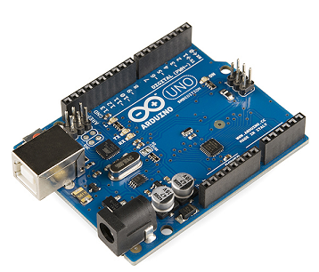

Fig 1: Arduino UNO

**Technical Specifications**

* [Microcontroller](https://en.wikipedia.org/wiki/Microcontroller): [Microchip](https://en.wikipedia.org/wiki/Microchip_Technology) [ATmega328P](https://en.wikipedia.org/wiki/ATmega328P) [[7]](https://en.wikipedia.org/wiki/Arduino_Uno#cite_note-website-7)
* Operating Voltage: 5 Volts
* Input Voltage: 7 to 20 Volts
* Digital I/O Pins: 14 (of which 6 can provide PWM output)
* Analog Input Pins: 6
* DC Current per I/O Pin: 20 mA
* DC Current for 3.3V Pin: 50 mA
* [Flash Memory](https://en.wikipedia.org/wiki/Flash_Memory): 32 KB of which 0.5 KB used by [bootloader](https://en.wikipedia.org/wiki/Booting" \l "BOOT-LOADER" \o "Booting)
* [SRAM](https://en.wikipedia.org/wiki/Static_random-access_memory): 2 KB
* [EEPROM](https://en.wikipedia.org/wiki/EEPROM): 1 KB
* Clock Speed: 16 MHz
* Length: 68.6 mm
* Width: 53.4 mm
* Weight: 25 g

### General pin functions

* **LED**: There is a built-in LED driven by digital pin 13. When the pin is high value, the LED is on, when the pin is low, it is off.
* **VIN**: The input voltage to the Arduino/Genuino board when it is using an external power source (as opposed to 5 volts from the USB connection or other regulated power source). You can supply voltage through this pin, or, if supplying voltage via the power jack, access it through this pin.
* **5V**: This pin outputs a regulated 5V from the regulator on the board. The board can be supplied with power either from the DC power jack (7 - 20V), the USB connector (5V), or the VIN pin of the board (7-20V). Supplying voltage via the 5V or 3.3V pins bypasses the regulator, and can damage the board.
* **3V3**: A 3.3 volt supply generated by the on-board regulator. Maximum current draw is 50 mA.
* **GND**: Ground pins.
* **IOREF**: This pin on the Arduino/Genuino board provides the voltage reference with which the microcontroller operates. A properly configured shield can read the IOREF pin voltage and select the appropriate power source, or enable voltage translators on the outputs to work with the 5V or 3.3V.
* **Reset**: Typically used to add a reset button to shields that block the one on the board.

### 

Fig 2: Pin Diagram of Arduino UNO atmega328

### Special pin functions

* **Serial** / [UART](https://en.wikipedia.org/wiki/UART): pins 0 (RX) and 1 (TX). Used to receive (RX) and transmit (TX) TTL serial data. These pins are connected to the corresponding pins of the ATmega8U2 USB-to-TTL serial chip.
* **External interrupts**: Pins 2 and 3. These pins can be configured to trigger an interrupt on a low value, a rising or falling edge, or a change in value.
* [**PWM**](https://en.wikipedia.org/wiki/Pulse-width_modulation) (pulse-width modulation): pins 3, 5, 6, 9, 10, and 11. Can provide 8-bit PWM output with the analog Write () function.
* [**SPI**](https://en.wikipedia.org/wiki/Serial_Peripheral_Interface) (Serial Peripheral Interface): pins 10 (SS), 11 (MOSI), 12 (MISO), and 13 (SCK). These pins support SPI communication using the SPI library.
* **TWI** (two-wire interface) / [I²C](https://en.wikipedia.org/wiki/I%C2%B2C): pin SDA (A4) and pin SCL (A5). Support TWI communication using the Wire library.
* **AREF** (analog reference): Reference voltage for the analog inputs.

**5.2. ISD1820**

**5.2.1 INTRODUCTION:**

The Voice module board is based on ISD18B20, which is a single-chip single-message record/playback device. Recordings are stored into on-chip non-volatile memory, providing zero-power message storage. With the embedded Flash memory employed, data retention up to 100 years and typical 100,000 erase/record cycles can be reached. Time for recording is 8-20 seconds.

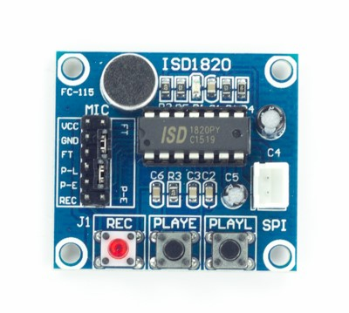

Fig 3: ISD1820 Voice Module

**5.2.2 SPECIFICATIONS:**

* On-board ISD1820 chip
* On-board microphone, can directly recording voice
* Can play a recording up to 10 seconds
* High-quality, natural voice restore, can be used as a propaganda module
* With a loop playback, jog play, single-pass playback mode
* The pins are leaded out, can control operating by microcontroller
* Working voltage: 3V-5V DC

**5.3. SIM300 GSM MODULE**

**5.3.1 INTRODUCTION:**

The module can be used to send SMS, receive and make the calls, and do the basic GSM operations with the help of AT commands. A standard RS232 interface is used so that we can use it to interface with microcontrollers and PCs. It has power regulation, SIM holder and external antennas.

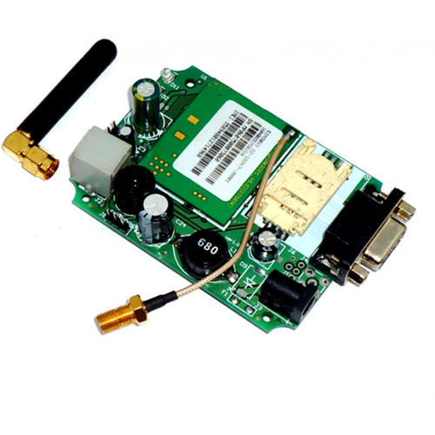

Fig: SIM300 GSM Module

**5.3.2 SPECIFICATIONS:**

* Uses SIM300 GSM module transmission.
* It has an on board wire antenna for better reception.
* Can be used for Data/Fax, GSM based Voice communications, TCP/IP stack, GPRS and SMS
* SIM300 allows an adjustable serial baud rate from 1200 to 115200 bps (9600 default).
* Provides RS232 interface for connection to computers and other devices.
* Can add external antenna with SMA connectors.
* Power, RING and Network LEDs for easy debugging.
* Provides serial TTL interface for easy and direct interface to microcontrollers.
* Can be controlled through standard AT commands

**5.4. SIM28M GPS RECEIVER**

**5.4.1 INTRODUCTION:**

This GPS Receiver Modem is based on SIMCOM'' Sim28M/Sim28 ML GPS Module. SIM 28 ML is stand-alone or A-GPS receiver with build in LNA. SIM 28M can relax antenna requirement and don’t need for external LNA. SIM28ML can track as low as -165 dBm signal even without network assistance. SIM28ML has excellent low power consumption characteristics (acquisition 17mA, tracking 16 mA). SIM28ML supports various location and navigation applications including autonomous GPS, QZSS,SBAS ranging(WASS, EGNOS, GAGAN, MSAS). DGPS and A-GPS.

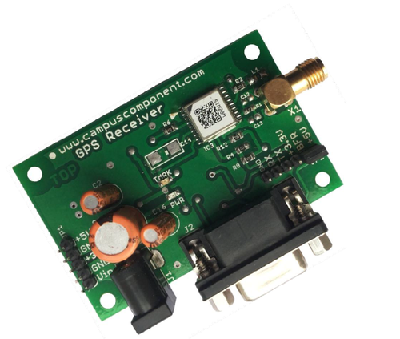

FIG: SIM28M GPS RECEIVER

**5.4.2 SPECIFICATIONS:**

* **Pwr LED :-**  Power LED ON indicated board is powered up.
* **TMRK LED :-**  Timemark LED is connected to TIMEMARK pin which starts blinking at 1 Hz (1 PPS one pulse per second) when GPS is FIXED.
* **RS232 Interface :-**  Any RS232 compatible device like PC can be connected to DB9 connector. User can observe data flow on softwares like hyperterminal, realterm etc. Baudrate to select is 9600.
* **TTL Interface** :- We can directly use TTL output which is available at connector JP2. A level shifter is used to make it compatible with +5V & + 3.3V microcontrollers. A 2 pin jumper is in default connection with BFR & +5V pins of JP2 so TTL ‘RX/TX’ of GPS modem can be connected to ‘RX/TX’ of any +5V microcontroller.

,

.

**5.5. SENSORS**

**5.5.1 ULTRASONIC SENSORS**

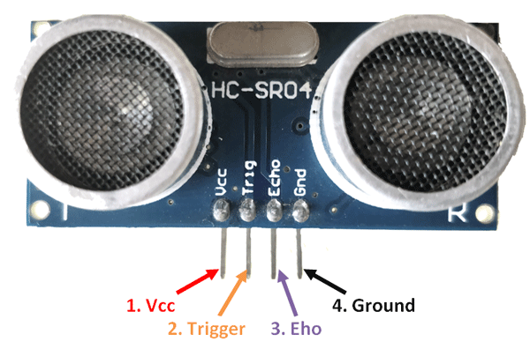

Fig 5.1: Ultrasonic Sensor

An ultrasonic sensor is an electronic device that measures the distance of a target object by emitting ultrasonic sound waves, and converts the reflected sound into an electrical signal. Ultrasonic waves travel faster than the speed of audible sound (i.e. the sound that humans can hear). Ultrasonic sensors have two main components: the transmitter (which emits the sound using piezoelectric crystals) and the receiver (which encounters the sound after it has travelled to and from the target).

**APPLICATIONS:**

Ultrasonic sensors are used primarily as **proximity sensors**. They can be found in automobile self-parking technology and anti-collision safety systems. Ultrasonic sensors are also used in robotic obstacle detection systems, as well as manufacturing technology. **In comparison to infrared (IR) sensors** in proximity sensing applications, ultrasonic sensors are not as susceptible to interference of smoke, gas, and other airborne particles (though the physical components are still affected by variables such as heat).

Ultrasonic sensors are also used as **level sensors** to detect, monitor, and regulate liquid levels in closed containers (such as vats in chemical factories). Most notably, ultrasonic technology has enabled the medical industry to produce images of internal organs, identify tumors, and ensure the health of babies in the womb.

**5.5.2. PIEZOELECTRIC SENSOR**

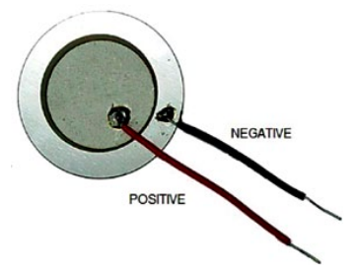

Fig 5.2: PIEZOELECTRIC SENSOR

A piezoelectric sensor is a device that uses the piezoelectric effect to measure changes in pressure, acceleration, temperature, strain, or force by converting them to an electrical charge. The prefix *piez -* is Greek for 'press' or 'squeeze' of various compound and forms.

**APPLICATIONS:**

* Piezoelectric sensors are versatile tools for the measurement of various processes. They are used for quality assurance, process control, and for research and development in many industries.
* They have been successfully used in various applications, such as in medical, aerospace, nuclear instrumentation, and as a tilt sensor in consumer electronics or a pressure sensor in the touch pads of mobile phones.
* The high modulus of elasticity of many piezoelectric materials is comparable to that of many metals and goes up to 106 N/m². Even though piezoelectric sensors are electromechanical systems that react to compression, the sensing elements show almost zero deflection.

# **5.6 VIBRATION MOTOR**

# **5.6.1 INTRODUCTION:**

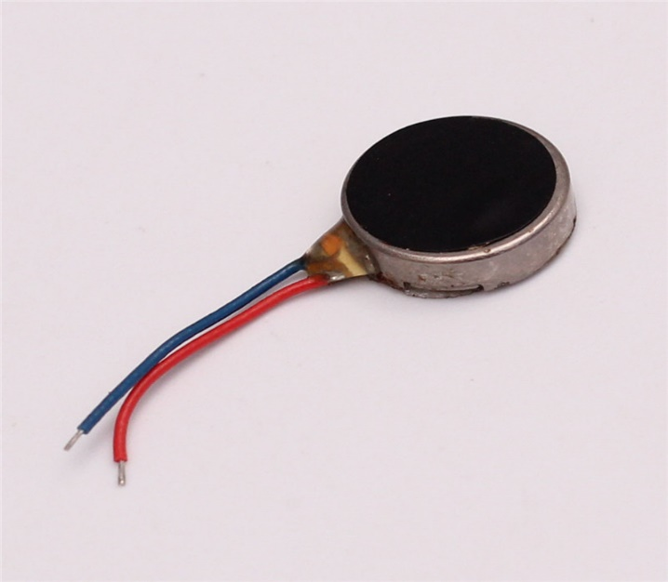

Fig 6: Flat 1034 mobile phone vibration motor

Vibration motor is a coreless DC motor and the size of this motor is compact. The main purpose of this motor is to alert the user from receiving the call by without sound/vibration .These motors are applicable for different applications like pagers, handsets, cell phones, etc.

**5.6.2 SPECIFICATIONS:**

1. Voltage Range: DC 2.5-4V.
2. Motor Diameter: 10 mm.
3. Motor Thickness: 3.4 mm.
4. Min. Rated Speed: 9000RPM
5. Max. Rated Current: 90mA

**CHAPTER 6**

**6.1 ABOUT THE CIRCUIT**

**6.1 BLOCK DIAGRAM**

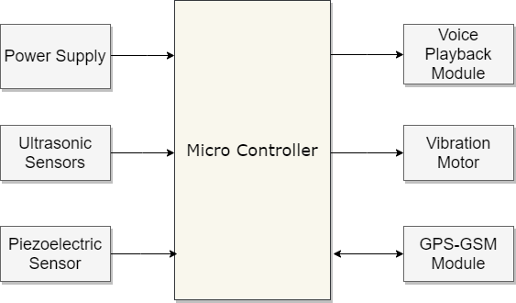

Fig: Block Diagram for Voice Assistive Smart Stick for Blinds

**CHAPTER 6**

**6.2 HARDWARE SETUP**

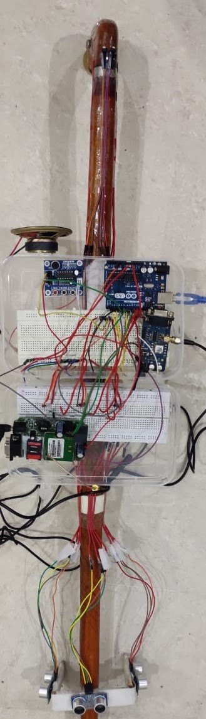

FIG : HARDWARE SETUP OF VOICE ASSISTIVE SMART STICK FOR BLIND 1

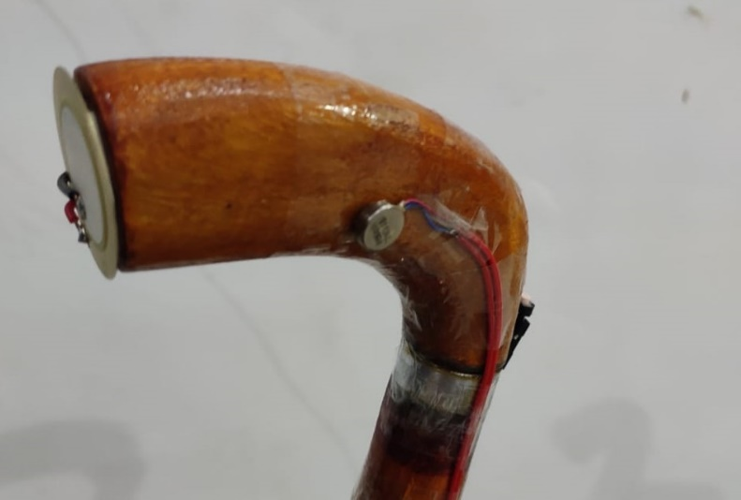

FIG : HARDWARE SETUP OF VOICE ASSISTIVE SMART STICK FOR BLIND 2

**CHAPTER 6**

**6.3 ABOUT THE SOFTWARE**

**6.3.1 SOFTWARE DESCRIPTION**

The [**Arduino**](https://en.wikipedia.org/wiki/Arduino)**Integrated Development Environment (**[**IDE**](https://en.wikipedia.org/wiki/Integrated_development_environment)**)** is a [cross-platform](https://en.wikipedia.org/wiki/Cross-platform) application (for [Windows](https://en.wikipedia.org/wiki/Windows), [macOS](https://en.wikipedia.org/wiki/MacOS" \o "MacOS), [Linux](https://en.wikipedia.org/wiki/Linux)) that is written in functions from [C](https://en.wikipedia.org/wiki/C_(programming_language)) and [C++](https://en.wikipedia.org/wiki/C%2B%2B_(programming_language))[2]](https://en.wikipedia.org/wiki/Arduino_IDE#cite_note-2). It is used to write and upload programs to Arduino compatible boards, but also, with the help of 3rd party cores, other vendor development boards.

The source code for the IDE is released under the [GNU General Public License](https://en.wikipedia.org/wiki/GNU_General_Public_License), version 2. The Arduino IDE supports the languages [C](https://en.wikipedia.org/wiki/C_(programming_language)) and [C++](https://en.wikipedia.org/wiki/C%2B%2B) using special rules of code structuring.[[5]](https://en.wikipedia.org/wiki/Arduino_IDE#cite_note-5) The Arduino IDE supplies a [software library](https://en.wikipedia.org/wiki/Software_library) from the [Wiring](https://en.wikipedia.org/wiki/Wiring_(development_platform)) project, which provides many common input and output procedures. User-written code only requires two basic functions, for starting the sketch and the main program loop, that are compiled and linked with a program stub *main()* into an executable [cyclic executive](https://en.wikipedia.org/wiki/Cyclic_executive) program with the [GNU toolchain](https://en.wikipedia.org/wiki/GNU_toolchain), also included with the IDE distribution.[[6]](https://en.wikipedia.org/wiki/Arduino_IDE#cite_note-6) The Arduino IDE employs the program *avrdude* to convert the executable code into a text file in hexadecimal encoding that is loaded into the Arduino board by a loader program in the board's firmware.

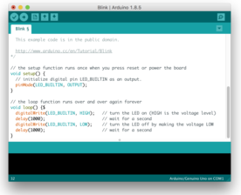

Fig 12: software of Arduino

**6.3.2 CODE**

#include <SoftwareSerial.h>

SoftwareSerial sim800l(7,10); // RX,TX for Arduino and for the module it's TXD RXD, they should be inverted

#define button1 12 //Button pin, on the other pin it's wired with GND

#define button2 13

const int piezo = A1;

#define PLAY_E 6

#define playTime 500

#define recordTime 3000

const int vib = 11;

bool button_State; //Button state

const int pingPin1 = 2; // Trigger Pin of Ultrasonic Sensor1

const int echoPin1 = 3; // Echo Pin of Ultrasonic Sensor1

const int pingPin2 = 4; // Trigger Pin of Ultrasonic Sensor2

const int echoPin2 = 5;Echo Pin of Ultrasonic Sensor2

const int pingPin3 = 8; // Trigger Pin of Ultrasonic Sensor 3

const int echoPin3 = 9; //echo pin of ultrasonic sensor 3

long duration, inches,d1, cm,cm1,cm3,cm2;

int a,b,c,butt1,butt2,count = 0;

void setup()

{

pinMode(vib,OUTPUT);

pinMode(PLAY_E,OUTPUT);

pinMode(button1, INPUT_PULLUP); //The button is always on HIGH level, when pressed it goes LOW

pinMode(button2, INPUT_PULLUP);

sim800l.begin(9600); //Module baude rate, this is on max, it depends on the version

Serial.begin(9600);

pinMode(pingPin1,OUTPUT);

pinMode(echoPin1,INPUT);

pinMode(8,OUTPUT);

pinMode(9,INPUT);

pinMode(4,OUTPUT);

pinMode(5,INPUT);

pinMode(piezo,INPUT);

delay(1000);

}

void loop()

{

int a = ultrasonic_1();

int c = ultrasonic_3();

int b = ultrasonic_2();

int d = button_1();

int e = button_2();

int f = piezo_1();

Serial.println(f);

Serial.print("button1 = ");

Serial.println(d);

Serial.print("button2 = ");

Serial.println(e);

if ((d == 1) || (f > 1))

{

count = 1 ;

// SendSMS();

delay(2000);

}

if(e==1&&count >0 )

{

count = 0;

// SendSMS_1();

}

if((c<13) || (b<13) || (a<13))

{

play();

vibration();

}

}

void SendSMS()

{

Serial.println("Sending SMS..."); //Show this message on serial monitor

sim800l.print("AT+CMGF=1\r"); //Set the module to SMS mode

delay(100);

sim800l.print("AT+CMGS=\"+91**********\"\r"); //Your phone number don't forget to include your country code, example +212123456789"

delay(500);

//sim800l.print("SIM800l is working");

sim800l.print("https://www.google.com/maps/?q=?");//This is the text to send to the phone number, don't make it too long or you have to modify the SoftwareSerial buffer

delay(500);

sim800l.print((char)26);// (required according to the datasheet)

delay(500);

sim800l.println();

Serial.println("Text Sent.");

delay(500);

}

void SendSMS_1()

{

Serial.println("Sending SMS..."); //Show this message on serial monitor

sim800l.print("AT+CMGF=1\r"); //Set the module to SMS mode

delay(100);

sim800l.print("AT+CMGS=\"+91**********\"\r"); //Your phone number don't forget to include your country code, example +212123456789"

delay(500);

//sim800l.print("SIM800l is working");

sim800l.print("Dont worry! I am safe now.");//This is the text to send to the phone number, don't make it too long or you have to modify the SoftwareSerial buffer

delay(500);

sim800l.print((char)26);// (required according to the datasheet)

delay(500);

sim800l.println();

Serial.println("Text Sent.");

delay(500);

}

int ultrasonic_1()

{

digitalWrite(2, LOW);

delayMicroseconds(2);

digitalWrite(2, HIGH);

delayMicroseconds(10);

digitalWrite(2, LOW);

d1 = pulseIn(3, HIGH);

cm1 = microsecondsToCentimeters(d1);

Serial.print(cm1);

Serial.print("cm1");

Serial.println();

delay(100);

return cm1;

}

int ultrasonic_2()

{

digitalWrite(4, LOW);

delayMicroseconds(2);

digitalWrite(4, HIGH);

delayMicroseconds(10);

digitalWrite(4, LOW);

d1 = pulseIn(5, HIGH);

cm2 = microsecondsToCentimeters(d1);

Serial.print(cm2);

Serial.print("cm2");

Serial.println();

delay(100);

return cm2;

}

int ultrasonic_3()

{

digitalWrite(8, LOW);

delayMicroseconds(2);

digitalWrite(8, HIGH);

delayMicroseconds(10);

digitalWrite(8, LOW);

d1 = pulseIn(9, HIGH);

cm3 = microsecondsToCentimeters(d1);

Serial.print(cm3);

Serial.print("cm3");

Serial.println();

delay(100);

return cm3;

}

int button_1()

{

int val = digitalRead(button1);

delay(500);

return val;

}

int button_2()

{

int val = digitalRead(button2);

delay(500);

return val;

}

void play()

{

digitalWrite(PLAY_E, HIGH);

delay(200);

digitalWrite(PLAY_E, LOW);

Serial.println("Playback Started");

delay(playTime);

}

void vibration()

{

digitalWrite(vib,HIGH);

delay(350);

digitalWrite(vib,LOW);

Serial.println("vib Started");

delay(200);

}

int piezo_1()

{

int a = analogRead(A1);

Serial.print("pizo = ");

Serial.println(a);

return a;

}

long microsecondsToInches(long microseconds) {

return microseconds / 74 / 2;

}

long microsecondsToCentimeters(long microseconds) {

return microseconds / 29 / 2;

}

**6.4 WORKING**

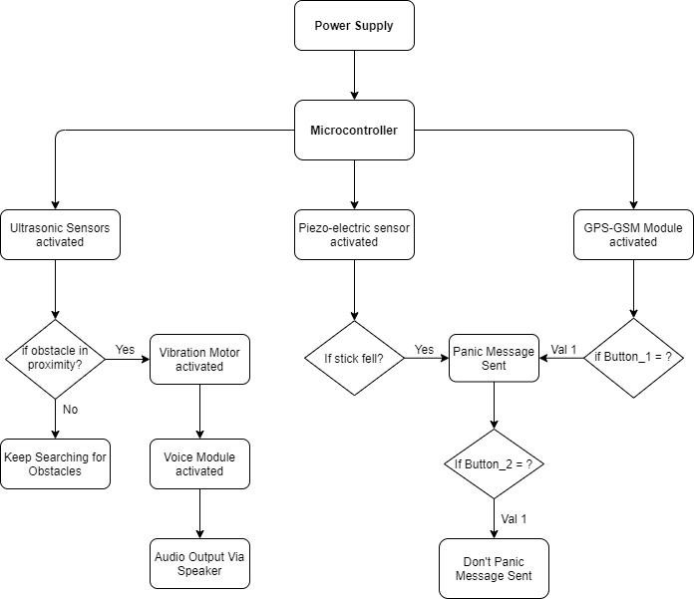

**CHAPTER 7**

**CONCLUSION**

The main advantage of the system is that it helps the blind people in both indoor and outdoor, care-free navigation. The devices placed in the stick makes it comfortable and easy to handle. The smart stick helps in detecting obstacles placed at a distance in front of the user. The system is suitable for both indoor and outdoor environment. The information regarding obstacles is given through voice alerts, eliminates the difficulty of understanding vibration patterns which was used in earlier systems. The system is a moderate budget mobile navigational aid for the visually impaired.

The voice playback module is comfortable to give instructions by using any language so that the system can be used by worldwide. The GPS and GSM modules are successfully operate in sending the location SMS within 2 minutes hence the work of sending message has successfully completed.

The smart walking stick, constructed with at most accuracy, will help the blind people to move from one place to another without others help. This could also be considered a crude way of giving the blind a sense of vision. This stick reduces the dependency of visually impaired people on other family members, friends and guide dogs while walking around. The proposed combination of various working units makes a real-time system that monitors position of the user and provides dual feedback making navigation more safe and secure. The smart stick detects objects or obstacles in front of users and feeds warning back, in the form of voice messages rather than vibration. Also the incorporation of automatic room equipment switching in the stick will be useful while they are indoor. The advantage of the system lies in the fact that it can offer a low-cost, reliable, portable, low-power consumption and robust solution for navigation with obvious short response time.

**CHAPTER 8**

**FUTURE SCOPE**

* The system can be modified by adding flame detector sensor to alert them to escape from the fire accidents. The principles of radar can be used to detect the long ranging target objects*.*
* To improve the capabilities by the system by incorporating landmark as saved destination
* An app/website can be created which will track the stick in real-time.
* Laser sensor can be deployed to accurately recognize the pits and holes on the road.
* An algorithm can be developed for detecting position and velocity of the nearby vehicles so that other methods of navigation can be implemented accurately.
* A proper database can be created and stored for Explanatory Data Analysis and can be further studied in order to support research purposes.
* The reaction time of the components can be further improved.

**REFERENCES :-**

1. Assistive Infrared Sensor Based Smart Stick for Blind People by Ayat A. Nada, Mahmoud A. Fakhr, Ahmed F. Seddik June 2015
2. Smart Cane Assisted Mobility for the Visually Impaired, World Academy of Science, Engineering and Technology International Journal of Computer, Electrical, Automation, Control and Information Engineering Vol:6, No:10, 2012
3. <http://ijesc.org/>
4. Ultrasonic and Voice Based Walking Stick for Blind People by D.Sekar, S.Sivakumar, P.Thiyagarajan, R. Premkumar, M. Vivek Kumar March 2016.
5. <http://campuscrm.campuscomponent.com/>
6. R. Lienhart and J. Maydt, An extended set of Haar-like features for rapid object detection, presented at the IEEE International Conference on Image Processing, 2002.
7. <https://www.irjet.net/archives>
8. Sung Jae Kang, et al." Development of an Intelligent Guide-Stick for the Blind", Proceeding of the IEEE international Conference on Robotics & Automation, 2001
9. <https://www.electronicwings.com/sensors-modules/gps-receiver-module>
10. World Health Organization. [(accessed on 14 September 2018)]; Available online: [http://www.who.int](http://www.who.int/).
11. Radhika R., Payal G.P., Rakshitha S., Rampur S. Smart stick for the blind a complete solution to reach the destination. Int. J. Mod. Treat. Eng. Res. 2016;3:659–662. [[Google Scholar](https://scholar.google.com/scholar_lookup?journal=Int.+J.+Mod.+Treat.+Eng.+Res.&title=Smart+stick+for+the+blind+a+complete+solution+to+reach+the+destination&author=R.+Radhika&author=G.P.+Payal&author=S.+Rakshitha&author=S.+Rampur&volume=3&publication_year=2016&pages=659-662&)]
12. 5. Sharma P., Shimi S.L., Chatterji S. Design of microcontroller based virtual eye for the blind. Int. J. Sci. Res. Eng. Technol. 2014;3:1137–1142. [[Google Scholar](https://scholar.google.com/scholar_lookup?journal=Int.+J.+Sci.+Res.+Eng.+Technol.&title=Design+of+microcontroller+based+virtual+eye+for+the+blind&author=P.+Sharma&author=S.L.+Shimi&author=S.+Chatterji&volume=3&publication_year=2014&pages=1137-1142&)]
13. wikipedia.com
14. ieeexplore.ieee.org