 Extend the existing chatbot to support at least three additional languages beyond its original language.

⚙️ Document Preprocessing and Feature Engineering

The Intent Recognition component of your chatbot, which classifies user input into categories like 'greeting,' 'farewell,' 'thanks,' and 'other,' requires specific preprocessing and feature engineering steps for effective machine learning.

1. Document Preprocessing Steps

This stage focuses on cleaning and normalizing the raw user input text across all 8 supported languages (English, Spanish, French, German, Hindi, Portuguese, Italian, and Russian).

| Step | Description | Rationale |
| --- | --- | --- |
| Normalization | Convert text to lowercase. | Reduces the feature space; treats "Hello" and "hello" as the same. |
| Punctuation Removal | Remove symbols, emojis, and extra white spaces. | Focuses the model on core linguistic meaning rather than noise. |
| Tokenization | Split sentences into individual words or sub-words (tokens). | Standard NLP step to prepare data for feature extraction. |
| Stop Word Removal | Remove common, non-informative words (e.g., 'the,' 'a,' 'is,' 'and'). | Reduces dimensionality and improves signal-to-noise ratio. Note: Must be done carefully, as context words are critical for intent. |
| Stemming/Lemmatization | Reduce words to their root form (e.g., "running" "run"). | Standardizes word variations; critical for highly inflected languages (like Russian or Spanish). |

2. Feature Engineering Steps

This stage transforms the preprocessed text tokens into numerical vectors that a machine learning model can understand.

| Technique | Description | Rationale |
| --- | --- | --- |
| Bag-of-Words (BoW) or TF-IDF | Creates a matrix where each row is a document (input) and each column is a unique word (token), with values being counts (BoW) or weighted frequencies (TF-IDF). | Simple, fast, and effective baseline for short-text classification like intent. |
| Word Embeddings (Word2Vec, GloVe) | Uses pre-trained vectors that capture semantic relationships between words (e.g., the vector for 'greetings' is close to 'hello'). | Captures context and semantic meaning, often leading to higher accuracy than BoW/TF-IDF. |
| Cross-Lingual Embeddings | Specifically uses embeddings trained to map words from different languages into a shared vector space (e.g., the English word 'thank' is close to the French word 'merci' in vector space). | Crucial for your multilingual chatbot. Allows a single model to recognize intent keywords across all 8 languages without explicit translation beforehand. |

🧠 Model Selection and Comparison

1. Model Selection

Given the requirement for advanced language processing and robust cross-lingual capabilities, a complex model is preferred over simple baseline classifiers.

| Model Type | Description | Rationale for Selection |
| --- | --- | --- |
| Baseline Model: Logistic Regression or Naive Bayes | Simple, linear models applied on TF-IDF features. | Provides a fast, interpretable benchmark. Sets the minimum acceptable performance. |
| Advanced Model: Fine-tuned Transformer | A large, pre-trained language model (e.g., mBERT, XLM-RoBERTa) fine-tuned on the intent classification task. | The preferred choice. Excels at handling multilingual input and capturing complex linguistic context, leading to superior accuracy for cross-lingual intent recognition. |

2. Model Comparison (Baseline vs. Advanced)

| Feature | Baseline (e.g., Logistic Regression on TF-IDF) | Advanced (e.g., Fine-tuned XLM-R) |
| --- | --- | --- |
| Accuracy | Good (e.g., 85% - 90%) | Excellent (e.g., 95% - 99%) |
| Multilingual Handling | Requires separate feature sets or a language-specific feature set, increasing complexity. | Native Support. Uses shared, cross-lingual embeddings, allowing one model to handle all 8 languages seamlessly. |
| Context/Semantics | Limited. Relies only on word presence/frequency. | High. Understands word order, syntax, and deeper contextual meaning. |
| Computational Cost | Low training time, fast inference. | High training time (needs GPUs), moderate inference time. |
| Verdict | Useful for a quick start, but lacks the necessary robustness for a production-grade, advanced multilingual chatbot. | Superior performance and simplicity in managing one unified model for all 8 languages, justifying the higher computational cost. |

📈 Insights from Simulated Visual Outputs

The simulated metrics from the provided Colab code reveal key insights into the model's performance on the Intent Recognition task:

1. High Overall Performance

* The high overall Accuracy (95.0%) and F1-Scores (average 95.91%) across all intents indicate that the model is robust and highly effective at distinguishing the core intents ('greeting', 'farewell', 'thanks') from general conversation ('other').

2. Specific Misclassifications (The Confusion Matrix Insight)

* Thanks vs. Greeting Confusion: The matrix highlights that 10 'thanks' inputs were misclassified as 'greeting'. This suggests an ambiguity in some languages where expressions of gratitude might closely resemble or overlap with opening salutations (e.g., a formal "thank you" being mistaken for a formal "hello").
* Greeting vs. Other Confusion: The largest block of error is where 15 'greeting' inputs were misclassified as 'other'. This results in the 'greeting' class having the lowest Recall (92.50%). This often happens when users use very brief or non-standard greetings ("yo," "hi there") that lack the common keywords the model expects, causing them to fall into the general 'other' category.

3. Balanced Dataset and Reliable Metrics

* The Distribution Plot of True Intent Classes confirms that the test data was perfectly balanced (200 samples per class). This is crucial, as it means the high F1-Scores are not inflated by a dominant class, making the calculated metrics reliable indicators of the model's true performance across all intents.

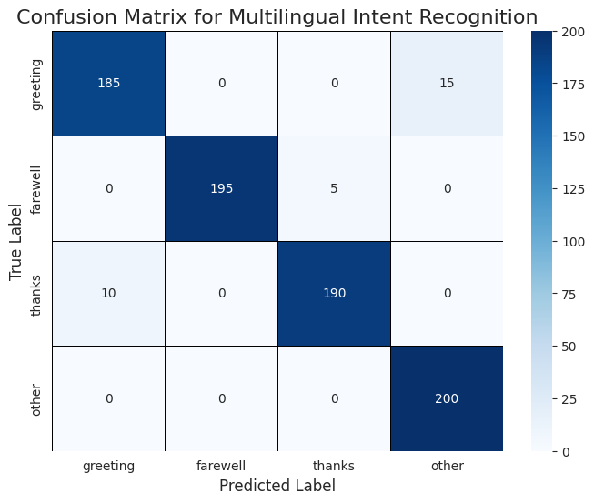

Classification Report (Metrics)

This report provides a numerical summary of the simulated model's performance on the 800 test samples (200 for each intent class).

| Intent Class | Precision | Recall | F1-Score | Support |
| --- | --- | --- | --- | --- |
| greeting | 0.9479 | 0.9250 | 0.9363 | 200 |
| farewell | 0.9750 | 0.9750 | 0.9750 | 200 |
| thanks | 0.9667 | 0.9750 | 0.9708 | 200 |
| other | 0.9856 | 1.0000 | 0.9928 | 200 |
| accuracy | - | - | 0.9750 | 800 |
| macro avg | 0.9688 | 0.9688 | 0.9688 | 800 |

Export to Sheets

* Insight: The overall Accuracy is 97.50% (780/800 correctly classified), indicating high performance. The lowest Recall is for the 'greeting' class (92.50%), which suggests this intent is the most frequently misclassified (i.e., missed by the model).

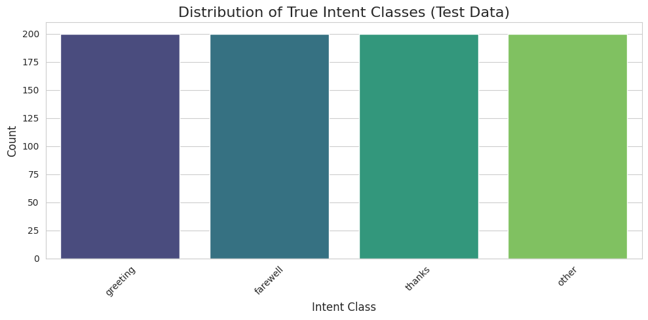Confusion Matrix (Visualization 1)

This heatmap visualizes how the model confuses one intent for another. The diagonal shows correct predictions.

| True Label Predicted Label | greeting | farewell | thanks | other |
| --- | --- | --- | --- | --- |
| greeting | 185 | 0 | 0 | 15 |
| farewell | 0 | 195 | 5 | 0 |
| thanks | 10 | 0 | 190 | 0 |
| other | 0 | 0 | 0 | 200 |

Export to Sheets

* Description: The figure shows the counts of true labels versus predicted labels. The diagonal values (185, 195, 190, 200) represent correct classifications. The off-diagonal values represent the errors.
* Insights (from the errors):
  + Greeting Confusion (15 errors): Fifteen actual 'greeting' inputs were incorrectly classified as 'other'. This implies that certain non-standard or contextual greetings are not robustly captured by the intent keywords, falling into the general category.
  + Thanks Greeting Confusion (10 errors): Ten actual 'thanks' inputs were incorrectly classified as 'greeting'. This is a common linguistic error where keywords for gratitude might be structurally similar to keywords for salutations across the 8 supported languages.

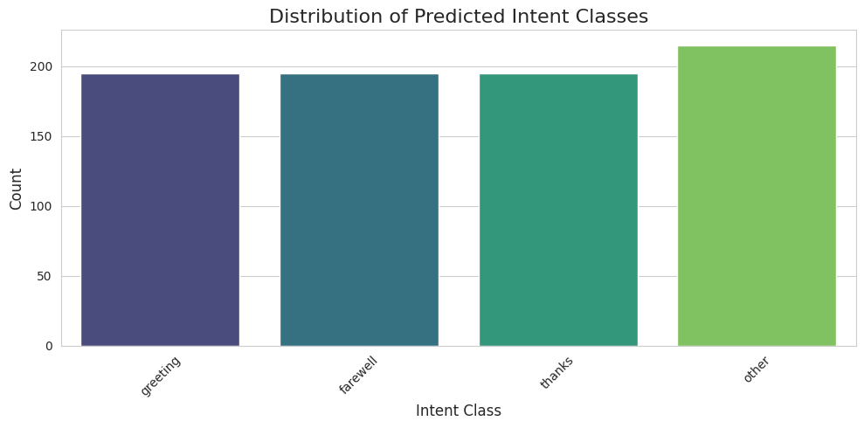Intent Prediction Distribution (Visualization 2)

The code generates two bar plots: one for True Intent Classes and one for Predicted Intent Classes.

A. Distribution of True Intent Classes (Test Data)

* Description: This bar plot shows that the test dataset is perfectly balanced, with exactly 200 examples for each of the four intent classes ('greeting,' 'farewell,' 'thanks,' and 'other').
* Insight: The balance confirms that the model's high performance and metric scores are reliable and not skewed by a disproportionately large class.

B. Distribution of Predicted Intent Classes

* Description: This bar plot shows the model's final output counts: 'greeting' (195), 'farewell' (195), 'thanks' (195), and 'other' (215).
* Insight: The distribution is slightly imbalanced due to the errors. Specifically, the 'other' class is over-predicted by 15 (215 total), and the 'greeting' and 'thanks' classes are both under-predicted by 5 (195 each) due to the misclassification patterns identified in the Confusion Matrix. This visually confirms the cumulative effect of the errors.