Speedy Car 1.0

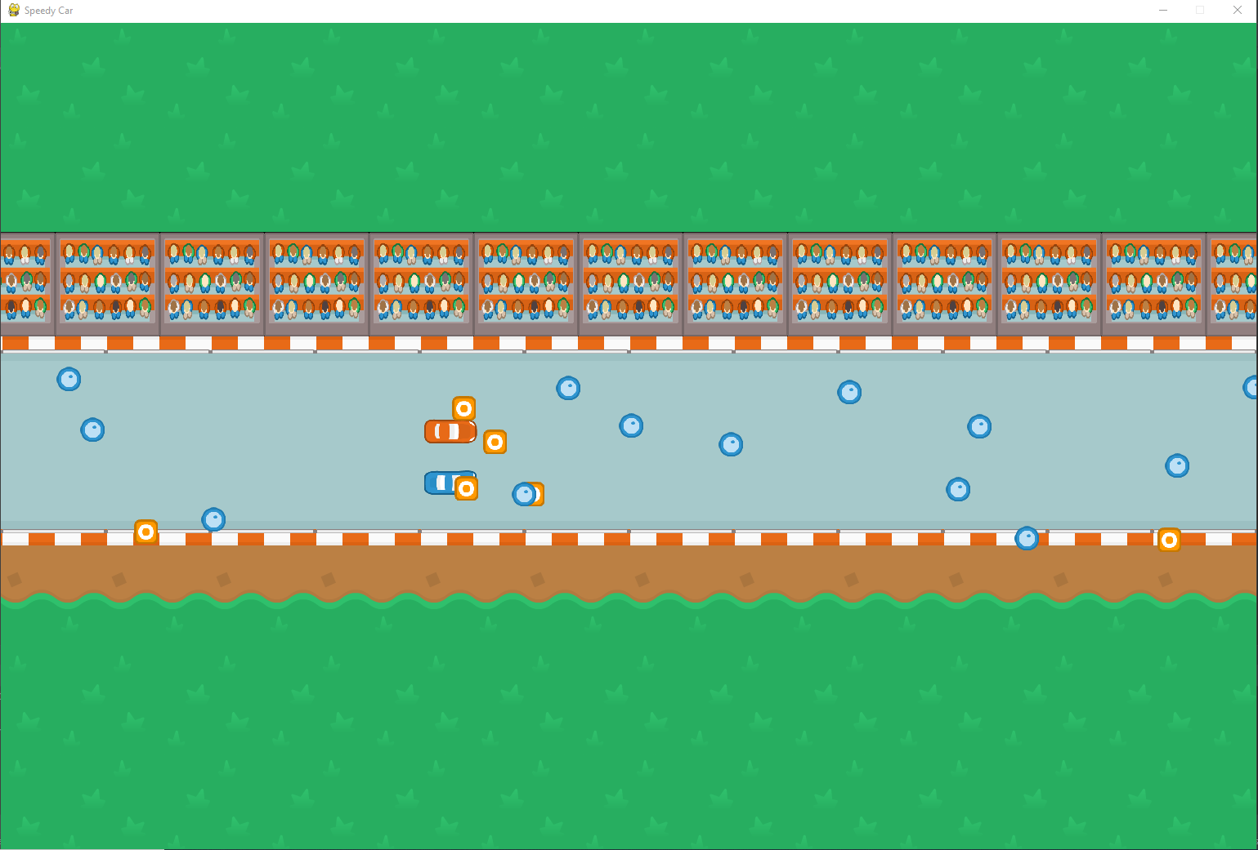

# Run the Game

1. Ensure that python3 is installed: sudo apt install python
2. Install pygame pip install pygame
3. Launch the game python game.py

# How to Play

* The goal is to last the longest without getting pushed to the end of the track by the obstacles.
* Blue car player uses up and down arrows to move the car
* Red car player uses w and s keys to move the car
* Press ‘Q’ or the red X to quit the game

# Additional Features

* The orange cones slow the cars down significantly
* The blue barrels speed the cars up
* The cars will slow down if the hit the barriers of the track