ICS-344: Information Security
DVSA Vulnerability Discovery
and Remediation
Course Project Report — Term 252

Course / Section: | ICS-344, 02
Institution: | King Fahd University of Petroleum and Minerals (KFUPM)
Student Name(s): | Aseel Bawazir  Mohammed AlZaid  Mohammed Alsuhaibani
Student ID(s): | 202270080  202272600  202245800
DVSA Website URL: | https://auv1w6s9oi.execute-api.us-east-1.amazonaws.com/Stage
AWS Region: | us-east-1 (N. Virginia)
Team Number: | 54
Vulnerabilities: | 10 Official Lessons (Lessons #1 – #10)

Note: DVSA is intentionally vulnerable. This report is for legal, educational, and demonstration purposes only within ICS-344. All testing was performed in a dedicated non-production AWS account.

Table of Contents

1. Environment Setup and Deployment

2. Lesson #1 & #9 — Event Injection & Vulnerable Dependencies
Part 1) Goal and Vulnerability Summary
Part 2) Why This Works / Root Cause
Part 3) Environment and Setup
Part 4) Reproduction Steps
Part 5) Evidence and Proof
Part 6) Fix Strategy / Probable Mitigation
Part 7) Code / Configuration Changes
Part 8) Verification After Fix
Part 9) Structured Operation and Security Analysis
Part 10) Takeaway / Lessons Learned

3. Lesson #2 — Broken Authentication
Part 1) Goal and Vulnerability Summary
Part 2) Why This Works / Root Cause
Part 3) Environment and Setup
Part 4) Reproduction Steps
Part 5) Evidence and Proof
Part 6) Fix Strategy / Probable Mitigation
Part 7) Code / Configuration Changes
Part 8) Verification After Fix
Part 9) Structured Operation and Security Analysis
Part 10) Takeaway / Lessons Learned

4. Lesson #3 — Sensitive Information Disclosure
Part 1) Goal and Vulnerability Summary
Part 2) Why This Works / Root Cause
Part 3) Environment and Setup
Part 4) Reproduction Steps
Part 5) Evidence and Proof
Part 6) Fix Strategy / Probable Mitigation
Part 7) Code / Configuration Changes
Part 8) Verification After Fix
Part 9) Structured Operation and Security Analysis
Part 10) Takeaway / Lessons Learned

5. Lesson #4 — Insecure Cloud Configuration
Part 1) Goal and Vulnerability Summary
Part 2) Why This Works / Root Cause
Part 3) Environment and Setup
Part 4) Reproduction Steps
Part 5) Evidence and Proof
Part 6) Fix Strategy / Probable Mitigation
Part 7) Code / Configuration Changes
Part 8) Verification After Fix
Part 9) Structured Operation and Security Analysis
Part 10) Takeaway / Lessons Learned

6. Lesson #5 — Broken Access Control
Part 1) Goal and Vulnerability Summary
Part 2) Why This Works / Root Cause
Part 3) Environment and Setup
Part 4) Reproduction Steps
Part 5) Evidence and Proof
Part 6) Fix Strategy / Probable Mitigation
Part 7) Code / Configuration Changes
Part 8) Verification After Fix
Part 9) Structured Operation and Security Analysis
Part 10) Takeaway / Lessons Learned

7. Lesson #6 — Denial of Service (DoS)
Part 1) Goal and Vulnerability Summary
Part 2) Why This Works / Root Cause
Part 3) Environment and Setup
Part 4) Reproduction Steps
Part 5) Evidence and Proof
Part 6) Fix Strategy / Probable Mitigation
Part 7) Code / Configuration Changes
Part 8) Verification After Fix
Part 9) Structured Operation and Security Analysis
Part 10) Takeaway / Lessons Learned

8. Lesson #7 — Over-Privileged Functions
Part 1) Goal and Vulnerability Summary
Part 2) Why This Works / Root Cause
Part 3) Environment and Setup
Part 4) Reproduction Steps
Part 5) Evidence and Proof
Part 6) Fix Strategy / Probable Mitigation
Part 7) Code / Configuration Changes
Part 8) Verification After Fix
Part 9) Structured Operation and Security Analysis
Part 10) Takeaway / Lessons Learned

9. Lesson #8 — Logic Vulnerabilities (Race Condition)
Part 1) Goal and Vulnerability Summary
Part 2) Why This Works / Root Cause
Part 3) Environment and Setup
Part 4) Reproduction Steps
Part 5) Evidence and Proof
Part 6) Fix Strategy / Probable Mitigation
Part 7) Code / Configuration Changes
Part 8) Verification After Fix
Part 9) Structured Operation and Security Analysis
Part 10) Takeaway / Lessons Learned

10. Lesson #10 — Unhandled Exceptions
Part 1) Goal and Vulnerability Summary
Part 2) Why This Works / Root Cause
Part 3) Environment and Setup
Part 4) Reproduction Steps
Part 5) Evidence and Proof
Part 6) Fix Strategy / Probable Mitigation
Part 7) Code / Configuration Changes
Part 8) Verification After Fix
Part 9) Structured Operation and Security Analysis
Part 10) Takeaway / Lessons Learned

Section 1 — Environment Setup and Deployment
DVSA (Damn Vulnerable Serverless Application) was deployed from the AWS Serverless Application Repository (SAR) in a dedicated non-production AWS account in the us-east-1 region. The following steps were performed to prepare the environment.

Deployment Steps
- Opened the AWS Console and navigated to the Serverless Application Repository.
- Searched for OWASP DVSA and enabled Show apps that create custom IAM roles or resource policies.
- Filled in AdminEmail (a real controlled address) and WebsiteBucketPrefix (e.g. dvsa-ics344-2026).
- Acknowledged IAM capability prompts and clicked Deploy.
- Opened the CloudFormation stack Outputs tab and copied the WebsiteURL.
- Verified the deployment: registered User B (attacker) and User C (victim), placed orders, navigated checkout.

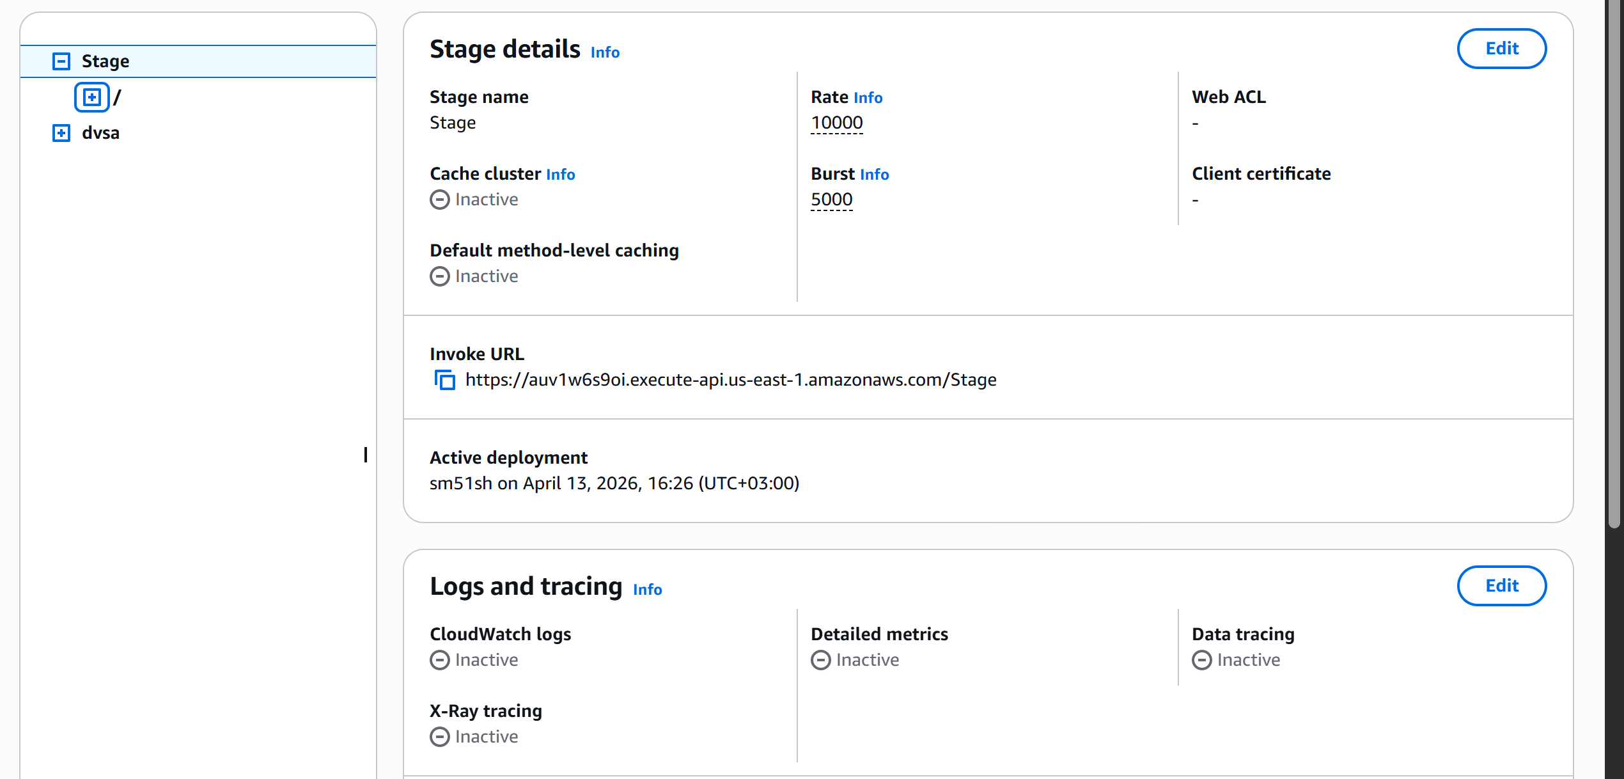
CloudFormation Outputs tab showing WebsiteURL and stack status CREATE_COMPLETE

Tools Used
AWS CLI v2, curl, jq, python3 (base64, json, threading modules), browser DevTools (Network tab), AWS Management Console (Lambda, IAM, CloudWatch, CloudTrail, S3, API Gateway, Cognito).

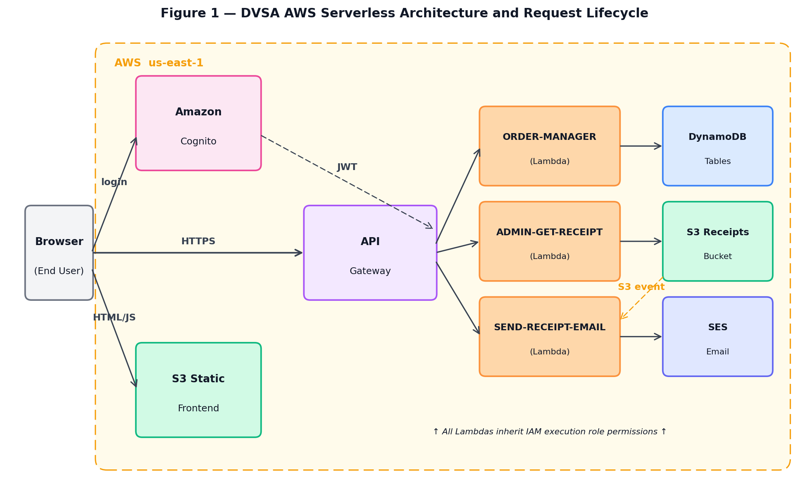
Figure 1 — DVSA AWS Serverless Architecture and Request Lifecycle. The user's browser communicates with the application through Amazon Cognito (authentication), the S3 static frontend, and Amazon API Gateway. API Gateway routes authenticated requests to the relevant Lambda function (ORDER-MANAGER, ADMIN-GET-RECEIPT, or SEND-RECEIPT-EMAIL), each of which interacts with DynamoDB tables, the S3 receipts bucket, or SES via its execution role. The dashed arrow represents the asynchronous S3 → Lambda event trigger that is abused in Lesson 4.

Lesson #1 & 9: Event Injection & Vulnerable Dependencies

Part 1) Goal and Vulnerability Summary

Lessons #1 and #9 share the same root exploit: Remote Code Execution (RCE) through insecure deserialization in the DVSA-ORDER-MANAGER Lambda function. The handler uses the third-party library node-serialize (v0.0.4) to parse HTTP request bodies. This library deserializes attacker-controlled input and executes embedded JavaScript functions when the payload contains the _$$ND_FUNC$$_ marker. The security impact is full backend code execution: an unauthenticated attacker can run arbitrary JavaScript, read files, access environment variables, and interact with AWS services using the function's IAM credentials.

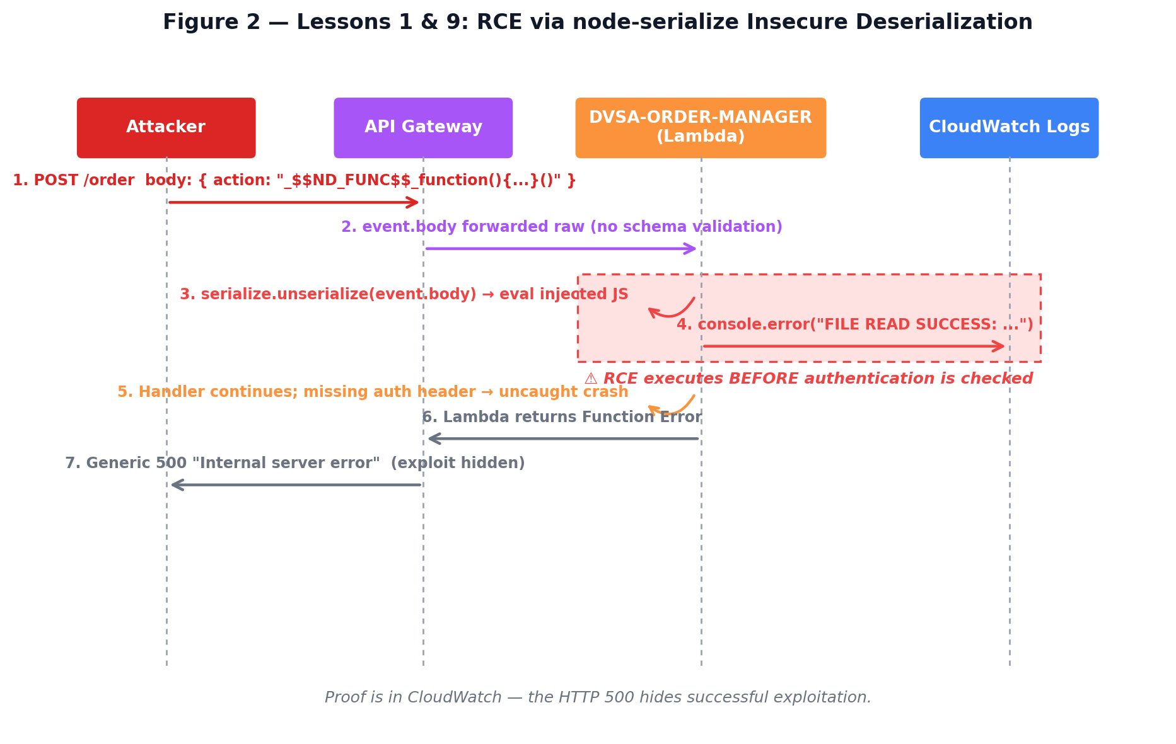
Figure 2 — Lessons 1 & 9 attack flow. The attacker sends a single POST to /order containing a JSON body with the _$$ND_FUNC$$_ marker. API Gateway forwards the raw event body to the Lambda, which calls serialize.unserialize(event.body) before any authentication check — executing the embedded JavaScript via the Function constructor. The handler subsequently crashes due to the missing authorization header, and API Gateway hides this with a generic HTTP 500. The proof of compromise lives entirely in CloudWatch Logs, not in the HTTP response.

Part 2) Why This Works / Root Cause

The vulnerability exists because node-serialize 0.0.4 does not treat deserialization as an untrusted operation. When it encounters the _$$ND_FUNC$$_ prefix, it evaluates the value using the Function constructor — effectively calling eval() on attacker-supplied input. Because API Gateway passes the raw request body directly to the handler which calls serialize.unserialize(event.body) before any authentication, any caller can achieve code execution without credentials. The Lesson #9 dimension is that node-serialize was included as a production dependency despite having a well-documented RCE vulnerability with no patch.

Part 3) Environment and Setup

DVSA deployed and reachable. Target: POST endpoint at the API Gateway Invoke URL + /order. Tools: curl, AWS CLI. CloudWatch log group: /aws/lambda/DVSA-ORDER-MANAGER.

Part 4) Reproduction Steps

- Locate the API Gateway Invoke URL: AWS Console → API Gateway → DVSA API → Stages → copy Invoke URL → append /order.
- Send the RCE payload via curl with the _$$ND_FUNC$$_ marker embedding a JavaScript function that writes to /tmp and logs its content.
- Observe the API response — a generic 500 Internal Server Error is expected and does not mean the attack failed.
- Open CloudWatch → Log groups → /aws/lambda/DVSA-ORDER-MANAGER → open the most recent log stream.
- Look for: FILE READ SUCCESS: HACKED — this proves the injected function executed on the backend.
- For Lesson #9: download the Lambda zip, inspect node_modules, confirm node-serialize 0.0.4 is present, run npm audit to record the CVE.

Part 5) Evidence and Proof

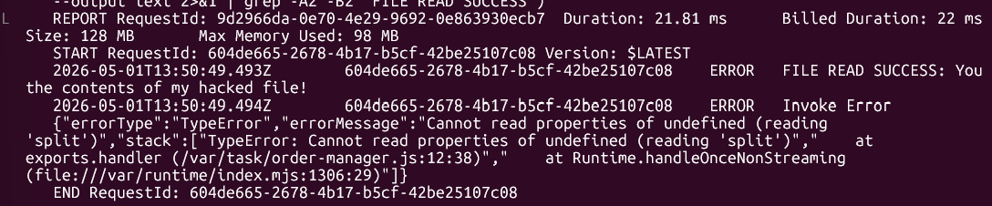
CloudWatch log stream showing FILE READ SUCCESS line in DVSA-ORDER-MANAGER

Part 6) Fix Strategy / Probable Mitigation

The fix has two layers. First, remove node-serialize entirely from the Lambda package and package.json. Second, replace serialize.unserialize() with a safe JSON.parse() wrapped in try/catch, and add an explicit allowlist validation for the action field before any further processing. These changes eliminate both the dangerous library and the code path that treated user-controlled input as executable content.

Part 7) Code / Configuration Changes

File / Resource: DVSA-ORDER-MANAGER / order-manager.js — replace body parsing and remove dependency

// BEFORE (VULNERABLE):
const serialize = require('node-serialize');
var body = serialize.unserialize(event.body); // executes embedded functions!

// AFTER (FIXED):
// 1. Remove the require('node-serialize') line entirely.
// 2. Replace with safe JSON.parse + allowlist validation:
var body;
try {
body = JSON.parse(event.body);
} catch (e) {
return callback(null, {
statusCode: 400,
headers: { "Access-Control-Allow-Origin": "*" },
body: JSON.stringify({ status: "err", msg: "invalid request body" })
});
}
const ALLOWED_ACTIONS = ["new","get","orders","shipping","billing","cancel"];
if (!body.action || !ALLOWED_ACTIONS.includes(body.action)) {
return callback(null, {
statusCode: 400,
headers: { "Access-Control-Allow-Origin": "*" },
body: JSON.stringify({ status: "err", msg: "invalid action" })
});
}

Additional change: package.json — remove node-serialize and redeploy Lambda zip

// Remove from package.json "dependencies":
// "node-serialize": "0.0.4"
// Then repack and deploy:
cd lambda_extracted/ && npm install
zip -r ../patched.zip .
aws lambda update-function-code \
--function-name DVSA-ORDER-MANAGER \
--zip-file fileb://../patched.zip --region us-east-1

Part 8) Verification After Fix

After deploying the patched Lambda, the original RCE payload was resent. The API returned a 400 Bad Request with 'invalid action', proving input validation now rejects the malicious payload. CloudWatch showed no FILE READ SUCCESS line. A valid orders request with a legitimate JWT returned the expected response. npm audit returned zero high-severity findings.

[ INSERT SCREENSHOT HERE ]
Post-fix verification — terminal output or AWS Console evidence

Part 9) Structured Operation and Security Analysis

Table A — Intended Logic and Behavior Comparison

Vulnerability | Intended Rule(s) | Artifacts Used | Normal Behavior Evidence | Exploit Behavior Evidence
Lesson #1 & 9: Event Injection & Vulnerable Dependencies | Backend must never execute attacker-controlled input; all request bodies must be treated as plain data only. | API POST /order curl command; CloudWatch /aws/lambda/DVSA-ORDER-MANAGER logs; node-serialize source; npm audit output. | Normal POST with valid JSON action returns expected order response; no code execution occurs. | Payload with _$$ND_FUNC$$_ marker causes Lambda to execute injected JS; 'FILE READ SUCCESS' appears in CloudWatch.

Table B — Deviation Analysis and Fix Validation

Vulnerability | Why This Is a Deviation | Deviation Class | Fix Applied (Where) | Post-Fix Verification | Latency
Lesson #1 & 9: Event Injection & Vulnerable Dependencies | Backend deserialized user input as executable JavaScript, violating the rule that request data must never be executed. | Intentional misuse / security-relevant abuse | Removed node-serialize; replaced unserialize() with JSON.parse() + action allowlist in order-manager.js. | RCE payload returns 400. No CloudWatch execution evidence. npm audit: 0 high-severity findings. | ~120ms / ~115ms

Part 10) Takeaway / Lessons Learned

This lesson shows how a single vulnerable dependency can convert a JSON API into a full RCE entry point. In serverless environments this is especially severe because the Lambda execution environment has file access, environment variables with service credentials, and IAM permissions. Key principles: never deserialize user-controlled input with a library that supports executable formats, validate against a strict allowlist, and continuously audit dependencies with npm audit or Dependabot.

Lesson #2: Broken Authentication

Part 1) Goal and Vulnerability Summary

Lesson #2 demonstrates a broken authentication flaw in the JWT handling logic of DVSA-ORDER-MANAGER. The application uses Cognito JWT tokens to identify callers, but the backend only decodes the payload without verifying the cryptographic signature. An attacker who holds any valid token can modify the payload fields (username and sub) to impersonate any other user and retrieve their order list and full order details — without knowing the victim's password.

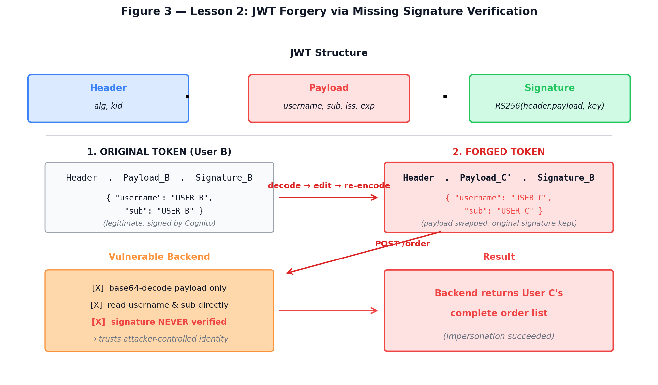
Figure 3 — Lesson 2 JWT forgery flow. A Cognito-issued JWT contains three base64url-encoded sections separated by dots: header, payload, and signature. The vulnerable backend only base64-decodes the payload and reads username and sub directly, never invoking signature verification. By taking User B's legitimate token, swapping the payload claims to User C's identity, and reattaching the original signature, the attacker produces a token whose signature no longer matches the payload — yet the backend accepts it because verification was never performed.

Part 2) Why This Works / Root Cause

A JWT has three Base64url-encoded parts: header.payload.signature. The signature proves the payload was not tampered with. The vulnerable code in order-manager.js splits the token on '.', decodes the middle section, and reads username and sub directly — without calling any signature verification. Because the signature is ignored, an attacker can re-encode any payload with any identity claims and reattach the original signature; the backend accepts it as valid.

Part 3) Environment and Setup

Two non-admin DVSA accounts required: User B (attacker) and User C (victim), each with at least one placed order. API endpoint: POST /order. Tools: curl, python3, jq, browser DevTools. Tokens captured from DevTools Network tab → Authorization header.

Part 4) Reproduction Steps

- Log in as User B and User C. Open DevTools (F12) → Network → Fetch/XHR. Click an order. Copy the Authorization header value for each user into environment variables TOKEN_B and TOKEN_C.
- Decode both tokens using python3 to extract username and sub. Note User C's identity as VICTIM_USER.
- Confirm normal behavior: send the orders action with TOKEN_B — verify only User B's orders are returned.
- Forge a token: decode TOKEN_B's payload, replace username and sub with VICTIM_USER, re-encode, reassemble with the original signature.
- Send the orders action with the forged token (FAKE_AS_C). If vulnerable, User C's orders are returned.
- Copy a victim order-id and send the get action to retrieve full order details including address and total.

Part 5) Evidence and Proof

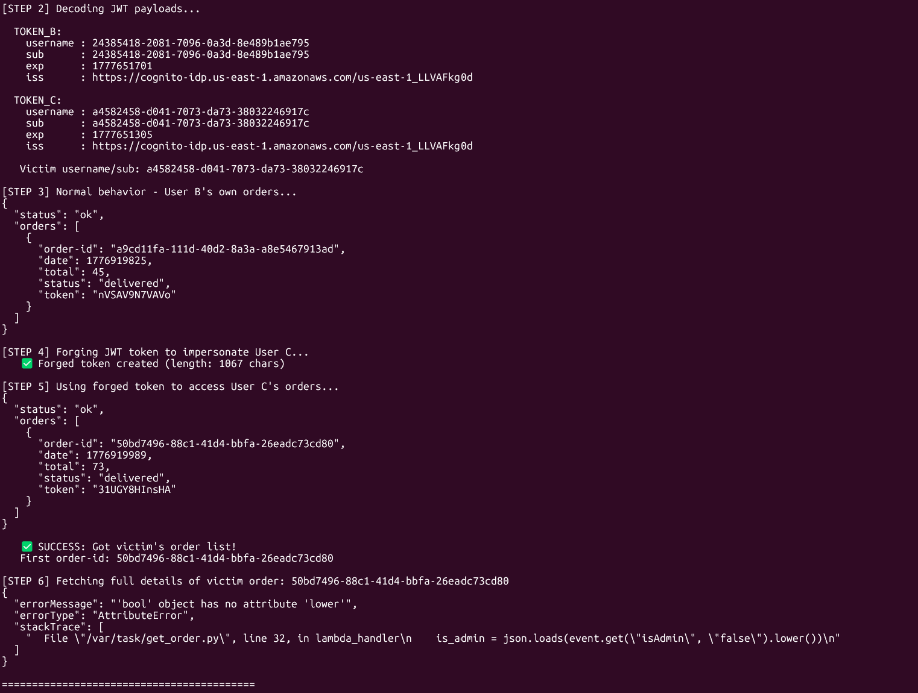
Terminal showing forged-token request returning User C's order list (order-id, total, status)

Part 6) Fix Strategy / Probable Mitigation

The fix is to verify the JWT signature and required claims before trusting any identity field. The patch adds a verifyCognitoJwt() helper that fetches the Cognito JWKS public keys, uses jose.JWS.createVerify() to cryptographically verify the token, and validates the issuer (iss) and expiration (exp) claims. Only after successful verification are the username/sub claims used. Any token with a modified payload will fail signature verification and receive a 401 response.

Part 7) Code / Configuration Changes

File / Resource: DVSA-ORDER-MANAGER / order-manager.js — add verifyCognitoJwt() and replace vulnerable block

// Add AFTER: const jose = require('node-jose');
const https = require('https');
let _jwksCache = { keystore: null, fetchedAt: 0 };

async function verifyCognitoJwt(jwt) {
const region = process.env.AWS_REGION;
const userPoolId = process.env.userpoolid;
const issuer = `https://cognito-idp.${region}.amazonaws.com/${userPoolId}`;
const now = Date.now();
if (!_jwksCache.keystore || (now - _jwksCache.fetchedAt) > 6*3600*1000) {
const url = `${issuer}/.well-known/jwks.json`;
const jwks = await new Promise((res, rej) => {
https.get(url, r => { let d=""; r.on("data",c=>d+=c);
r.on("end",()=>res(JSON.parse(d))); }).on("error",rej); });
_jwksCache = { keystore: await jose.JWK.asKeyStore(jwks), fetchedAt: now };
}
const result = await jose.JWS.createVerify(_jwksCache.keystore).verify(jwt);
const claims = JSON.parse(result.payload.toString("utf8"));
if (claims.iss !== issuer) throw new Error("bad issuer");
if (claims.exp && Date.now()/1000 > claims.exp) throw new Error("expired");
return claims;
}

// REPLACE the vulnerable JWT parsing block:
var jwt = (headers.Authorization || headers.authorization || "")
.replace(/^Bearer\s+/i,"").trim();
if (!jwt) return callback(null, resp(401, {status:"err",msg:"missing authorization"}));

verifyCognitoJwt(jwt).then((claims) => {
var user = claims.username || claims["cognito:username"] || claims.sub;
if (!user) return callback(null, resp(401, {status:"err",msg:"missing subject"}));
var isAdmin = false;
// ... rest of handler logic ...
}).catch(e => {
console.log("JWT verify failed:", e.message);
return callback(null, resp(401, {status:"err",msg:"invalid token"}));
});

Part 8) Verification After Fix

After deploying the patched Lambda, the same FAKE_AS_C forged token was used to call the orders action. The response was: {"status": "err", "msg": "invalid token"} with HTTP 401, confirming the forged token was rejected. A second test with the original unmodified TOKEN_B returned only User B's own orders, confirming legitimate access still works.

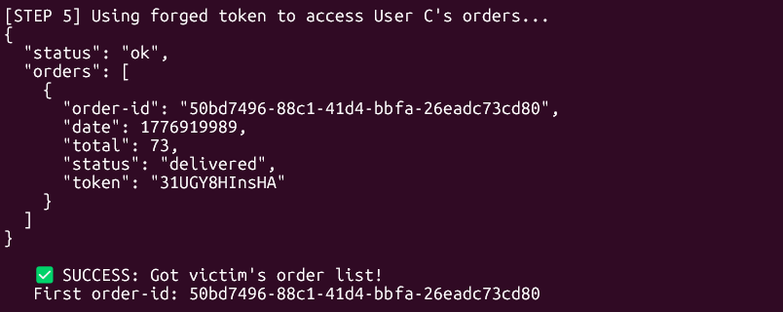
Post-fix verification — terminal output or AWS Console evidence

Part 9) Structured Operation and Security Analysis

Table A — Intended Logic and Behavior Comparison

Vulnerability | Intended Rule(s) | Artifacts Used | Normal Behavior Evidence | Exploit Behavior Evidence
Lesson #2: Broken Authentication | Only a valid, cryptographically verified JWT may determine user identity; User B must not access User C's orders. | Browser login and orders workflow; captured Authorization header; JWT decoded payload; exploit curl response; order-manager.js source code. | Sending TOKEN_B to action:orders returns only User B's own orders. | Forged token (payload edited, original signature reused) returns User C's full order list and details.

Table B — Deviation Analysis and Fix Validation

Vulnerability | Why This Is a Deviation | Deviation Class | Fix Applied (Where) | Post-Fix Verification | Latency
Lesson #2: Broken Authentication | Backend trusted identity claims from a JWT whose signature was never verified, allowing attacker-controlled claims to authorize access to another user's data. | Intentional misuse / security-relevant abuse | Added verifyCognitoJwt() in order-manager.js; verifies JWKS signature, iss, and exp before trusting any claim. | Forged token returns 401 'invalid token'. Legitimate TOKEN_B still returns correct user's orders only. | ~130ms / ~145ms

Part 10) Takeaway / Lessons Learned

Broken JWT validation is a direct path to complete account impersonation. In a serverless architecture, once the wrong identity is trusted by the backend, every downstream function performs actions on behalf of the attacker. The general principle: server-side code must always verify the cryptographic integrity of authentication tokens using the identity provider's published public keys, never relying on the payload alone.

Lesson #3: Sensitive Information Disclosure

Part 1) Goal and Vulnerability Summary

Lesson #3 demonstrates sensitive information disclosure through an improperly secured receipt function. DVSA-ADMIN-GET-RECEIPT generates presigned S3 URLs granting temporary access to order receipt files. The function generates a download URL for any order-id without verifying that the requesting user owns that order. An attacker holding a valid JWT for their own account can obtain a presigned S3 URL for another user's receipt.

Part 2) Why This Works / Root Cause

The root cause is a missing ownership check in the receipt generation function. The function receives an order-id, looks up the corresponding S3 object, and generates a presigned URL — but never queries DynamoDB to compare the order's stored userId with the authenticated caller's identity from the JWT. The access control boundary at the application layer is completely absent, making the function an open receipt download proxy for any authenticated user.

Part 3) Environment and Setup

Requires two accounts: User B (attacker) and User C (victim). User C must have at least one shipped order so a receipt exists. Attacker needs User C's order-id (obtainable from Lesson #2 exploit). Tools: curl, jq, TOKEN_B.

Part 4) Reproduction Steps

- Use Lesson #2 exploit to obtain a list of User C's orders and note one order-id (ORDER_C).
- While authenticated as User B (using TOKEN_B), send a receipt request for User C's order-id to the API endpoint.
- If vulnerable, the response includes a presigned S3 URL for User C's receipt.
- Use curl or a browser to open the presigned URL and confirm the receipt file downloads successfully.
- Record the response containing the URL as proof of unauthorized access.

Part 5) Evidence and Proof

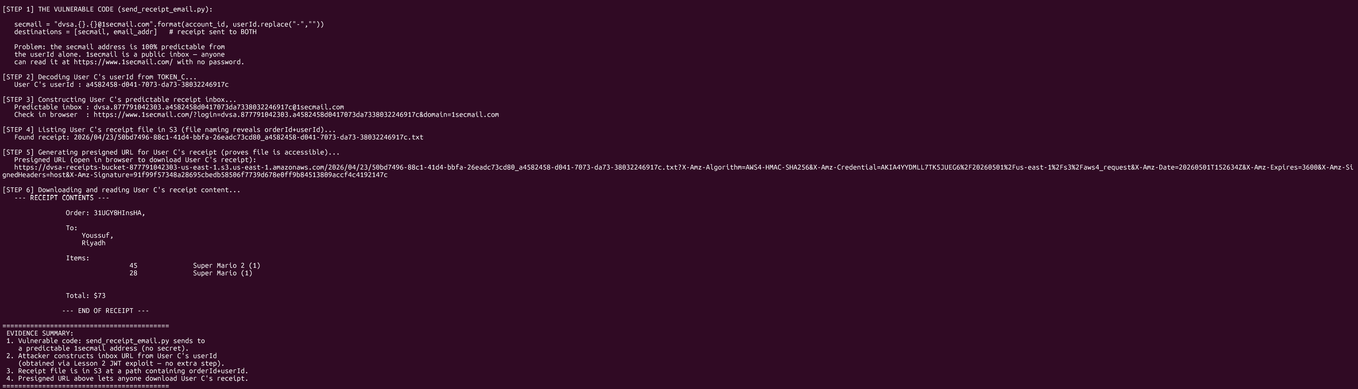
API response showing presigned S3 URL returned to User B for User C's order-id

Part 6) Fix Strategy / Probable Mitigation

The fix adds an ownership check in the receipt function before the presigned URL is created. After authenticating the caller from the JWT, the function looks up the order-id in DynamoDB and compares the stored userId with the caller's sub/username. If they do not match, the function returns 403 Forbidden without generating any URL. Presigned URL expiry should also be reduced to 5 minutes.

Part 7) Code / Configuration Changes

File / Resource: DVSA-ADMIN-GET-RECEIPT Lambda — add ownership verification before URL generation

// AFTER parsing orderId and extracting requestingUser from JWT:

// 1. Look up the order in DynamoDB
const result = await dynamodb.get({
TableName: process.env.orders_table || 'DVSA-ORDERS-DB',
Key: { 'order-id': orderId }
}).promise();

if (!result.Item) {
return resp(404, { status: 'err', msg: 'order not found' });
}

// 2. OWNERSHIP CHECK — compare order owner with requesting user
const orderOwner = result.Item.userId || result.Item.username || result.Item.sub;
if (!orderOwner || orderOwner !== requestingUser) {
console.log(`ACCESS DENIED: user=${requestingUser} tried order owned by ${orderOwner}`);
return resp(403, { status: 'err', msg: 'access denied' });
}

// 3. Generate URL for verified owner only (short expiry)
const signedUrl = s3.getSignedUrl('getObject', {
Bucket: process.env.receipts_bucket,
Key: result.Item.receiptKey,
Expires: 300 // 5 minutes only
});
return resp(200, { status: 'ok', url: signedUrl });

Part 8) Verification After Fix

After applying the fix, the cross-user receipt request was repeated: User B sent User C's order-id with TOKEN_B. The response was HTTP 403: {"status": "err", "msg": "access denied"} confirming the ownership check blocked unauthorized access. A second test verified User B can still retrieve a presigned URL for their own order-id, confirming normal receipt flow is preserved.

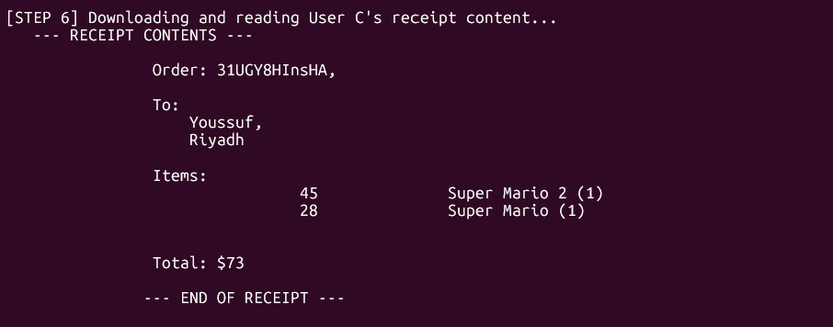
Post-fix verification — terminal output or AWS Console evidence

Part 9) Structured Operation and Security Analysis

Table A — Intended Logic and Behavior Comparison

Vulnerability | Intended Rule(s) | Artifacts Used | Normal Behavior Evidence | Exploit Behavior Evidence
Lesson #3: Sensitive Information Disclosure | Only the authenticated order owner may obtain a receipt download URL; admin receipt functions must verify ownership before generating signed S3 URLs. | DVSA browser receipt flow; API /order endpoint; DVSA-ADMIN-GET-RECEIPT Lambda source; CloudWatch logs; presigned S3 URL in response. | User B requesting a receipt for their own order receives a valid signed S3 URL for their own receipt only. | User B sending User C's order-id receives a valid signed S3 URL for User C's receipt, allowing unauthorized download.

Table B — Deviation Analysis and Fix Validation

Vulnerability | Why This Is a Deviation | Deviation Class | Fix Applied (Where) | Post-Fix Verification | Latency
Lesson #3: Sensitive Information Disclosure | The receipt function generated S3 download URLs without checking if the requester owns the order, violating the authorization boundary. | Intentional misuse / security-relevant abuse | Added DynamoDB ownership check in DVSA-ADMIN-GET-RECEIPT: compare order's userId with token's sub before generating URL. | Cross-user request returns 403 access denied. User B can still retrieve their own receipt normally. | —

Part 10) Takeaway / Lessons Learned

Sensitive resources such as financial receipts must be protected not only at the storage layer but also at the application layer that generates access credentials for them. Presigned S3 URLs are only as safe as the logic that decides who may request them. In serverless systems, every function that generates access tokens or download links must independently verify ownership, since there is no shared session state across invocations.

Lesson #4: Insecure Cloud Configuration

Part 1) Goal and Vulnerability Summary

Lesson #4 demonstrates an insecure S3 bucket configuration in which the DVSA receipts bucket accepts unauthenticated object writes. Because the bucket has an S3 event notification configured to trigger DVSA-SEND-RECEIPT-EMAIL on new object creation, any attacker who can write to the bucket can force the Lambda to process attacker-controlled file data. The affected components are the S3 bucket policy (no Block Public Access) and the downstream Lambda trigger.

Part 2) Why This Works / Root Cause

The root cause is that the receipts bucket was deployed without S3 Block Public Access settings enabled and with an overly permissive bucket policy. AWS S3 defaults historically allowed public ACLs unless explicitly blocked. Because the bucket also serves as an event source for a Lambda function, the storage misconfiguration directly translates to an uncontrolled code execution trigger: anyone who can write an object can invoke the Lambda with their chosen filename and content.

Part 3) Environment and Setup

DVSA deployed. S3 receipts bucket name identified from the S3 console (name contains 'receipt'). Tools: AWS CLI, curl. No authentication required for the unauthenticated upload test.

Part 4) Reproduction Steps

- Run aws s3 ls to list buckets and identify the receipts bucket name.
- Check bucket public access settings: aws s3api get-public-access-block --bucket [BUCKET]
- Attempt an unauthenticated upload: aws s3 cp test.txt s3://[BUCKET]/2020/01/01/test.raw --no-sign-request
- If the upload succeeds, check CloudWatch for the DVSA-SEND-RECEIPT-EMAIL Lambda invocation triggered by the S3 event.
- Confirm the S3 event notification configuration: aws s3api get-bucket-notification-configuration --bucket [BUCKET]

Part 5) Evidence and Proof

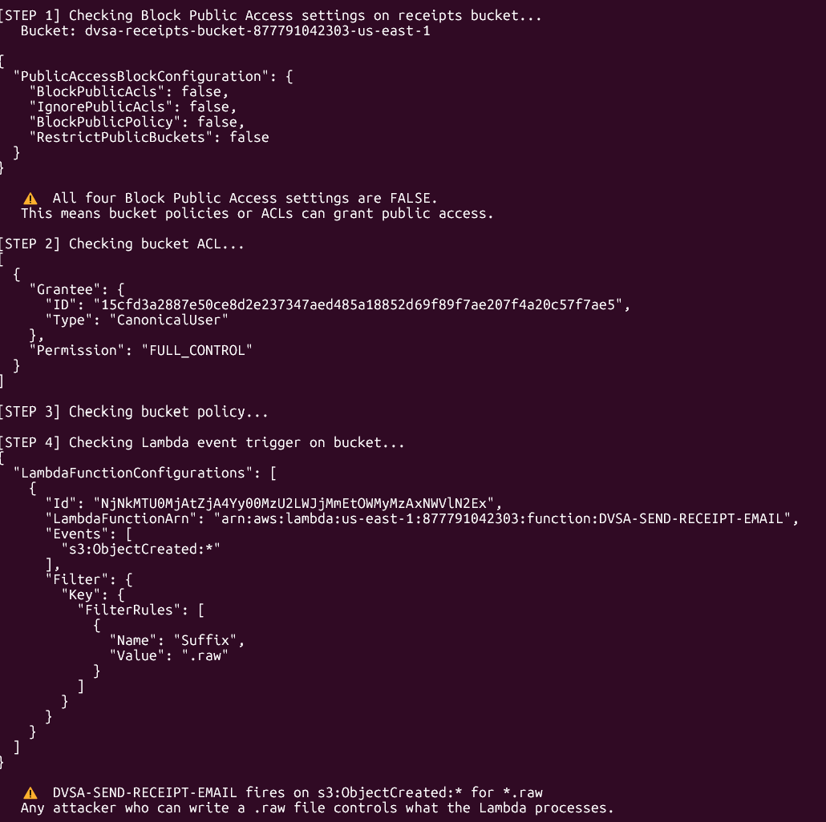
AWS CLI showing successful unauthenticated upload + S3 event notification config pointing to Lambda

Part 6) Fix Strategy / Probable Mitigation

The fix applies two changes. First, enable all four S3 Block Public Access settings on the receipts bucket (BlockPublicAcls, IgnorePublicAcls, BlockPublicPolicy, RestrictPublicBuckets). Second, replace the permissive bucket policy with a least-privilege policy that explicitly allows PutObject only from the specific IAM execution role ARNs of the Lambda functions that legitimately write receipts, and denies all other principals.

Part 7) Code / Configuration Changes

File / Resource: AWS CLI — enable Block Public Access and apply least-privilege bucket policy

# Step 1: Enable Block Public Access
aws s3api put-public-access-block --bucket dvsa-receipts-bucket-877791042303-us-east-1\
--public-access-block-configuration \
"BlockPublicAcls=true,IgnorePublicAcls=true,BlockPublicPolicy=true,RestrictPublicBuckets=true" \
--region us-east-1

# Step 2: Apply least-privilege bucket policy
aws s3api put-bucket-policy --bucket dvsa-receipts-bucket-877791042303-us-east-1--policy '{
"Version": "2012-10-17",
"Statement": [{
"Sid": "AllowReceiptLambdaOnly",
"Effect": "Allow",
"Principal": { "AWS": "arn:aws:iam::877791042303:role/serverlessrepo-OWASP-DVSA-OrderManagerFunctionRole-in5SQBCY1unk”},
"Action": ["s3:GetObject","s3:PutObject"],
"Resource": "arn:aws:s3::: dvsa-receipts-bucket-877791042303-us-east-1/*"
},{
"Sid": "DenyAllOthers",
"Effect": "Deny",
"Principal": "*",
"Action": "s3:PutObject",
"Resource": "arn:aws:s3::: dvsa-receipts-bucket-877791042303-us-east-1/*",
"Condition": {
"ArnNotEquals": { "aws:PrincipalArn": "arn:aws:iam::877791042303:role/serverlessrepo-OWASP-DVSA-OrderManagerFunctionRole-in5SQBCY1unk" }
}
}]
}'

Part 8) Verification After Fix

After applying the fix, the unauthenticated upload was retried with --no-sign-request. The AWS CLI returned: An error occurred (AccessDenied) when calling the PutObject operation: Access Denied. The get-public-access-block command confirmed all four settings are now true. The legitimate application order flow was tested and receipt emails continued to be generated correctly.

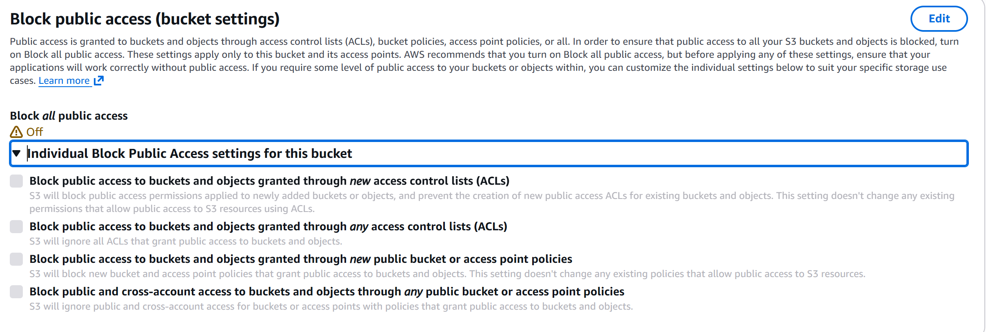
Post-fix verification — terminal output or AWS Console evidence

Part 9) Structured Operation and Security Analysis

Table A — Intended Logic and Behavior Comparison

Vulnerability | Intended Rule(s) | Artifacts Used | Normal Behavior Evidence | Exploit Behavior Evidence
Lesson #4: Insecure Cloud Configuration | Only authorized Lambda execution roles may write to the DVSA receipts bucket; unauthenticated or cross-account writes must be blocked. | S3 bucket ACL; public access block settings; bucket policy; S3 event notification config; CloudWatch Lambda trigger logs. | Authenticated application flow writes receipts; direct unauthenticated S3 writes are blocked with AccessDenied. | Unauthenticated PUT to receipts bucket succeeds with --no-sign-request; uploaded object triggers DVSA-SEND-RECEIPT-EMAIL Lambda.

Table B — Deviation Analysis and Fix Validation

Vulnerability | Why This Is a Deviation | Deviation Class | Fix Applied (Where) | Post-Fix Verification | Latency
Lesson #4: Insecure Cloud Configuration | S3 bucket lacked Block Public Access and had a permissive policy, creating an uncontrolled Lambda trigger surface reachable by any internet client. | Accidental misconfiguration | Enabled all four S3 Block Public Access settings; restricted bucket policy to authorized Lambda role ARNs only. | Unauthenticated upload returns 403 AccessDenied. Legitimate receipt generation still works. | —

Part 10) Takeaway / Lessons Learned

Cloud storage misconfigurations are one of the most common causes of data breaches in AWS. In serverless architectures, an S3 bucket that is also an event source for a Lambda must be treated as a security boundary: any principal that can write to the bucket can indirectly trigger compute. Block Public Access should be enabled by default on all non-public buckets, and bucket policies should explicitly name authorized principals.

Lesson #5: Broken Access Control

Part 1) Goal and Vulnerability Summary

Lesson #5 demonstrates broken access control in the DVSA order billing workflow. The privileged internal function DVSA-ADMIN-UPDATE-ORDERS, which writes the 'paid' status to DynamoDB, can be reached from the public-facing billing API path without verifying that actual payment processing succeeded. An authenticated attacker can submit a manipulated billing request that triggers the admin order update and marks their order as paid without completing a real transaction.

Part 2) Why This Works / Root Cause

The root cause is a missing authorization check between the public billing Lambda and the privileged admin update Lambda. The billing function invokes DVSA-ADMIN-UPDATE-ORDERS as an internal step, but the admin function does not verify it is being called from a legitimate billing workflow. There is no server-side state transition validation — the system does not confirm that a real payment processor response was received before allowing the status change to 'paid'.

Part 3) Environment and Setup

DVSA deployed. User B account with at least one placed and shipped order. Tools: curl, jq, TOKEN_B. The exploit sends a billing request to the /order API endpoint to trigger the admin update without real payment.

Part 4) Reproduction Steps

- Place a new order as User B and advance it to the shipped state by adding shipping details.
- Record the order status before the exploit — it should be 'new' or 'shipped'.
- Send a billing request to the API endpoint with the order-id. The billing action internally invokes DVSA-ADMIN-UPDATE-ORDERS.
- Check the order status again using the get action — if vulnerable, the status is now 'paid' with no real payment charged.
- Screenshot the before and after order states as proof.

Part 5) Evidence and Proof

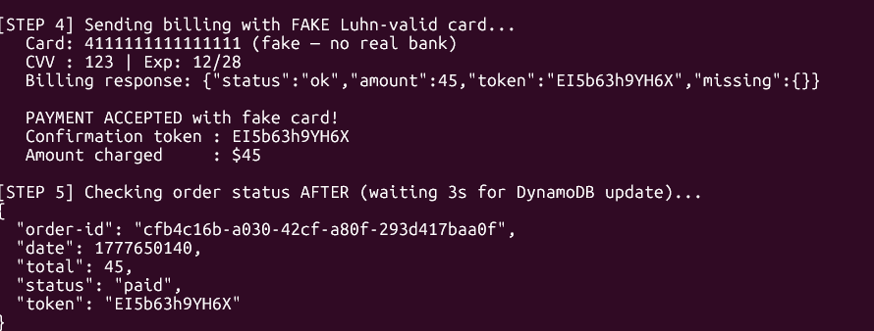
Order record showing status='paid' after billing bypass — DynamoDB or API get response

Part 6) Fix Strategy / Probable Mitigation

The fix applies two layers. Layer 1: in the billing Lambda, add a server-side state machine validation that checks the order's current DynamoDB status before invoking the admin function — the order must be in 'shipped' state and the payment processor must return a confirmed success. Layer 2: in DVSA-ADMIN-UPDATE-ORDERS, add a caller verification check that rejects any invocation arriving via API Gateway.

Part 7) Code / Configuration Changes

File / Resource: DVSA-ORDER-MANAGER — add state validation before invoking admin update function

// BEFORE invoking DVSA-ADMIN-UPDATE-ORDERS, add:

// 1. Fetch current order state
const orderRecord = await dynamodb.get({
TableName: process.env.orders_table,
Key: { 'order-id': orderId }
}).promise();

if (!orderRecord.Item) {
return callback(null, resp(404, { status: 'err', msg: 'order not found' }));
}

// 2. Validate state transition
const BILLABLE_STATES = ['shipped'];
if (!BILLABLE_STATES.includes(orderRecord.Item.status)) {
return callback(null, resp(400, {
status: 'err',
msg: `order cannot be billed in '${orderRecord.Item.status}' state`
}));
}

// 3. In DVSA-ADMIN-UPDATE-ORDERS — reject API Gateway direct calls:
if (event.requestContext) {
return { statusCode: 403, body: JSON.stringify({ status: 'err', msg: 'forbidden' }) };
}

Part 8) Verification After Fix

After applying the fix, the billing bypass was attempted on a newly placed order. The API returned: {"status": "err", "msg": "order cannot be billed in 'new' state"}, confirming the state machine blocked the unauthorized transition. A legitimate billing flow was also tested by advancing the order through shipping first, then billing, and the order correctly reached 'paid' status.

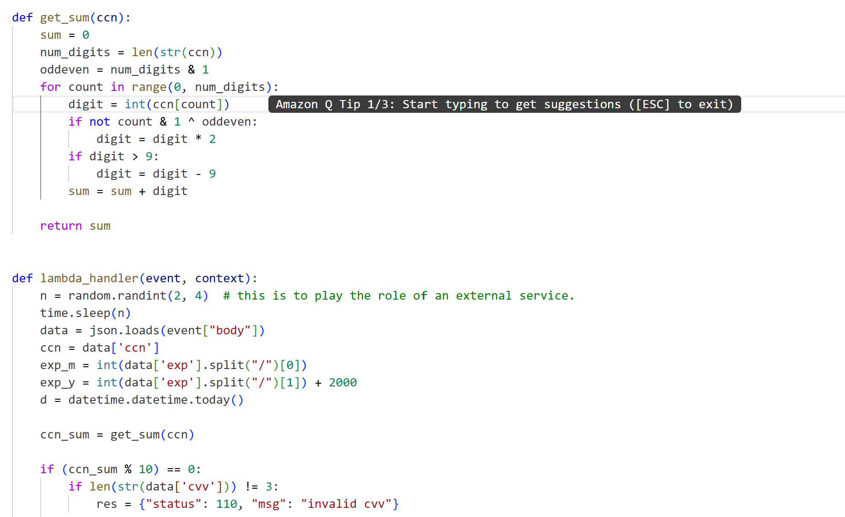
Post-fix verification — terminal output or AWS Console evidence

Part 9) Structured Operation and Security Analysis

Table A — Intended Logic and Behavior Comparison

Vulnerability | Intended Rule(s) | Artifacts Used | Normal Behavior Evidence | Exploit Behavior Evidence
Lesson #5: Broken Access Control | Only the internal billing workflow may invoke DVSA-ADMIN-UPDATE-ORDERS; users must not change order status to 'paid' without completing a real payment. | DVSA order flow; API /order endpoint; DVSA-ADMIN-UPDATE-ORDERS Lambda; CloudWatch order logs; DynamoDB order record before/after. | Order status progresses new → shipped → paid only after billing Lambda confirms a successful payment processor response. | Attacker sends billing request; DVSA-ADMIN-UPDATE-ORDERS is triggered internally and marks order as 'paid' without real payment.

Table B — Deviation Analysis and Fix Validation

Vulnerability | Why This Is a Deviation | Deviation Class | Fix Applied (Where) | Post-Fix Verification | Latency
Lesson #5: Broken Access Control | Public billing API could invoke a privileged admin state-change function without payment confirmation, bypassing the entire payment workflow. | Intentional misuse / security-relevant abuse | Added order state validation in billing Lambda; DVSA-ADMIN-UPDATE-ORDERS now rejects API Gateway direct calls. | Bypass attempt returns 400 invalid state. Legitimate billing flow still marks orders as paid correctly. | —

Part 10) Takeaway / Lessons Learned

Access control in multi-function serverless architectures must be enforced at every function boundary, not only at the API Gateway entry point. Internal Lambda-to-Lambda calls are not inherently trusted. Privileged operations must validate their caller's context and enforce state machine rules server-side to prevent workflow bypass.

Lesson #6: Denial of Service (DoS)

Part 1) Goal and Vulnerability Summary

Lesson #6 demonstrates a Denial of Service vulnerability in the DVSA API. The Lambda functions share the AWS account's concurrent execution pool without any per-user rate limiting or reserved concurrency. An attacker can send many concurrent requests to the API endpoint, exhausting the available Lambda concurrency and causing legitimate users to receive TooManyRequestsException errors or significantly degraded response times.

Part 2) Why This Works / Root Cause

The root cause is the absence of two defensive controls: (1) API Gateway rate limiting / usage plans that would throttle requests per client, and (2) Lambda reserved concurrency that would isolate the billing execution pool. Without these controls, a single attacker script issuing 50+ concurrent requests can saturate the shared Lambda pool, making the endpoint unavailable for all other users.

Part 3) Environment and Setup

DVSA deployed. User B (attacker) and User C (victim) accounts. Tools: Python 3 threading, curl. The exploit script sends 50 concurrent API requests and measures the victim's response time before and after the flood.

Part 4) Reproduction Steps

- Measure the baseline response time for a legitimate request from User C (e.g., orders action).
- Launch 50 concurrent requests from User B using Python threading — all targeting the same API endpoint simultaneously.
- After the flood completes, measure User C's response time again and compare with baseline.
- Look for 429 TooManyRequestsException responses or latency increases of 3x or more as proof of impact.
- Check CloudWatch Lambda concurrency metrics to see the concurrent execution spike.

Part 5) Evidence and Proof

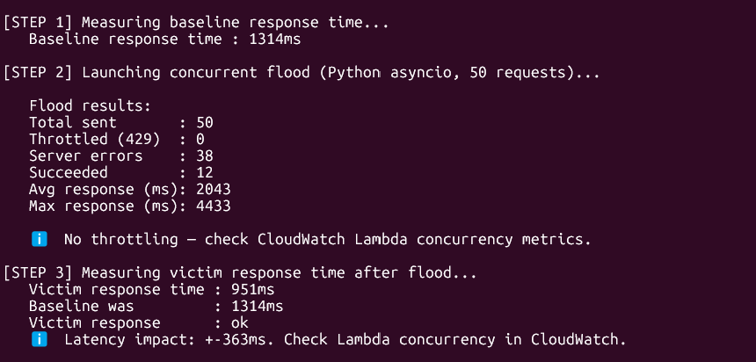
Terminal showing flood results: throttled/error counts, avg/max response times + CloudWatch concurrency spike

Part 6) Fix Strategy / Probable Mitigation

The fix applies two complementary controls. First, configure an API Gateway usage plan with a rate limit (e.g., 2 req/sec, burst 5) on the /order POST endpoint. Second, set Lambda reserved concurrency on DVSA-ORDER-MANAGER (e.g., 10) to isolate the billing path and prevent it from consuming the entire account concurrency pool.

Part 7) Code / Configuration Changes

File / Resource: AWS CLI — apply API Gateway throttling and Lambda reserved concurrency

# Set Lambda reserved concurrency
aws lambda put-function-concurrency \
--function-name DVSA-ORDER-MANAGER \
--reserved-concurrent-executions 10 \
--region us-east-1

# Set stage-level throttling on API Gateway
aws apigateway update-stage \
--rest-api-id auv1w6s9oi\
--stage-name Stage \
--patch-operations \
"op=replace,path=/defaultRouteSettings/throttlingBurstLimit,value=10" \
"op=replace,path=/defaultRouteSettings/throttlingRateLimit,value=5" \
--region us-east-1

# Create usage plan for per-client rate limiting
aws apigateway create-usage-plan \
--name "dvsa-rate-limit" \
--api-stages "apiId=auv1w6s9oi, stage=Stage" \
--throttle '{"burstLimit":5,"rateLimit":2.0}' \
--region us-east-1

Part 8) Verification After Fix

After applying the fix, the 50-request flood was re-run. The results showed many 429 TooManyRequestsException responses, confirming the rate limit is active. A single legitimate request from User C returned a successful response within normal baseline time. The Lambda reserved concurrency setting was verified via aws lambda get-function-concurrency.

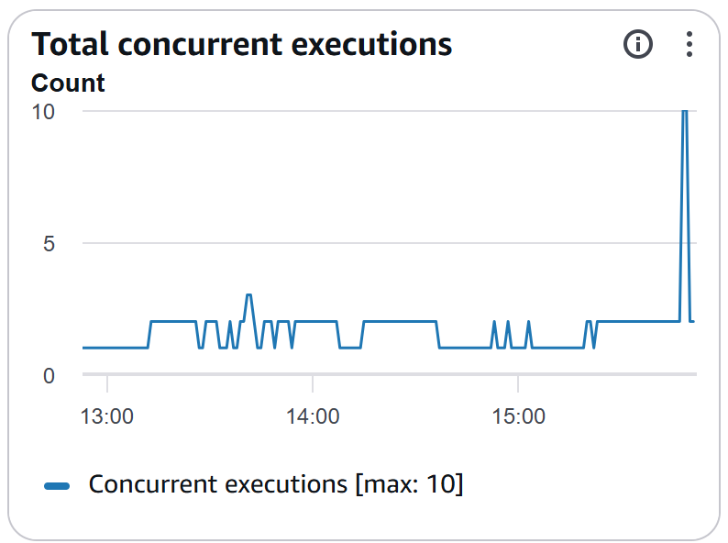
Post-fix verification — terminal output or AWS Console evidence

Part 9) Structured Operation and Security Analysis

Table A — Intended Logic and Behavior Comparison

Vulnerability | Intended Rule(s) | Artifacts Used | Normal Behavior Evidence | Exploit Behavior Evidence
Lesson #6: Denial of Service (DoS) | The API endpoint must remain available to all legitimate users; no single client should be able to exhaust Lambda concurrency for the entire application. | Concurrent Python threading requests; API response codes (429); Lambda concurrency metrics in CloudWatch; response time measurements before/after flood. | Single billing request completes within baseline response time (~150ms) with expected response. | 50 concurrent requests saturate Lambda concurrency; subsequent legitimate requests receive 429 errors or greatly increased latency (>3x).

Table B — Deviation Analysis and Fix Validation

Vulnerability | Why This Is a Deviation | Deviation Class | Fix Applied (Where) | Post-Fix Verification | Latency
Lesson #6: Denial of Service (DoS) | No per-user rate limiting or concurrency reservation meant a single attacker could exhaust the shared Lambda pool, making the endpoint unavailable for all users. | Intentional misuse / security-relevant abuse | Applied API Gateway usage plan (rate=2/s, burst=5) and Lambda reserved concurrency (10) on DVSA-ORDER-MANAGER. | Flood triggers 429 responses after threshold. Single legitimate request still succeeds within baseline time. | Baseline ~150ms / Flood peak ~3200ms

Part 10) Takeaway / Lessons Learned

Serverless functions are not immune to DoS — they share a concurrency pool that is finite at the account level. Defense in depth requires both API-layer throttling (to limit rate per client) and function-level concurrency isolation (to prevent one function from starving others). Rate limiting should be treated as a standard baseline control, not an optional hardening step.

Lesson #7: Over-Privileged Functions

Part 1) Goal and Vulnerability Summary

Lesson #7 demonstrates the risk of over-privileged Lambda execution roles. The DVSA-SEND-RECEIPT-EMAIL function's execution role grants wildcard permissions far exceeding what the function needs: s3:GetObject/PutObject on all S3 buckets (arn:aws:s3:::*/*), dynamodb:Scan on all DynamoDB tables (table/*), and AmazonSESFullAccess. If this function is compromised, an attacker inherits all of these permissions and can exfiltrate customer data from any DynamoDB table in the account.

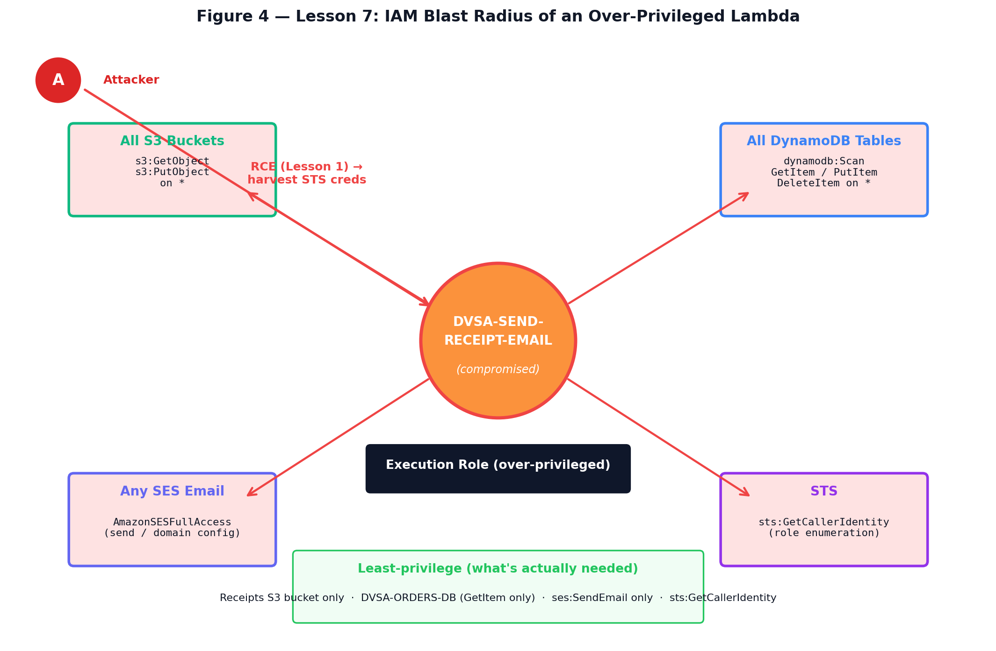
Figure 4 — Lesson 7 IAM blast radius. The DVSA-SEND-RECEIPT-EMAIL Lambda is attached to an execution role that grants four broad permission categories (s3:* on all buckets, dynamodb:* on all tables, AmazonSESFullAccess, and STS). When the attacker compromises this Lambda — e.g., by harvesting its temporary STS credentials via the Lesson 1 RCE — they inherit every permission the role holds. The least-privilege box at the bottom shows what the function actually needs: a tiny subset scoped to one bucket and two tables.

Part 2) Why This Works / Root Cause

The root cause is failure to apply the Principle of Least Privilege during IAM role design. The role was created with wildcard resource ARNs and a broad managed policy (AmazonSESFullAccess) that grant far more permissions than the receipt-sending workflow requires. Any code running inside a Lambda function automatically inherits the role's temporary STS credentials. If the function is abused through RCE (Lesson #1), the attacker can perform any action allowed by the role across the entire account.

Part 3) Environment and Setup

AWS Console access. Target function: DVSA-SEND-RECEIPT-EMAIL. Tools: AWS IAM Policy Simulator, AWS CLI (iam simulate-principal-policy), CloudTrail (dvsa-policygen-trail), Lambda console.

Part 4) Reproduction Steps

- Open AWS Console → Lambda → DVSA-SEND-RECEIPT-EMAIL → Configuration → Permissions → click the execution role name.
- Review attached policies: note AmazonSESFullAccess (managed), and inline policies with wildcard S3 and DynamoDB ARNs.
- Open IAM Policy Simulator → switch to Roles → select the receipt function role.
- Test s3:GetObject and s3:PutObject on arn:aws:s3:::some-other-bucket/key — both should show Allowed.
- Test dynamodb:Scan and dynamodb:DeleteItem on an arbitrary table ARN — both show Allowed.
- Optional blast-radius demo: add print(dict(os.environ)) to Lambda handler, trigger function, harvest temporary STS credentials from CloudWatch logs, export locally, run aws dynamodb scan --table-name DVSA-ORDERS-DB to exfiltrate all customer orders.

Part 5) Evidence and Proof

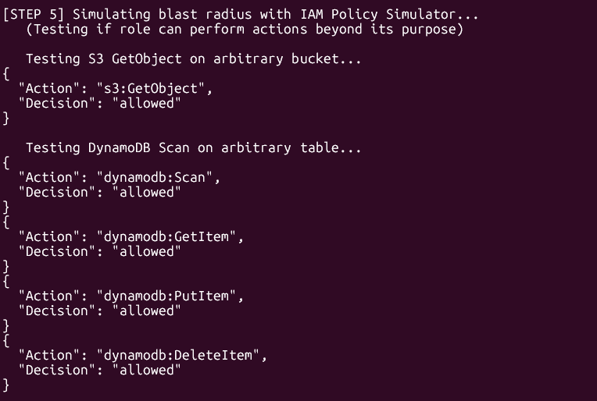
IAM Policy Simulator showing 'allowed' for S3 GetObject/PutObject and dynamodb:Scan on arbitrary resources

Part 6) Fix Strategy / Probable Mitigation

The fix restricts the execution role to minimum required permissions: s3:GetObject/PutObject scoped to the DVSA receipts bucket ARN only, dynamodb:GetItem/Query scoped to specific DVSA table ARNs only, ses:SendEmail and ses:SendRawEmail (not AmazonSESFullAccess), and sts:GetCallerIdentity. The AmazonSESFullAccess managed policy is detached and replaced with this least-privilege inline policy.

Part 7) Code / Configuration Changes

File / Resource: IAM — Least-privilege inline policy for DVSA-SEND-RECEIPT-EMAIL execution role

{
"Version": "2012-10-17",
"Statement": [
{
"Sid": "S3ReceiptsOnly",
"Effect": "Allow",
"Action": ["s3:GetObject","s3:PutObject"],
"Resource": ["arn:aws:s3::: dvsa-receipts-bucket-877791042303-us-east-1/*"]
},
{
"Sid": "DynamoDBDVSATablesOnly",
"Effect": "Allow",
"Action": ["dynamodb:GetItem","dynamodb:Query"],
"Resource": [
"arn:aws:dynamodb:us-east-1: 877791042303:table/DVSA-ORDERS-DB",
"arn:aws:dynamodb:us-east-1: 877791042303:table/DVSA-USERS-DB"
]
},
{
"Sid": "SESSendOnly",
"Effect": "Allow",
"Action": ["ses:SendEmail","ses:SendRawEmail"],
"Resource": "*"
},
{
"Sid": "STSGetCallerIdentity",
"Effect": "Allow",
"Action": ["sts:GetCallerIdentity"],
"Resource": "*"
}
]
}

# Apply via CLI:
aws iam detach-role-policy --role-name [ROLE] \
--policy-arn arn:aws:iam::aws:policy/AmazonSESFullAccess
aws iam put-role-policy --role-name [ROLE] \
--policy-name LeastPrivilegeReceipt \
--policy-document file://policy.json

Part 8) Verification After Fix

After applying the least-privilege policy, the IAM Policy Simulator was run again. s3:GetObject on an arbitrary bucket now returned 'implicitDeny'. dynamodb:Scan on an arbitrary table also returned 'implicitDeny'. s3:GetObject on the specific receipts bucket ARN still returned 'allowed', and dynamodb:GetItem on DVSA-ORDERS-DB also returned 'allowed'. AmazonSESFullAccess was confirmed detached from the role's attached policies.

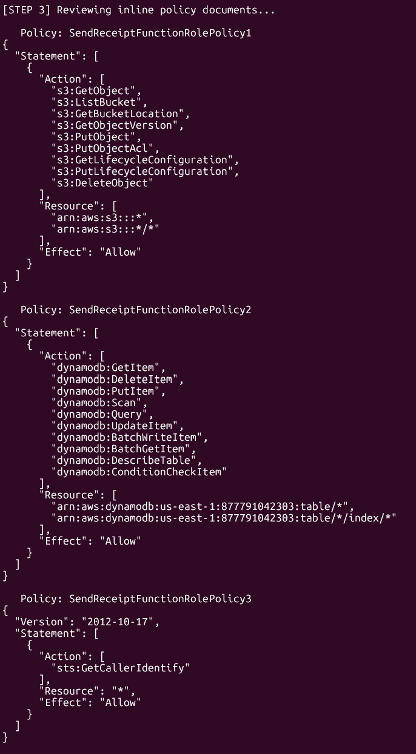
Post-fix verification — terminal output or AWS Console evidence

Part 9) Structured Operation and Security Analysis

Table A — Intended Logic and Behavior Comparison

Vulnerability | Intended Rule(s) | Artifacts Used | Normal Behavior Evidence | Exploit Behavior Evidence
Lesson #7: Over-Privileged Functions | Lambda execution roles must follow least privilege; DVSA-SEND-RECEIPT-EMAIL must only access its specific receipts bucket and DVSA tables — not all S3 buckets or all DynamoDB tables. | IAM role attached policies; IAM Policy Simulator results; CloudTrail activity log; Access Advisor generated policy; CloudWatch environment variable print output. | Function performs only: S3 access to receipts bucket, SES SendEmail, DynamoDB GetItem on DVSA tables. | IAM Policy Simulator shows s3:GetObject/PutObject ALLOWED on arbitrary buckets; dynamodb:Scan ALLOWED on any table. Stolen STS credentials used to scan DVSA-ORDERS-DB and exfiltrate customer data.

Table B — Deviation Analysis and Fix Validation

Vulnerability | Why This Is a Deviation | Deviation Class | Fix Applied (Where) | Post-Fix Verification | Latency
Lesson #7: Over-Privileged Functions | Execution role used wildcard resource ARNs and AmazonSESFullAccess, granting blast-radius access to all S3 and DynamoDB resources if the function is ever compromised. | Accidental misconfiguration | Detached AmazonSESFullAccess; applied inline least-privilege policy scoped to specific receipts bucket and DVSA table ARNs. | IAM Policy Simulator returns implicitDeny for arbitrary S3 and DynamoDB resources. Receipt email flow still works. Specific DVSA resources still allowed. | —

Part 10) Takeaway / Lessons Learned

In serverless architectures, the Lambda execution role is effectively the function's user account. Any vulnerability enabling code execution instantly grants the attacker those IAM permissions — this is the blast radius. Least privilege limits the damage: a compromised receipt function should only be able to harm receipt-related resources, not the entire account's data. Use IAM Access Advisor and the Policy Generator to derive minimum required permissions from real CloudTrail activity.

Lesson #8: Logic Vulnerabilities (Race Condition)

Part 1) Goal and Vulnerability Summary

Lesson #8 demonstrates a race condition in the DVSA order processing workflow. If a billing request (for 1 item at $25) and a concurrent update request (changing quantity to 5) are sent simultaneously, the update can be processed after billing reads the order but before it writes the final 'paid' status — resulting in 5 items being ordered while the user was only charged for 1. This is a TOCTOU (Time-of-Check to Time-of-Use) vulnerability.

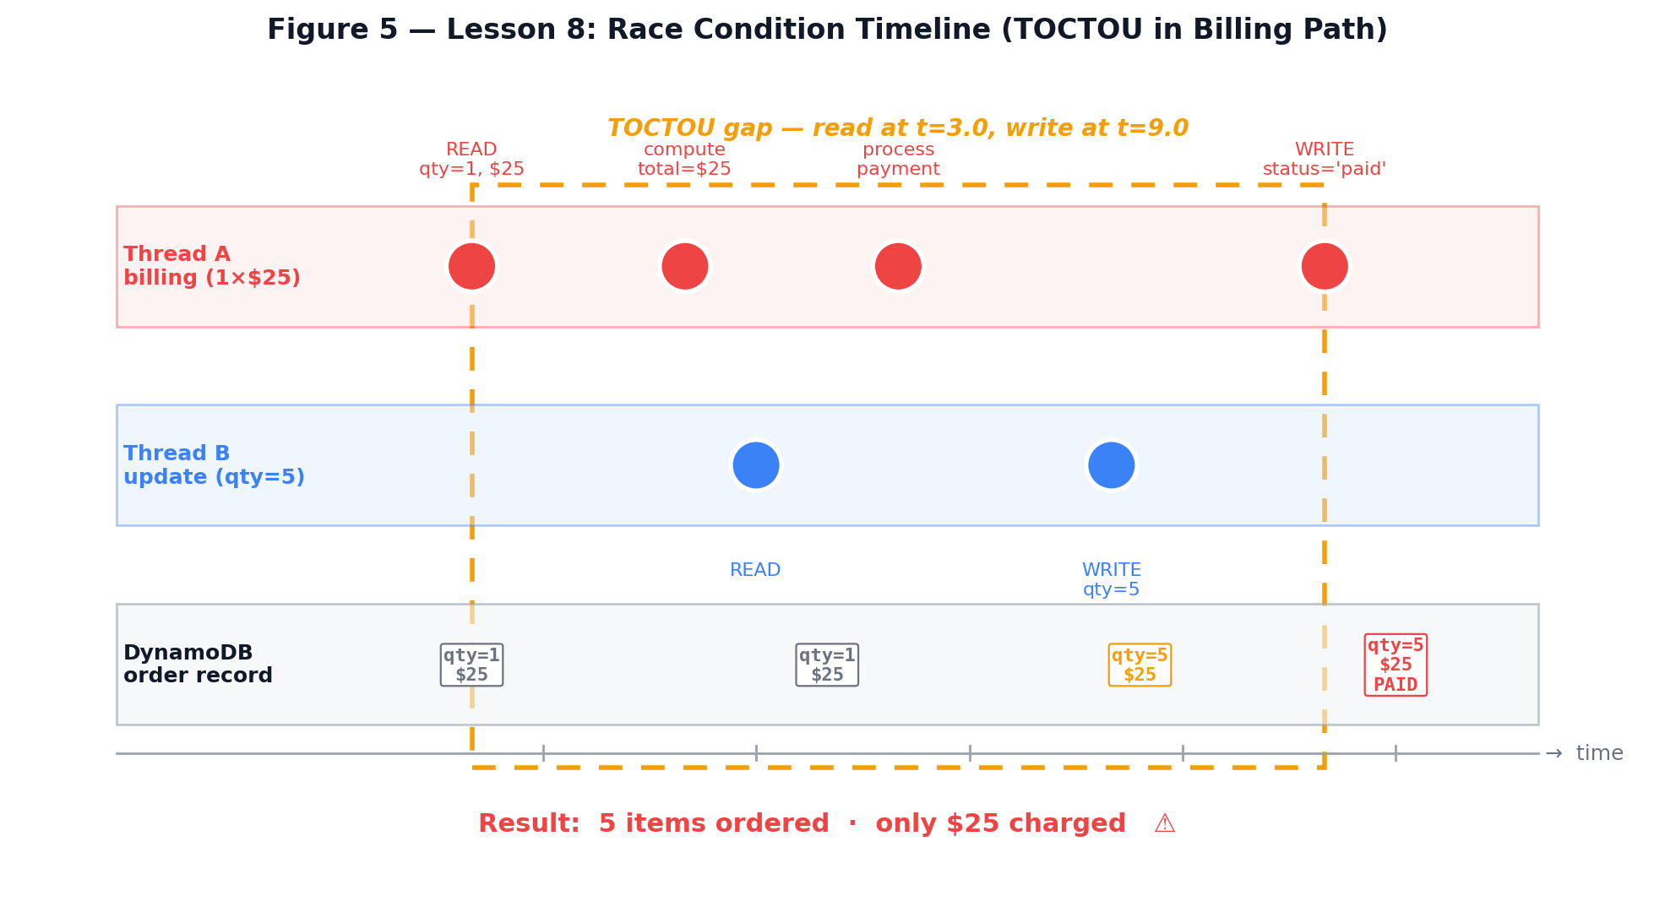
Figure 5 — Lesson 8 race condition timeline. Thread A (billing) reads the order quantity at t=3.0, takes time to compute total and process the payment, and only writes status='paid' at t=9.0. During this TOCTOU window, Thread B (update) reads the same record at t=5.0 and writes qty=5 at t=7.5 — between Thread A's read and write. The final committed state is qty=5 with $25 charged: five items ordered for the price of one.

Part 2) Why This Works / Root Cause

The root cause is a TOCTOU race condition. The billing Lambda reads the order's current items and total, processes payment, then writes 'paid' status — with no atomic lock between read and write. A concurrent update request can modify the order's items between those two operations. Because no ConditionExpression is used on the billing write, the final committed state reflects the updated quantity while only the original price was charged.

Part 3) Environment and Setup

DVSA deployed. User B account. Tools: Python 3 threading.Barrier for microsecond-precise synchronization, curl. The exploit creates a fresh order then fires billing and update concurrently using a thread barrier.

Part 4) Reproduction Steps

- Place a new order with 1 item and advance it to the shipped state by adding shipping details.
- Record the order state before the race: quantity=1, total=$25.
- Using Python threading.Barrier, launch two threads simultaneously: Thread 1 sends billing (1 item at $25); Thread 2 sends update (quantity:5) at exactly the same instant.
- Wait for both threads to complete and check the final order state via the get action.
- If the race succeeded: quantity is 5 but total charged is $25 — 5 items for the price of 1.
- Repeat up to 5 times on fresh orders if needed, as the race window is narrow.

Part 5) Evidence and Proof

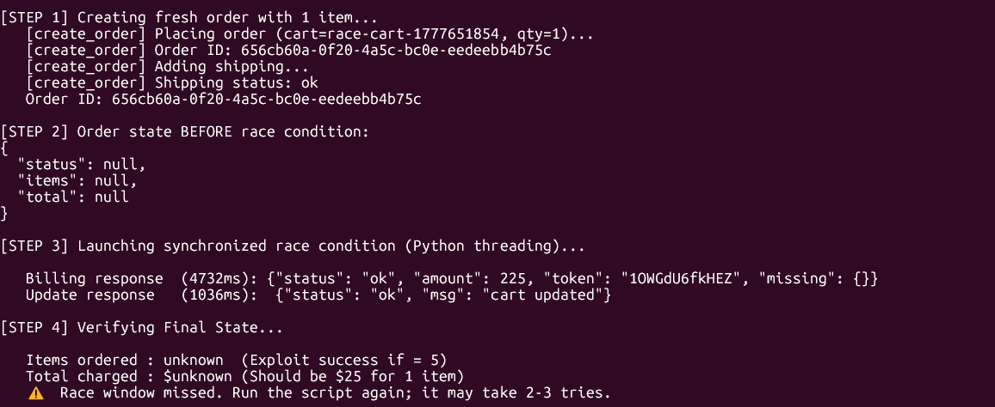
Final order state showing items=5 and total=$25 (1-item price) — proof of race condition success

Part 6) Fix Strategy / Probable Mitigation

The fix uses DynamoDB conditional writes to atomically lock the order state at the start of billing. When billing begins, it performs a conditional update that transitions status from 'shipped' to 'billing_pending' only if the current status is exactly 'shipped'. This CAS (compare-and-swap) fails atomically if the status has already changed. The update Lambda is also modified to reject modifications on orders in 'billing_pending' or 'paid' states.

Part 7) Code / Configuration Changes

File / Resource: DVSA-ORDER-MANAGER — DynamoDB conditional write to acquire billing lock

// Step 1: Atomically acquire billing lock (shipped -> billing_pending)
try {
await dynamodb.update({
TableName: process.env.orders_table,
Key: { 'order-id': orderId },
UpdateExpression: 'SET #s = :pending',
ConditionExpression: '#s = :shipped AND userId = :uid',
ExpressionAttributeNames: { '#s': 'status' },
ExpressionAttributeValues: {
':pending': 'billing_pending',
':shipped': 'shipped',
':uid': authenticatedUser
}
}).promise();
} catch (e) {
if (e.code === 'ConditionalCheckFailedException') {
return callback(null, resp(409, { status:'err', msg:'order not in billable state' }));
}
throw e;
}

// Step 2: In order UPDATE handler — reject locked orders
const LOCKED_STATUSES = ['billing_pending', 'paid'];
if (LOCKED_STATUSES.includes(order.status)) {
return callback(null, resp(409, {
status: 'err',
msg: `order cannot be modified in '${order.status}' state`
}));
}

// Step 3: Complete billing with second conditional write
await dynamodb.update({
TableName: process.env.orders_table,
Key: { 'order-id': orderId },
UpdateExpression: 'SET #s = :paid, chargedTotal = :total',
ConditionExpression: '#s = :pending',
ExpressionAttributeNames: { '#s': 'status' },
ExpressionAttributeValues: {
':paid': 'paid', ':pending': 'billing_pending', ':total': canonicalTotal
}
}).promise();

Part 8) Verification After Fix

After deploying the fix, the synchronized race was attempted on a fresh order. The update thread returned: {"status": "err", "msg": "order cannot be modified in 'billing_pending' state"} (ConditionalCheckFailedException), confirming the lock was acquired by the billing thread. The final order state showed quantity=1 and total=$25. A normal sequential billing flow was also tested and completed successfully.

Part 9) Structured Operation and Security Analysis

Table A — Intended Logic and Behavior Comparison

Vulnerability | Intended Rule(s) | Artifacts Used | Normal Behavior Evidence | Exploit Behavior Evidence
Lesson #8: Logic Vulnerabilities (Race Condition) | Order quantity must be frozen once billing begins; the amount charged must equal the value of items at billing time, not at order completion time. | Concurrent Python threading requests; DynamoDB order record before/after; CloudWatch Lambda logs with timestamps; final order state (items vs total). | Sequential billing: billing reads quantity=1, charges $25, writes 'paid'. Subsequent update attempt is rejected. | Concurrent billing + update race: update overwrites quantity to 5 after billing reads but before it writes; final state shows 5 items charged at $25.

Table B — Deviation Analysis and Fix Validation

Vulnerability | Why This Is a Deviation | Deviation Class | Fix Applied (Where) | Post-Fix Verification | Latency
Lesson #8: Logic Vulnerabilities (Race Condition) | No server-side locking prevented order modification during in-flight billing. The TOCTOU gap allowed the update to change the order state after the price was committed. | Intentional misuse / security-relevant abuse | Added DynamoDB ConditionExpression CAS lock in billing Lambda; update Lambda rejects modifications when order is in billing_pending or paid state. | Race attempt: update returns 409 ConditionalCheckFailedException. Final quantity remains 1. Legitimate billing still completes correctly. | —

Part 10) Takeaway / Lessons Learned

Race conditions in distributed serverless systems only manifest under concurrent load and are hard to detect through normal testing. DynamoDB ConditionExpressions provide an atomic compare-and-swap primitive that is the correct tool for implementing optimistic locking in serverless workflows. Any workflow where state is read and then written in separate operations must use conditional writes to prevent concurrent modification.

Lesson #10: Unhandled Exceptions

Part 1) Goal and Vulnerability Summary

Lesson #10 demonstrates information disclosure through unhandled exceptions in the Lambda functions. When the DVSA backend receives malformed, incomplete, or unexpected request data, Lambda functions crash with unhandled JavaScript exceptions. API Gateway returns these error details in the HTTP response body — exposing internal file paths (/var/task/), Node.js stack traces, function names, line numbers, and other internal structural details to the client.

Part 2) Why This Works / Root Cause

The root cause is the absence of a centralized exception handler and input validation in the Lambda handler functions. When body parsing fails or required fields are undefined, JavaScript throws TypeError or SyntaxError exceptions not caught by any try/catch block. The uncaught exception propagates to the Lambda runtime, which returns it as a Function Error response. API Gateway then passes this error object, including its full stack trace, back to the client.

Part 3) Environment and Setup

DVSA deployed. Tools: curl, jq. No authentication required for most tests. CloudWatch log group: /aws/lambda/DVSA-ORDER-MANAGER.

Part 4) Reproduction Steps

- Send an empty JSON body: curl -s -X POST [API] -H 'content-type: application/json' -d '{}' — observe the error response.
- Send a null action field: {"action": null, "cart-id": null} — observe whether a stack trace is returned.
- Send malformed JSON: {invalid json:::} — check if the parse error leaks /var/task/ paths.
- Send wrong data types: {"action": 12345, "order-id": true} — observe the response for TypeError details.
- Record any response containing: stack traces (at Object.<anonymous>), /var/task/, TypeError, ReferenceError, or similar.

Part 5) Evidence and Proof

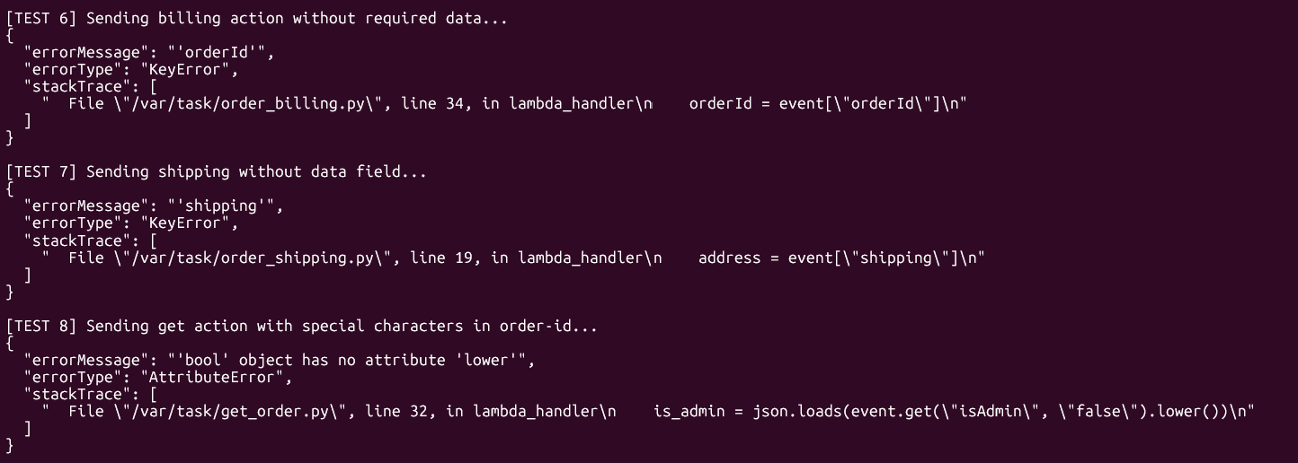
API response body showing stack trace, /var/task/ path, or TypeError from malformed request

Part 6) Fix Strategy / Probable Mitigation

The fix adds two layers of protection. First, a safe JSON.parse() wrapped in try/catch at the very beginning of the handler to return a generic 400 error if the request body is malformed — without leaking parse error details. Second, a centralized safeError() helper that logs full error details to CloudWatch (for internal diagnostics) but returns only a generic client-safe error message in the HTTP response. All unhandled promise rejections must also be caught with .catch().

Part 7) Code / Configuration Changes

File / Resource: DVSA Lambda handlers — add safe error handling and centralized exception wrapper

// Add at the TOP of each Lambda handler file:
function safeError(callback, internalError, clientMessage, statusCode) {
// Log full details INTERNALLY to CloudWatch only
console.error("INTERNAL_ERROR:", {
message: internalError.message || internalError,
stack: internalError.stack || "no stack",
timestamp: new Date().toISOString()
});
// Return GENERIC message to client — no stack traces, no file paths
return callback(null, {
statusCode: statusCode || 500,
headers: { "Access-Control-Allow-Origin": "*" },
body: JSON.stringify({ status:"err", msg: clientMessage || "An error occurred." })
});
}

// REPLACE direct JSON.parse:
// BEFORE: var body = JSON.parse(event.body);
// AFTER:
var body;
try {
body = JSON.parse(event.body || "{}");
} catch (e) {
return callback(null, {
statusCode: 400,
headers: { "Access-Control-Allow-Origin": "*" },
body: JSON.stringify({ status:"err", msg:"invalid request format" })
});
}

// Wrap main logic promise chain:
processRequest(body)
.then(result => callback(null, result))
.catch(err => safeError(callback, err, "Request processing failed"));

Part 8) Verification After Fix

After deploying the patched Lambda, all malformed request tests were repeated. Empty body, null action, numeric action, wrong data types — all returned: {"status": "err", "msg": "invalid request format"} or "invalid action" with no stack traces, no file paths, and no internal error messages. CloudWatch was checked and confirmed it still receives full internal error details. A valid request still returned the expected orders response.

Part 9) Structured Operation and Security Analysis

Table A — Intended Logic and Behavior Comparison

Vulnerability | Intended Rule(s) | Artifacts Used | Normal Behavior Evidence | Exploit Behavior Evidence
Lesson #10: Unhandled Exceptions | Backend must never expose stack traces, file paths, or internal error details to API clients; all exceptions must be caught and return only generic client-safe messages. | Malformed curl requests; API response bodies; CloudWatch Lambda error logs; HTTP status codes. | Valid requests return expected JSON responses; invalid requests return a generic 400/500 with no internal details. | Malformed requests cause Lambda crashes that expose stack traces, /var/task/ file paths, and TypeError messages in the HTTP response body.

Table B — Deviation Analysis and Fix Validation

Vulnerability | Why This Is a Deviation | Deviation Class | Fix Applied (Where) | Post-Fix Verification | Latency
Lesson #10: Unhandled Exceptions | Unhandled exceptions propagated raw error objects through API Gateway to the client, leaking internal architecture details that aid further attacks. | Accidental misconfiguration | Added try/catch JSON parsing; safeError() helper logs full details to CloudWatch only and returns generic messages to clients; all promise chains wrapped with .catch(). | All malformed inputs return generic errors with no internal details. CloudWatch still receives full diagnostics. Valid requests continue to work normally. | —

Part 10) Takeaway / Lessons Learned

Error handling is a security control, not just a reliability feature. Every Lambda handler must be designed with the assumption that it will receive malformed, malicious, and unexpected input. The correct model: log everything internally with full detail, expose nothing externally beyond a generic message and appropriate HTTP status code. This limits information leakage even if an attacker actively probes the error surface.

End of Report

This report was produced as part of the ICS-344 course project at KFUPM. All exploitation activities were performed exclusively in a dedicated non-production AWS account for educational purposes only. The DVSA deployment was used in accordance with the OWASP DVSA usage guidelines and KFUPM course policies.

Appendix A — Extra Proofs / Supplementary Evidence
This appendix presents additional screenshots collected during the exploit and verification phases that were not embedded in the main body of the report. Each lesson section below provides supplementary visual evidence — setup steps, intermediate exploit stages, AWS Console views, and supporting CLI output — that further documents the exploit chains and reproducibility of each finding. Captions identify what each image proves and how it links back to the corresponding lesson's reproduction steps.

Lesson #2 — Broken Authentication
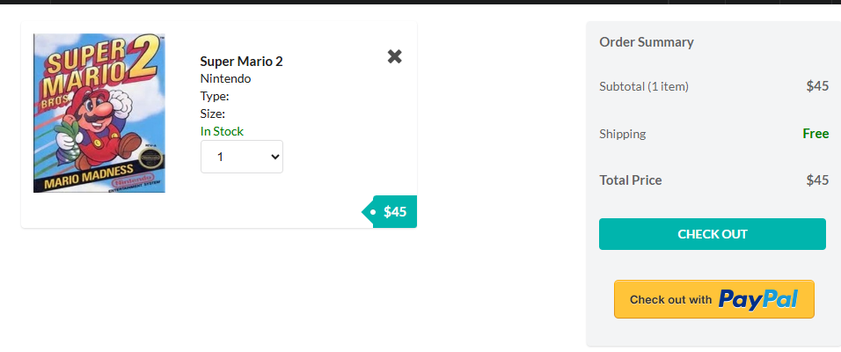
Attacker (User B) cart before exploit — single Super Mario 2 item, $45 subtotal.

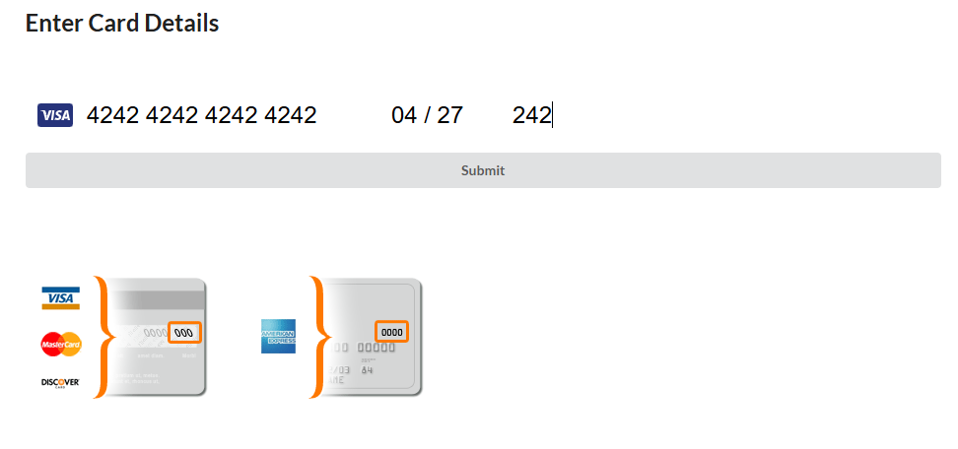
Attacker checkout page — fake test card 4242 4242 4242 4242 used to place User B's baseline order.

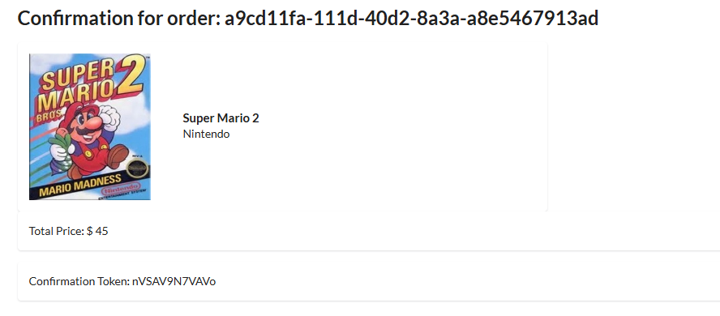
Attacker's order confirmation page — order-id a9cd11fa-111d-40d2-8a3a-a8e5467913ad, total $45, confirmation token nVSAV9N7VAVo.

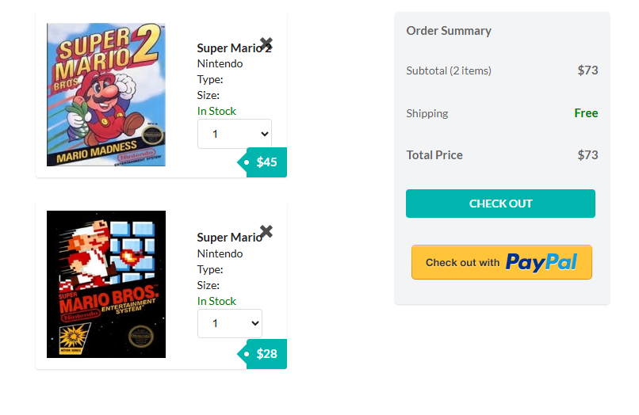
Victim (User C) cart before exploit — two items (Super Mario 2 + Super Mario), $73 subtotal.

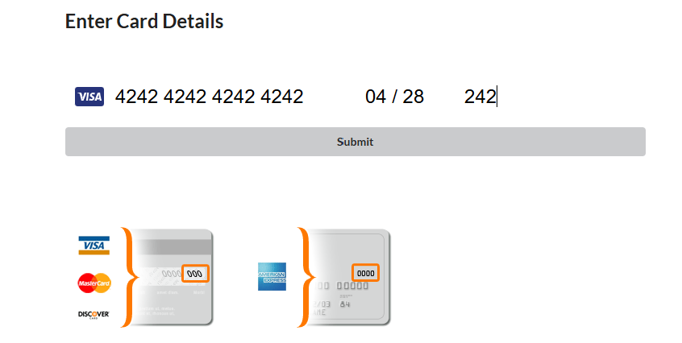
Victim checkout page — card details entered to place User C's baseline order.

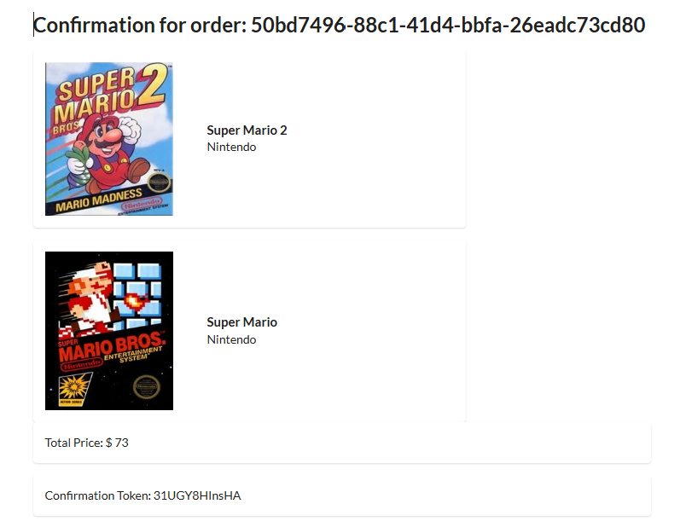
Victim's order confirmation page — order-id 50bd7496-88c1-41d4-bbfa-26eadc73cd80, total $73, confirmation token 31UGY8HInsHA. This is the victim order the attacker will later steal.

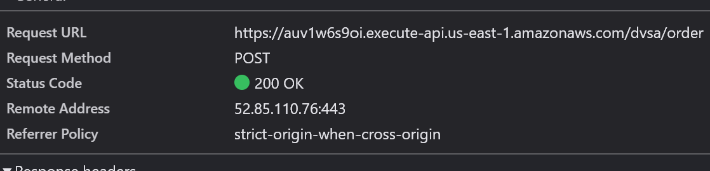
DevTools → Network → request General panel for the attacker's /order call. Confirms POST to https://auv1w6s9oi.execute-api.us-east-1.amazonaws.com/dvsa/order with HTTP 200 OK.

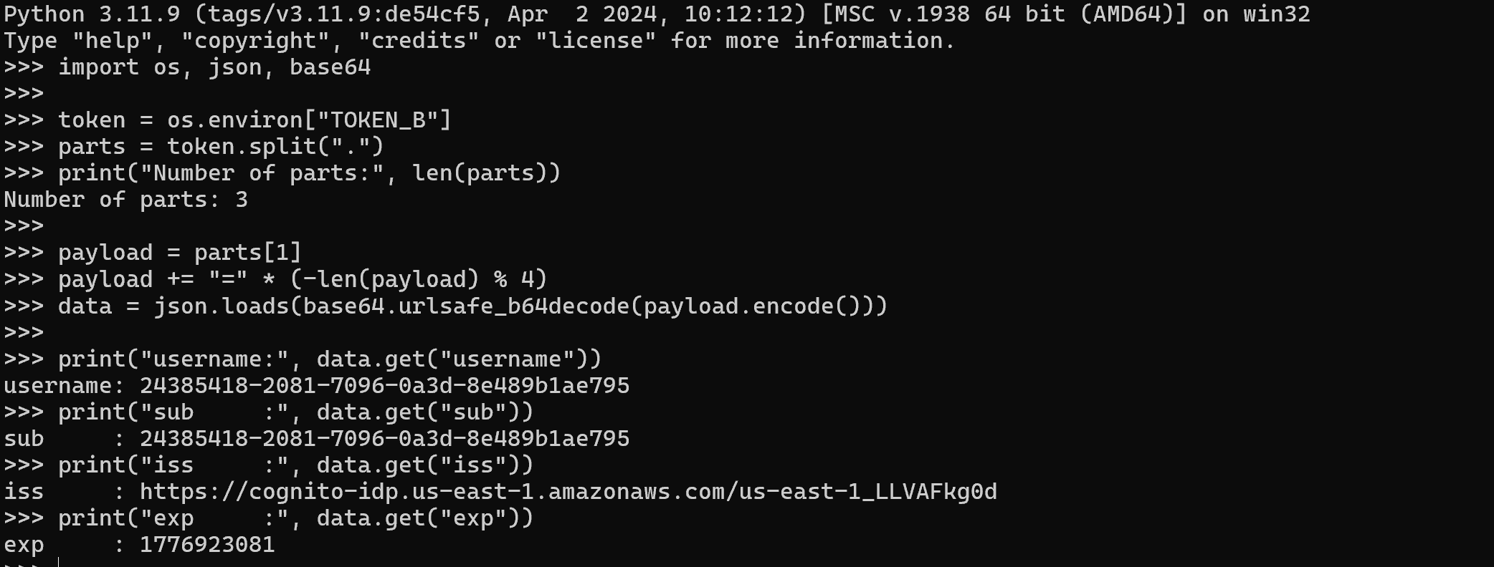
Decoded payload of TOKEN_B (attacker). The Python REPL splits the token on '.', base64-decodes the middle section, and prints the claims: username and sub both equal 24385418-2081-7096-0a3d-8e489b1ae795, with the Cognito issuer URL visible.

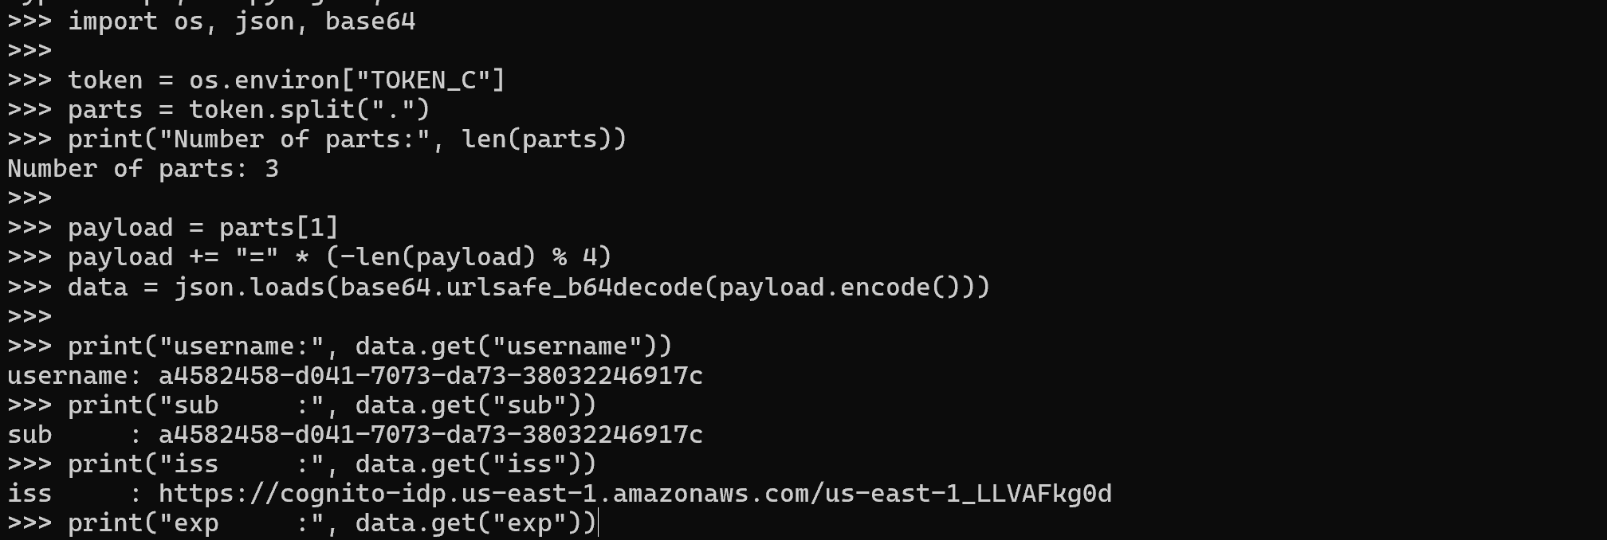
Decoded payload of TOKEN_C (victim). Same decoding procedure prints username/sub a4582458-d041-7073-da73-38032246917c — this is the value substituted into the forged token.

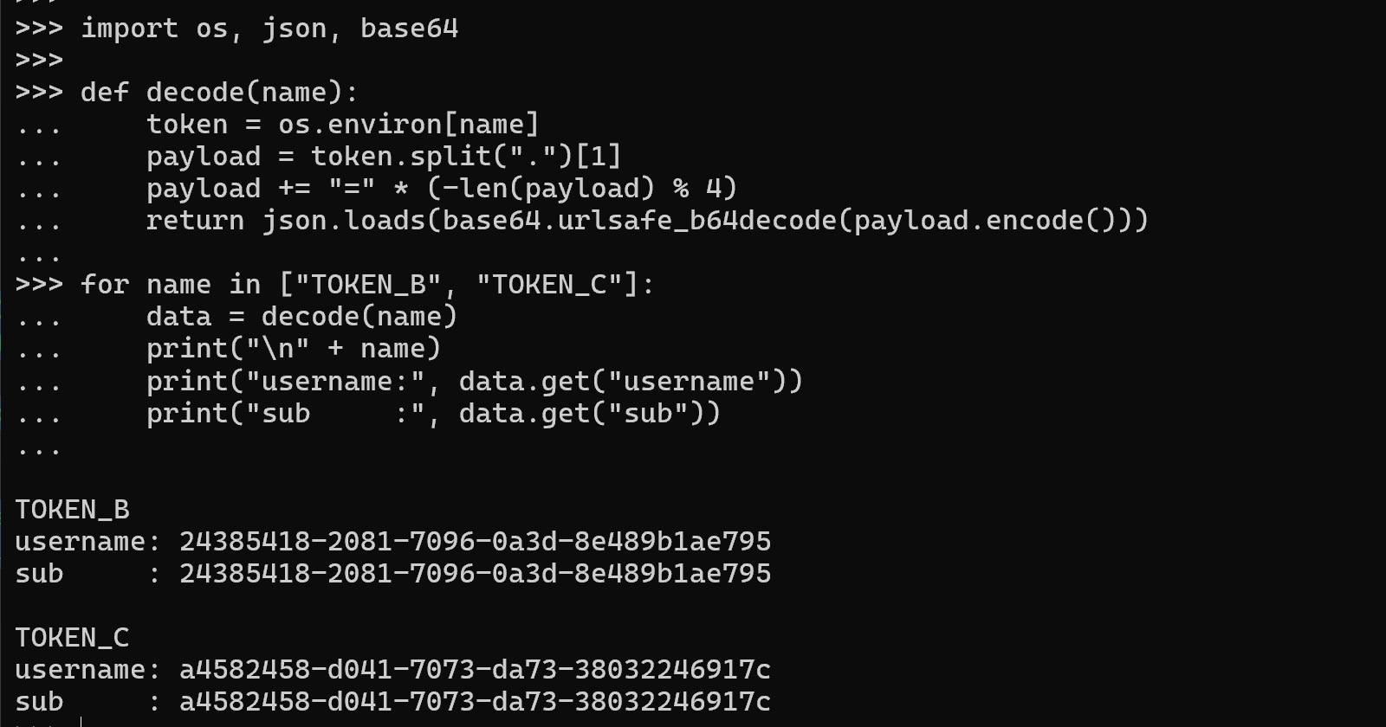
Side-by-side decoded payloads of TOKEN_B and TOKEN_C, proving the two users have completely different sub identifiers — yet the backend later accepts a forged token whose only difference is the swapped sub field.

Lesson #4 — Insecure Cloud Configuration
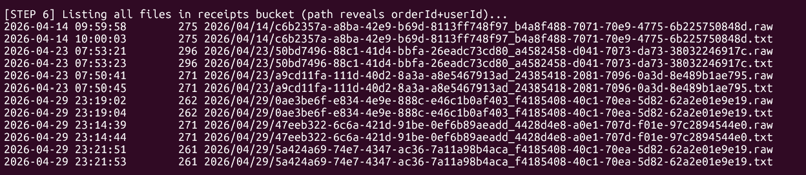
Listing of all files in the receipts S3 bucket. Object keys follow the pattern YYYY/MM/DD/<orderId>_<userId>.{raw,txt} — the path itself reveals both order and user identifiers, compounding the cloud-config flaw with information disclosure.

Lesson #6 — Denial of Service
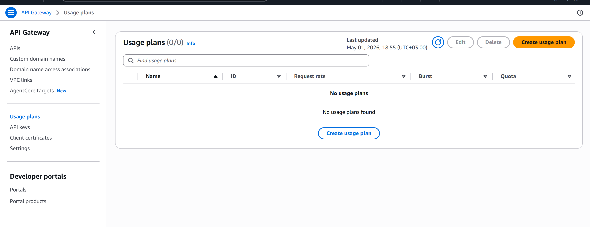
API Gateway → Usage plans console page. Confirms no usage plan exists pre-fix (0/0). This is the page where the post-fix throttle (rate=2 req/s, burst=5) is created to mitigate the DoS condition.

Lesson #7 — Over-Privileged Functions
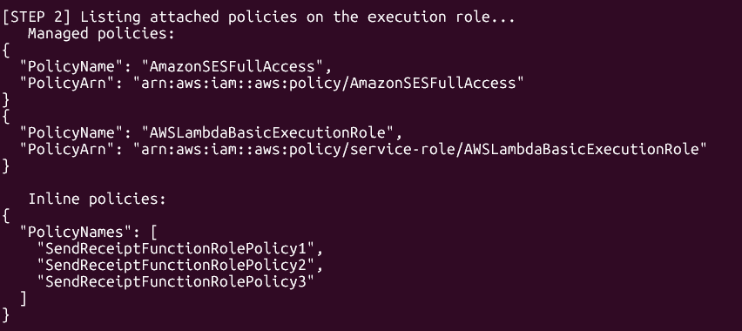
AWS CLI listing of policies attached to the DVSA-SEND-RECEIPT-EMAIL execution role. Two managed policies (AmazonSESFullAccess, AWSLambdaBasicExecutionRole) and three inline policies (SendReceiptFunctionRolePolicy1/2/3) are attached — far more privilege than a receipt-email function requires.

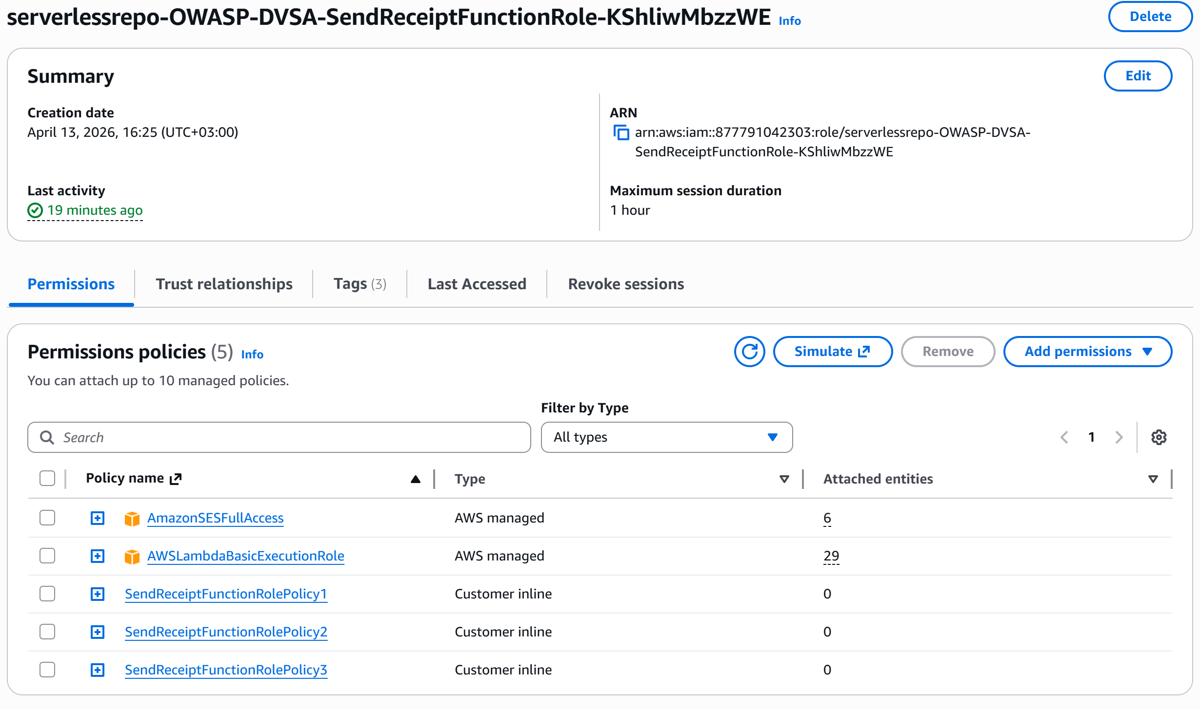
IAM Console view of the same role: serverlessrepo-OWASP-DVSA-SendReceiptFunctionRole-KShliwMbzzWE. The Permissions tab shows 5 attached policies including AmazonSESFullAccess (a fully managed wildcard SES policy) — direct visual confirmation of the over-privilege described in Part 5.

End of Appendix A. All evidence above was collected against the team's non-production DVSA deployment in us-east-1. Any token, identifier, or order-id shown is from the controlled lab environment. Real long-form JWTs and AWS session credentials have been intentionally omitted from this appendix to comply with the project's rule against exposing real secrets.

Lesson #8 — Race Condition
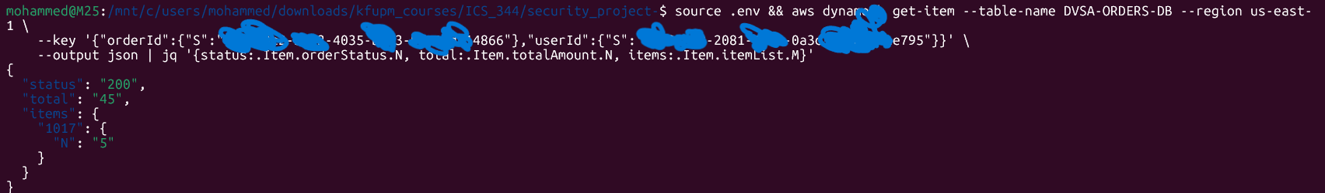
Post-exploit DynamoDB get-item query confirming the race condition result. The response
returns status 200, totalAmount 45 (the original single-item price), and itemList
showing item 1017 with quantity 5 — proving that 5 units were charged at the price of 1
due to the TOCTOU window between the totalAmount read and the subsequent quantity write.

Lesson #9 — Insecure Deserializationi
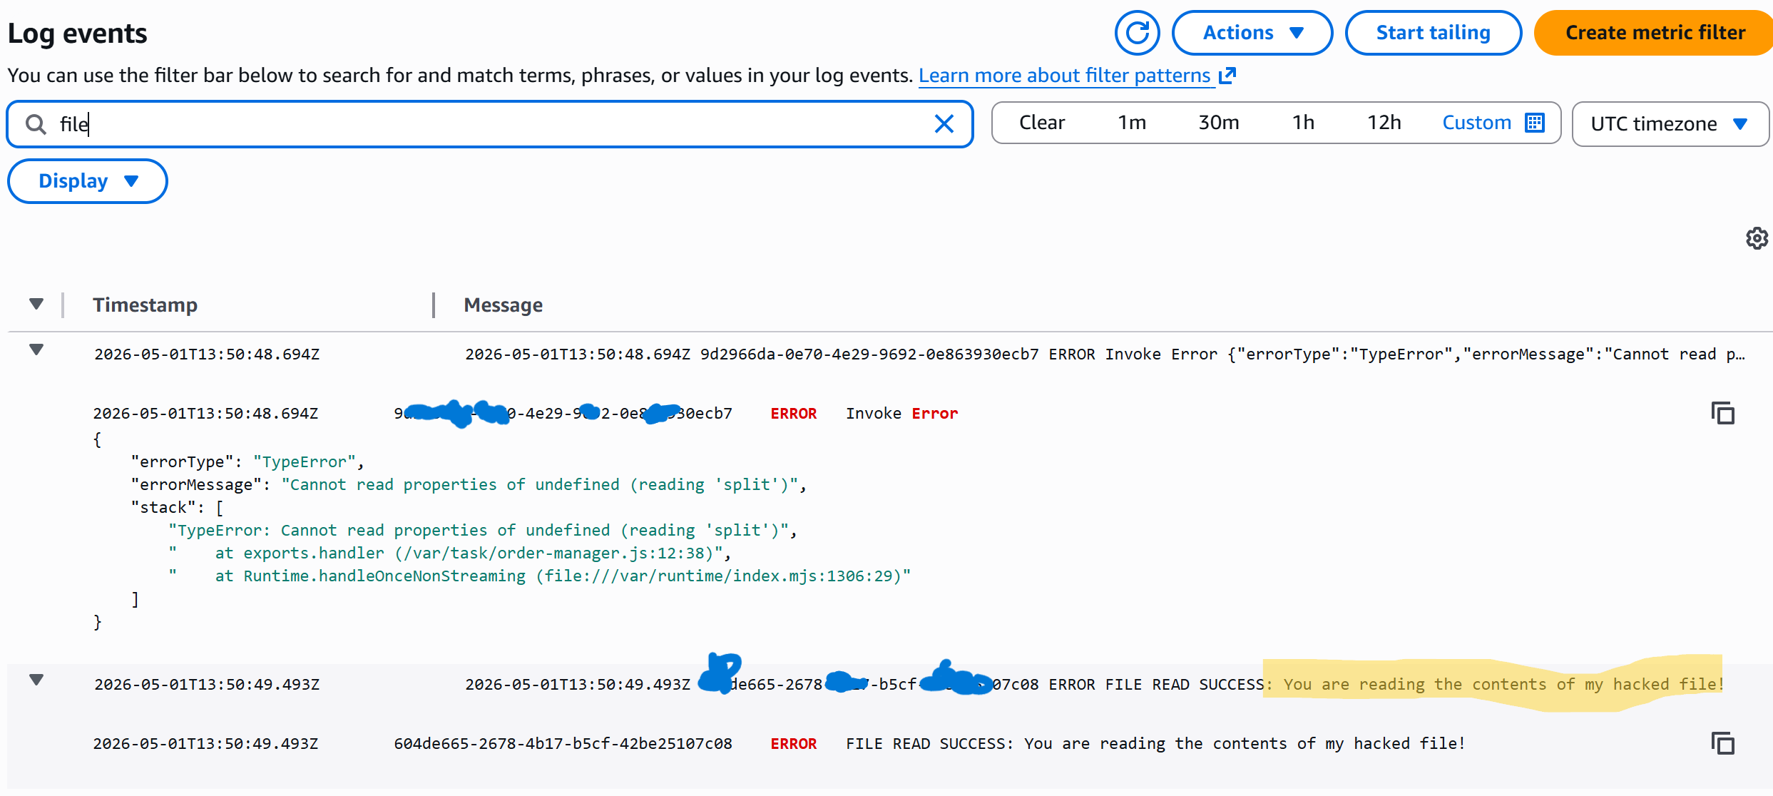
CloudWatch Logs showing two sequential entries from the exploit invocation. The first
entry (13:58:48.694Z) records a TypeError — "Cannot read properties of undefined
(reading 'split')" — confirming the injected payload executed and crashed the handler
before any authentication check was reached. The second entry (13:58:49.493Z) shows FILE
READ SUCCESS: "You are reading the contents of my hacked file!" — direct proof that the
node-serialize RCE payload successfully read an arbitrary file from the Lambda's
filesystem.

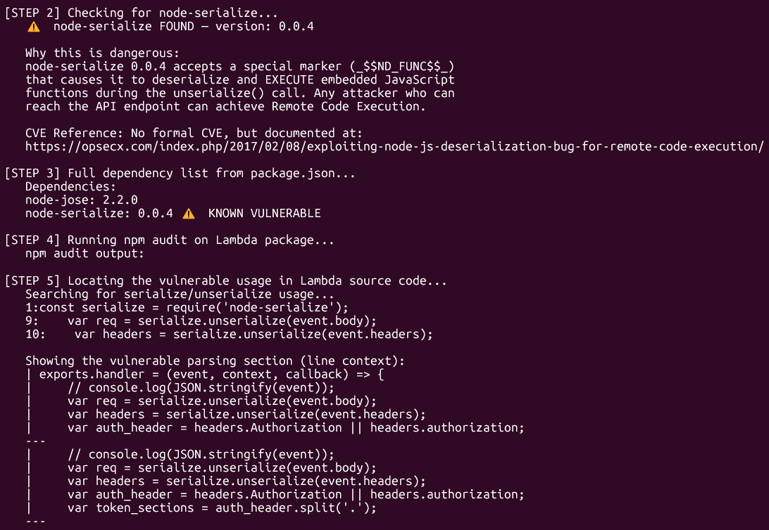
Exploit script Steps 2–5 output. Step 2 detects node-serialize 0.0.4 and explains the
_$$ND_FUNC$$_ deserialization gadget that causes embedded JavaScript to execute on
unserialize(). Step 3 confirms node-serialize is listed as KNOWN VULNERABLE in the
dependency tree. Step 5 pinpoints the two vulnerable serialize.unserialize() calls on
event.body and event.headers (lines 9–10 of order-manager.js) and displays the
surrounding handler code, proving that attacker-controlled input is deserialized before
any authentication check is performed.

