CSE 482 Project - Part II: Data Analysis

A. Problem Definition
Title: Movie Recommendation System using Collaborative Filtering
Team Member: Mehrshad Bagherebadian
Note: This project is completed individually.
The goal of this project is to develop a movie recommendation system using the MovieLens latest-small dataset. The main problem is to predict how a user would rate a movie they have not already rated, and then use those predictions to recommend movies. This problem matches the recommender system project option, which requires both user-based and item-based collaborative filtering.
The specific questions addressed in this stage are:
- Can user-movie rating data be used to predict ratings for unseen movies?
- Which method performs better on the test set: user-based collaborative filtering or item-based collaborative filtering?
- How do rating distributions, user activity, movie popularity, and genre information affect the recommendation task?
- Can the analysis produce outputs that will support the later web interface, such as rated movies, recommended movies, and similar users?

B. Feature Selection
The main features were selected from the cleaned MovieLens tables stored in the MySQL database created in Part I. The recommendation models primarily use the user-movie rating matrix, while the genre fields are used as additional movie metadata for interpretation and future improvement.
Feature | Source | Reason for Use
userId | ratings | Identifies each user and is needed to calculate user-based nearest neighbors.
movieId | ratings/movies | Identifies each movie and is needed to calculate item-based nearest neighbors.
rating | ratings | Primary target value and explicit user preference signal.
title | movies | Used to display human-readable recommendation results.
genres | movies_genres | Additional movie metadata used for analysis and later recommendation interpretation.
The timestamp was converted to a readable datetime format during preprocessing, but it was not used as a primary model feature in this stage. The current objective is rating prediction using collaborative filtering rather than time-series modeling.

C. Model Training
The data was split into training and test sets using an 80/20 split. The training set contained 80,668 ratings and the test set contained 20,168 ratings. All 610 users were represented in both sets. Similarities and nearest neighbors were calculated using only the training data to avoid leakage from the test set.
Three models were evaluated:
- Baseline user-mean model: predicts a user average rating when available.
- User-based collaborative filtering: finds the top-k most similar users and predicts ratings using weighted averages from similar users.
- Item-based collaborative filtering: finds the top-k most similar movies and predicts ratings using weighted averages from movies the user already rated.
The neighborhood size was tested and set to k = 100. Increasing k from 50 to 100 improved both collaborative filtering models. Model performance was evaluated using Root Mean Squared Error (RMSE) and Mean Absolute Error (MAE), where lower values indicate better prediction accuracy.
Model | RMSE | MAE
Baseline User Mean | 0.9413 | 0.7347
User-Based CF | 0.9676 | 0.7476
Item-Based CF | 0.9016 | 0.6801
The item-based collaborative filtering model performed best, with RMSE = 0.9016 and MAE = 0.6801. It outperformed both the baseline model and the user-based collaborative filtering model. The user-based model did not outperform the baseline, which is likely due to the high sparsity of the user-item matrix. Because many users rate only a small portion of all available movies, user-user similarities can be weak or noisy. Item-based collaborative filtering was more stable because popular movies provide more shared rating information across users.

D. Visualization
Several visualizations were generated to understand the dataset and evaluate the models. These figures summarize the distribution of ratings, user activity, movie popularity, genre composition, and model accuracy.
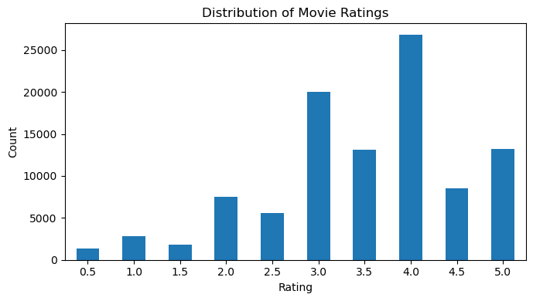
Figure 1. Distribution of movie ratings.
Most ratings are concentrated around 3.0 to 4.0, with 4.0 being the most common rating. This indicates that users tend to rate movies positively, which is important when interpreting prediction errors.
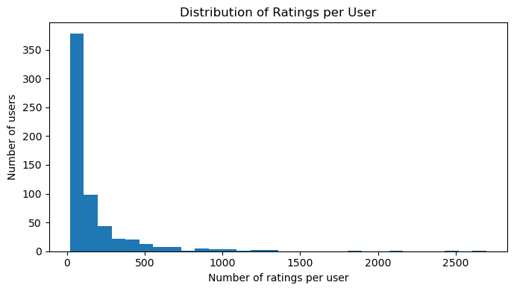
Figure 2. Distribution of ratings per user.
The distribution of ratings per user is highly skewed. Most users rated a relatively small number of movies, while a few users rated many movies. This imbalance affects user-based collaborative filtering because highly active users contribute more similarity information than less active users.
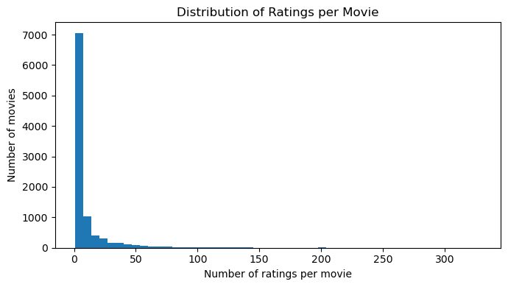
Figure 3. Distribution of ratings per movie.
The distribution of ratings per movie is also highly skewed. Many movies have very few ratings, while a small number of popular movies have many ratings. This contributes to matrix sparsity and affects the reliability of predictions for less commonly rated movies.
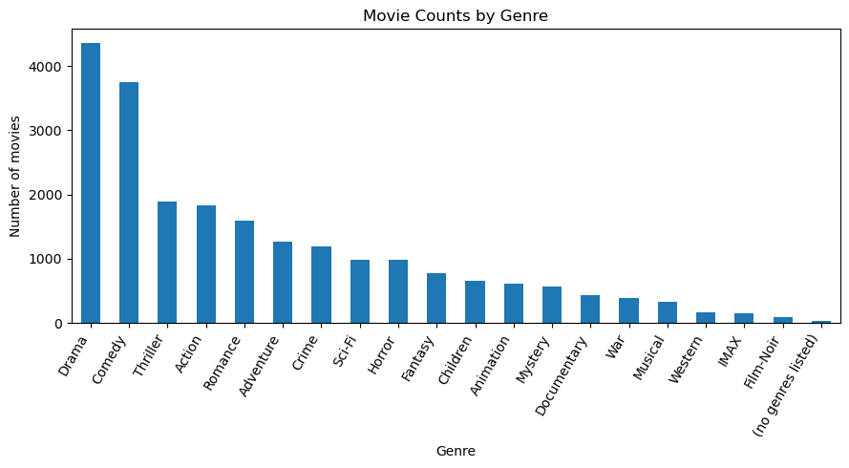
Figure 4. Movie counts by genre.
The most common genres are Drama, Comedy, Thriller, Action, and Romance. Genre information was not the primary input to the collaborative filtering models, but it provides useful metadata for interpreting recommendations and can be used in future hybrid recommendation approaches.
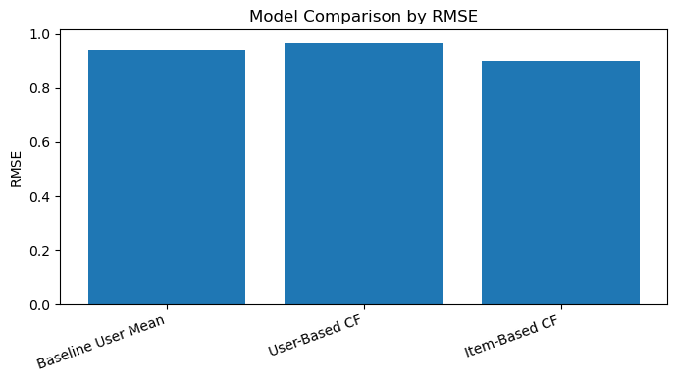
Figure 5. Model comparison by RMSE.
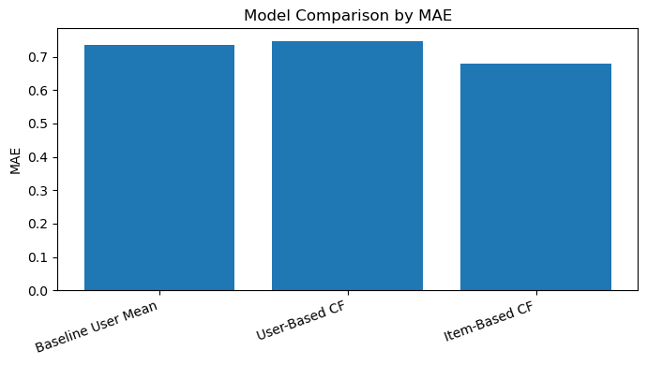
Figure 6. Model comparison by MAE.
Both RMSE and MAE show that item-based collaborative filtering achieved the best performance. The model comparison also shows that user-based collaborative filtering was weaker than the baseline, supporting the conclusion that user similarity is less reliable in this sparse dataset.
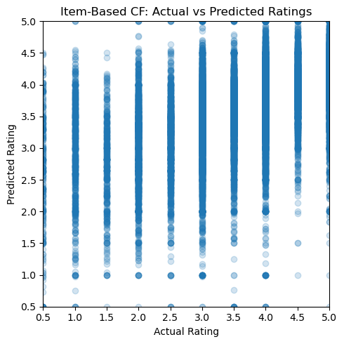
Figure 7. Item-based collaborative filtering: actual vs. predicted ratings.
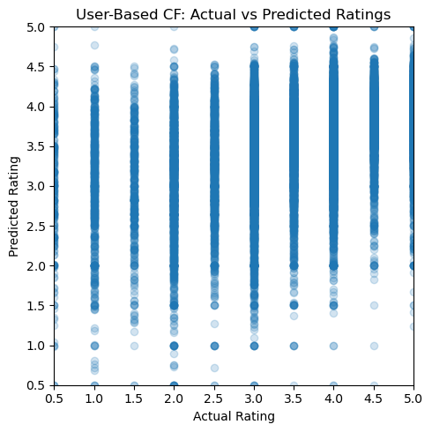
Figure 8. User-based collaborative filtering: actual vs. predicted ratings.
The prediction scatter plots compare actual ratings with predicted ratings on the test set. The plots show that predictions generally fall within the valid rating range, but there is still noticeable spread, which is expected because ratings are subjective and the dataset is sparse.

E. Report
Part II completed the data analysis stage of the project. The data was loaded from the MySQL database, explored visually, split into training and test sets, and used to train baseline, user-based, and item-based recommendation models.
The main result is that item-based collaborative filtering performed best, achieving RMSE = 0.9016 and MAE = 0.6801. This suggests that movie-to-movie similarity was more reliable than user-to-user similarity for this dataset. The high sparsity of the user-item matrix likely reduced the effectiveness of user-based collaborative filtering.
The analysis also produced outputs that will support later project stages. For a selected user, the notebook generated a list of movies already rated by the user, recommended movies not yet rated by the user, and similar users based on rating behavior. These outputs directly support the final web interface requirements, including displaying rated items, providing recommendations, and showing users with similar preferences.
Overall, the Part II analysis demonstrates that the processed MovieLens dataset is suitable for building a recommender system and that item-based collaborative filtering should be used as the primary recommendation method moving forward.

