D6300 genome annotation summary

Information
D6300
Theoretical Composition Based on Genomic DNA: Listeria monocytogenes - 12%, Pseudomonas aeruginosa - 12%, Bacillus subtilis - 12%, Escherichia coli - 12%, Salmonella enterica - 12%, Lactobacillus fermentum - 12%, Enterococcus faecalis - 12%, Staphylococcus aureus - 12%, Saccharomyces cerevisiae - 2%, and Cryptococcus neoformans - 2%
Genome assembly:
hifiasm-meta v0.3 (https://github.com/xfengnefx/hifiasm-meta)
Genome annotation:
- Bacterial genomes: annotation with Prokka (v1.14.6) https://github.com/tseemann/prokka
  - Assessment with BUSCO (v5.4.6) with the bacteria_odb10 lineage dataset https://busco.ezlab.org/
- Fungal genomes: annotation and assessment with FunGAP (v1.1.1) https://github.com/CompSynBioLab-KoreaUniv/FunGAP
Organism | Dataset | Complete | Single | Duplicated | Fragmented | Missing
Staphylococcus aureus | bacteria_odb10 | 100 | 100 | 0 | 0 | 0
P. aeruginosa | bacteria_odb10 | 100 | 99.2 | 0.8 | 0 | 0
Listeria monocytogenes | bacteria_odb10 | 100 | 99.2 | 0.8 | 0 | 0
Bacillus subtilis | bacteria_odb10 | 100 | 86.3 | 13.7 | 0 | 0
Salmonella enterica | bacteria_odb10 | 98.4 | 98.4 | 0 | 0 | 1.6
Enterococcus faecalis | bacteria_odb10 | 98.4 | 97.6 | 0.8 | 1.6 | 0
L. fermentum | bacteria_odb10 | 98.4 | 97.6 | 0.8 | 0.8 | 0.8
Escherichia coli | bacteria_odb10 | 99.2 | 98.4 | 0.8 | 0 | 0.8

Bacterial species
organism | contigs | bases | CDS | gene | rRNA | repeat_region | tRNA | tmRNA
Staphylococcus aureus | 3 | 2729384 | 2473 | 2553 | 19 |  | 60 | 1
Pseudomonas aeruginosa | 2 | 6846579 | 6339 | 6430 | 12 | 4 | 78 | 1
Listeria monocytogenes | 1 | 3032011 | 2965 | 3051 | 18 | 1 | 67 | 1
Bacillus subtilis | 2 | 4222511 | 4129 | 4237 | 30 |  | 77 | 1
Salmonella enterica | 3 | 4824135 | 4610 | 4721 | 22 | 2 | 88 | 1
Enterococcus faecalis | 1 | 2895646 | 2731 | 2808 | 12 | 2 | 64 | 1
Lactobacillus fermentum | 20 | 2227379 | 2253 | 2328 | 15 | 1 | 59 | 1
Escherichia coli | 2 | 4925141 | 4630 | 4747 | 22 | 2 | 94 | 1

Busco completeness

Saccharomyces cerevisiae
The 8,263 genes were predicted in this genome.

1. Gene structure
Attributes | Values
Total protein-coding genes | 8,263
Transcript length (avg / med) | 1,493.2 / 1,233.0
CDS length (avg / med) | 1,476.1 / 1,221.0
Protein length (avg / med) | 492.0 / 407.0
Exon length (avg / med) | 1,382.7 / 1,149.0
Intron length (avg / med) | 253.0 / 133.0
Spliced genes | 522 (6.32%)
Gene density (genes/Mb) | 440.23
Number of introns | 558
Number of introns per gene (med) | 1.0
Number of exons | 8,821
Number of exons per gene (med) | 1.0

2. Transcriptome reads assembly
Attributes | Values
Number of mapped reads | 137,568,322
Number of assembled contigs | 20,373
Number of contigs > 1 kbp | 4,548
Total transcript size (Mbp) | 15,414,121

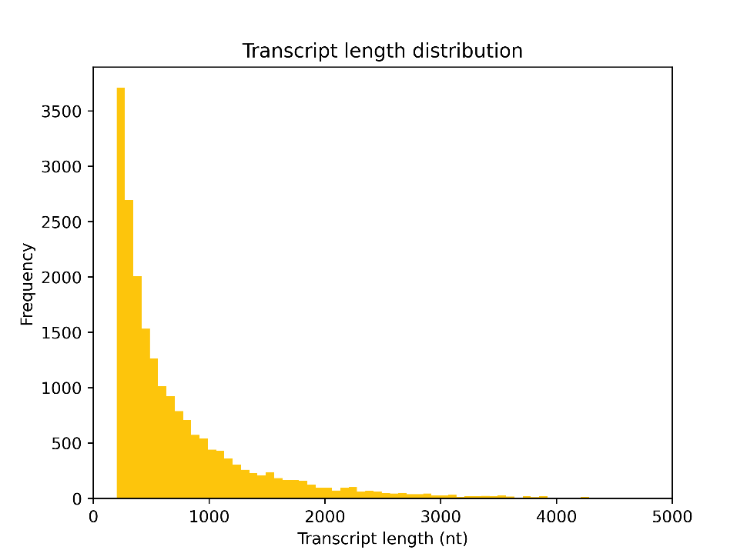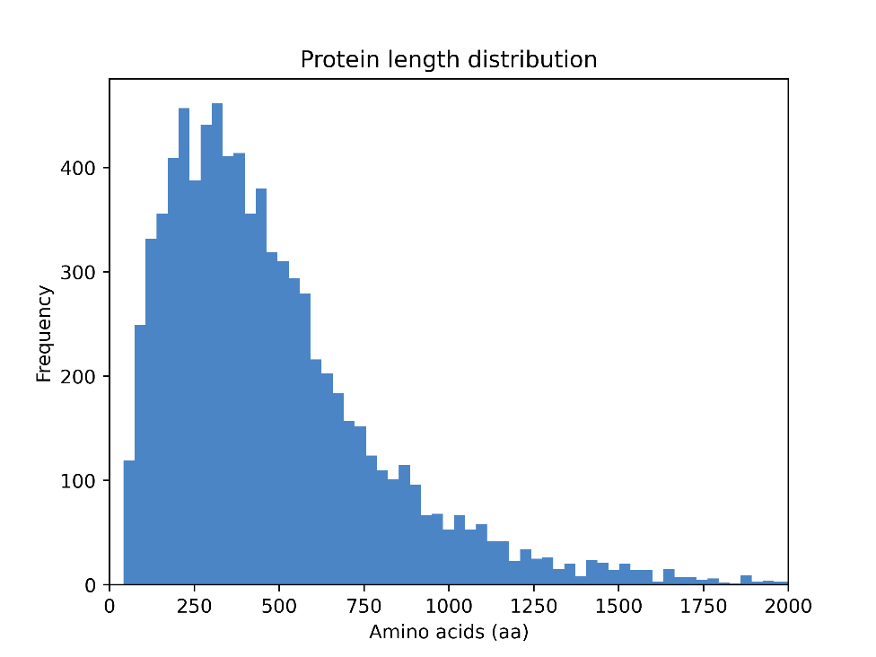
Busco completeness
C:95.4%[S:45.3%,D:50.1%],F:0.7%,M:3.9%,n:1706
1626 Complete BUSCOs (C)
772 Complete and single-copy BUSCOs (S)
854 Complete and duplicated BUSCOs (D)
12 Fragmented BUSCOs (F)
68 Missing BUSCOs (M)
1706 Total BUSCO groups searched

Cryptococcus neoformans

The 9,503 genes were predicted in this genome.

1. Gene structure
Attributes | Values
Total protein-coding genes | 9,503
Transcript length (avg / med) | 1,885.1 / 1,568.0
CDS length (avg / med) | 1,544.4 / 1,260.0
Protein length (avg / med) | 514.8 / 420.0
Exon length (avg / med) | 250.5 / 145.0
Intron length (avg / med) | 65.9 / 55.0
Spliced genes | 8,924 (93.91%)
Gene density (genes/Mb) | 361.25
Number of introns | 49,091
Number of introns per gene (med) | 4.0
Number of exons | 58,594
Number of exons per gene (med) | 5.0

2. Transcriptome reads assembly
Attributes | Values
Number of mapped reads | 144,050,842
Number of assembled contigs | 33,575
Number of contigs > 1 kbp | 25,518
Total transcript size (Mbp) | 81,816,921

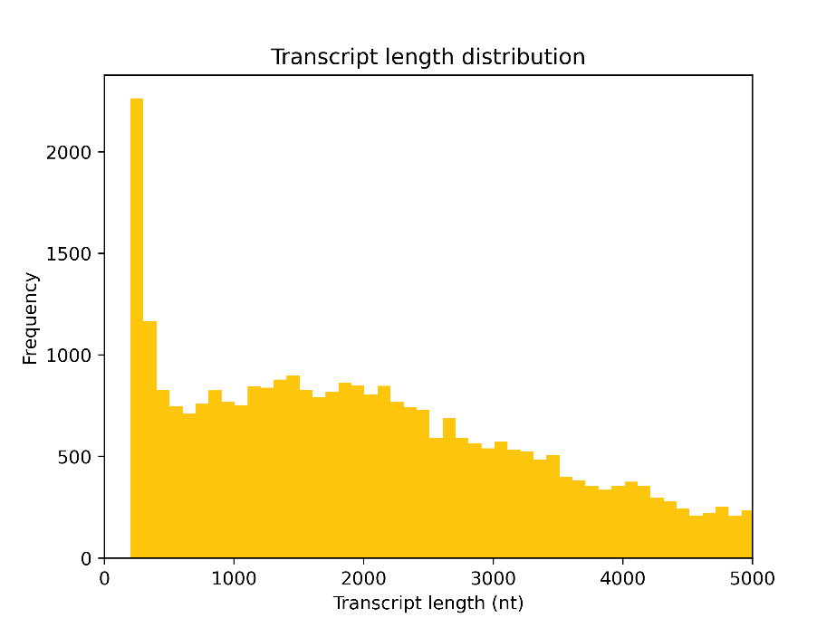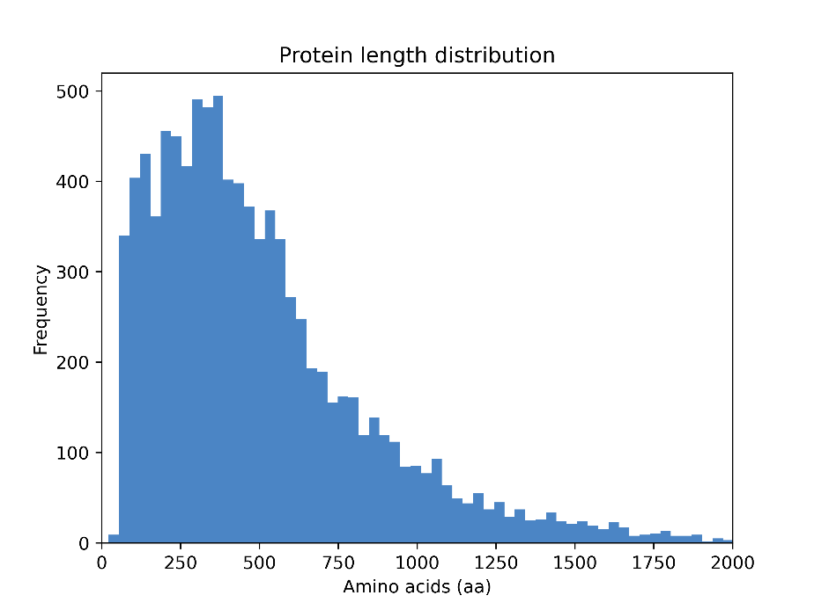
Busco completeness
C:53.0%[S:34.4%,D:18.6%],F:6.7%,M:40.3%,n:1706
904 Complete BUSCOs (C)
587 Complete and single-copy BUSCOs (S)
317 Complete and duplicated BUSCOs (D)
115 Fragmented BUSCOs (F)
687 Missing BUSCOs (M)
1706 Total BUSCO groups searched

