# Introduction

Innovator 1 project is to create an ASR based Smart Home System, to offer best human interaction with home devices.

## 1.1 Revision History

| Revision | Date | Prepared By | Comments |
| --- | --- | --- | --- |
| PA1 |  | Xuesong | Initial creation. |
| PA2 |  | Jianhui | Update after first review.   * Add chapters 3,4,5 outline |

## 1.2 Overview

Below picture shows a typical user scenario of the system. ASR(Auto Speech Recognition) devices record user's speech and do speech recognize, resulsting as device operation action, then control Wireless Switch devices to turn on/off lights.

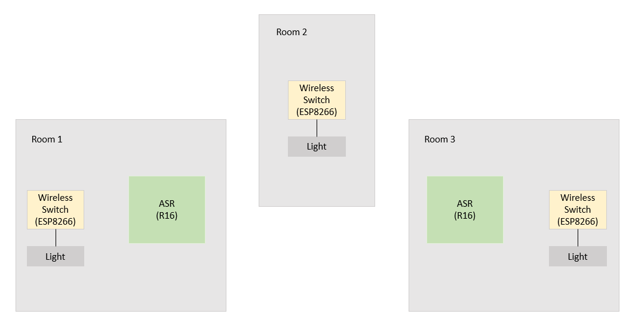

Speech: "灵犀灵犀，开卧室灯" and etc.

Action: turn on/off lights

Communication Technology: Wifi

## 2 Architecture

### 2.1 Hardware architecture

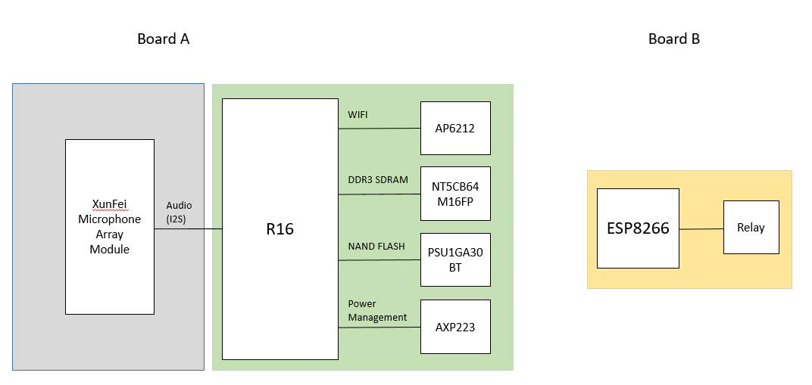

Board A (ASR Board)

CPU: R16, Quad-core Cortex™-A7

Recorder: Xunfei 6-microphone array or 2-microphone array module

Board B (Actuator Board)

CPU: ESP8266, WIFI SoC, 32bit, 80Mhz-160Mhz

Actuator: Relay

### 2.2 Software architecture

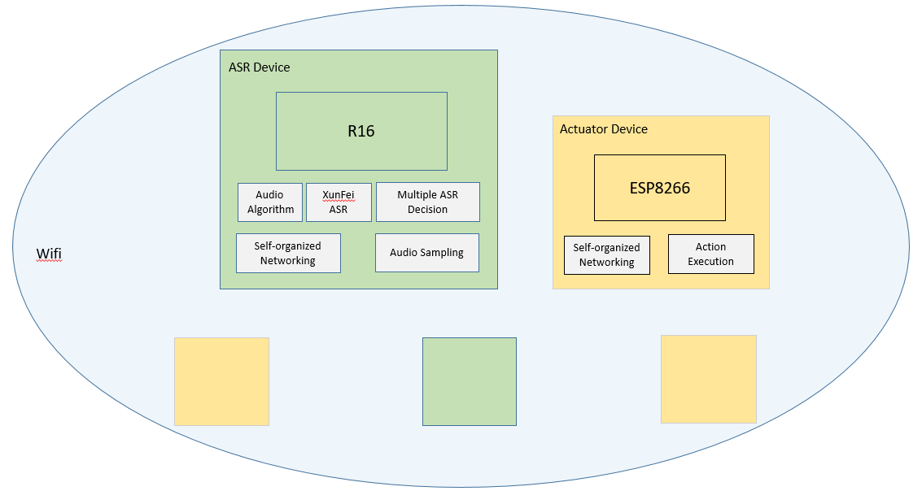

- Self-organized Networking

Self-organize network among ASR devices and Actuator devices, including devices identification, action notification and etc.

- Audio Sampling

Sample I2S stream from Xunfei Microphone Array.

- Audio Algorithm

Far Field Voice Processing Algorithms to handle audio stream from Microphone Array.

- XunFei ASR

Use XunFei SDK to do ASR and anlysis results.

- Multiple ASR Decision

Arbitration among ASR results from multiple ASR devices.

## 3. ASB subsystem

### 3.1 Xufei microphone array

Voice date channel.

### 3.2 R16, voice date processer

Voice date receive

Interact with Xunfei/Xunfei Cloud

## 4. Controller subsystem

### 4.1 Control Channel

### 4.2 network management

### 4.3 message flow

### 4.4 semantic analysis

## 5. Actuator