# Requirements

* Program to be executed with Python 3.8
  + Determine by the name “cp*” in the file:
    - rsid_py.**cp38**-win_amd64.pyd
* Install library requirements from requirements.txt
* Intel F455 camera to be connected to device

## Building RealSense library guide

* Building guide:
  + <https://github.com/IntelRealSense/RealSenseID/tree/master/samples>
  + <https://github.com/IntelRealSense/RealSenseID/tree/master/samples/python>
  + <https://github.com/IntelRealSense/RealSenseID/tree/master/tools>
* When building the python wrapper from C++, your most active python version will be the resulting python version being used to build the resulting C++ to python wrapper
  + 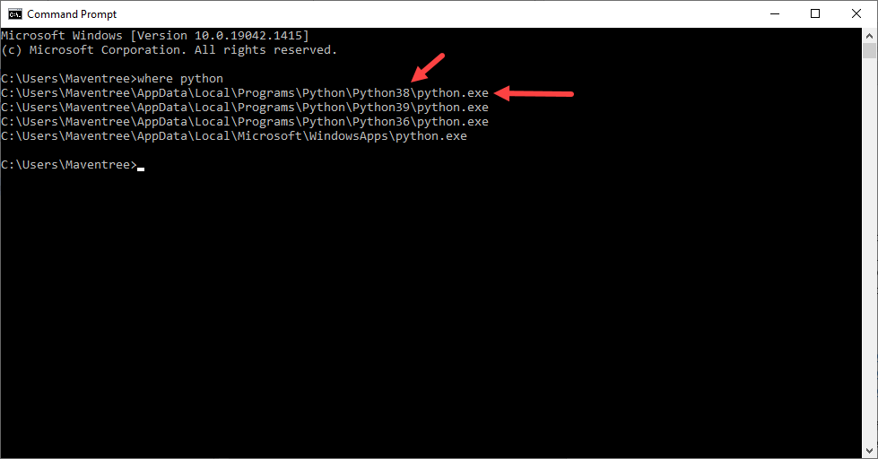
* To change the python version that cmake is using:
  + <https://stackoverflow.com/a/16045924/11537143>

# PyCharm requirements

* If using pycharm, the src folder must be marked as “Sources Root”
  + 