**Employee Management Assignment:**

**Technology Used:**

Front End: Angular 7

Back End: C# .Net core with SQL

Steps to run:

* Update the connection string in appsetting.json file.
* Logs path can be updated in Web.config file.
* In Commandprompt navigate to folder [CopiedProjectDirectory]/EmployeeAssignment/EmployeeAssignment
* Run command dotnet run

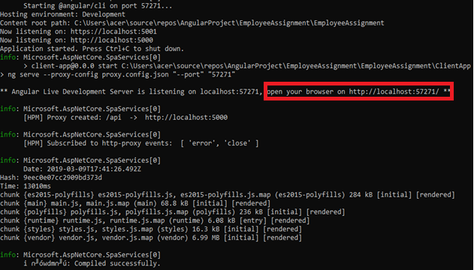

* In browser, open <http://localhost:57271> (port no from above output)
* Below are the screenshots

**Create Employee:**

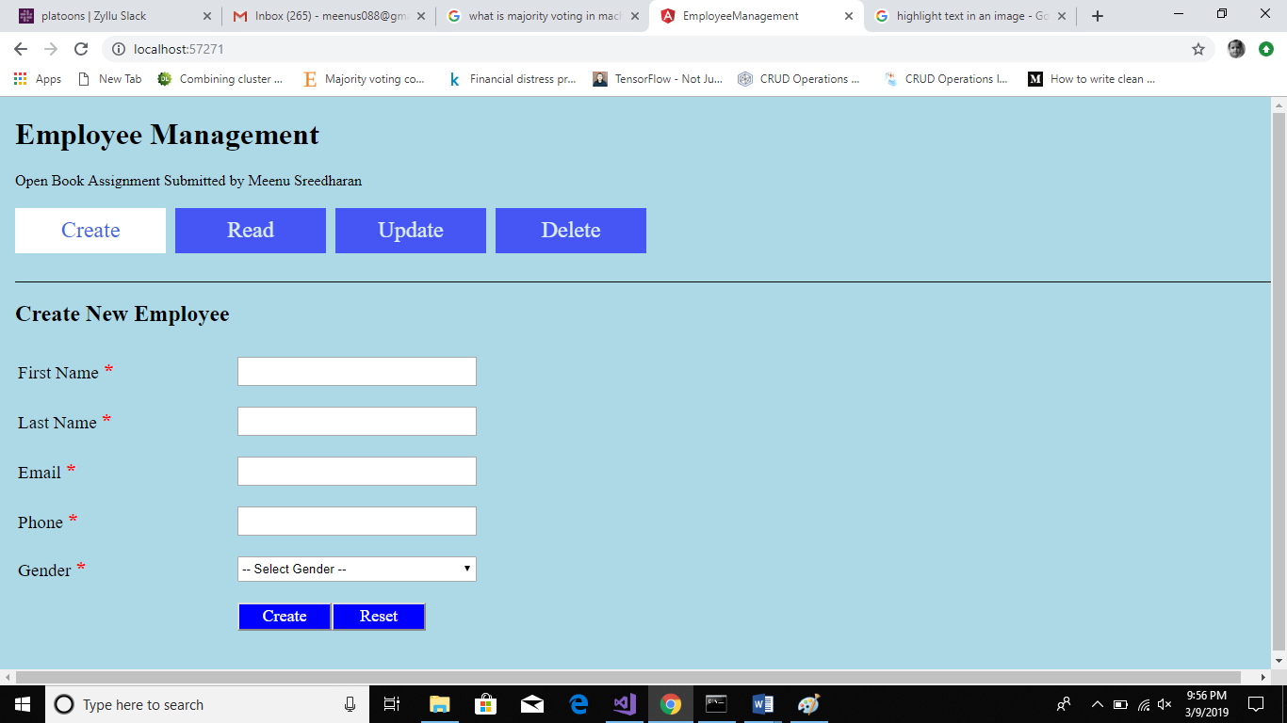 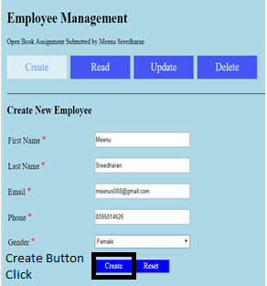

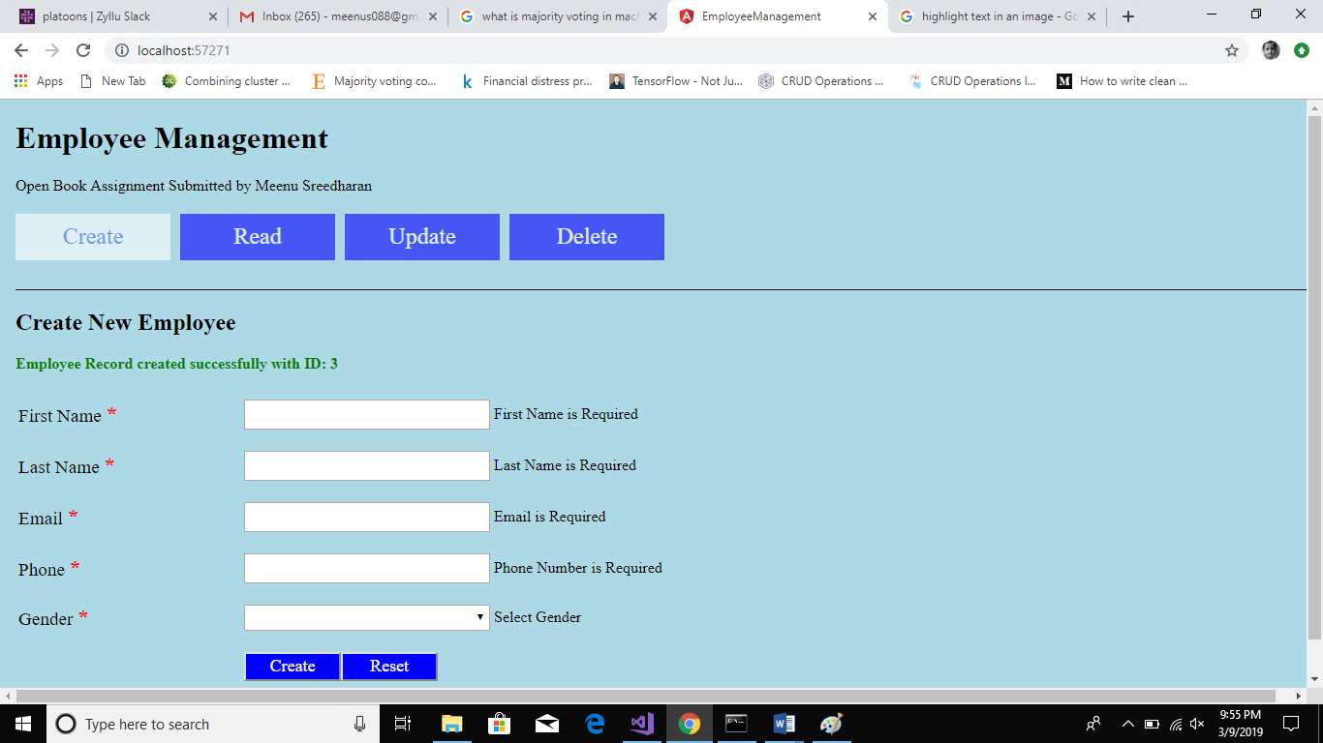

**Read Employee:**

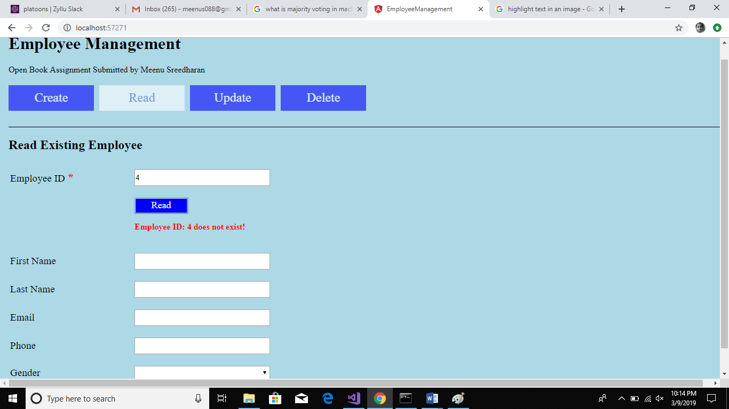 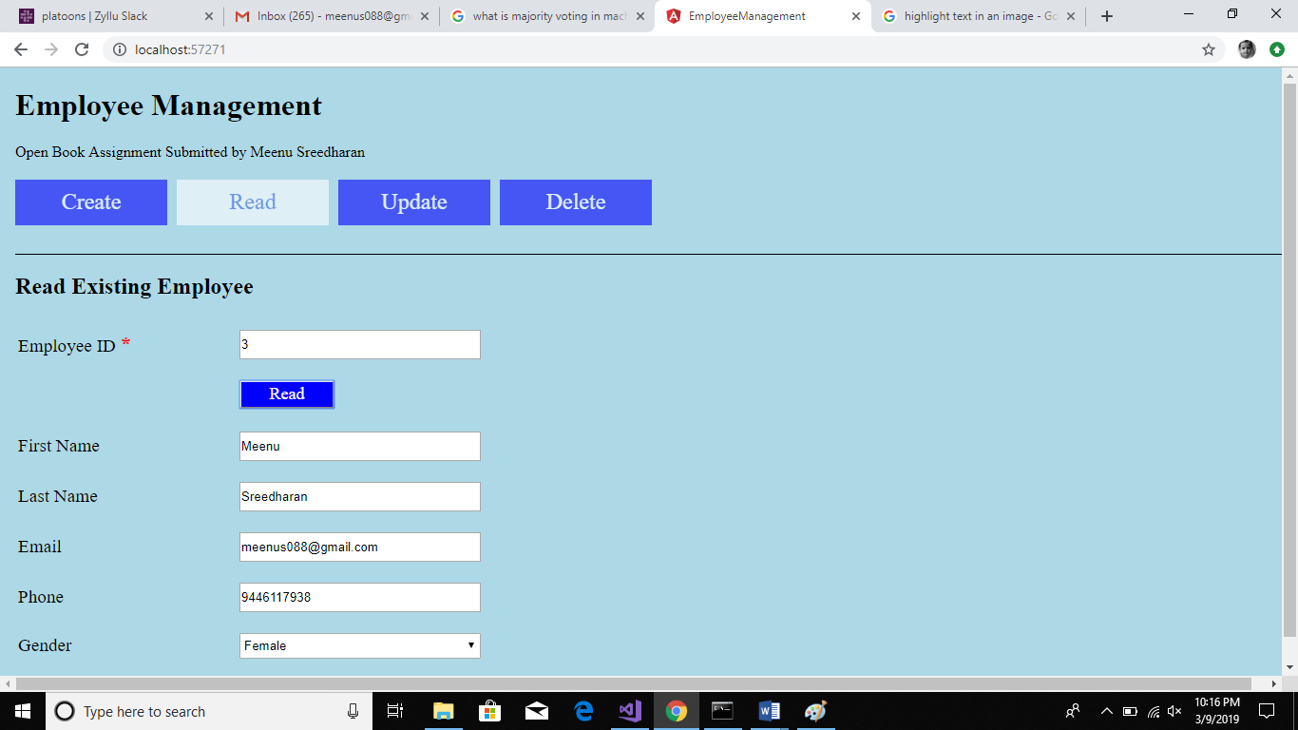

**Update Employee**

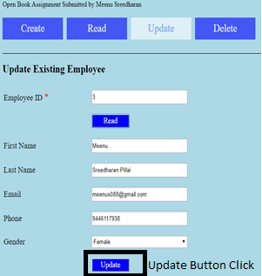 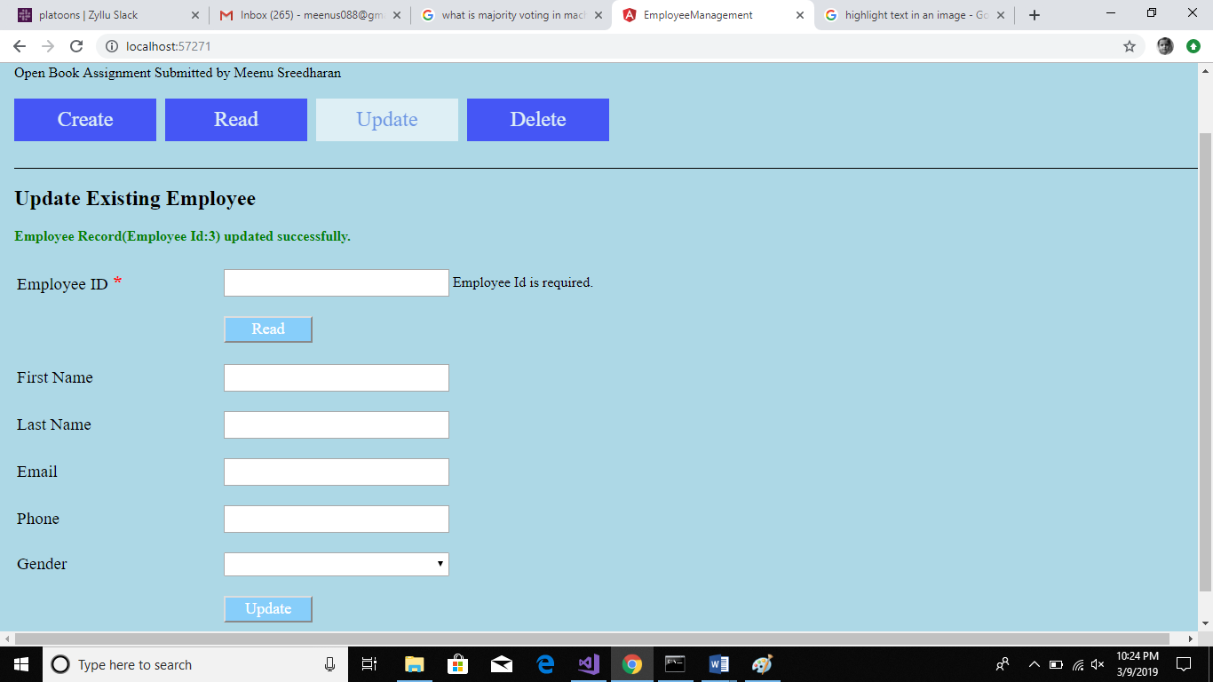

**Delete Employee:**

