Project-Chapter 10 (100 points)
Student Name: NETID:

Project: The Circle2D Class

Problem Description:
Define the Circle2D class that contains:
- Two double data fields named x and y that specify the center of the circle with get methods.
- A data field radius with a get method.
- A no-arg constructor that creates a default circle with (0, 0) for (x, y) and 1 for radius.
- A constructor that creates a circle with the specified x, y, and radius.
- A method getArea() that returns the area of the circle.
- A method getPerimeter() that returns the perimeter of the circle.
- A method contains(double x, double y) that returns true if the specified point (x, y) is inside this circle. See Figure 10.14(a).
- A method contains(Circle2D circle) that returns true if the specified circle is inside this circle. See Figure 10.14(b).
- A method overlaps(Circle2D circle) that returns true if the specified circle overlaps with this circle. See the figure below.

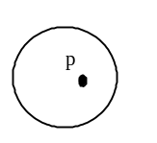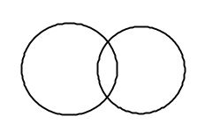

(a) (b) (c)

Figure
(a) A point is inside the circle. (b) A circle is inside another circle. (c) A circle overlaps another circle.

Draw the UML diagram for the class. Implement the class. Write a test program that creates a Circle2D object c1 (new Circle2D(2, 2, 5.5)), displays its area and perimeter, and displays the result of c1.contains(3, 3), c1.contains(new Circle2D(4, 5, 10.5)), and c1.overlaps(new Circle2D(3, 5, 2.3)).

Design:
Draw the UML class diagram here

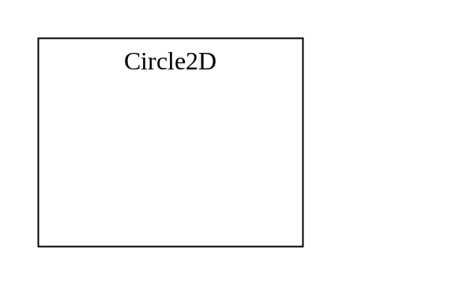

Coding: (Copy and Paste Source Code here. Format your code using Courier 10pts)

public class Exercise10_11 {
public static void main(String[] args) {
Circle2D c1 = new Circle2D(2, 2, 5.5);
System.out.println("Area is " + c1.getArea());
System.out.println("Perimeter is " + c1.getPerimeter());
System.out.println(c1.contains(3, 3));
System.out.println(c1.contains(new Circle2D(4, 5, 10.5)));
System.out.println(c1.overlaps(new Circle2D(3, 5, 2.3)));
}
}

class Circle2D {
// Implement your class here
}

Submit the following items:

1. Submit this word file to Blackboard before the due day

2. Submit the source code files to Blackboard before the due day

