CreditReversalService-XML Configuration
If we want to change DB then below Data Source will be used and can be modified
Data Source :
Data Source=(local);Min Pool Size=0;Max Pool Size=100;Pooling=true;Initial Catalog=creditreversaldemo; User ID=CreditRepair;Password=am9fctNYPA

CreditReversalPrintService - Installation steps
- Place CreditReversalPrintService folder in any drive.
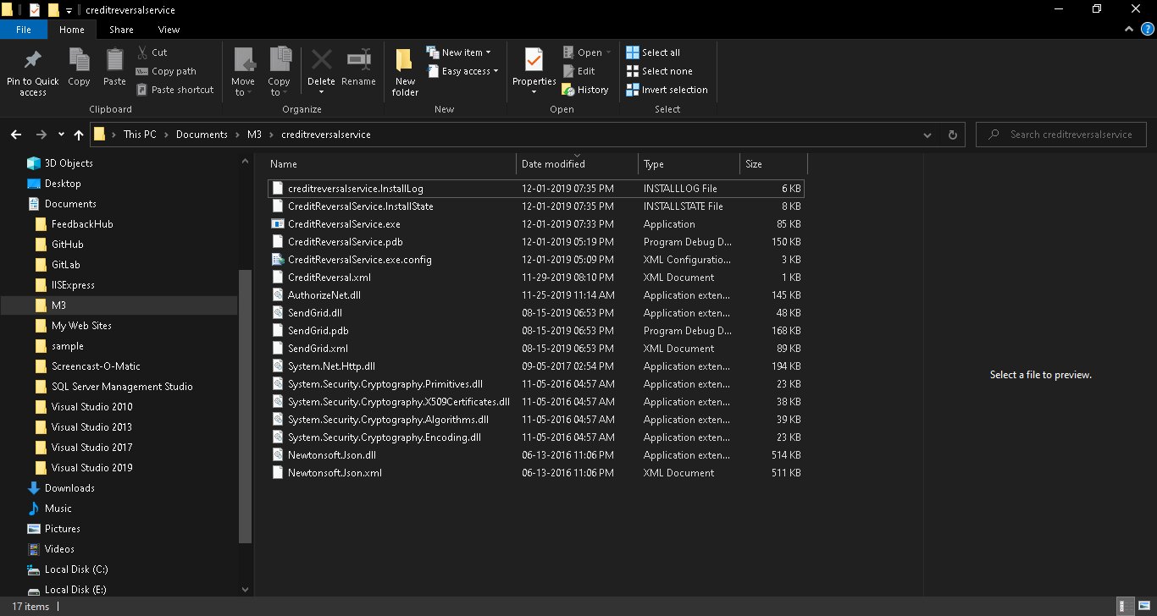

- Open Visual Studio Developer Command prompt and Click Run as Administrator.
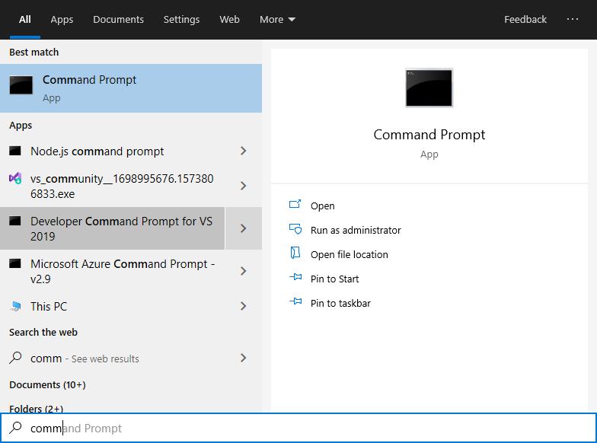

- Type below code on command prompt to install service
InstallUtil C:\Users\Satish\Documents\M3\CreditReversalService\CreditReversalService.exe
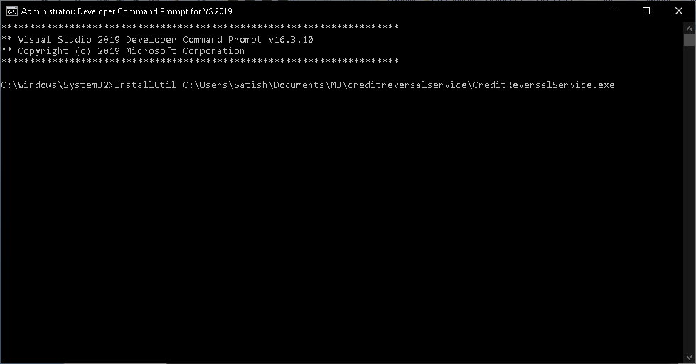
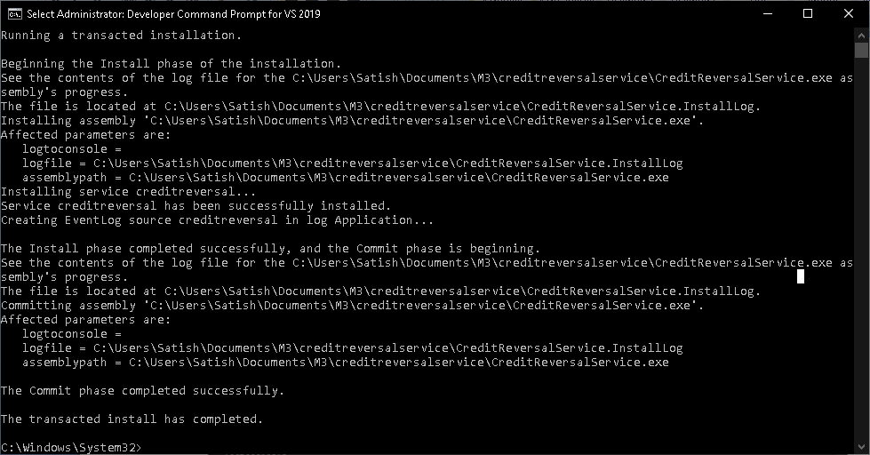

- After installing service then installed service will be displayed in services anf if we Open services.msc. Then It will display creditreversal service in start mode.
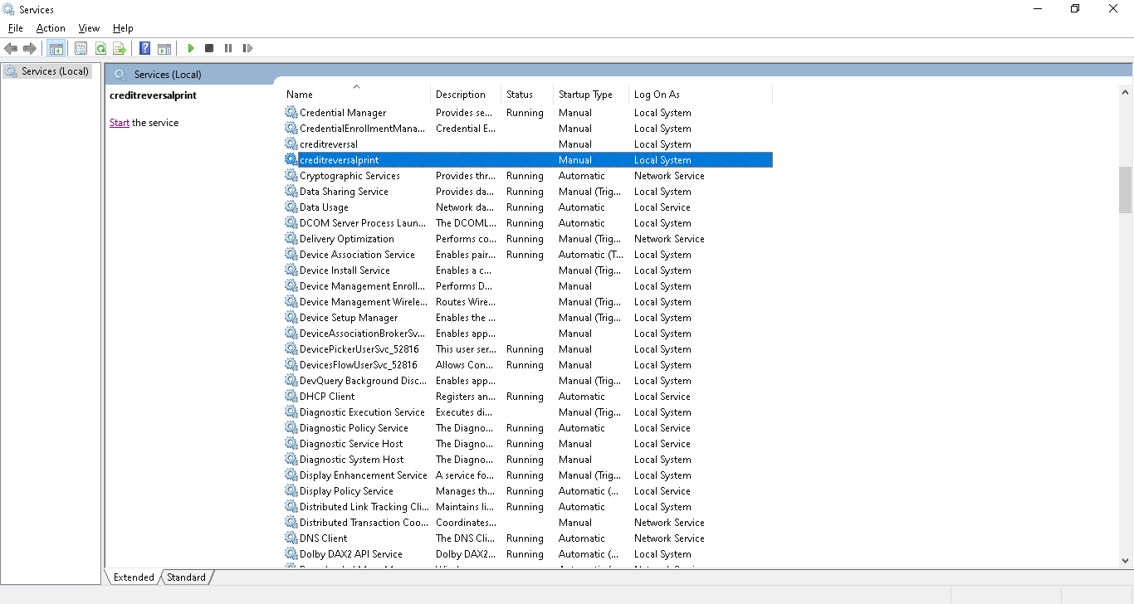

- Using Task Sheduler we can start and stop creditreversalprint service.
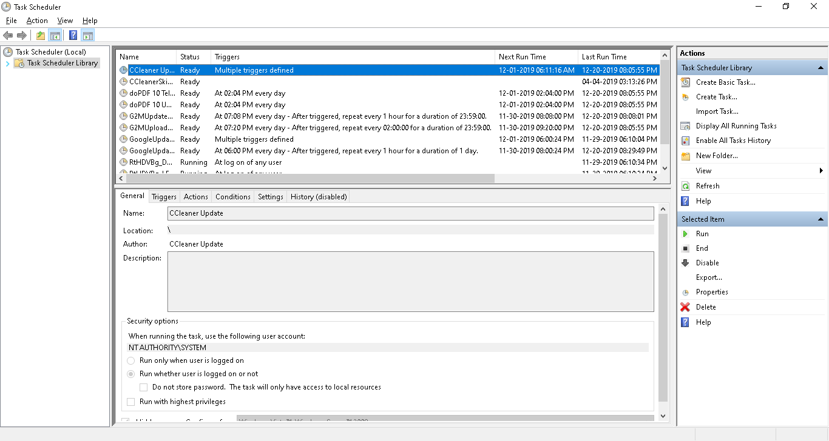

If we want to create task then please follow below steps
a) Create task – Start CreditReversalPrint
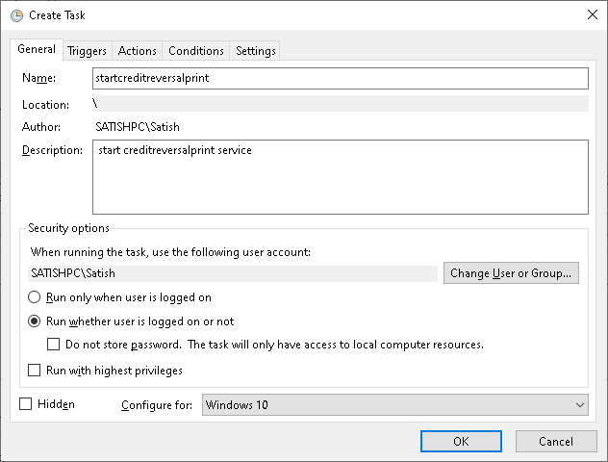

b)In below screenshot we need to follow steps as on screen for scheduling task

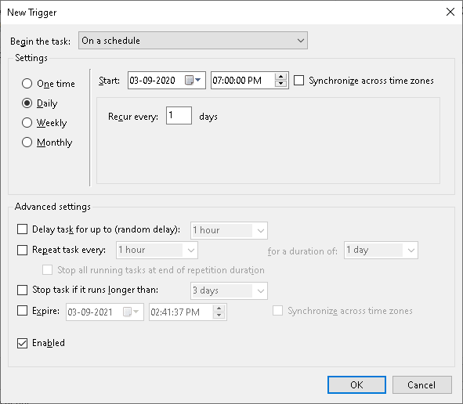

c)In the above screen if we click ok button then below screen shot will be displayed

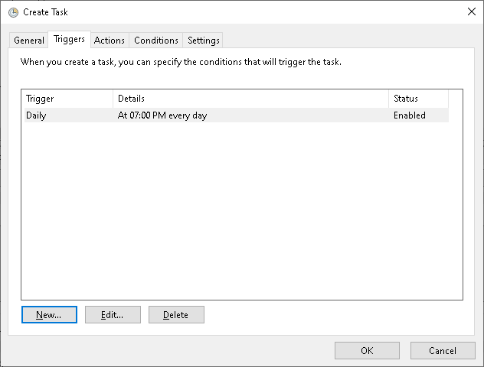

d)In the below screen we need to create progam as on screen for triggering task

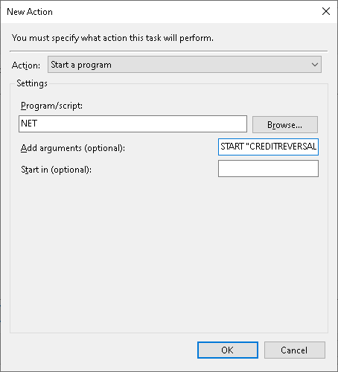

If we click ok button to the above screen then below screen will be displayed in which near Power default checkbox will be selected we need to unselect checkbox since we want to work service on battery power
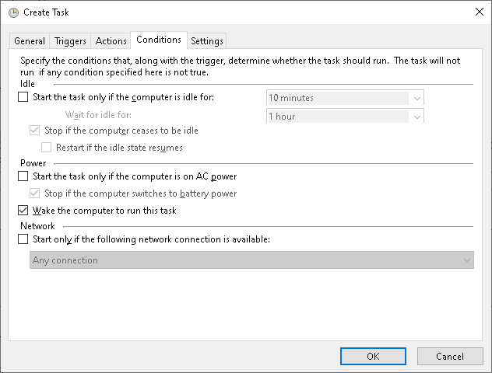

Once we click ok Button in the above screen then Login page for task Scheduler will be displayed in that we have to enter one time password and click ok button
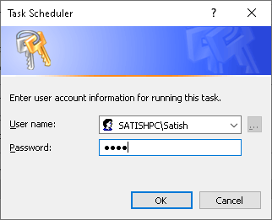
Created task will be displayed on the below screen
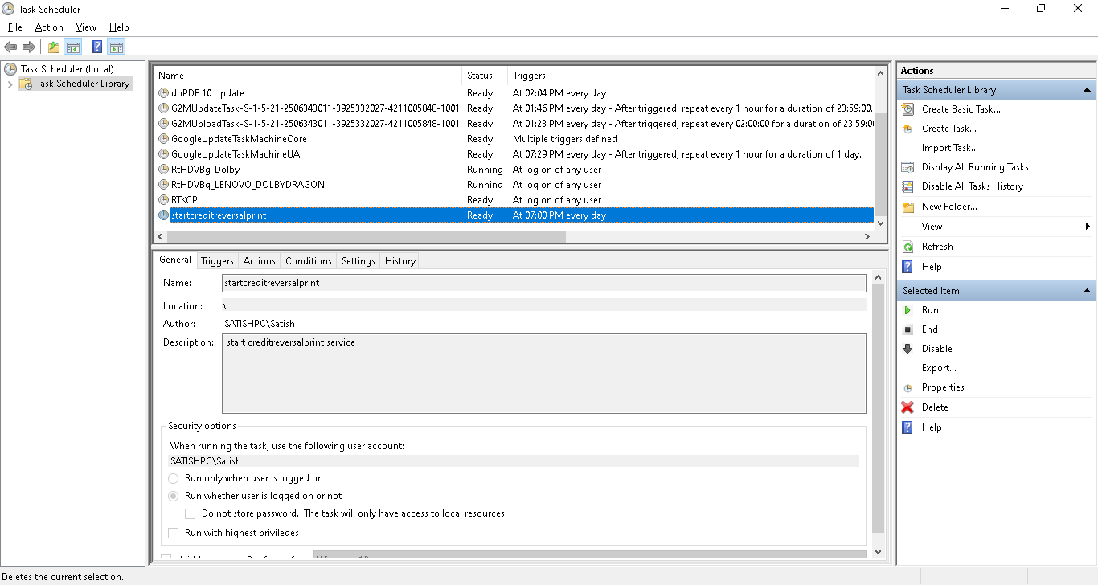

Based on created task services will be running


How to Stop service using task for that we have follow below steps
Same steps like above.

